MyDesign Portfolio
Element G Initial Template

Element G: Construction of a Testable Prototype

Final Prototype Iteration Explanation (G1)
Date: March 14, 2025
 | Details | Tools and Manufacturing Methods used
Step 1 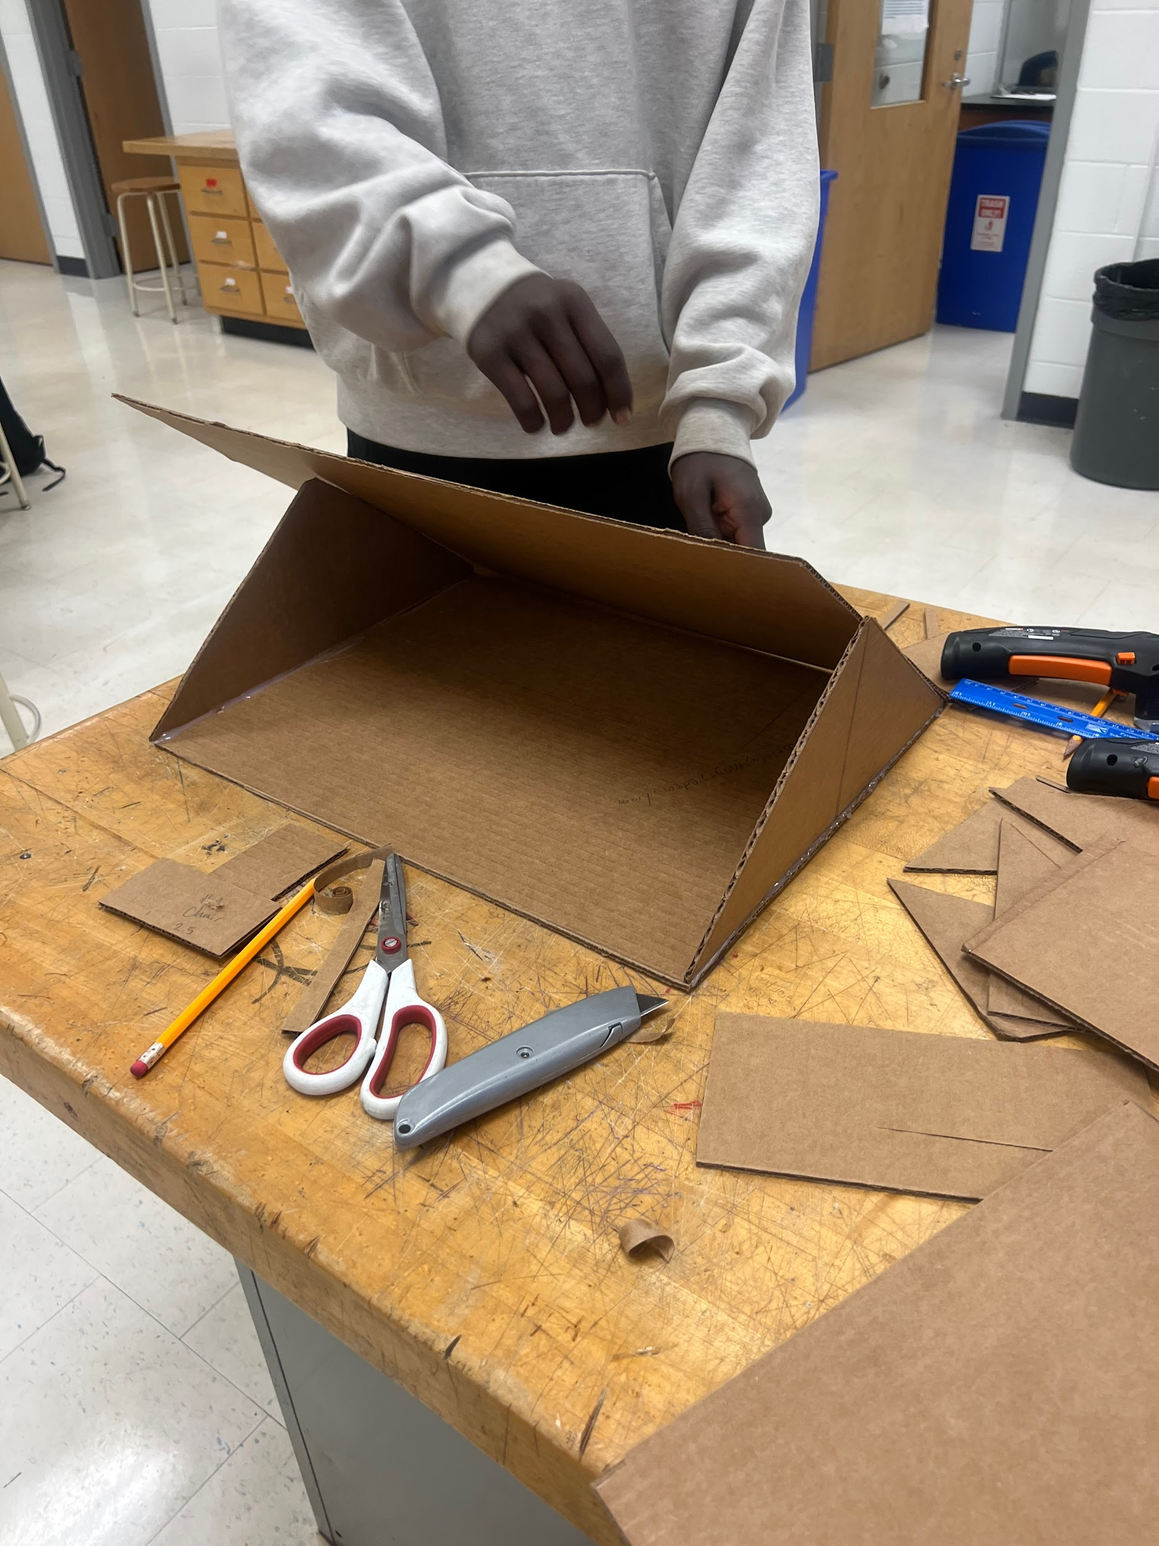 | Create a triangular roof, the 2 outer big pieces will be 9 x 18in, and the smaller triangles holding it together will be a 9x14in roof to support the fire detection system, measuring the whole house (12 x 18in ). The base of the roof is precisely measured as the house. | 4 Cardboards, 2 at an angle and 2 filling it. Material: a cardboard cutter to make a straight, steady cut, adding a bit of pressure and moving your arm steadily  ahead.
Step 2  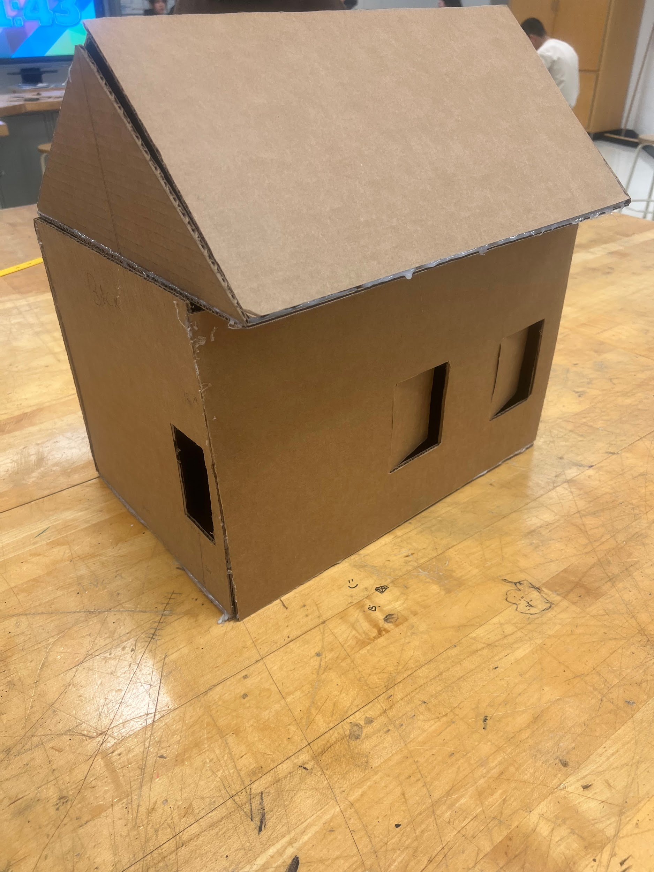 | Make 3 windows. 2 windows on the 12 x 18in which is the back wall ( the opposite wall from the front door), and one in the 6x12in room, but will be on the 12x12in wall. measuring 3 x 4in, but 3in away from the wall on the 12x18in wall in the 6x12in room, also one on the 12x12 wall in the 6x12in room. | One of the exterior cardboards ( 12 x 18in) is used with a coping saw to cut windows, along with a drill, to drill the holes of the sketched windows, so that the coping saw can cut through it.
Step 3  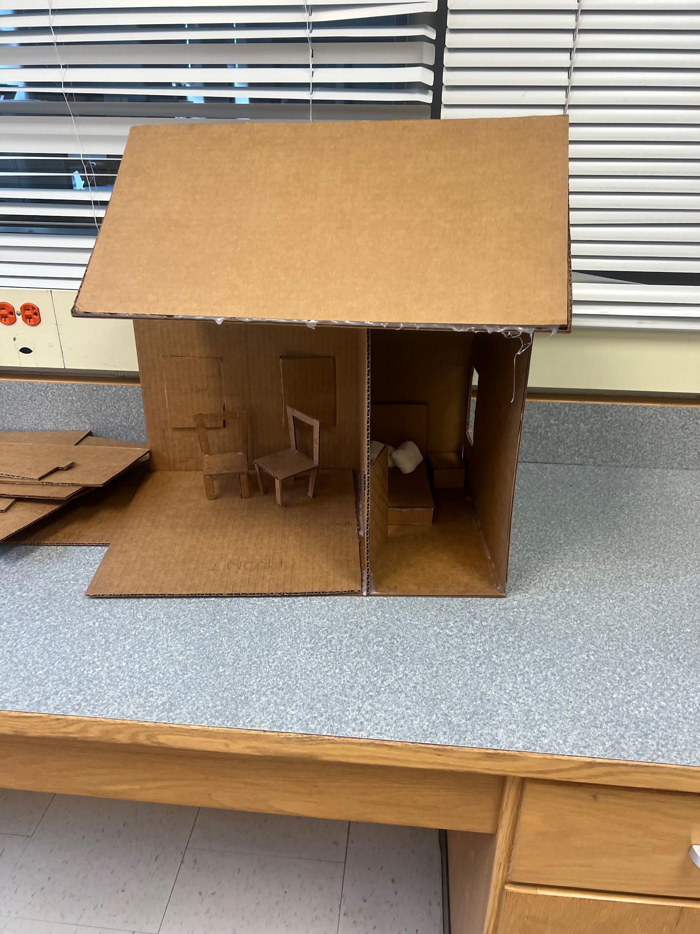 | An interior wall needs to be created to make two rooms, so it's cut out by 12x12in to fit perfectly between 6 inches away from one side of the 12x12in exterior wall on the outside. So it would make 2 rooms of 12x12 and 6x12. | For the interior wall, an electric cardboard cutter will be needed to make a perfect cut. Cutting a 12 x 12 cardboard from any cardboard.
Step 4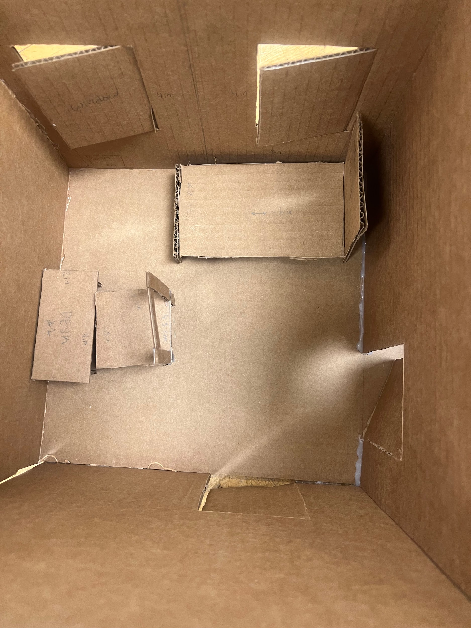 | Make a bed, the vision is to make it look neat, so the bed's backboard will be 4.5 x 3.5in, along with 2 legs connecting it, with measurements of 1.5 x 1.5in. | Needs: scissors and a precision paper cutter  The precision paper cutter will be used to cut/ outline the sketch that was created.  The scissors will be used to fully cut out the board to make the bed and desk that's needed.
Step 5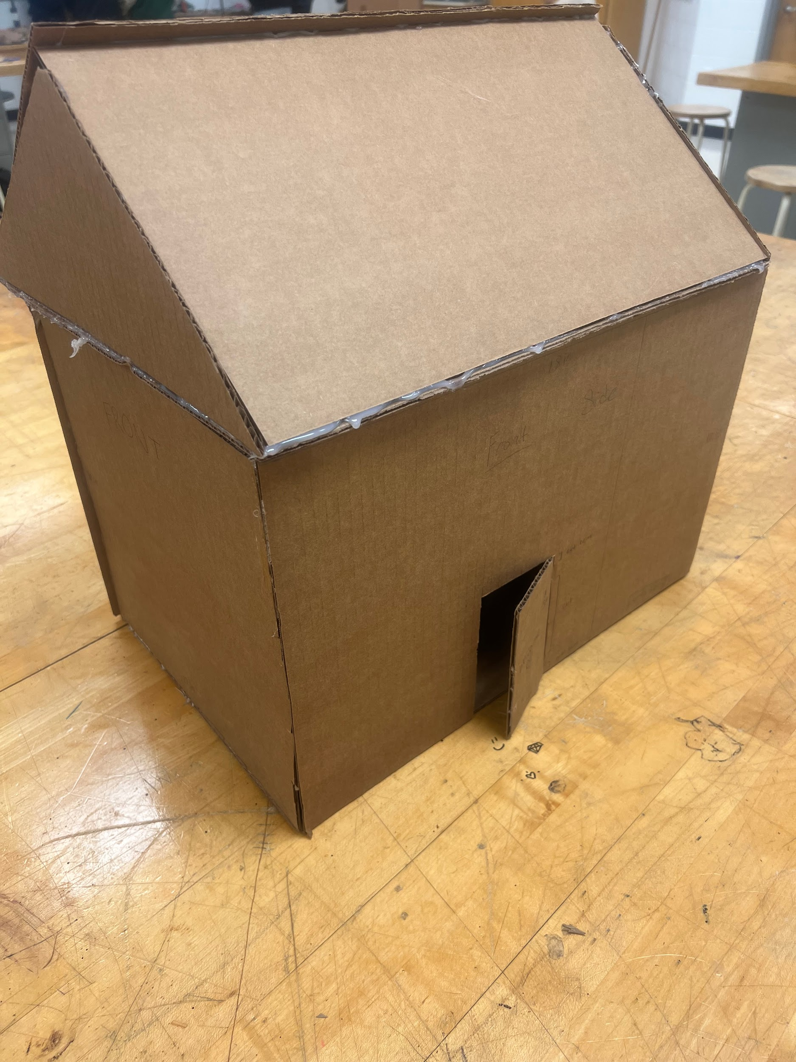 | On the front view of the house, a door will be needed, which will be 3 x 5in, but 1cm will be cut off along the side of the door so it can function | Scissors and a precision paper cutter will be mandatory since it's not that hard of a cut.  Precision paper cutter to deeply, basically sketch out how you want it to look like/ be cut, which will make it easy for the scissors to go through and cut smoothly
Step 6 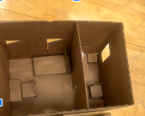 | 2x desk and 2x chairs will be made, that have measurements of 4 x 2in ( desks) that have legs, that go by measurements of 1.5 x 1.5in.
Step 7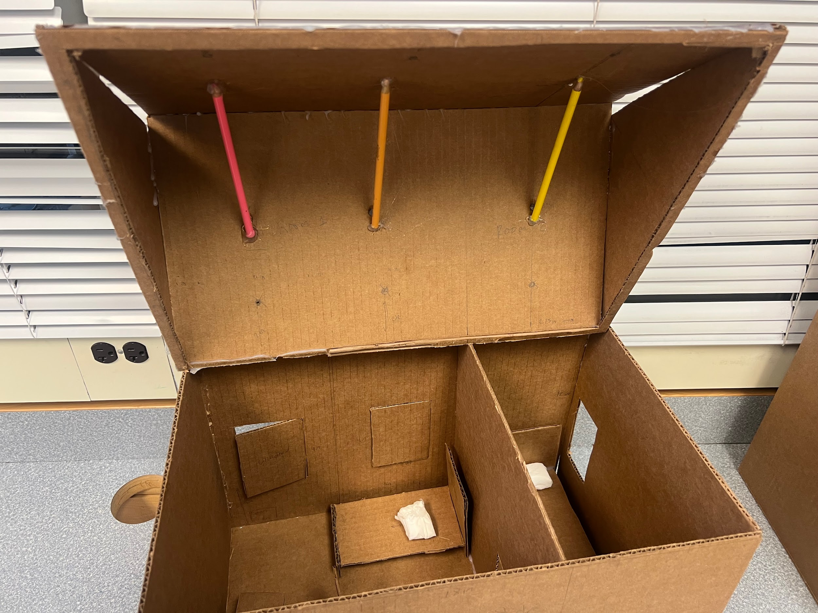 | A detection system is required, so the idea was to envision where and how we wanted it to work, typically with pencils or some sort of wood that would hold the balloons on the roof. | Needs/what we used: a pencil and an Ad-Tech Pro-200- glue gun.  optional: any type of wood ( like A stick)  A pencil will be used on the roof, so that the balloons can hang from it until they’re popped by the fire. The glue will be used to keep it in place where we want the pencil to be.
Notes of the progression from your blueprint to your (various) physical prototype(s), including why and how aspects of your design may have changed:
Instead of us using pencils, we ended up using wooden sticks. As we were testing/ trying to get the balloons onto the pencils, they weren't meeting our satisfaction due to them not being sturdy enough to hold the balloons.
Final Prototype Construction of Design #2 ‘
Date:
 | Details | Tools and Manufacturing Methods used
Step 1  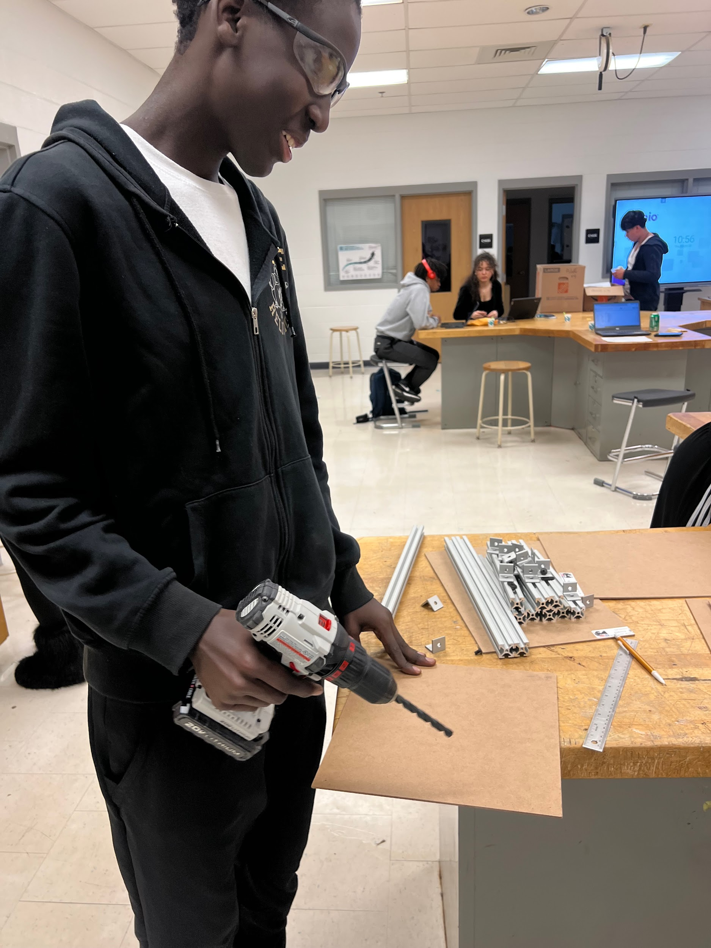 | Get 2 12 x 12 boards and drill a 3/12-inch hole in each corner. This means you should have 4 drilled holes in each corner on both 12x12 cardboards. | You will need eye shield glasses, so that the cardboard/ dust doesn't come into contact with your eyes.  You will need
Step 2  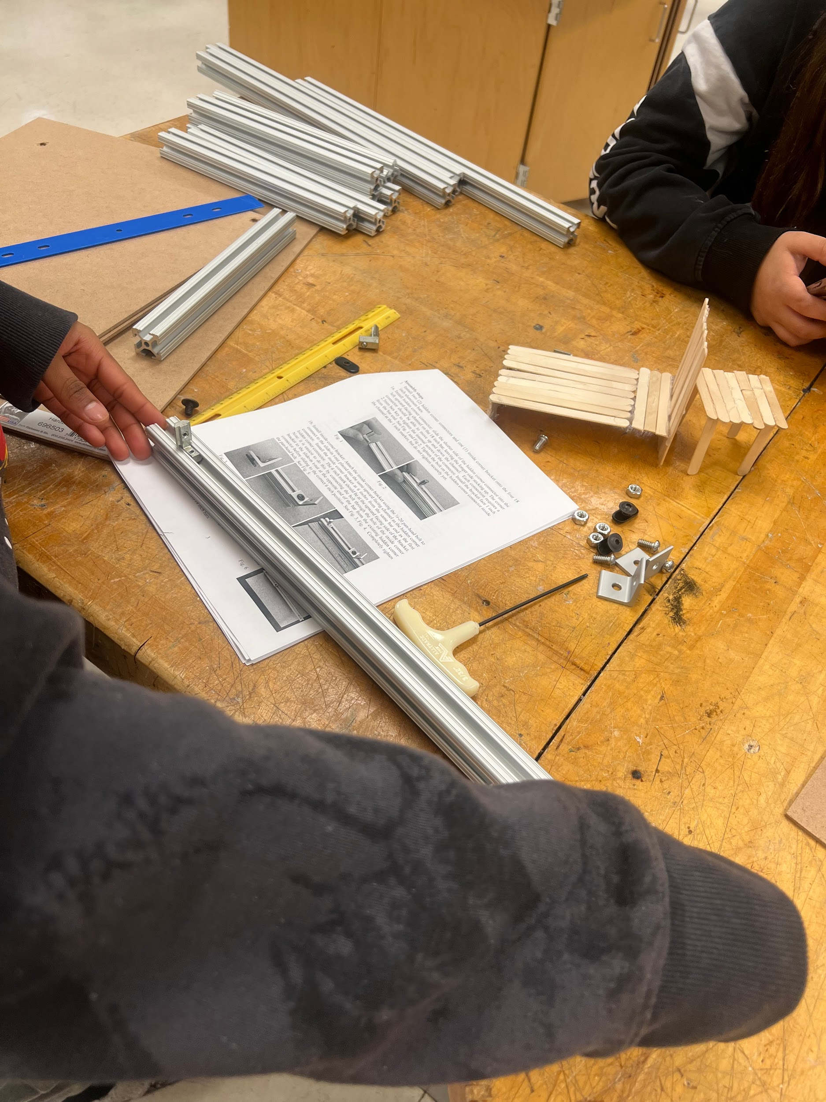 | This is the process when you start building your house. Each corner connector will be used in each corner, inserted 1 inch away from the base of the aluminum bar. | You will need a….. Screw driver.  While screwing in the corner connector you will have to remember  Righty tighty, lefty loosy.  And making sure the measurement is accurate, one inch away from the end of each side of the bar,  In all 12 aluminum bars, there should be 2 hidden corner connectors.  There should be no gap when connecting it all.
Step 3  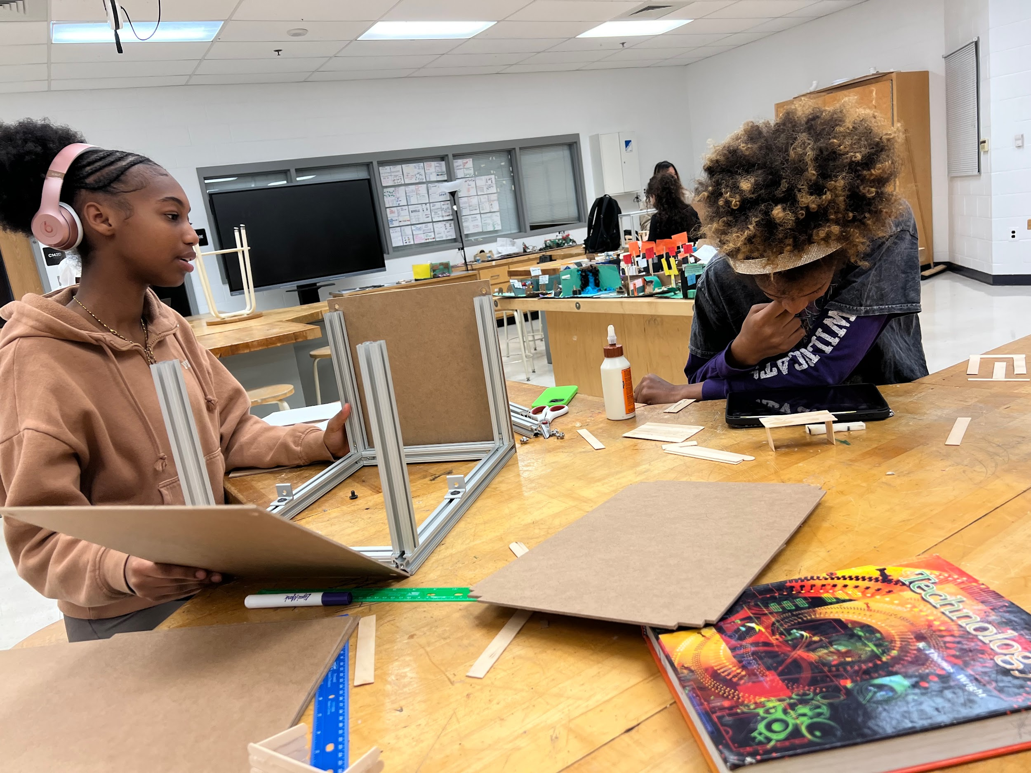 | Put all the cardboards through the metal pieces. | No tools will be needed except your hands. If it doesn’t fit, that probably means you didn't measure accurately, the 1 inch away. But everything should slide right through, pushing it with a little force.
Step 4 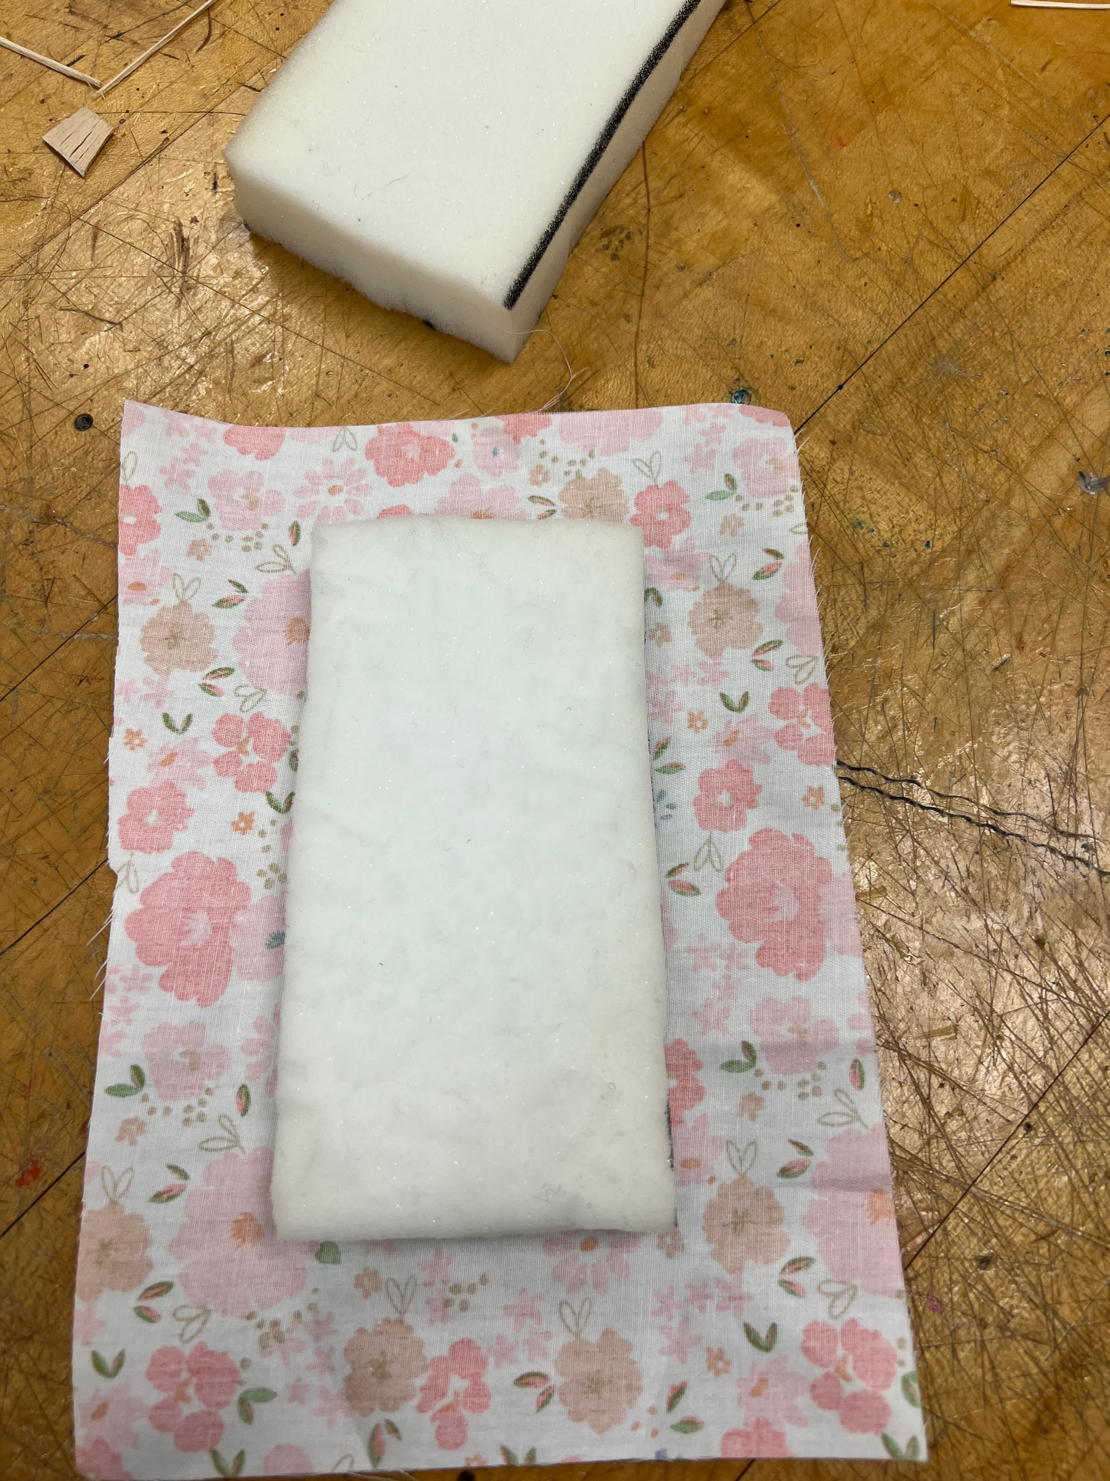  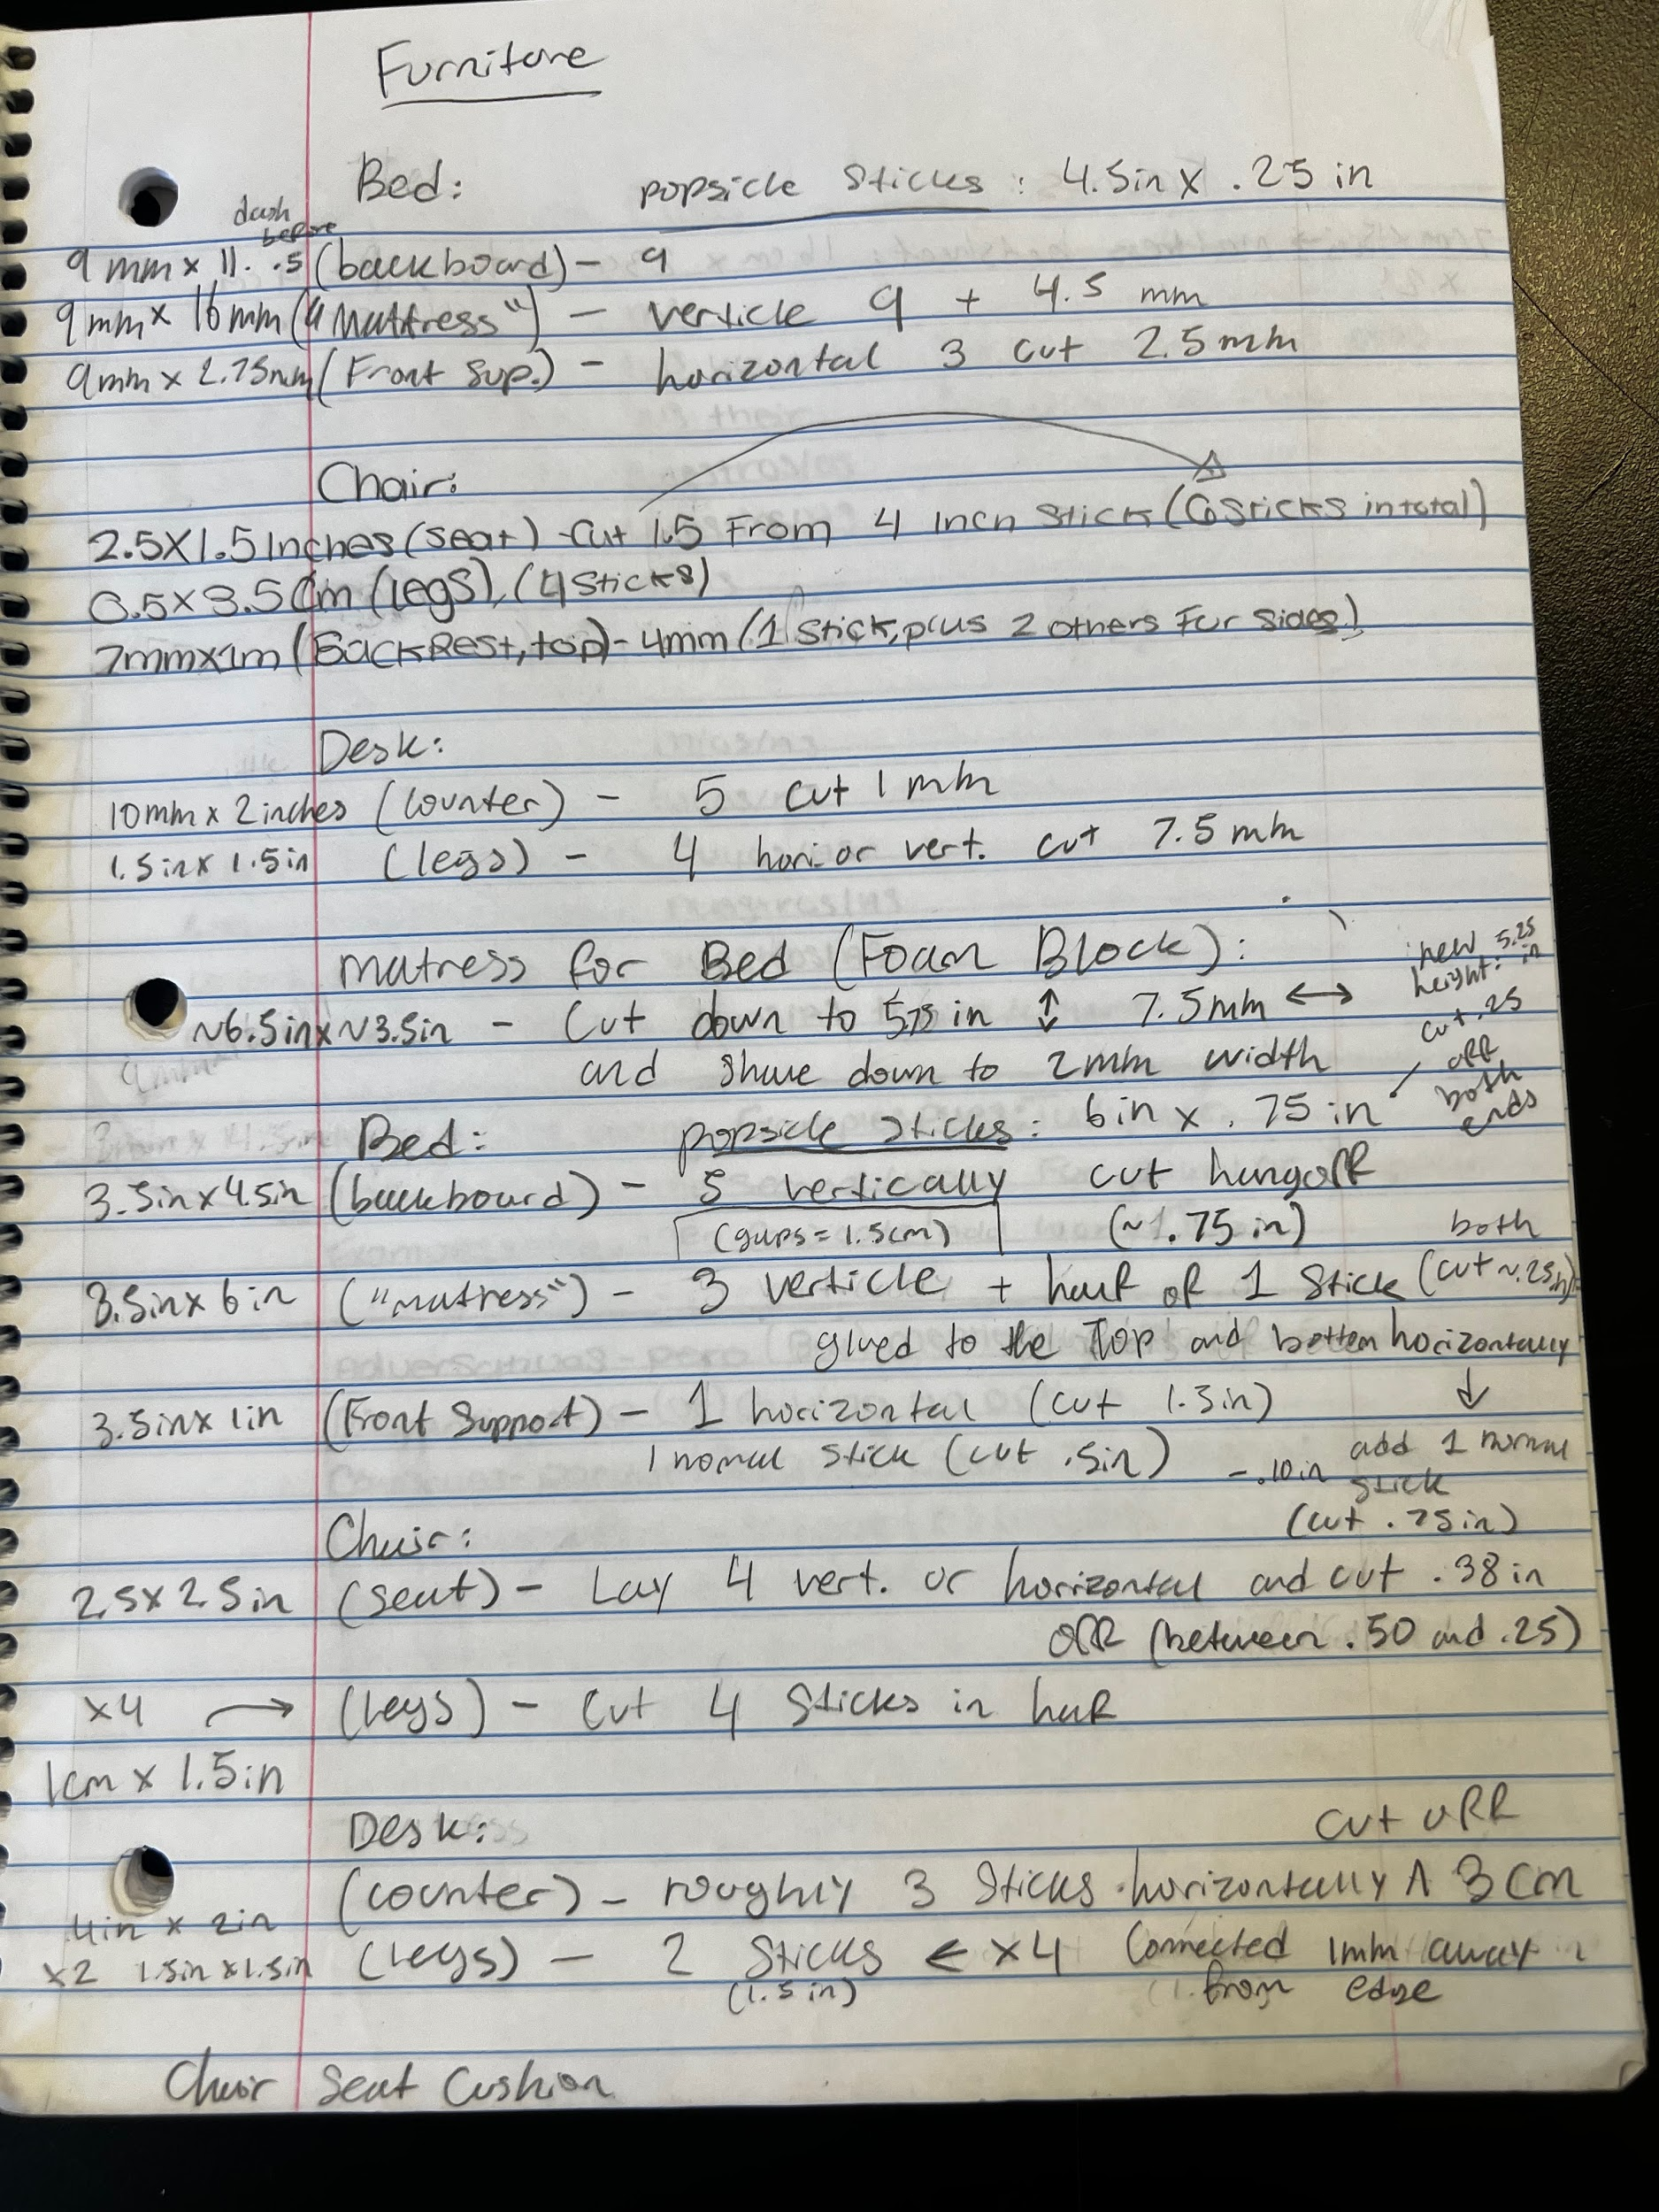 | You’ll need to make Furniture/ add fabric. Which is included on the 2x Beds and the creatively made 3x curtains, that go by measurements of 3.5 x 6in ( “mattress.”) | Mandatory: glue gun or gorilla glue.  What we used: Gorilla Glue (the majority of our stuff)  You would use sticks to build everything else: desks, chairs, and beds.  For the bed, you will be provided foam, you will use that to sketch out the size of the actual made and
Step 5 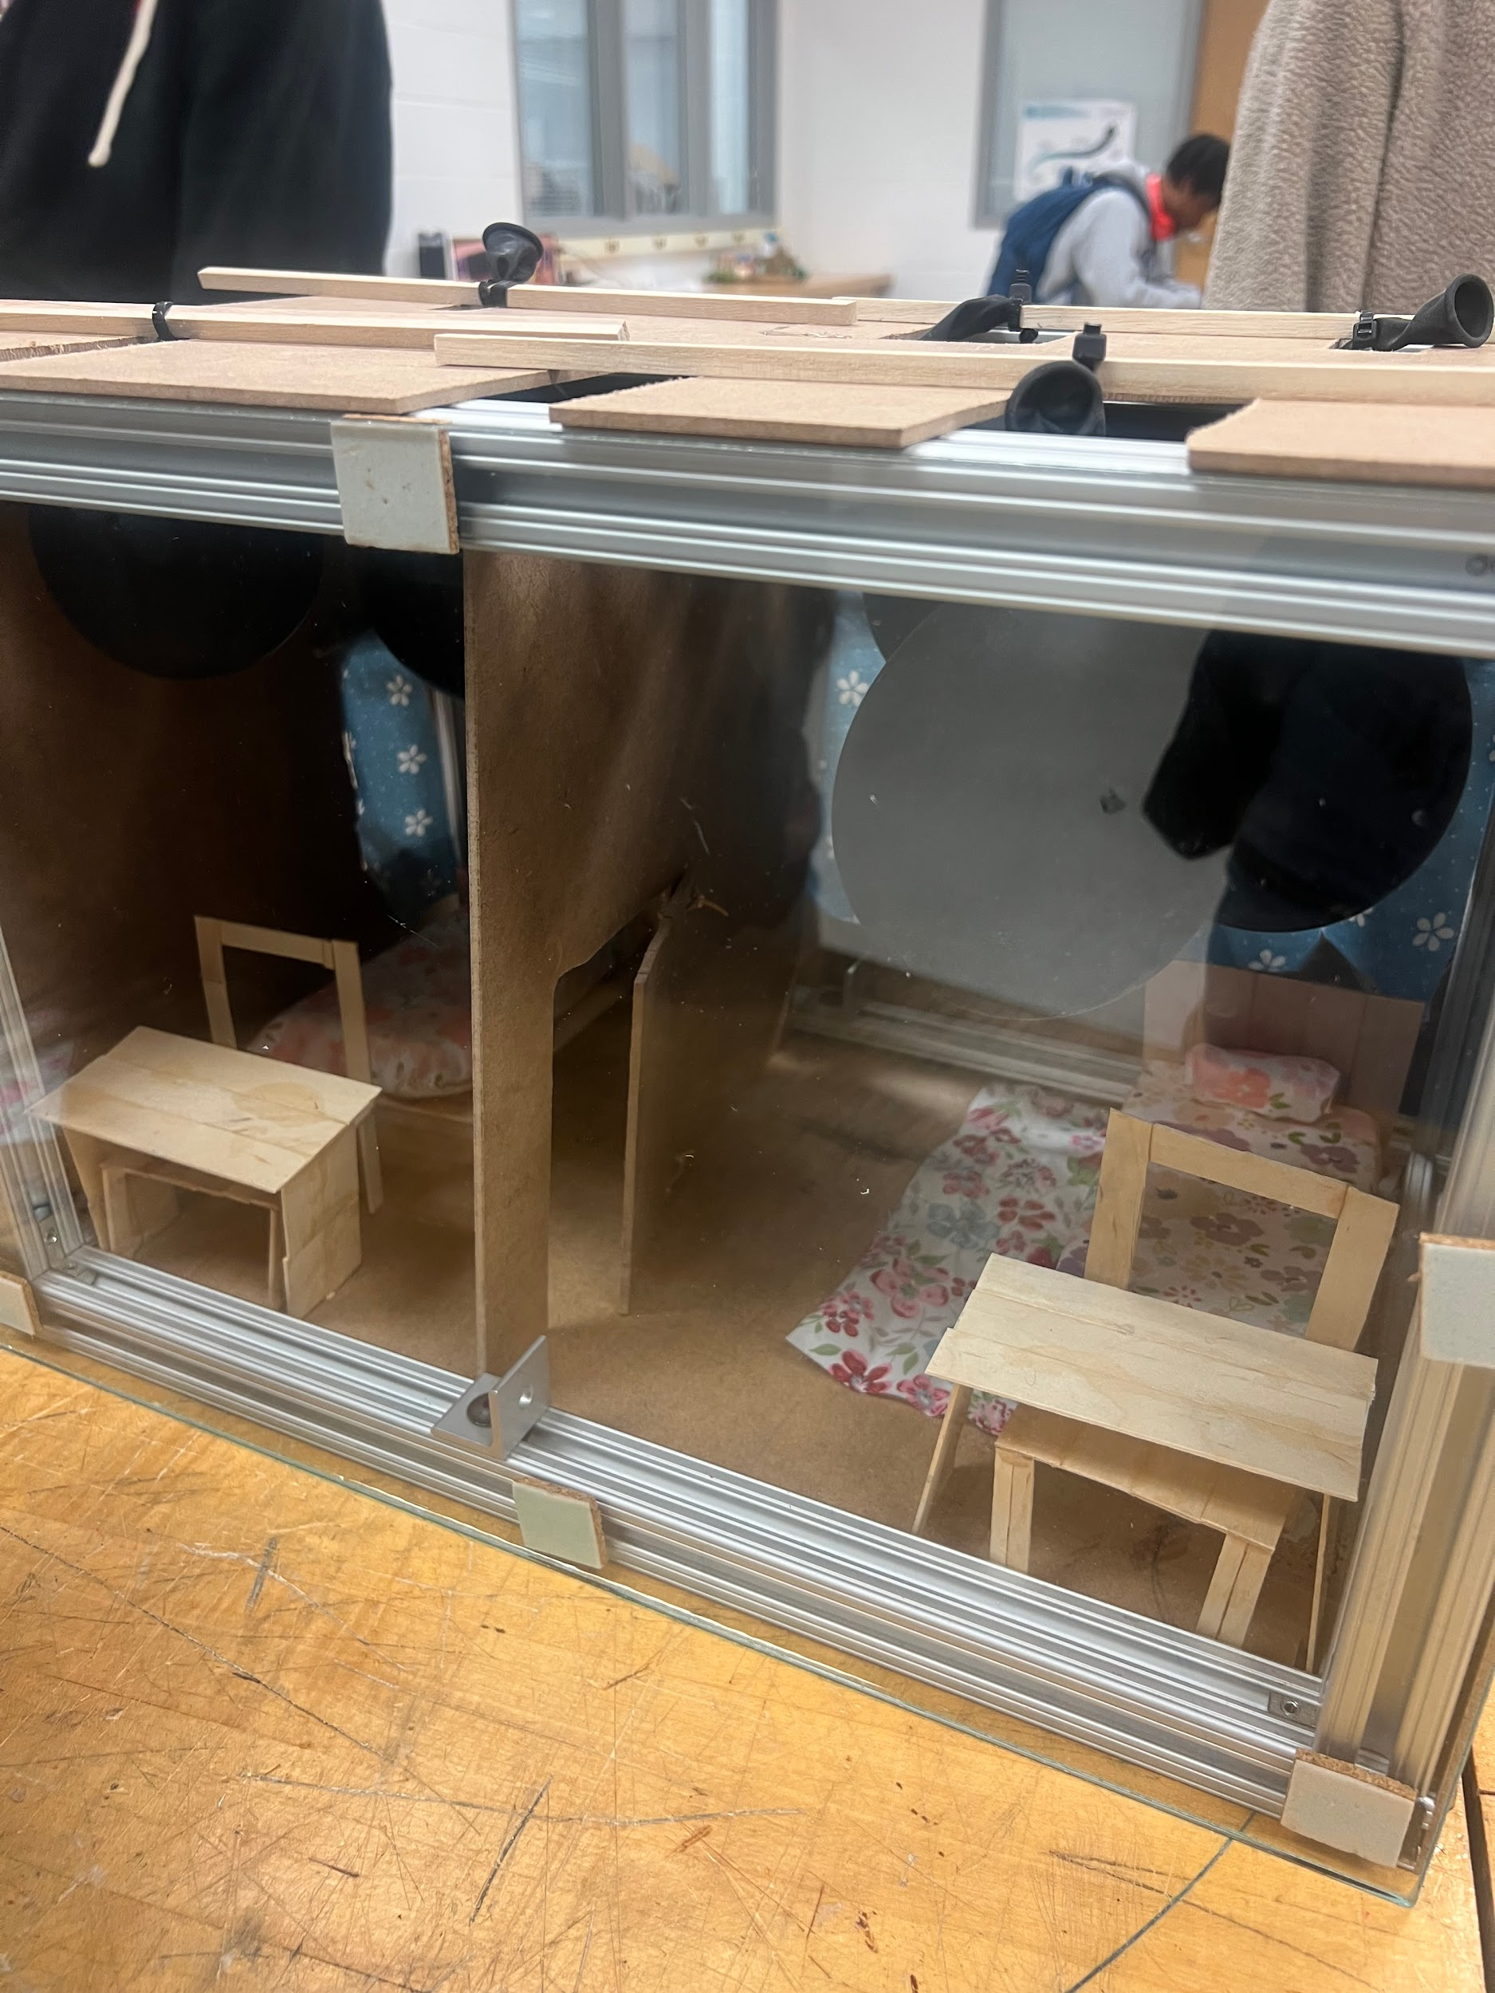 | A suppression system is made by filling up the balloons to a specific amount of pressure, not too small, but big enough that when the fire touches it, it will pop, due to how thin the balloon will be. | You will only need 4 sticks and 4 balloons, specifically 2 small balloons in the front and big ones in the back.  You will also need to make 4 doors/ boxes so that the balloons can go through them.
Step 6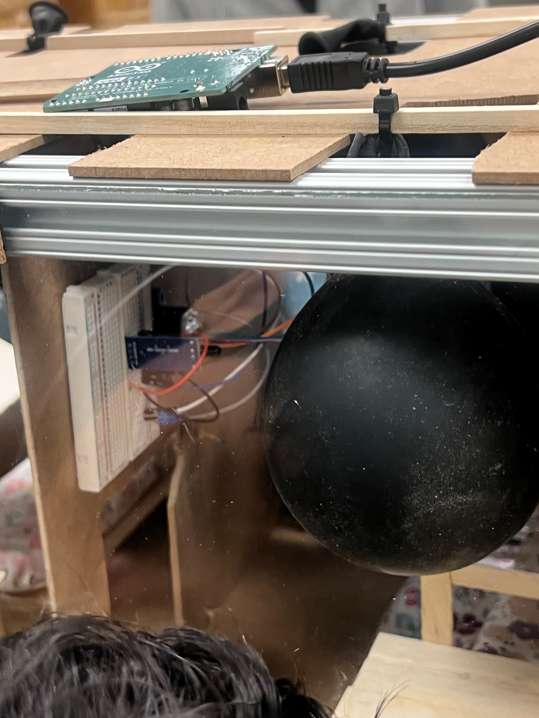 | Now we have to start thinking about where the system will be most valuable, and we thought on the wall, since we guessed that the fire would start lower, so instead of the system being on the roof, we moved it a little lower on the wall | All you will need is 2 black sticky pads to attach the system to the wall. Peel one side of the sticky pads, and connect them to the back of the system, and the other one pad is peeled and connected to the wall. That way, all you have to do is attach the system, and it should hold onto the wall.
Step 7

Notes of the progression from your blueprint to your (various) physical prototype(s), including why and how aspects of your design may have changed:
When we were building our suppression and detection/ notification system, instead of using 3 sticks/ pencils, we ended up using more, and having to make openings/ boxes for the balloons to fit so that they would be able to pop and decrease the fire from rising. We also thought, instead of the system being directly on the roof, to move it to the top right corner of the wall, so once the fire starts, it will detect it faster, instead of waiting for the fire to spread before it goes off.

Material name | Description | Where material was purchased | Cost per unit | # units | Total cost per item
Ad-tech pro- 200  ( glue gun) | Mandatory for anything the guerrilla glue took too long to do. |   Gluegun.com | $57 | 3 | $171
Hidden- Corner connector | This goes 1 inch away on each corner of the aluminum bar, and it is required to keep all the bars together. | everestpartsupplies.com | $6.72- 8.10 | 12 | $80.46  -$97.2
Aluminum extrusion | This is the main part of the house that will be built: the outline/ base of the house. | amazon.com | $7.6 | 12 | $91.2
L- Brackets | This is important for the interior wall, and where it should be, for example, you would put it on the aluminum extrusion bar 6 inches away from one side. Overall useful just to know where your wall would easily be. | homedepot | $4.86 | 4 | $19.44
Adhesive sticky pads | This item is used to stick on our most important objects, which are the window and the system. | amazon.com | $6.17 | 5 | $30.85
Coping saw | This is used to go through the drill holes and make the windows. Used to cut cardboard. | homedepot.com  walmart.com | $6.09 | 1 | cheapest:$ 6.09  Cheap:  $8.49
20V lithium-electric drill | This will only be used to drill the holes of the windows. | amazon.com  walmart.com | $49.99 | 1 | $49.99

Detailed sketches, which might include CAD if you have learned it in your class:
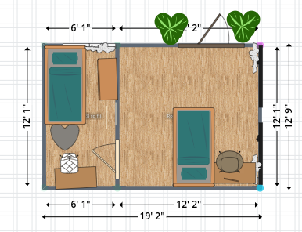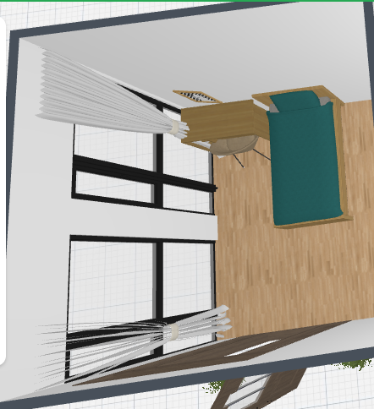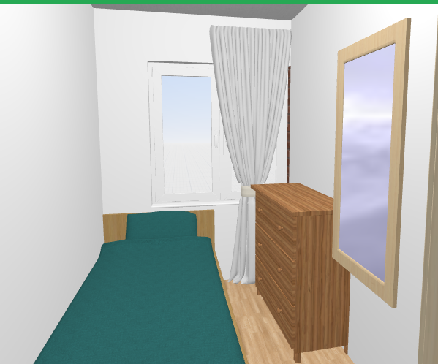

Construction of the Final Prototype (G2)

For example, if you have a design requirement that your design can "transport medicine a distance of 5 meters in 1 minute", is your prototype sufficiently functional such that you can test that? (e.g. can the prototype move the medicine at least a little bit?)
 | How will this prototype allow you to collect objective, measurable data?
Detection system ( high priority) | trigger the alarm in response to the smoke or heat.  Record response times, accuracy. You can measure this by testing if the system consistently  This allows the person to be fully aware of the condition/ event they are currently in without any human intervention.
Notification system( high priority) | By monitoring the status of smoke and heat detectors and recording a response to them. This data allows us to identify new ideas for improvement and strategies. The measurable data includes alert time, the number of notifications sent, and the reaction time.
Suppression system  (high priority) | Light a heated object near the detector and see if water is able to come out and stop the fire. Run a test and track the time it took. and the success rate. This can be used to detect potential issues and further analyze the fire.
A specific amount of materials ( high priority) | Weigh or measure all materials used, record, and compare with the required limits. Helps you ensure consistent results and avoid mistakes. This helps to collect accurate data, which can be used to create conclusions about the process or to understand the situation.
Accurate measurements  (high priority) | Use rulers, measuring tapes, or digital tools to compare the dimensions to the blueprint and what you wanted. Record in mm or cm to be precise. Use measurement tools to compare the prototype's dimensions
Furniture  (low priority) | Check if the furniture fits within the design space and supports their intended function, measure dimensions and placement accuracy. The measurable data could include size.
Interior design  (low priority) | Use rating scales to evaluate your satisfaction.

Testing or Modeling of Attributes (G3, G4) and Addressing Non-Testable Attributes (G4)

Attribute | Description | Describe your prototype’s functionality to test this attribute
Detection system | Uses sensors to detect motion | Set a heat source ( candle, lighter, etc) near the sensor and see/ confirm if it responds
Notification system | Send an alert when motion is detected | Trigger detection and wait for/check for alarm sounds, or a message.
Suppression system | Automatically activates to release water when fire is detected | Trigger fire detection and see if the balloon is thin enough to pop, to release water.
Emergency lighting | Lights up rooms and helps people to be aware that a fire is happening. | Cut the power and confirm that emergency lights can still be turnt on.
Emergency exit

Addressing Non-Testable Attributes (G4)

Attribute | Justification for why this attribute cannot be modeled or tested with your prototype
Suppression system | Unrealistic to test in a school environment ( balloons filled with water), and it will potentially set off other ones in the school if we use one in our class.
Power backup system | It will be hard to trigger in class.
Fire department alert | No real alert would be sent to the fire services, since this is only a test, not an actual occurring fire.
Emergency lighting

Element G: Construction of a Testable Prototype
 | 5 | 4 | 3 | 2 | 1 | 0
1. Final Prototype Iteration Explanation. The Final Prototype Iteration is _____________. | clearly and fully explained | clearly and adequately explained | adequately explained | somewhat explained but with gaps | only minimally explained | is unclear or is missing altogether
2. Construction of the Final Prototype. The Final Prototype Iteration is _____________. | constructed with enough detail to assure that objective data on all or nearly all design requirements could be determined | constructed with enough detail to assure that objective data on many or nearly all design requirements could be determined | constructed with enough detail to assure that objective data on some design requirements could be determined | constructed with enough detail to assure that objective data on at least a few design requirements could be determined | not constructed with enough detail to assure that objective data on at least one design requirement could be determined | not applicable to any design requirements and/or functional claims
3.Testing or Modeling of Attributes. _____________ attributes (sub-systems) of the unique solution that can be tested or modeled mathematically are addressed. | All | Most | Some | A Few | No more than one | None of the
4.Addressing non-Testable Attributes. _____________ justification is provided for those that cannot be tested or modeled mathematically and thus require expert review. | A well supported | A generally supported | An adequately supported | Developing | Insufficient | No

