Section G: Construction of a Testable Prototype

We are trying to stop the black swivel desktop from moving, we are creating a way for students to lock the ability for it to move easily. Our solution is to place rubber bands over the desk’s swivel mechanism pole and add resistance to slow down the desk.
To build our initial prototype we planned to use the RUISHYY brand tactical rubber bands size #94 (3 ½” x ¾”). Our initial idea was to put one of these around the swivel mechanism, but we realized that it would be too thin. Thus, we decided that we would tape two of them together and put them around the swivel mechanism. We were about to order the rubber bands when we decided to double-check the size of the rubber bands relative to the circumference of the mechanism on the desk on which we would be putting the band around. We realized that they were too large, and would therefore not work. Because of this, we switched to our final prototype, which involved changing the rubber bands to ones with a 1.27 inch diameter.

RUISHYY tactical rubber bands
To build our final prototype, we took two Grifiti small silicone rubber bands and taped them together. We decided to use these rubber bands because of their diameter of 1.27 inches, a length that we decided would be suitable for our desk pole with a diameter of 1.5 inches. This way the rubber bands would have a tight grip on the desk to ensure it would not move. They have a width of 0.5 inches, so the total width when connected is 1 inch. To attach them, we laid two out folded next to each other, the long side next to the long side, and we used very strong duct tape to put them together. We switched to this prototype because we discovered that our initial one would be too large. Our first prototype had a diameter that was too big for the desk and would have no effect on the problem. So, we switched rubber bands and came up with this, our final prototype, with the correct size.
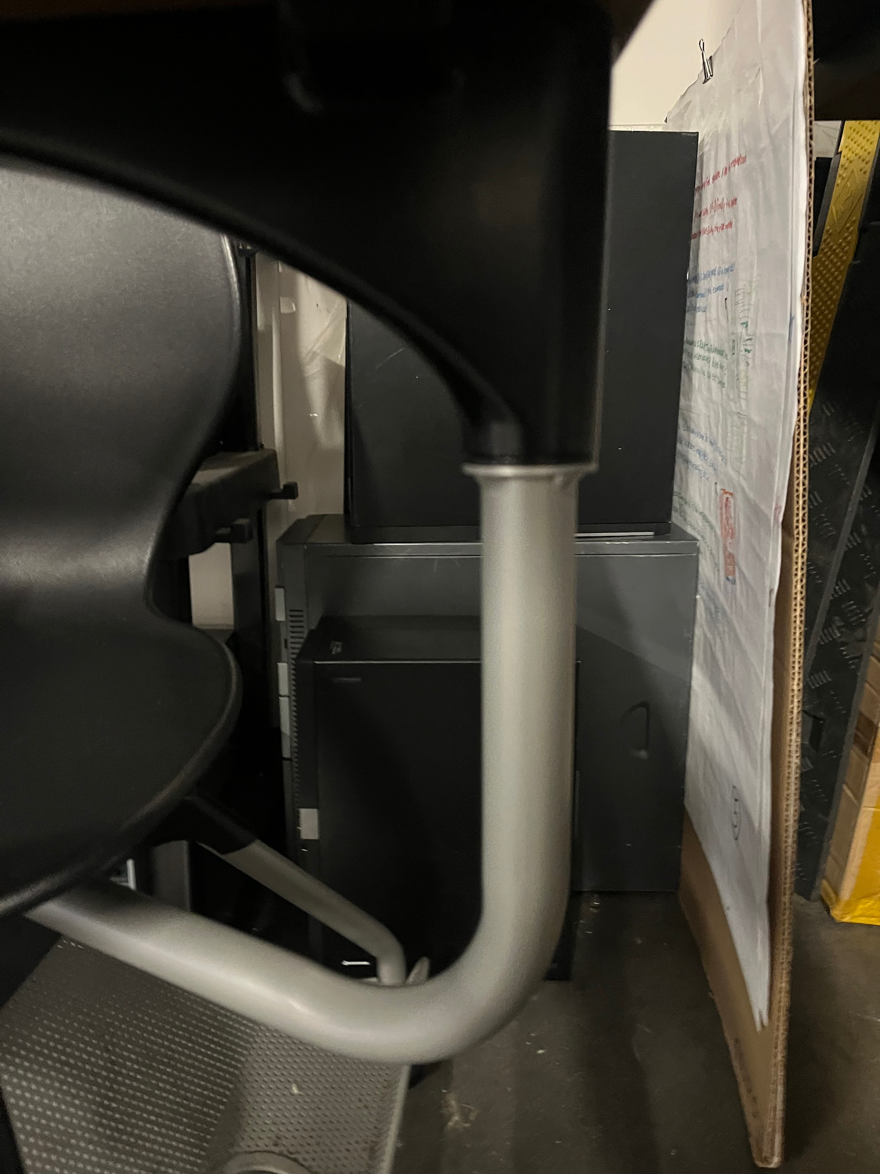
Grifiti silicone rubber bands

This prototype will allow us to test if the rubber works to add resistance to the desk’s swivel mechanism. When we test our design, we will see whether or not it meets our requirements of being able to “lock”, being able to “unlock”, and is easy to use. Once we put this solution on the desk, we will be able to conduct our tests and evaluate if this design meets all of our requirements.
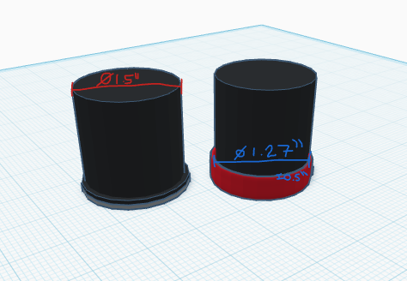
CAD drawing of our initial design

For our final prototype, we decided to take another route. After ordering the rubber bands, we discovered that they would not be strong enough to meet our design requirements. Our experts had given us feedback earlier with suggestions for a hole in the desk, and a pin to lock it in place. We decided to use this idea for our final prototype, so we drilled a hole through all three pieces making up the desk pole. We were given a release pin from the robotics team, and used a drill bit matching the size of the pin. Once we had made the hole and ensured that the pin would fit inside, we added tape to signify where the holes were to our stakeholders.
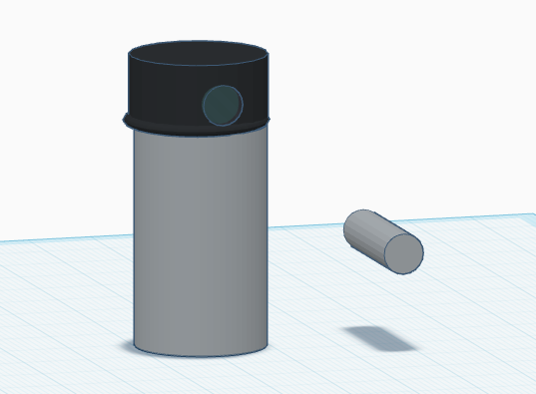
CAD drawing of our final design

We ended up keeping the pin mechanism as our final prototype, but we added a second pin mechanism, similar to the first, in order to lock the side-to-side swivel of the desk. To build this, we drilled a hole through the bottom of the desk pole, beneath the chair. We were given an aluminum rod by Mr. Binsner, but it was slightly too large to fit in the hole so we ground down the end. Then, we bent the rod in order to create a handle shape so that it would be easier for our stakeholders to use. Next, we cut the rod so that it was no longer too long. Lastly, we added tape to signify where the holes were to our stakeholders.
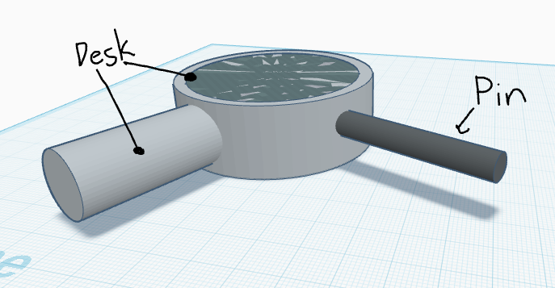
CAD drawing of the second portion of our final design

We are going to test our solution by obtaining metal pins, building our solution, and applying it to the black swivel desk we have in the classroom. While testing, we will ensure that we pay close attention to our 3 high-priority design requirements: the ability for our mechanism to lock, being able to unlock and being easy to use. We will test the ability to lock by applying the mechanism and running multiple tests where we swivel the desk and see if it rotates. If it does not rotate, we have met that design requirement. We will then test the ability to unlock by attempting to remove or unlock the mechanism without tools, while sitting at the desk. This simulates the situation in which our stakeholders will be unlocking the desk, meaning that it is an accurate test of our design requirements. Lastly, we will see if it is easy to use by having stakeholders attempt to lock and unlock the desk and have them rate the difficulty on a scale of 1-10, with 1 being incredibly easy to use and 10 being incredibly difficult. This gives us accurate data on the functionality and simplicity of our design because people who did not design it or know how it works will be testing it.

The feedback we received from our expert Ms. Meghan about our testing plan was that it would be more logical to test multiple solutions in tandem, instead of testing one and then the next. For example, we can test the solution with the rubber bands at the same time as a different potential solution. This feedback makes sense because it saves time and it means that we do not waste as much time waiting for materials for different prototypes to arrive, because we can order them all at once and test each prototype as the materials arrive. Ms. Meghan, the expert who gave us feedback on our testing process, is a Google engineer who came and talked to our class. She has worked in many engineering jobs throughout her career. Her experience and her advanced education on the topic make her an expert on the subject, especially since she has worked on and seen projects like ours before.

One of our design requirements that cannot be tested is the bulkiness of the solution. Since, due to a limited budget, we cannot afford to test a lot of solutions, we cannot easily compare this solution to other possible solutions. Due to this, we cannot compare the bulkiness, meaning that we won’t know how bulky this solution is relative to others. However, we can work around this by having our stakeholders, DCI students in particular, test our prototype in order to ensure that its bulkiness is satisfactory.

