MyDesign Portfolio
Element G Initial Template

How to use this template
Teachers: You may customize this document before providing it to students.
Students: The template below is one way to present your construction of a testable prototype, but the specific assignment given by your instructor may require a different structure or dictate different details. If you make a copy of this template to edit for your own prototype construction details, be sure to delete the instructions.
Guidance before filling out the template that follows:
- Because you will iterate on your design multiple times, you will need to create multiple copies of these sections. Think of this Element as another piece of a diary that you will date and keep adding to throughout your work until your final iteration. It’s critical that iteration shines through in this Element also.
- You will then proceed on to test and analyze this design and then determine your next iteration, returning to this Element afterwards when you are ready to construct a new testable prototype. Fill out each of these steps again.

Element G: Construction of a Testable Prototype

Final Prototype Iteration Explanation (G1)
This section focuses on the process of explaining your prototypes. While the title of the subelement focuses on your final prototype, you must have at least an initial prototype and a final prototype, with additional prototypes in-between being desirable. Note that you never know which prototype is your final prototype until after you test it, so be sure to record all of the information for each prototype. Use as many copies of this sub-template as needed.
Ensure that photos are taken from multiple angles so that all sides and subsystems can be seen. All images should have captions and should be referenced in-text.
Prototype Construction of Design #1 (make as many copies, updating the design number, as needed)
Date:03/25/2025
Photos with captions of your full construction process from day 1 of building through to the last day of constructing your final prototype iteration:
Details about all steps of construction (add step numbers as needed), including the tools and manufacturing methods used:
 | Details | Tools and Manufacturing Methods used
Step 1 | Research the rest of the material needed
Step 2 | Find a way to be able to make sure it would heat up | Aluminum metal plate
Step 3 | Figure out where we are going to place the heating system underneath the robot | We used measuring tape and a rule to measure how wide and what the length.
Step 4
Step 5
Step 6
Step 7

Notes of the progression from your blueprint to your (various) physical prototype(s), including why and how aspects of your design may have changed:
Final Prototype Construction of Design #2 (change this number to match the design number you’re on)
Date: 03/20/2025- first 2 weeks of march
Photos with captions of your full construction process from day 1 of building through to the last day of constructing your final prototype iteration:
Details about all steps of construction (add step numbers as needed), including the tools and manufacturing methods used:
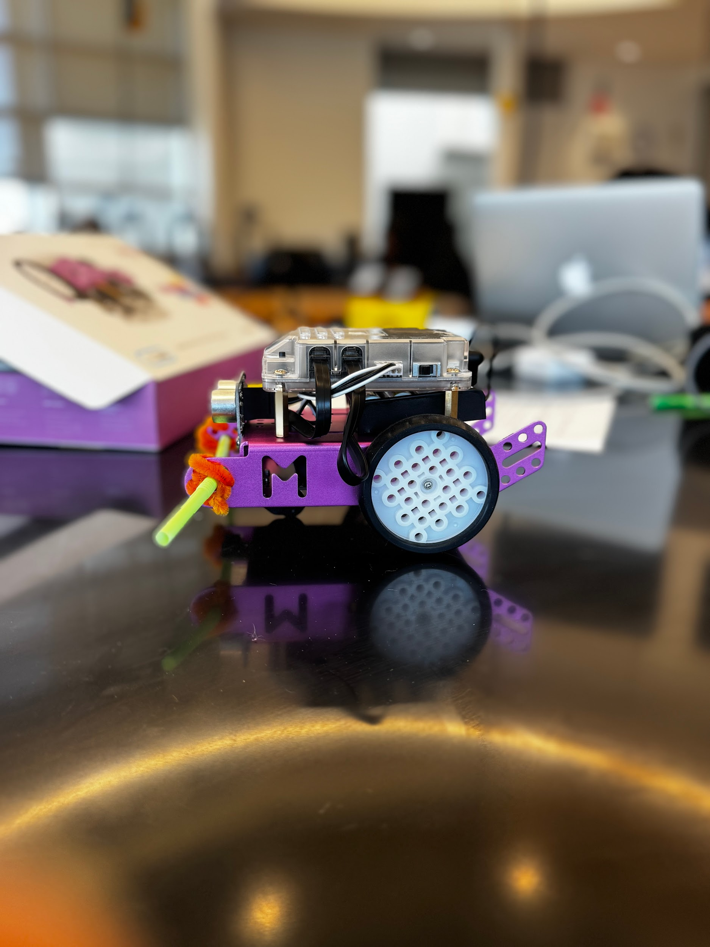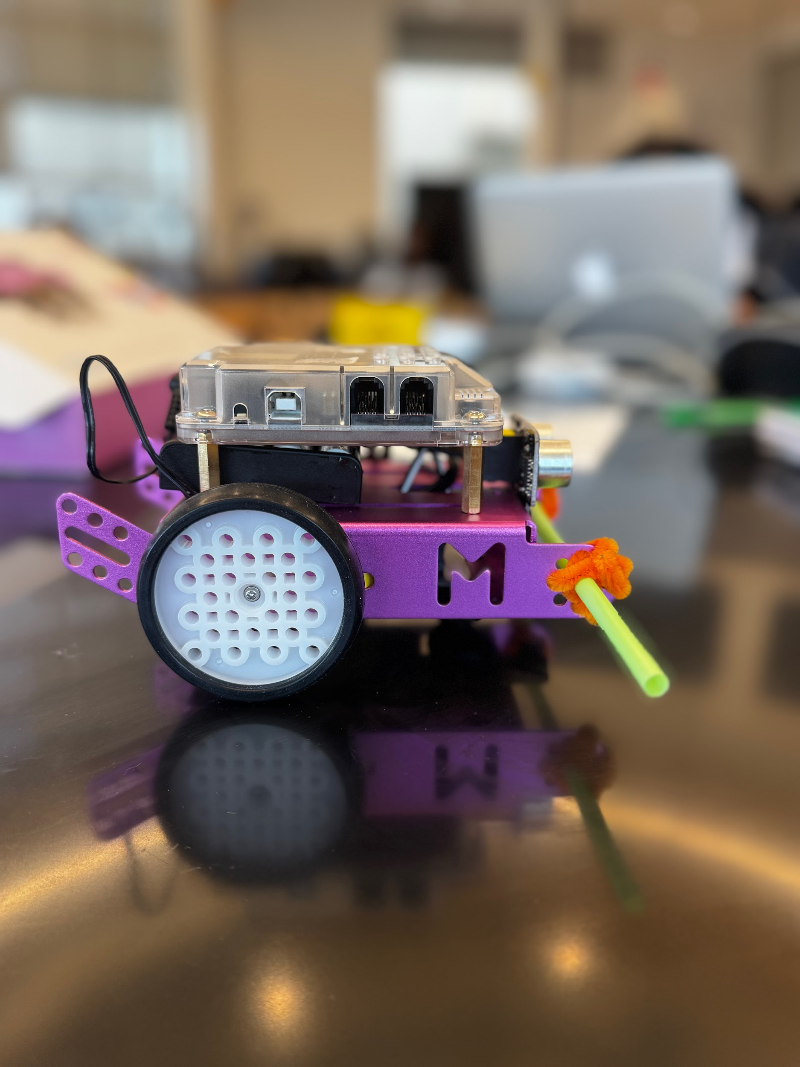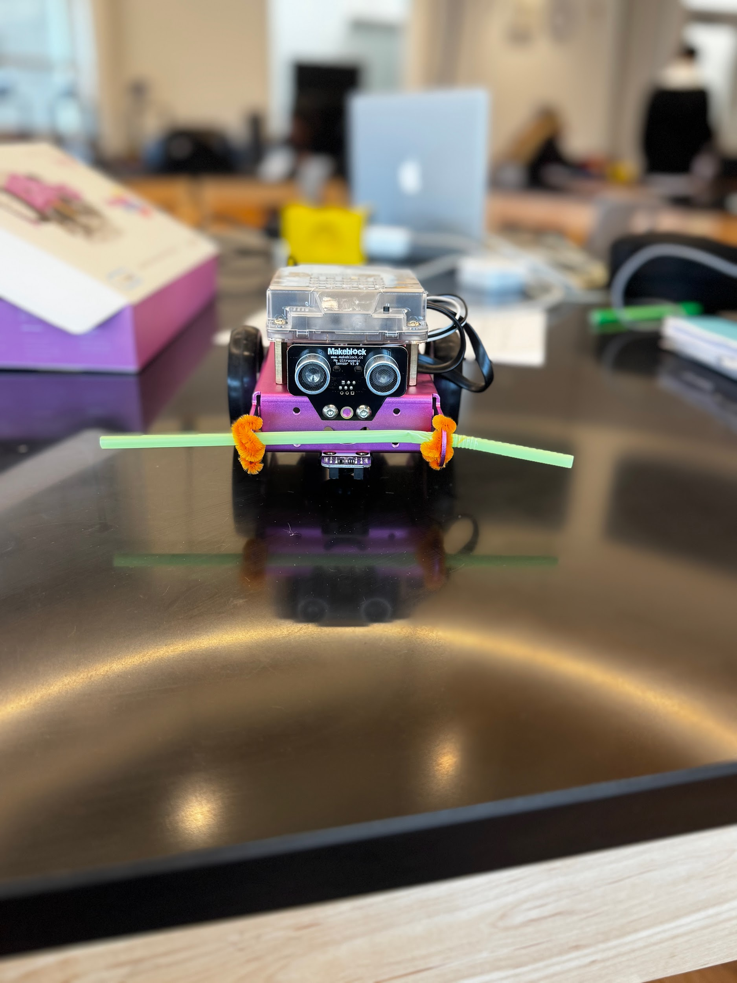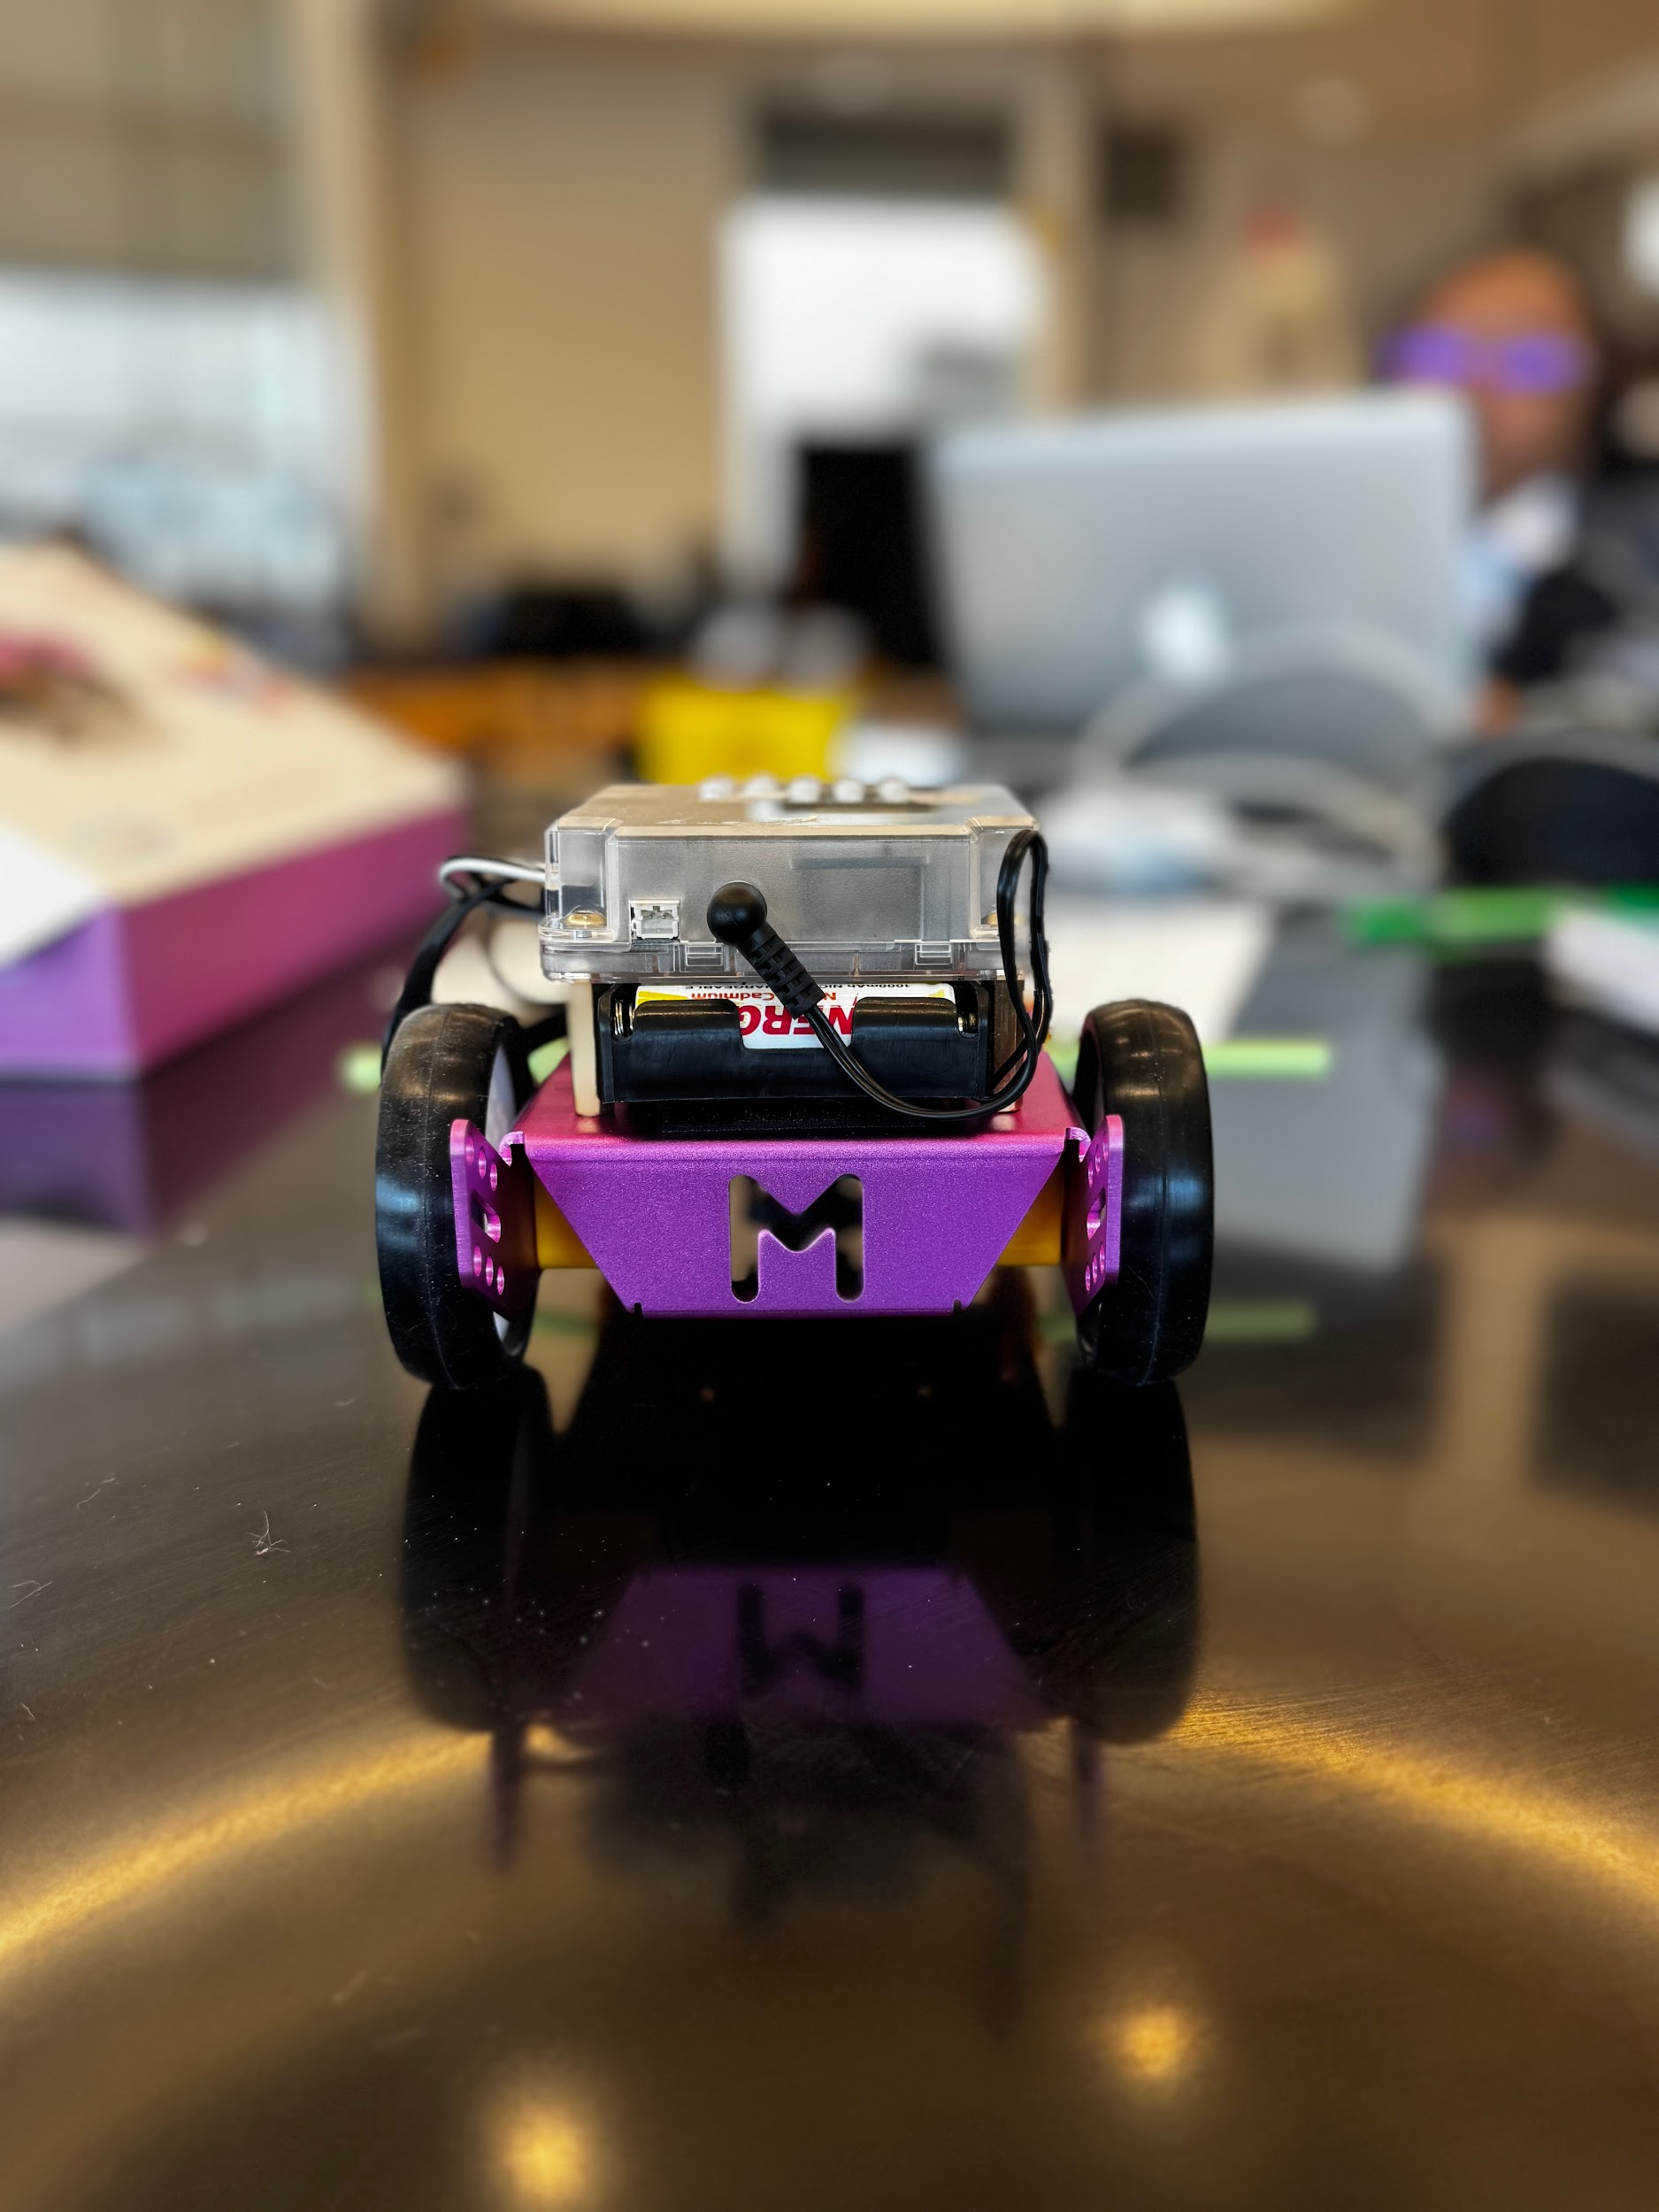
 | Details | Tools and Manufacturing Methods used
Step 1 | The mBot was given to us on an idea we had to make a moveable machine to melt the snow when the mBot is moving. We got the robot from our teacher it w | mBot Makeblock
Step 2 |  | straws
Step 3 |  | pipe cleaners
Step 4
Step 5
Step 6
Step 7

Notes of the progression from your blueprint to your (various) physical prototype(s), including why and how aspects of your design may have changed:
List of material details, including item name, description, where it was purchased/obtained (include URL if applicable), cost per unit (if applicable), # of units, total cost (if applicable)

Material name | Description | Where material was purchased | Cost per unit | # units | Total cost per item
mBot |  | Amazon | $79 | 1 | $79
ceramic PTC |  |  | $9.99 | 1 | $9.99
Metal Aluminum Sheet |  | Amazon | $9.99 | 1 | $9.99
Aikon cable cover wire |  | Amazon | $124.99

Detailed sketches, which might include CAD if you have learned it in your class:

Construction of the Final Prototype (G2)
When you’ve finished construction of your final prototype, you must be sure that your prototype allows sufficient functionality that you could collect objective, measurable data for all or nearly all of your design requirements. This requires you to look back at your design requirements from Element C. Copy all of your design requirements from Element C into this table and then add how your prototype will allow you to collect objective, measurable data. Note any weaknesses you find or details that will require expert review because they cannot be mathematically modeled or tested,
For example, if you have a design requirement that your design can "transport medicine a distance of 5 meters in 1 minute", is your prototype sufficiently functional such that you can test that? (e.g. can the prototype move the medicine at least a little bit?)
Design Requirement | How will this prototype allow you to collect objective, measurable data?
Type of Ice Melt/De-icer | The ice melts should not cause any additional cracking or be vulnerable to more damage over time to the concrete. (did not test)
Quality of Materials | Ensure use of high quality materials by checking reviews of the product.
Proper Curing | This design needs a strong top coat for the concrete as well as a good snow and ice remover so that the top doesn’t crack.
Cost | We need to make sure that the cost of all of the materials is reasonable so that we don't waste money on expensive or less crucial parts.
Control of Temperature and Weather | Maintaining a temperature of 20-25°C makes sure that there is concrete durable This helps prevent freeze-thaw damage and improves the longevity of the concrete itself.
Clearing the area | Making sure the area is cleared of dirt, debris, and loose concrete so that the repair materials bond properly.
Control of Shrinkage | When sealant is put on the pavement that it does not crack under pressure, heat or a chemical change on the pavement.

Testing or Modeling of Attributes (G3, G4) and Addressing Non-Testable Attributes (G4)
Describe all of your prototype's attributes (features, aspects, details, or subsystems). Demonstrate that your prototype is constructed with sufficient functionality that your prototype can test all attributes of your design. This requires you to look back at your initial proposed design details from Element D.
For example, if your initial design details called for wheels and motors, is your prototype sufficiently functional such that you can test out those wheels and motors?
If there are aspects of your design that you believe cannot be physically prototyped or mathematically modeled within the scope and limits of your class, you must later provide evidence that an expert has reviewed your justifications and that you have incorporated their feedback. You do not need to conduct that review in Element G. For now, enter “expert review required” for these attributes in the final column.

Attribute | Description | Describe your prototype’s functionality to test this attribute
mBot | The robot dispenses the salt and spreads it as it moves

Addressing Non-Testable Attributes (G4)
For all attributes that you listed “expert review required” in the table above, provide a justification for why that is true. "Field experts" are professionals who spend at least a portion of their time working in a field directly related to your project. These field experts are not permitted to double count as stakeholders.
Attribute | Justification for why this attribute cannot be modeled or tested with your prototype

