MyDesign Portfolio
Element G Initial Template

How to use this template
Guidance before filling out the template that follows:
- Because you will iterate on your design multiple times, you will need to create multiple copies of these sections. Think of this Element as another piece of a diary that you will date and keep adding to throughout your work until your final iteration. It’s critical that iteration shines through in this Element also.
- You will then proceed on to test and analyze this design and then determine your next iteration, returning to this Element afterwards when you are ready to construct a new testable prototype. Fill out each of these steps again.

Element G: Construction of a Testable Prototype

Final Prototype Iteration Explanation (G1)
This section focuses on the process of explaining your prototypes. While the title of the subelement focuses on your final prototype, you must have at least an initial prototype and a final prototype, with additional prototypes in-between being desirable. Note that you never know which prototype is your final prototype until after you test it, so be sure to record all of the information for each prototype. Use as many copies of this sub-template as needed.
Ensure that photos are taken from multiple angles so that all sides and subsystems can be seen. All images should have captions and should be referenced in-text.
Prototype Construction of Design #1 (make as many copies, updating the design number, as needed)
Date:
Photos with captions of your full construction process from day 1 of building through to the last day of constructing your final prototype iteration:
Details about all steps of construction (add step numbers as needed), including the tools and manufacturing methods used:
 | Details | Tools and Manufacturing Methods used
Step 1 | Retrieve materials and tools | -Power drill, screws, wood planks, measuring tape, saw, sandpaper, marker.
Step 2 | Measure wood into correct dimensions, taking into account the size of an average guitar. | -Measure tape  -Measuring
Step 3 | Cut wood into appropriate parts (back and four legs) and lengths | -Saw, marker  -Cutting
Step 4 | Sand wooden parts into safe ones. | -Sandpaper  -Sanding
Step 5 | Plan and mark where to screw. | Measuring tape, marker  -Measuring
Step 6 | Screw bottom legs into back. | -Power drill, screws  -Drilling and screwing
Step 7 | Screw upper legs into back. | -Power drill, screws  -Drilling and screwing.

Notes of the progression from your blueprint to your (various) physical prototype(s), including why and how aspects of your design may have changed:
STOP HERE—Create the initial prototype and test it. After you have iterated on the initial design, you will complete the second part of this document. You may iterate more than once.
Final Prototype Construction of Design #2 (change this number to match the design number you’re on)
Date:
Photos with captions of your full construction process from day 1 of building through to the last day of constructing your final prototype iteration:
Details about all steps of construction (add step numbers as needed), including the tools and manufacturing methods used:
 | Details | Tools and Manufacturing Methods used
Step 1 | Measure cardboard | Cardboard, pen, and ruler
Step 2 | Cut cardboard into the 5 pieces | Boxcutter
Step 3 | Tape legs to the bottom of the spine | tape
Step 4 | Cut slits into the mid-top of the spine | Box cutter
Step 5 | Insert arms into the slits
Step 6 | Reinforce arms with tape | tape
Step 7

Notes of the progression from your blueprint to your (various) physical prototype(s), including why and how aspects of your design may have changed:
List of material details, including item name, description, where it was purchased/obtained (include URL if applicable), cost per unit (if applicable), # of units, total cost (if applicable)

Material name | Description | Where material was purchased | Cost per unit | # units | Total cost per item
Cardboard | cardboard | Got it from the classroom | $0.50 | 1 | $0.50
Tape | Duct tape | Got it from the classroom | $5 | 1 | $5

Detailed sketches, which might include CAD if you have learned it in your class:

Construction of the Final Prototype (G2)
When you’ve finished construction of your final prototype, you must be sure that your prototype allows sufficient functionality that you could collect objective, measurable data for all or nearly all of your design requirements. This requires you to look back at your design requirements from Element C.
Copy all of your design requirements from Element C into this table and then add how your prototype will allow you to collect objective, measurable data. Note any weaknesses you find or details that will require expert review because they cannot be mathematically modeled or tested,
For example, if you have a design requirement that your design can "transport medicine a distance of 5 meters in 1 minute", is your prototype sufficiently functional such that you can test that? (e.g. can the prototype move the medicine at least a little bit?)

G3
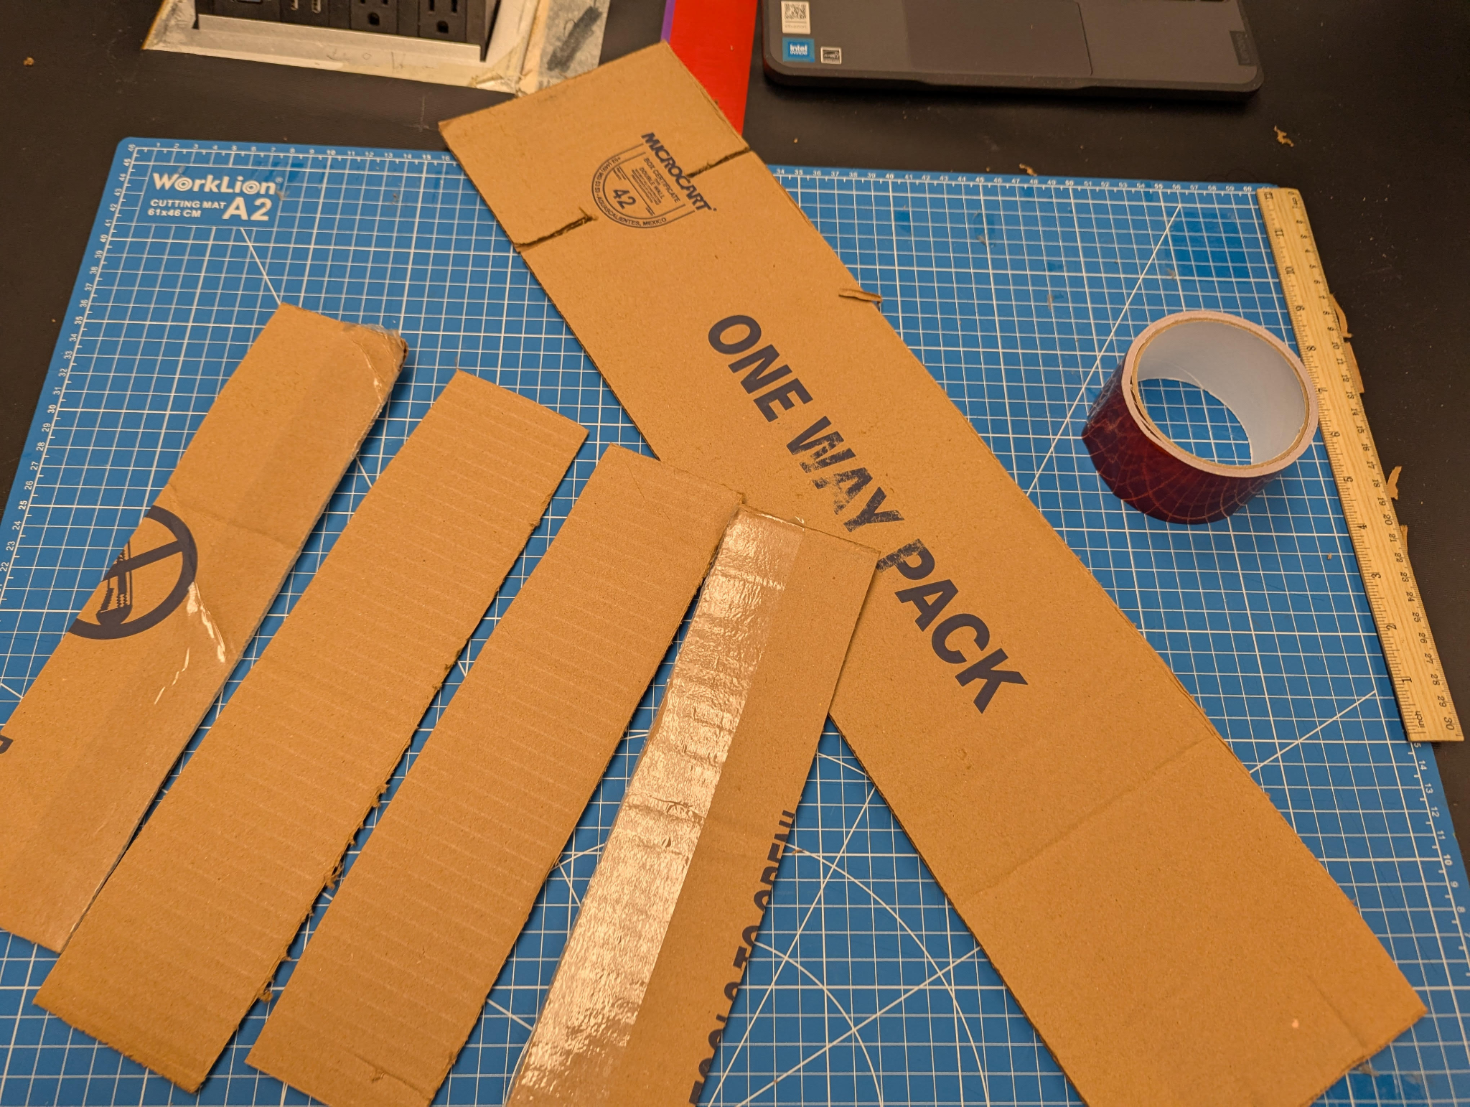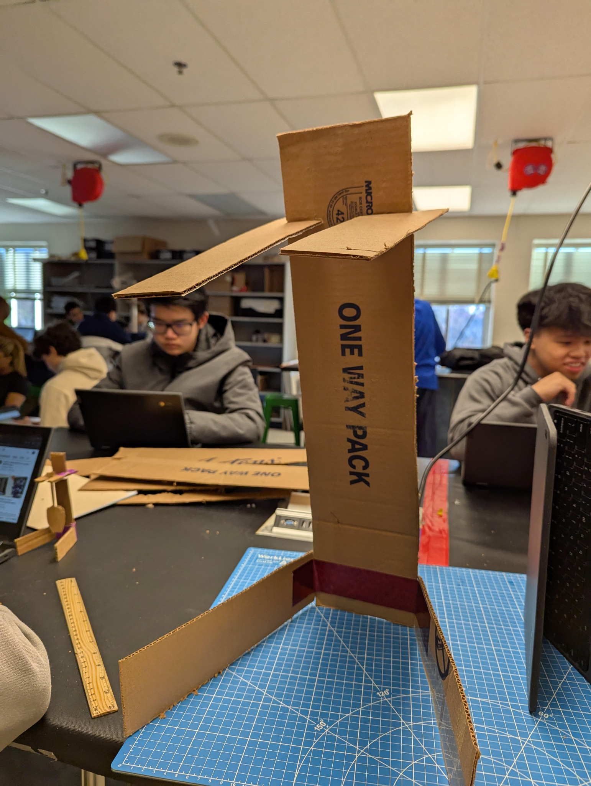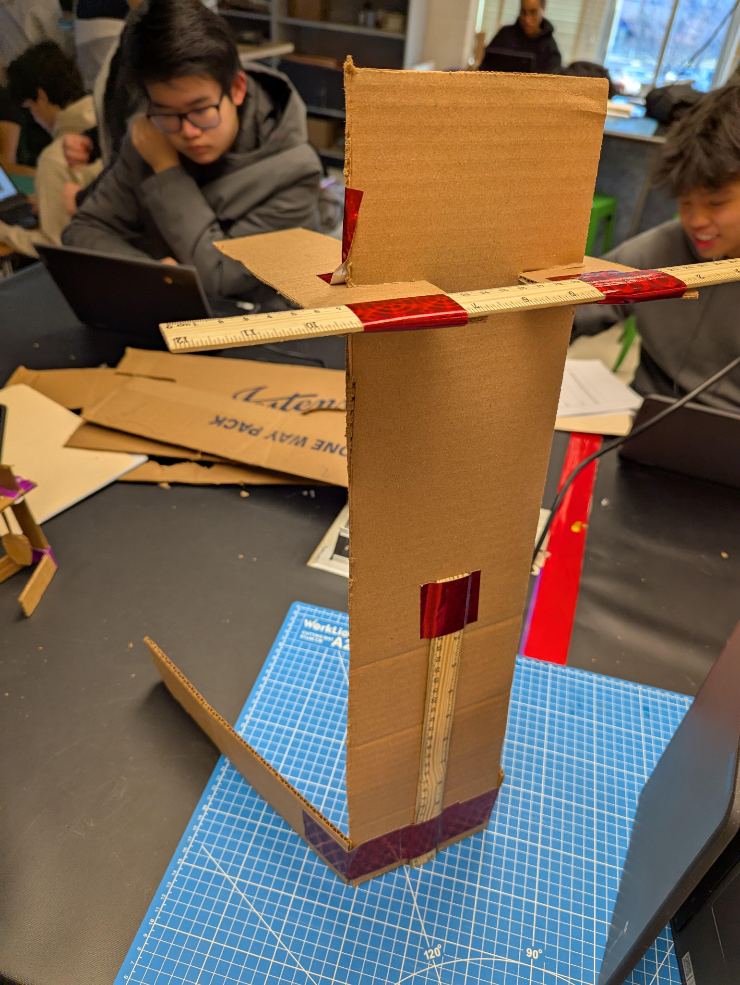
 | Details | Tools and Manufacturing Methods used
Step 1 | Measure cardboard | Cardboard, pen, and ruler
Step 2 | Cut cardboard into the 5 pieces | Boxcutter
Step 3 | Tape legs to the bottom of the spine | tape
Step 4 | Cut slits into the mid-top of the spine | Box cutter
Step 5 | Insert arms into the slits
Step 6 | Reinforce arms with tape | tape
Step 7

Design Requirement | How will this prototype allow you to collect objective, measurable data?
Can it hold up a guitar | We can place a scaled down weight of a guitar on it.
Is it accessible | We can test taking off and putting on a scaled down guitar and see how long it takes.
Does it cost less than $10 | We can minimize the number of parts and make sure they’re cheap.

Testing or Modeling of Attributes (G3, G4) and Addressing Non-Testable Attributes (G4)
Describe all of your prototype's attributes (features, aspects, details, or subsystems). Demonstrate that your prototype is constructed with sufficient functionality that your prototype can test all attributes of your design. This requires you to look back at your initial proposed design details from Element D.
For example, if your initial design details called for wheels and motors, is your prototype sufficiently functional such that you can test out those wheels and motors?
If there are aspects of your design that you believe cannot be physically prototyped or mathematically modeled within the scope and limits of your class, you must later provide evidence that an expert has reviewed your justifications and that you have incorporated their feedback. You do not need to conduct that review in Element G. For now, enter “expert review required” for these attributes in the final column.
Attribute | Description | Describe your prototype’s functionality to test this attribute
Arms | Medium length pieces of cardboard that are at the top of the spine. | This prototype can hold up some weight with its arms, similar to the real thing holding up a guitar using those arms.
Legs | Long pieces of cardboard that are at the bottom of the spine. | This prototype’s legs can help balance the prototype and hold up some of the guitar’s weight directly too.
Spine | Long piece of cardboard standing up. | This prototype’s spine holds up the entire prototype well.

Addressing Non-Testable Attributes (G4)
For all attributes that you listed “expert review required” in the table above, provide a justification for why that is true. "Field experts" are professionals who spend at least a portion of their time working in a field directly related to your project. These field experts are not permitted to double count as stakeholders.
Attribute | Justification for why this attribute cannot be modeled or tested with your prototype
Cost | It will be basically impossible to test the cost of the prototype fairly, since it is smaller and uses different materials than whatever the real one will use.

Element G: Construction of a Testable Prototype
 | 5 | 4 | 3 | 2 | 1 | 0
1. Final Prototype Iteration Explanation. The Final Prototype Iteration is _____________. | clearly and fully explained | clearly and adequately explained | adequately explained | somewhat explained but with gaps | only minimally explained | is unclear or is missing altogether
2. Construction of the Final Prototype. The Final Prototype Iteration is _____________. | constructed with enough detail to assure that objective data on all or nearly all design requirements could be determined | constructed with enough detail to assure that objective data on many or nearly all design requirements could be determined | constructed with enough detail to assure that objective data on some design requirements could be determined | constructed with enough detail to assure that objective data on at least a few design requirements could be determined | not constructed with enough detail to assure that objective data on at least one design requirement could be determined | not applicable to any design requirements and/or functional claims
3.Testing or Modeling of Attributes. _____________ attributes (sub-systems) of the unique solution that can be tested or modeled mathematically are addressed. | All | Most | Some | A Few | No more than one | None of the
4.Addressing non-Testable Attributes. _____________ justification is provided for those that cannot be tested or modeled mathematically and thus require expert review. | A well supported | A generally supported | An adequately supported | Developing | Insufficient | No

