The Athletic Commons at GPS needs backpack organization because the backpacks cause safety issues, as well as creating a choke point which slows down everyone trying to use the athletic commons after school.
For our first prototype, we used foam core to represent the plexiglass and plastic straws and wooden dowels for the hinges. We hot glued the straws to the sides of the foam core then put the dowels through them to hold the foam pieces together, while still making the foam core able to bend. In this design we added tracks to the top of each of the cubbies to make the prototype stack better (see figures 1 and 2). We decided that these tracks were not going to be on the next prototype because they were creating problems with the stability (see figure 3). In this prototype we also created tracks so the lid of the cubby can be slid/snapped on (see figure 4). Next we took this design and 3D printed it to test if the slot hinges (see figure 5 and 6) would work for our final design.
After we proved the hinge would work, we took an overstuffed backpack and measured it to get the best dimensions for a backpack cubby (fig 11-13). We changed our materials to left over plexiglass from Covid shields and 3D printed hinges. We had to measure everything very precisely to make sure that the plexiglass would slide into the tracks properly (fig 9). We used the laser cutter to cut the plexiglass and the 3d printer to print the hinges. We put everything together with hot glue, which did not work well. We will need to use acrylic glue for the next prototype since the prototype fell apart with hot glue. This design though, was completely collapsible (see fig. 10) which is super important to one of our design goals.
Our final design was constructed after this. We used plexiglass for the shelves and 3d printed hinges (fig 14). The final dimensions are 20x16 for the base and 16x16 for the walls. We added a back to this design to add more stability. This design has two cubbies stacked on top of eachother. We tried two different acrylic glues to see which one worked better. We wound up using Gorilla glue acrylic glue to hold all of the pieces in the design together because it has a 10 minute set time, so we could adjust things as we needed.

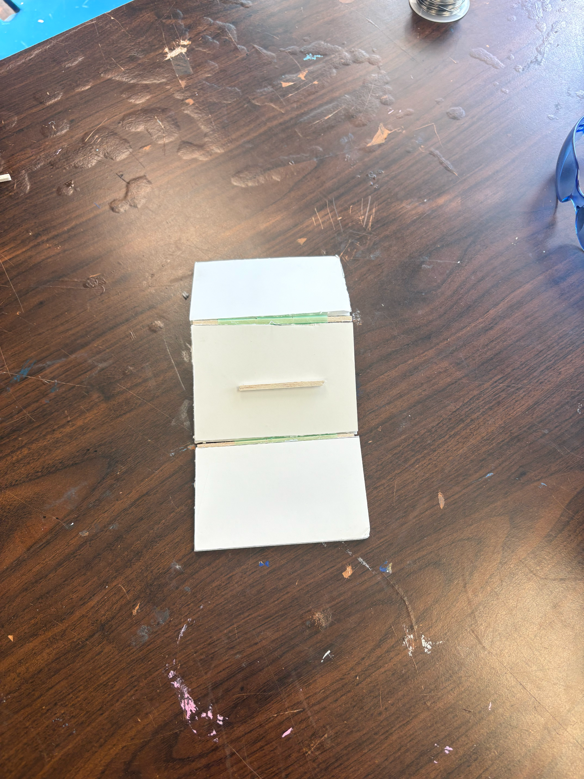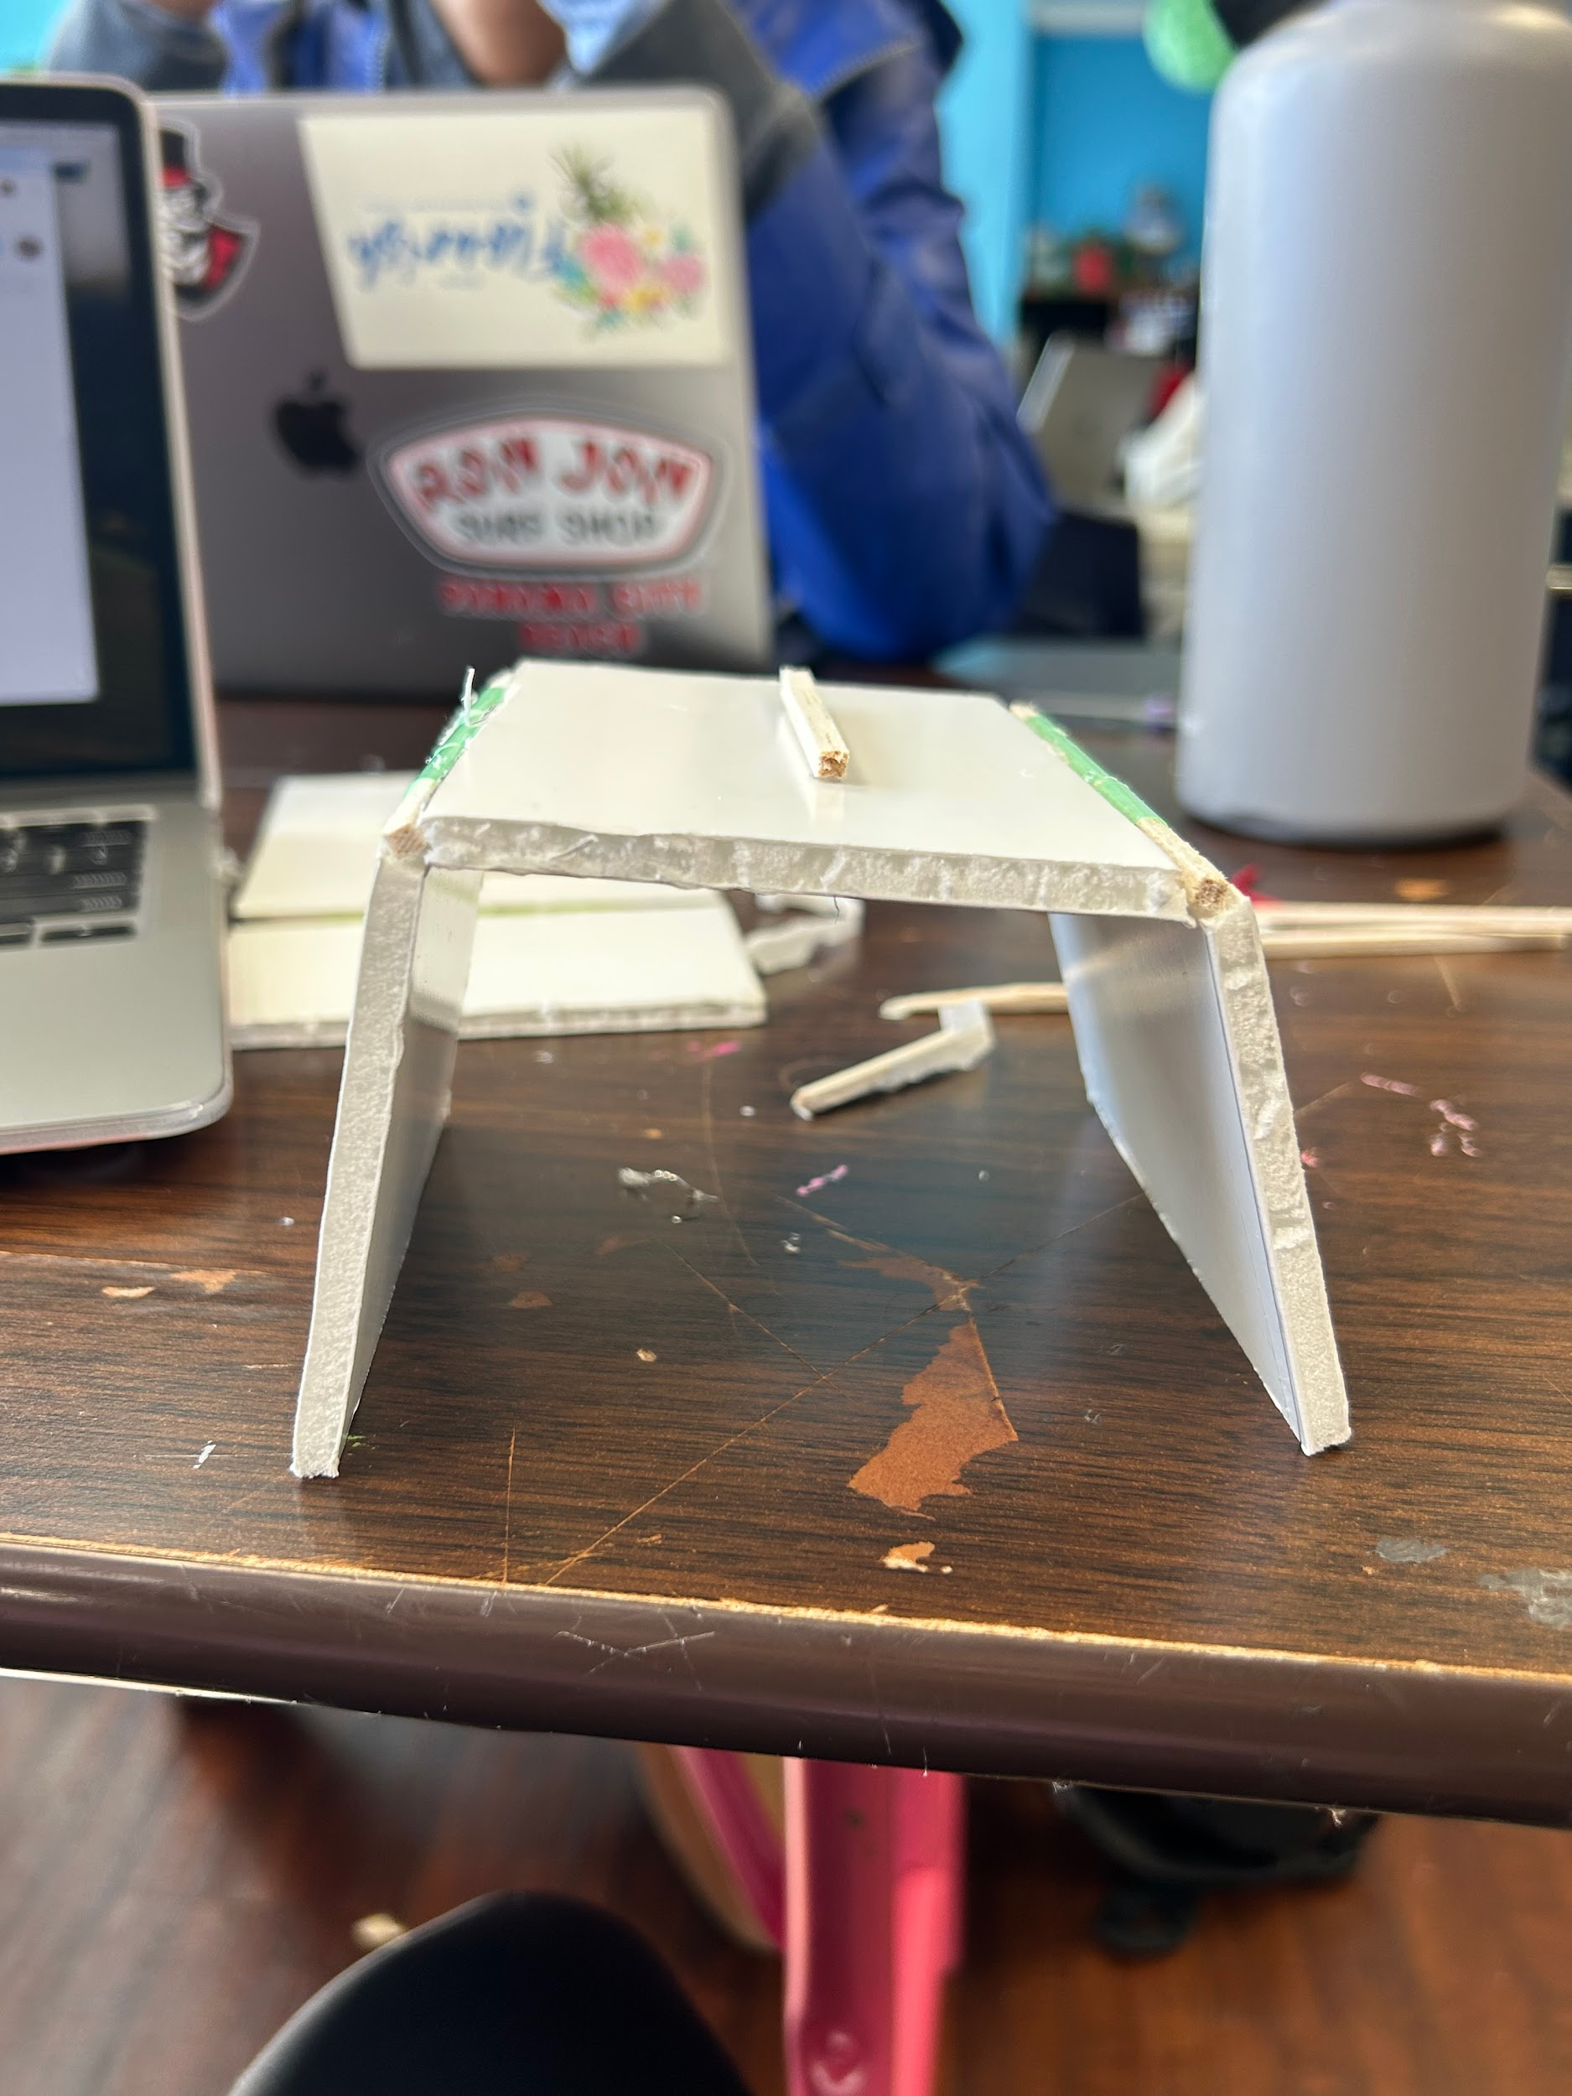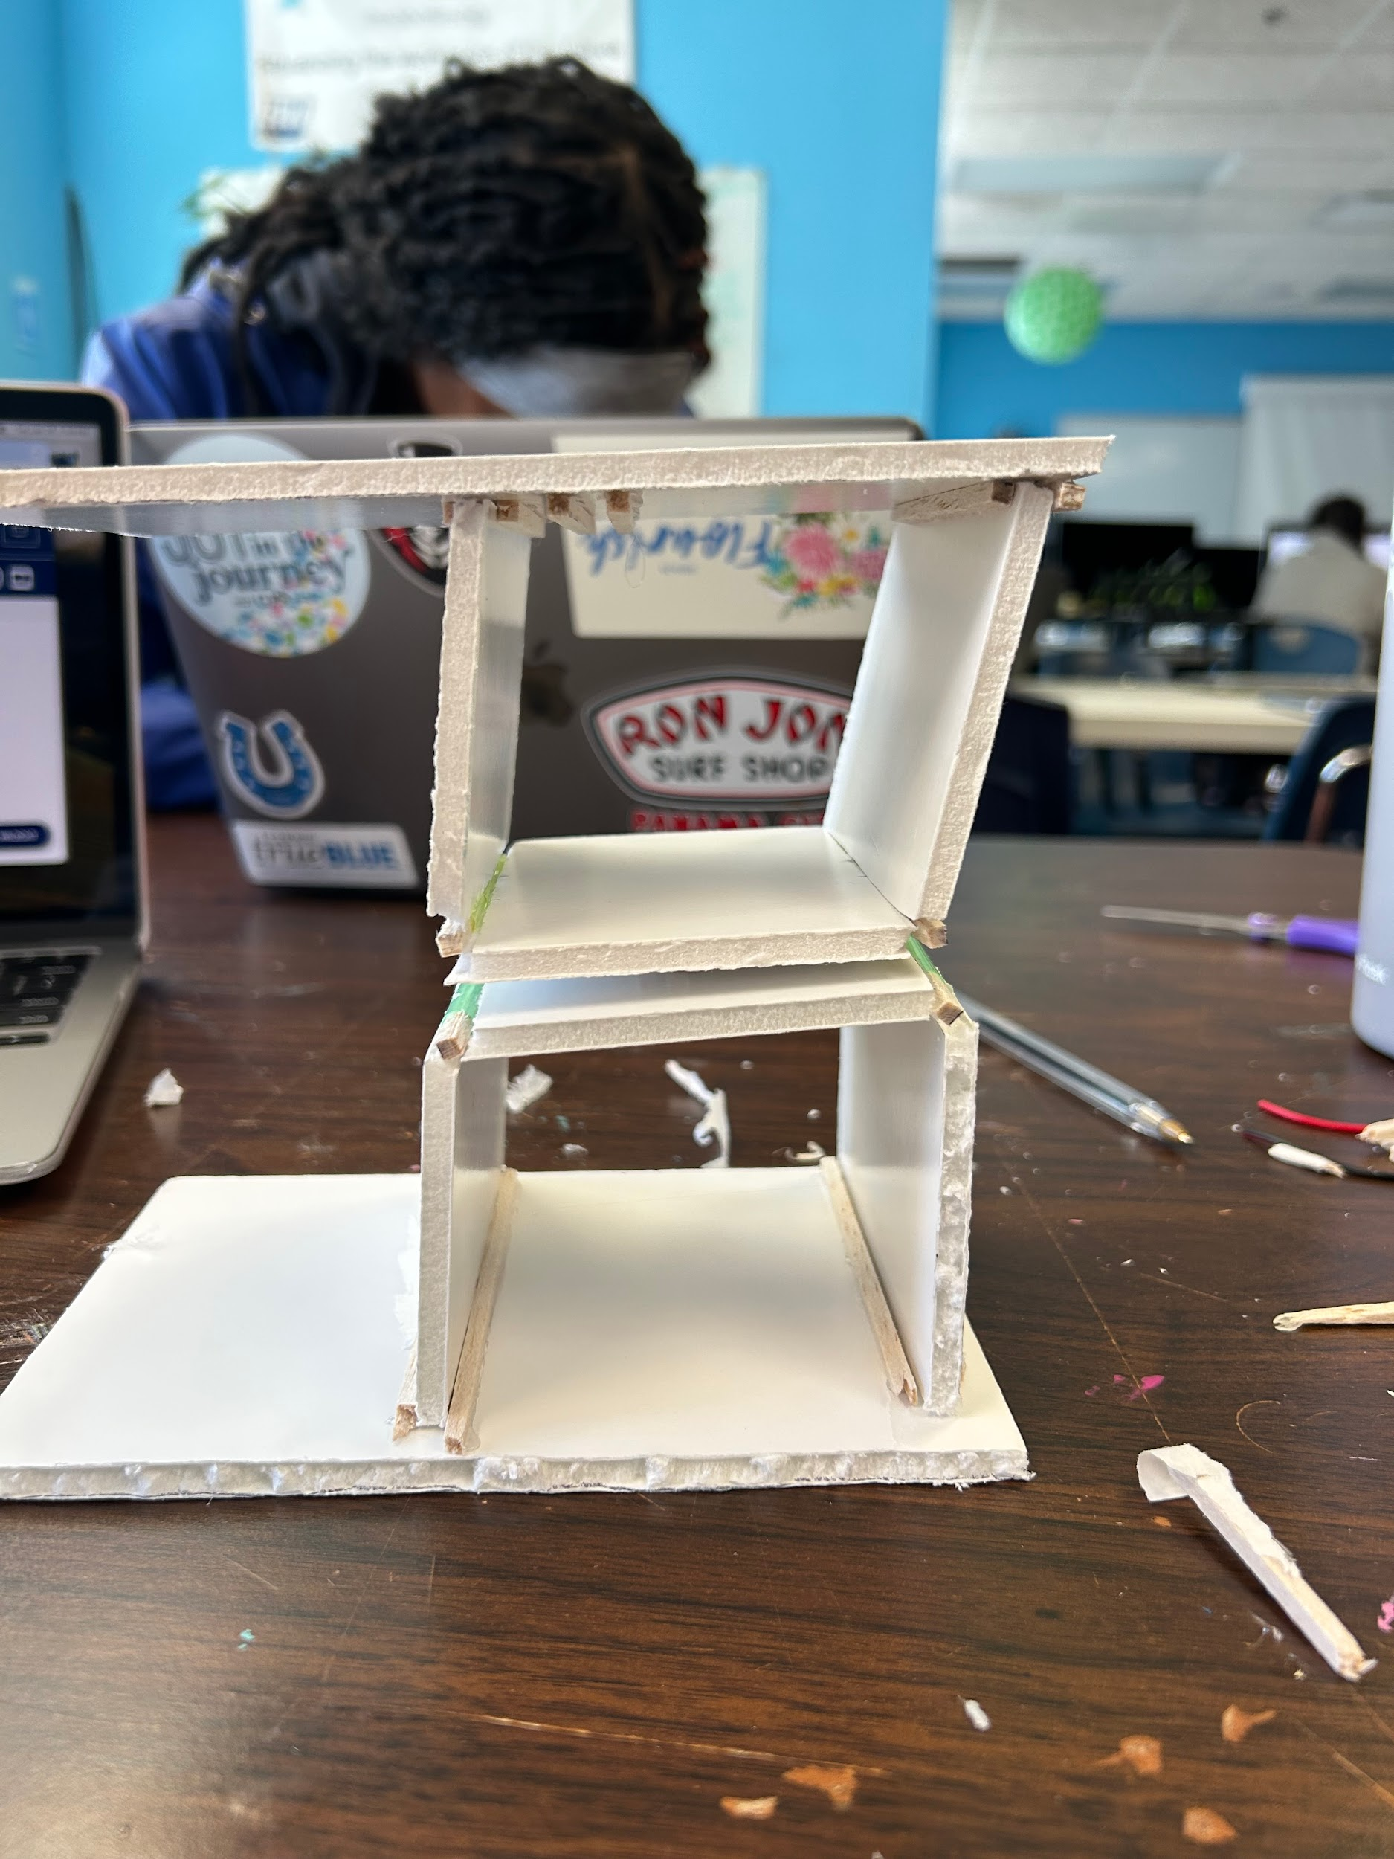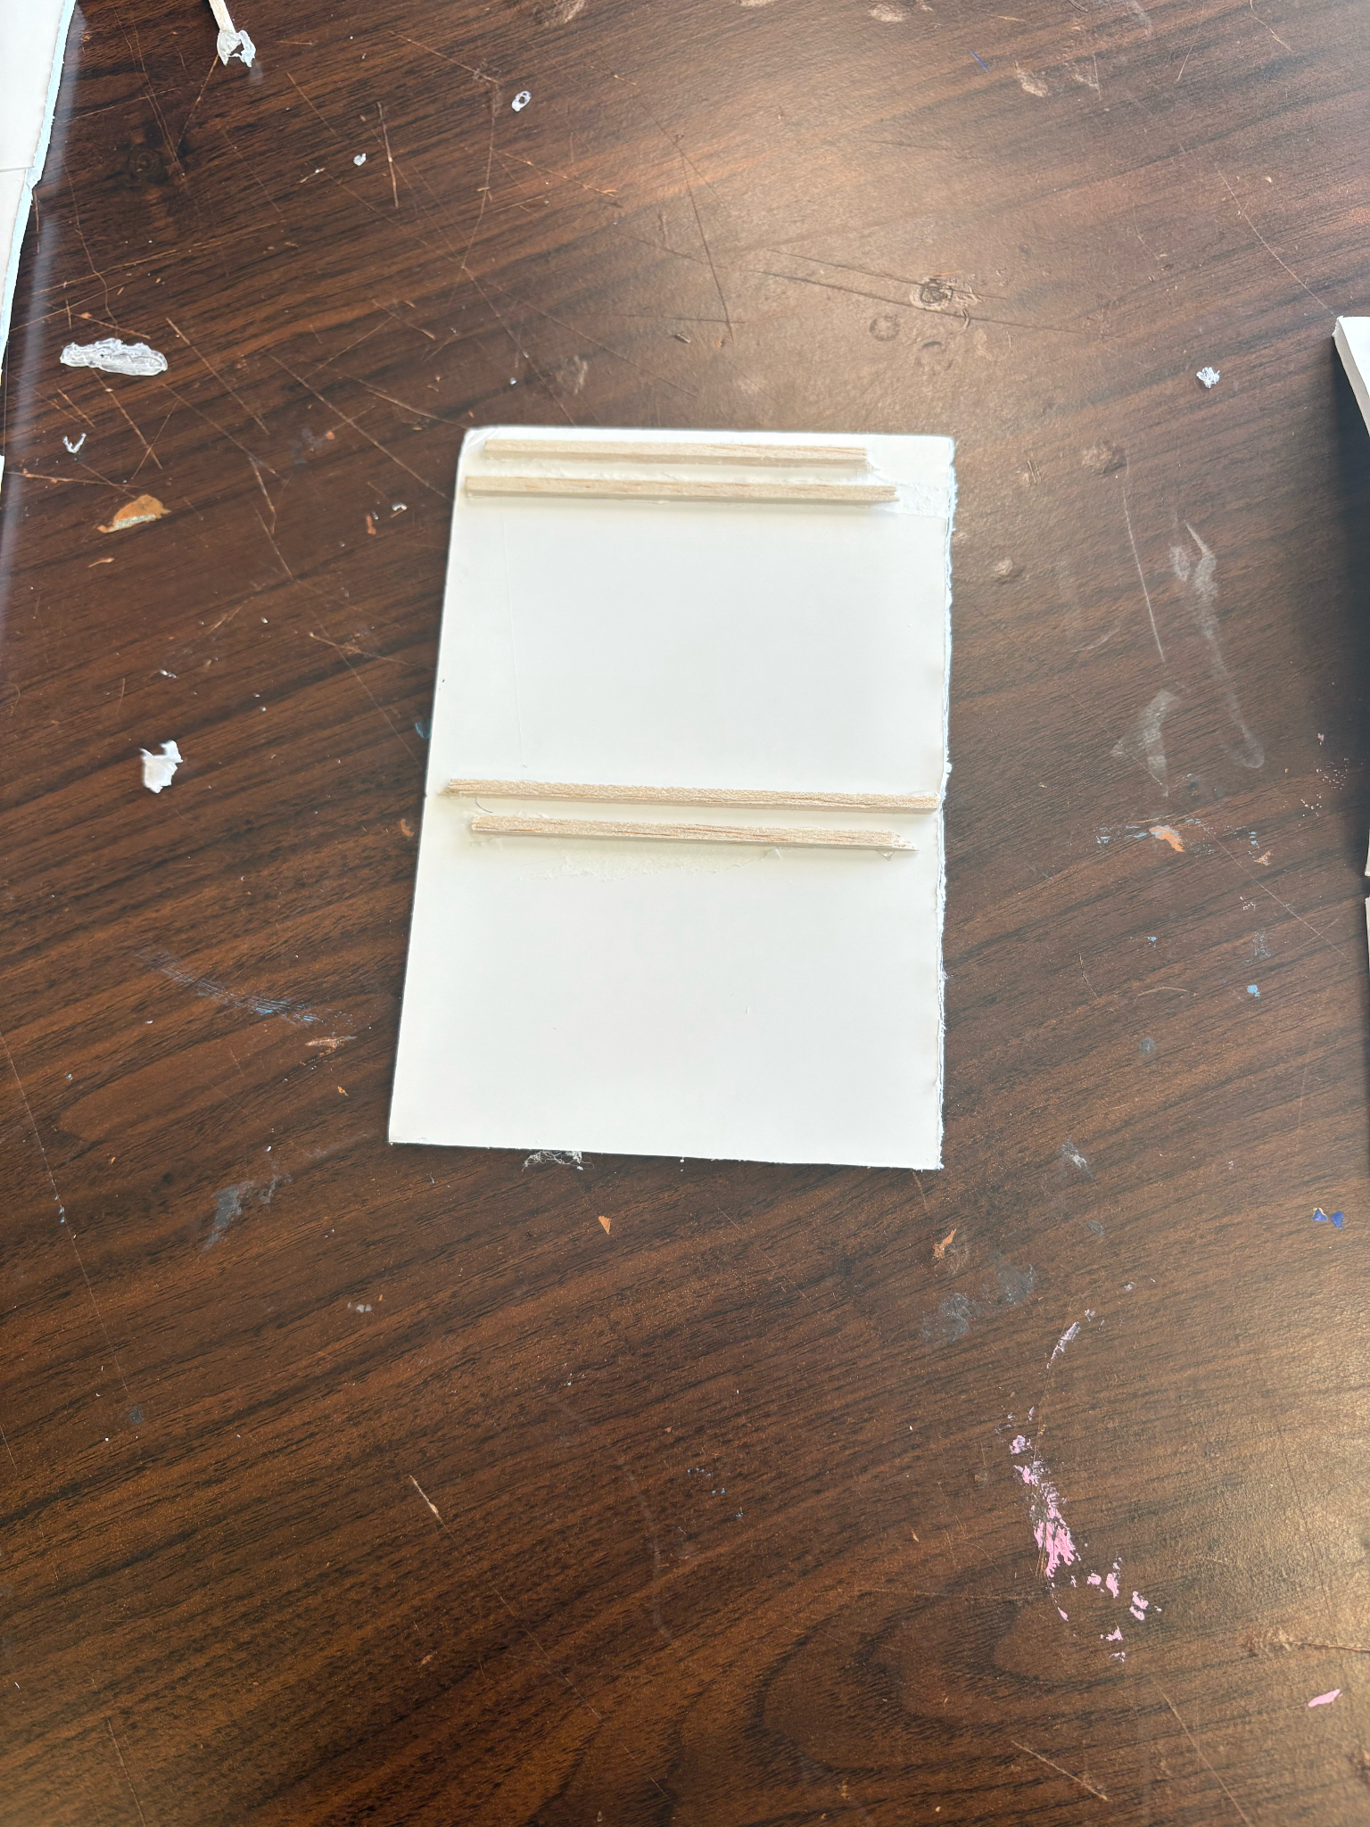
Figure 1 Figure 2 Figure 3 Figure 4
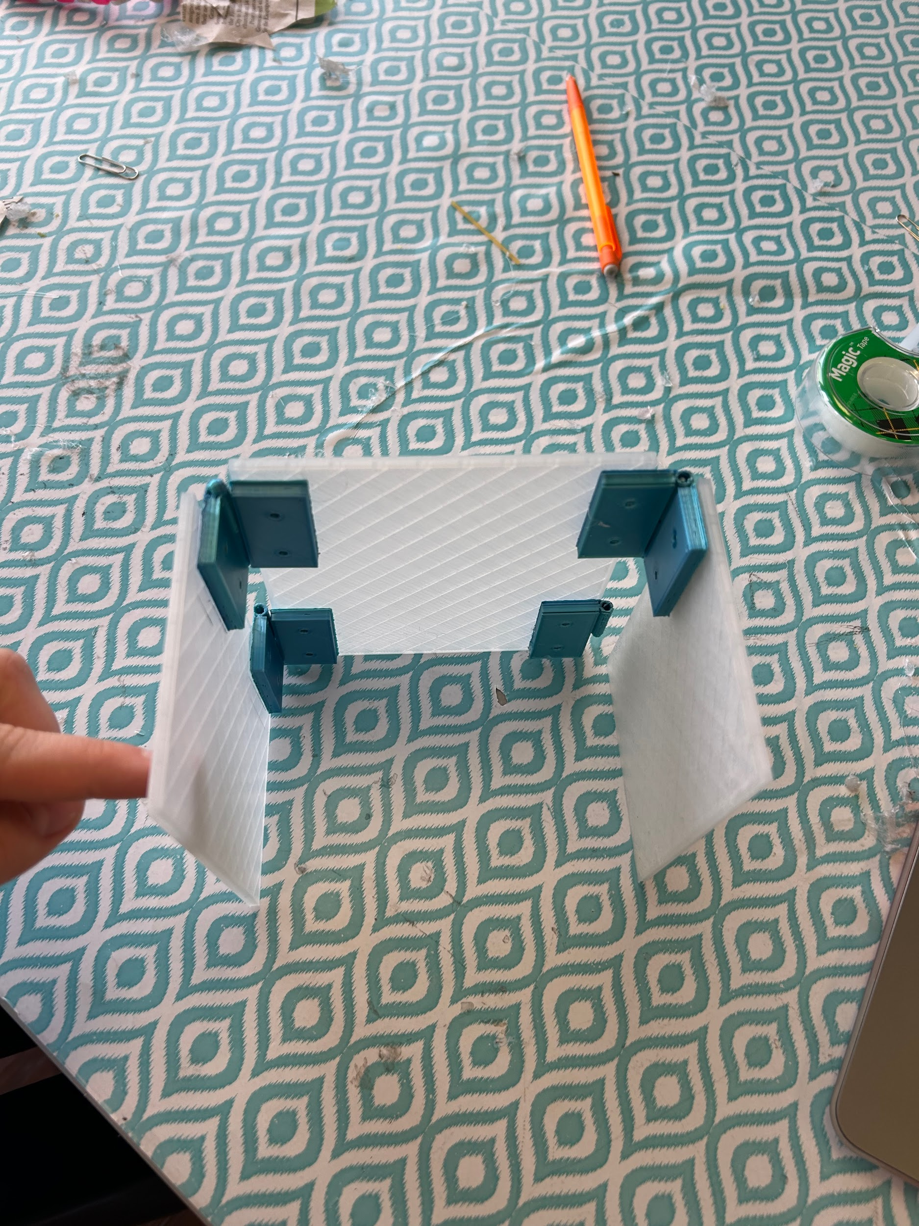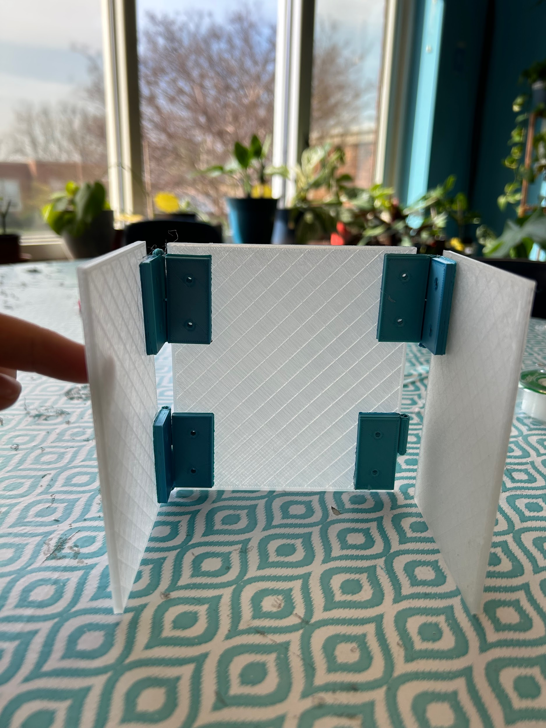
Figure 5 Figure 6

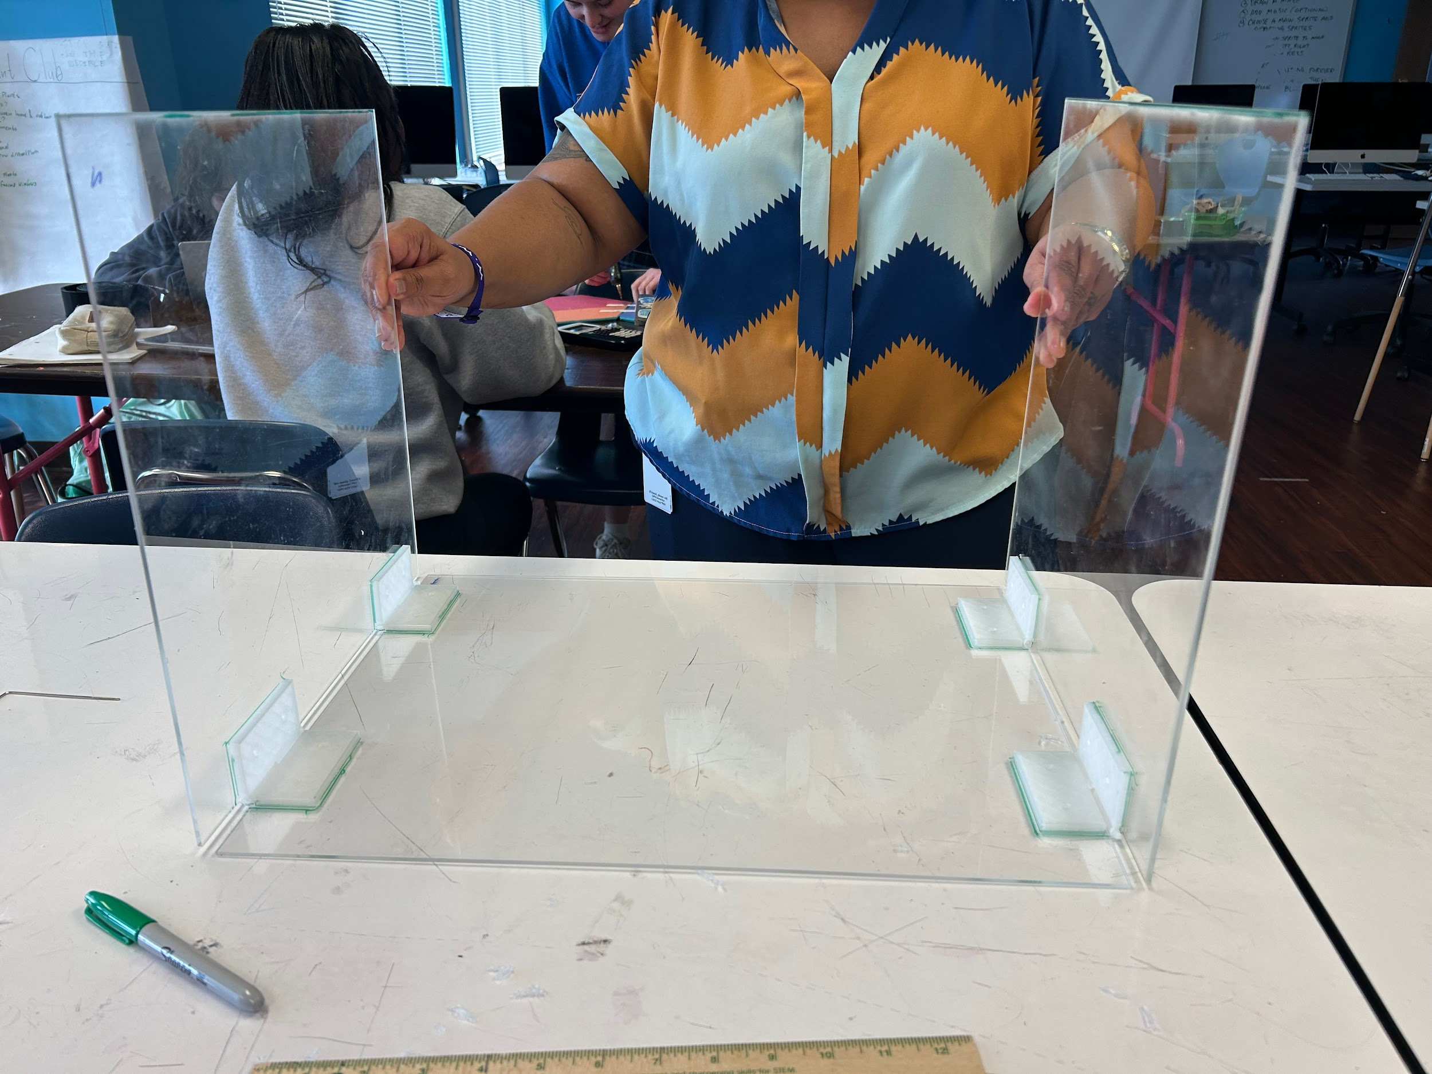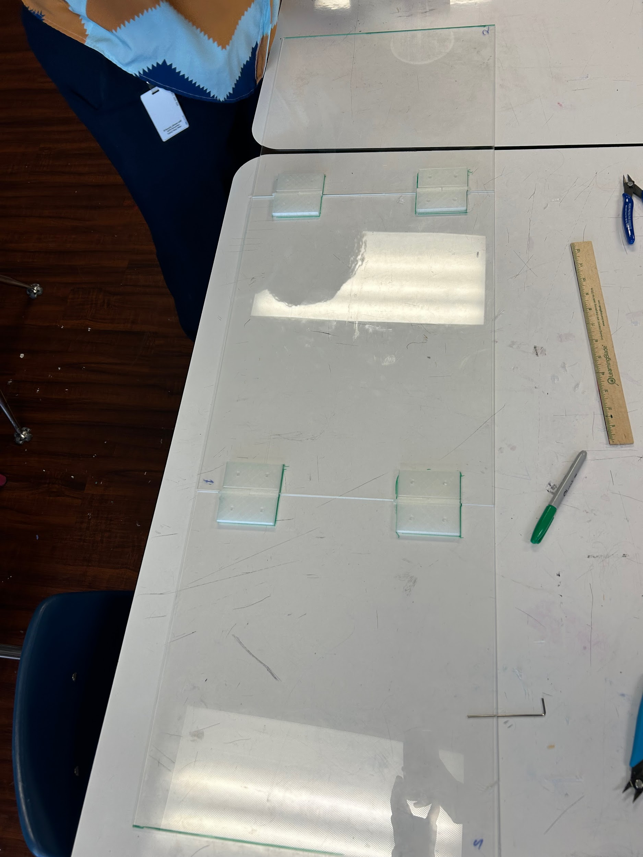
Figure 7 Figure 8
`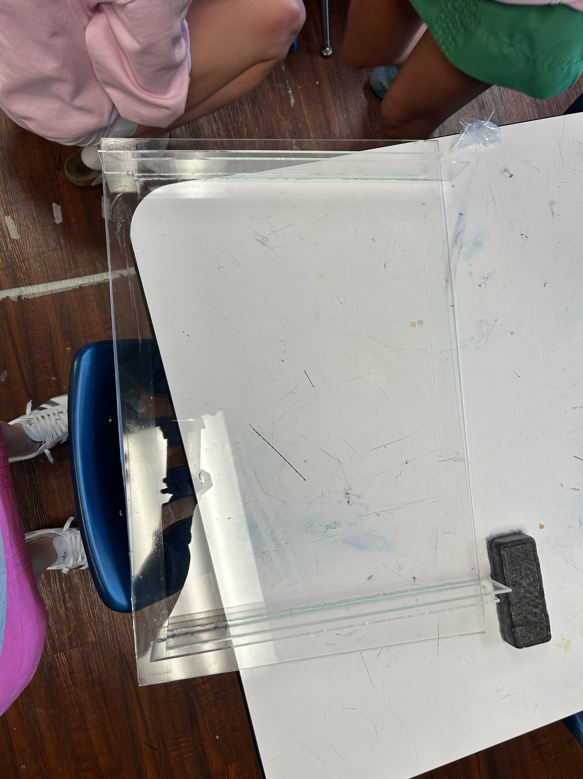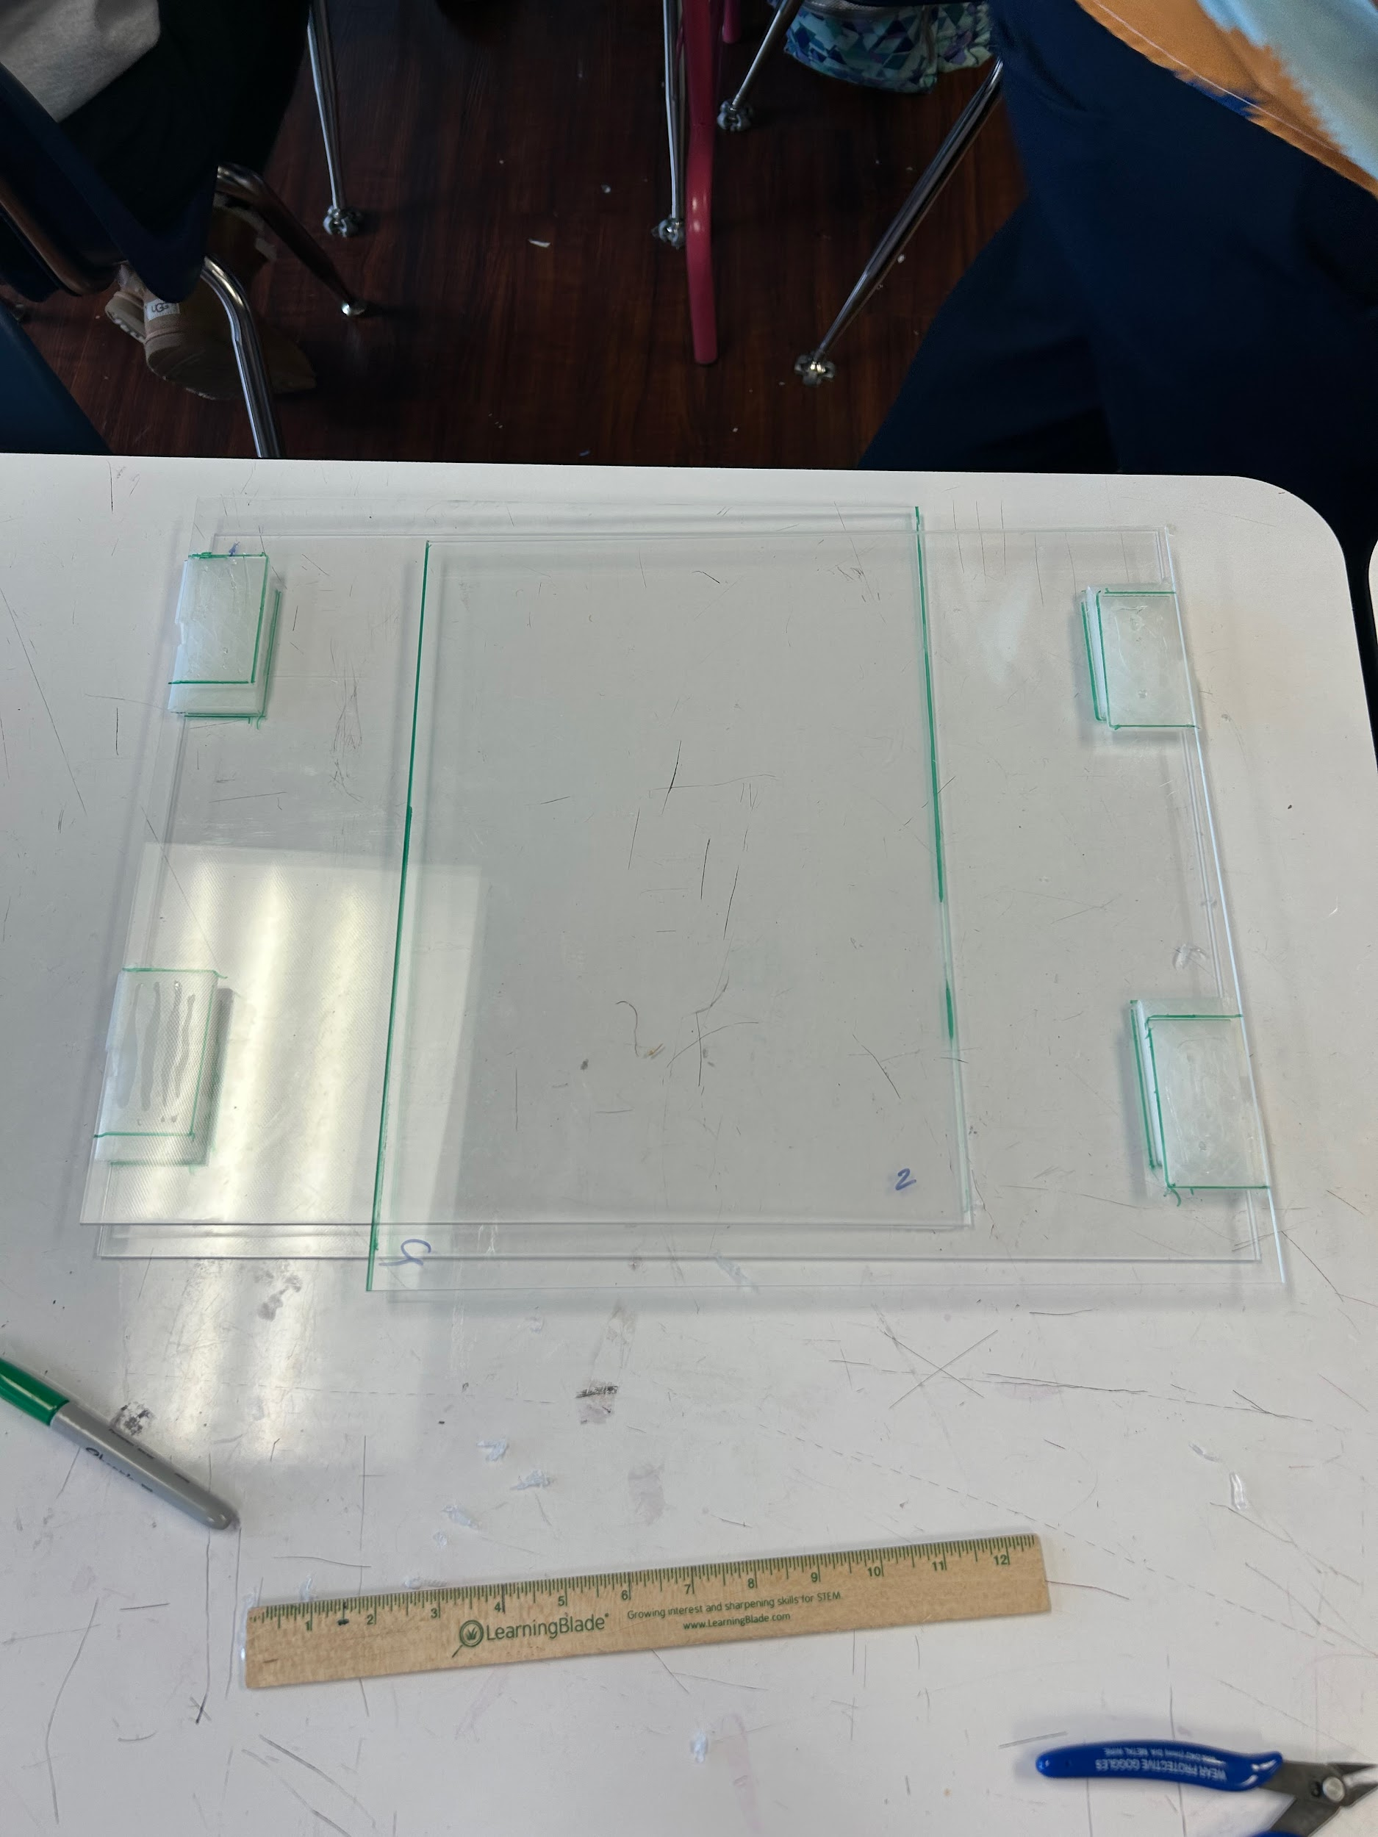
Figure 9 Figure 10
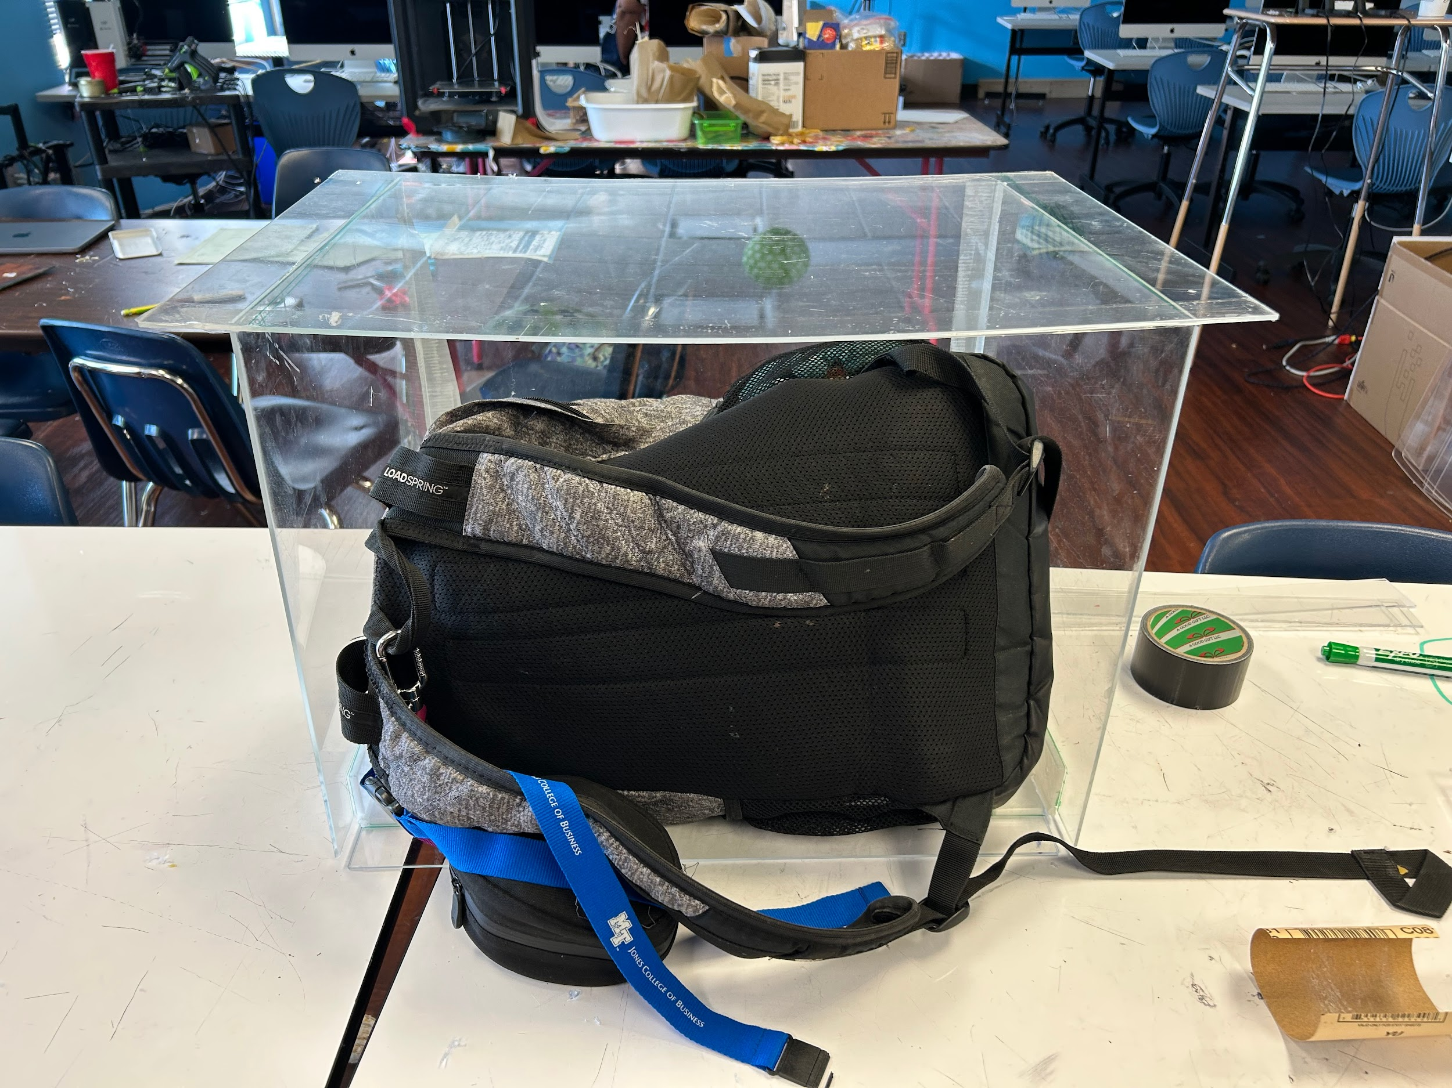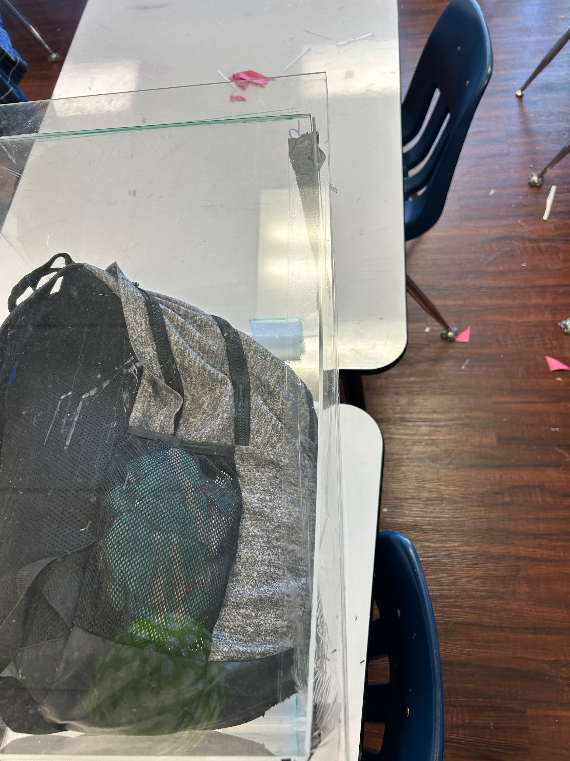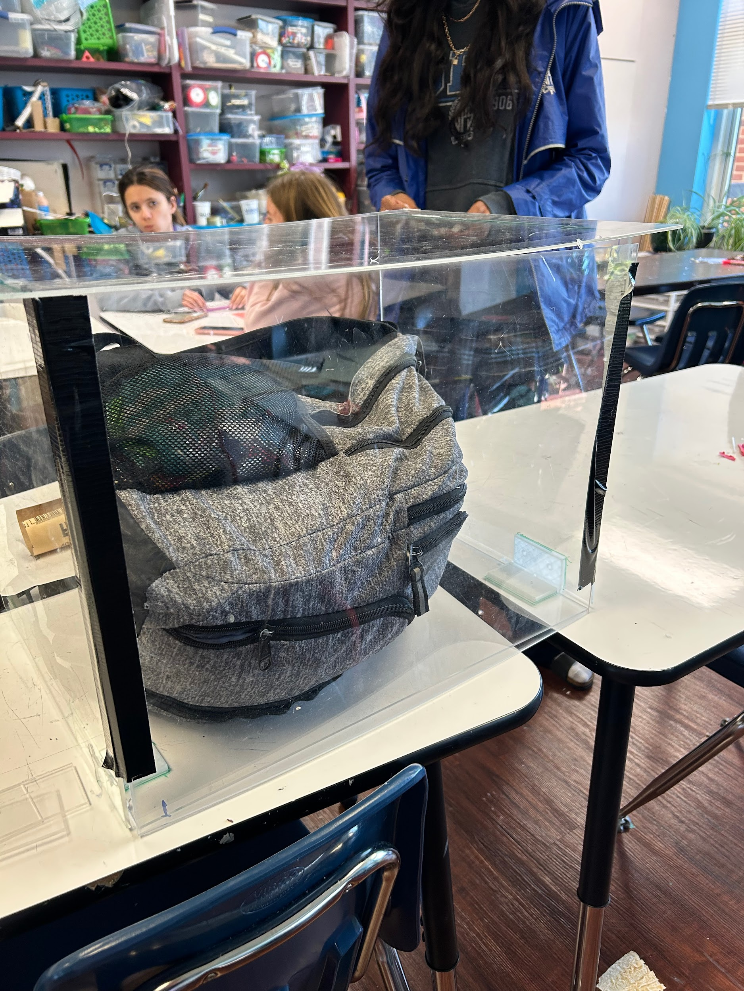
Figure 11 Figure 12 Figure 13

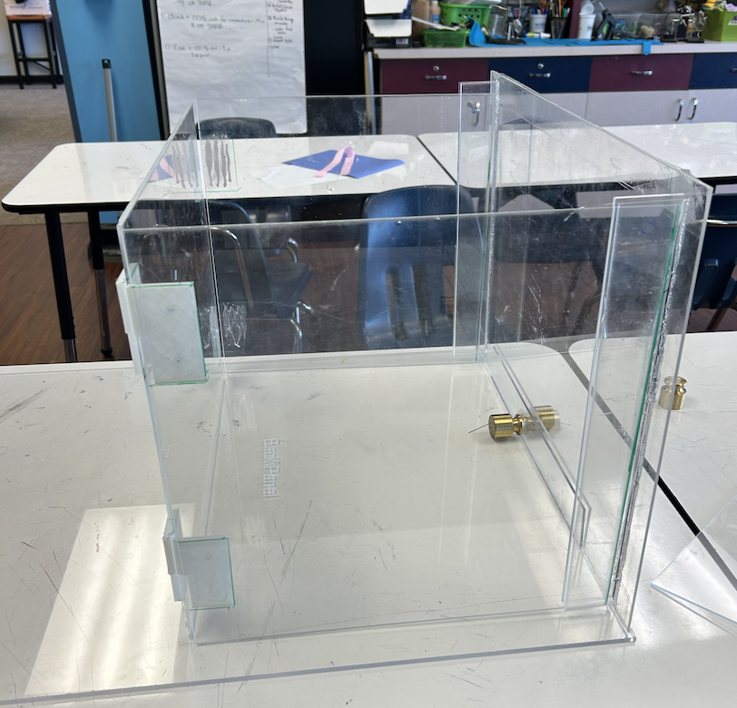
Figure 14

