MyDesign Portfolio
Element G Initial Template

How to use this template

Students: The template below is one way to present your construction of a testable prototype
Guidance before filling out the template that follows:
- Because you will iterate on your design multiple times, you will need to create multiple copies of these sections. Think of this Element as another piece of a diary that you will date and keep adding to throughout your work until your final iteration. It’s critical that iteration shines through in this Element also.
- You will then proceed on to test and analyze this design and then determine your next iteration, returning to this Element afterwards when you are ready to construct a new testable prototype. Fill out each of these steps again.

Element G: Construction of a Testable Prototype

Final Prototype Iteration Explanation (G1)
This section focuses on the process of explaining your prototypes. While the title of the subelement focuses on your final prototype, you must have at least an initial prototype and a final prototype, with additional prototypes in-between being desirable. Note that you never know which prototype is your final prototype until after you test it, so be sure to record all of the information for each prototype. Use as many copies of this sub-template as needed.
Ensure that photos are taken from multiple angles so that all sides and subsystems can be seen. All images should have captions and should be referenced in-text.
Final Prototype Construction of Design #1 (change this number to match the design number you’re on)
Date:
Photos with captions of your full construction process from day 1 of building through to the last day of constructing your final prototype iteration:
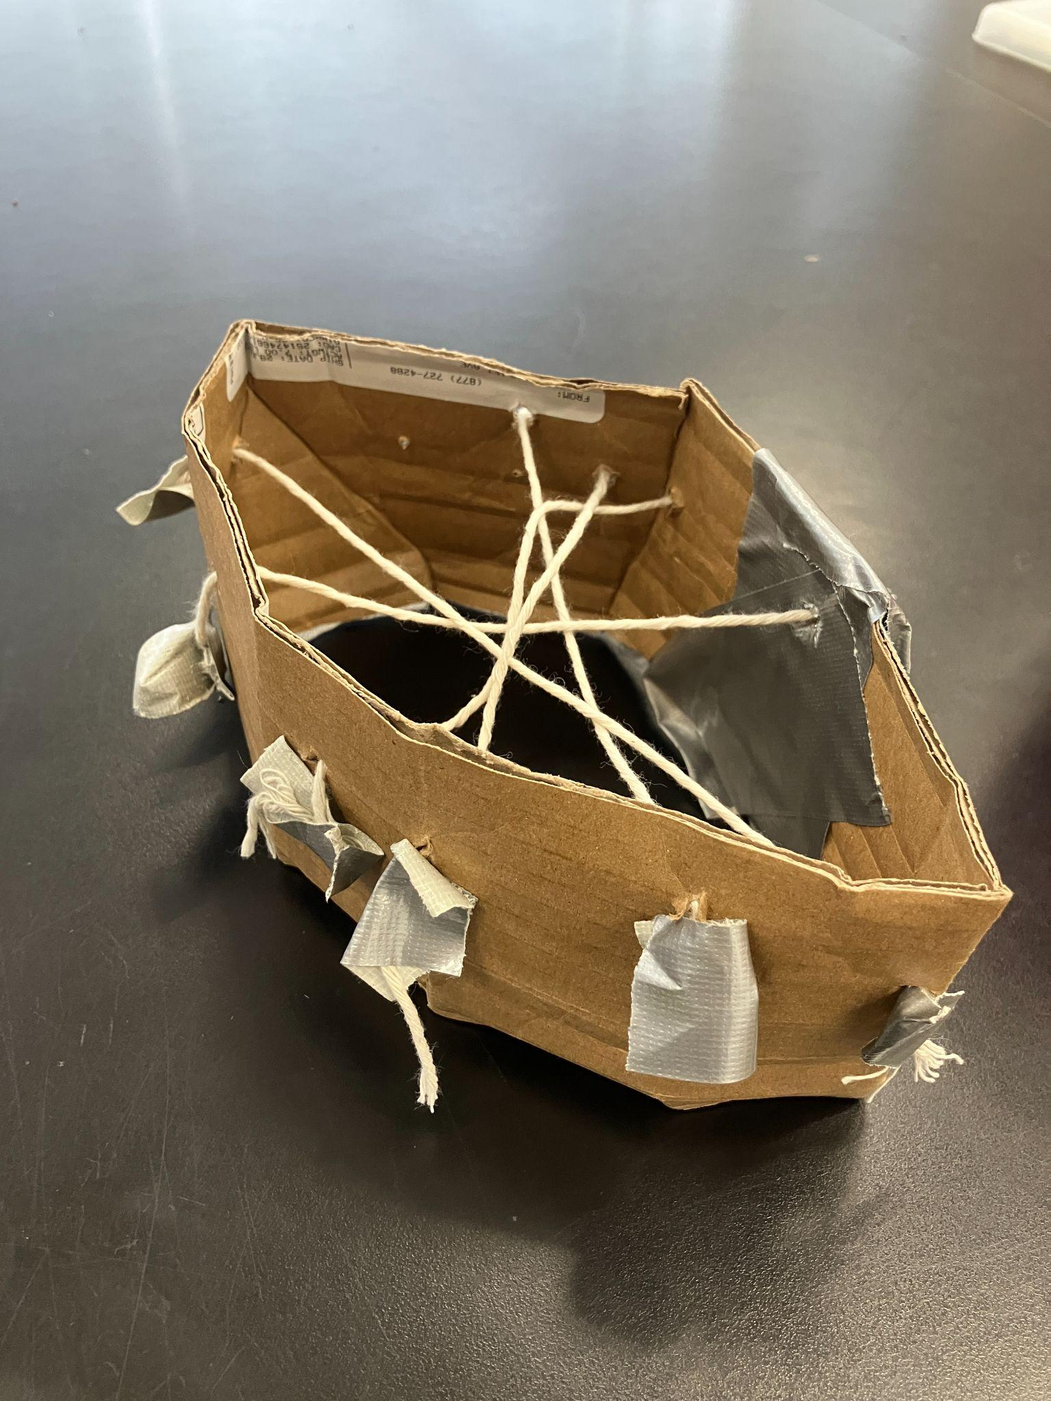
Details about all steps of construction (add step numbers as needed), including the tools and manufacturing methods used:
 | Details | Tools and Manufacturing Methods used
Step 1 | Draw design of our prototype
Step 2 | Cut out cardboard into correct shape and tape it together
Step 3 | Feed string through holes in cardboard
Step 4 | Tape the ends of the pieces of string

Notes of the progression from your blueprint to your (various) physical prototype(s), including why and how aspects of your design may have changed:
We designed our drum stand as a spider web so that you can adjust the tightness of the strings.

Prototype Construction of Design #2 (make as many copies, updating the design number, as needed)
Date:
Photos with captions of your full construction process from day 1 of building through to the last day of constructing your final prototype iteration:
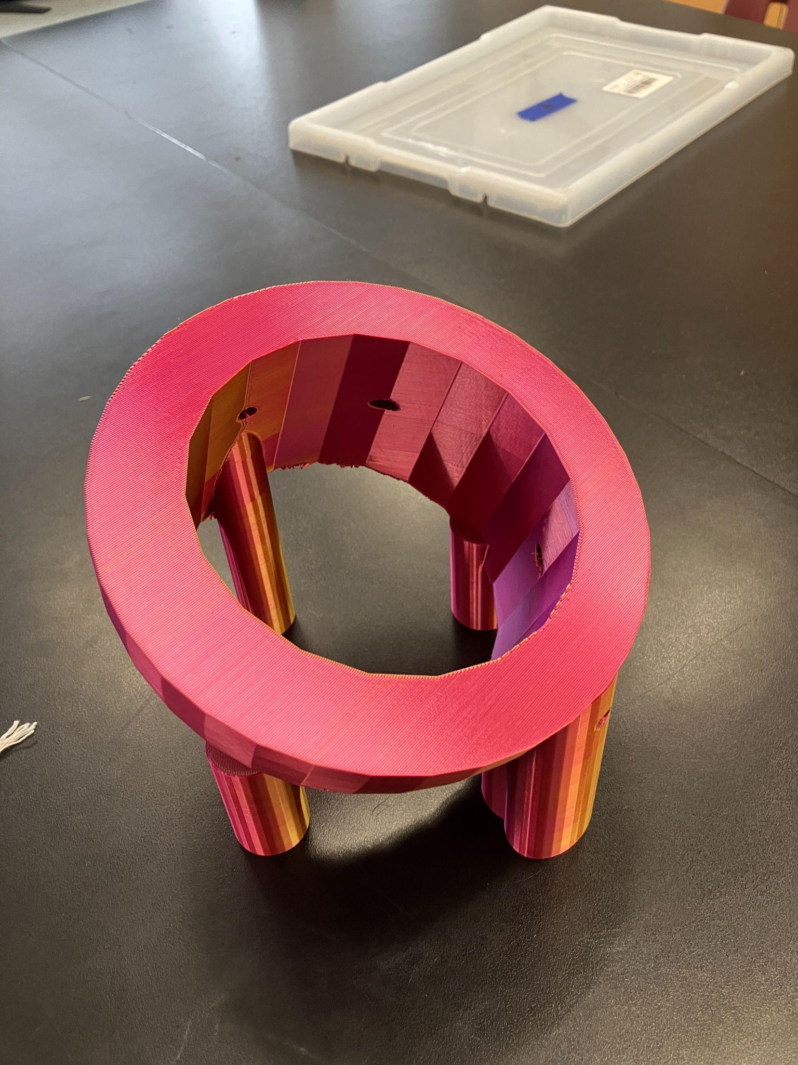
Details about all steps of construction (add step numbers as needed), including the tools and manufacturing methods used:
 | Details | Tools and Manufacturing Methods used
Step 1 | Draw design of our prototype
Step 2 | Create 3D design in tinkercad | Tinkercad software
Step 3 | 3D print bowl and legs | 3D printer
Step 4 | Feed string through holes in the bowl
Step 5 | Tighten strings and tie knots in them

Notes of the progression from your blueprint to your (various) physical prototype(s), including why and how aspects of your design may have changed:
We needed the drum stand to sit at an angle and have enough strength to support the drum
Final Prototype Construction of Design #3 (change this number to match the design number you’re on)
Date:
Photos with captions of your full construction process from day 1 of building through to the last day of constructing your final prototype iteration:
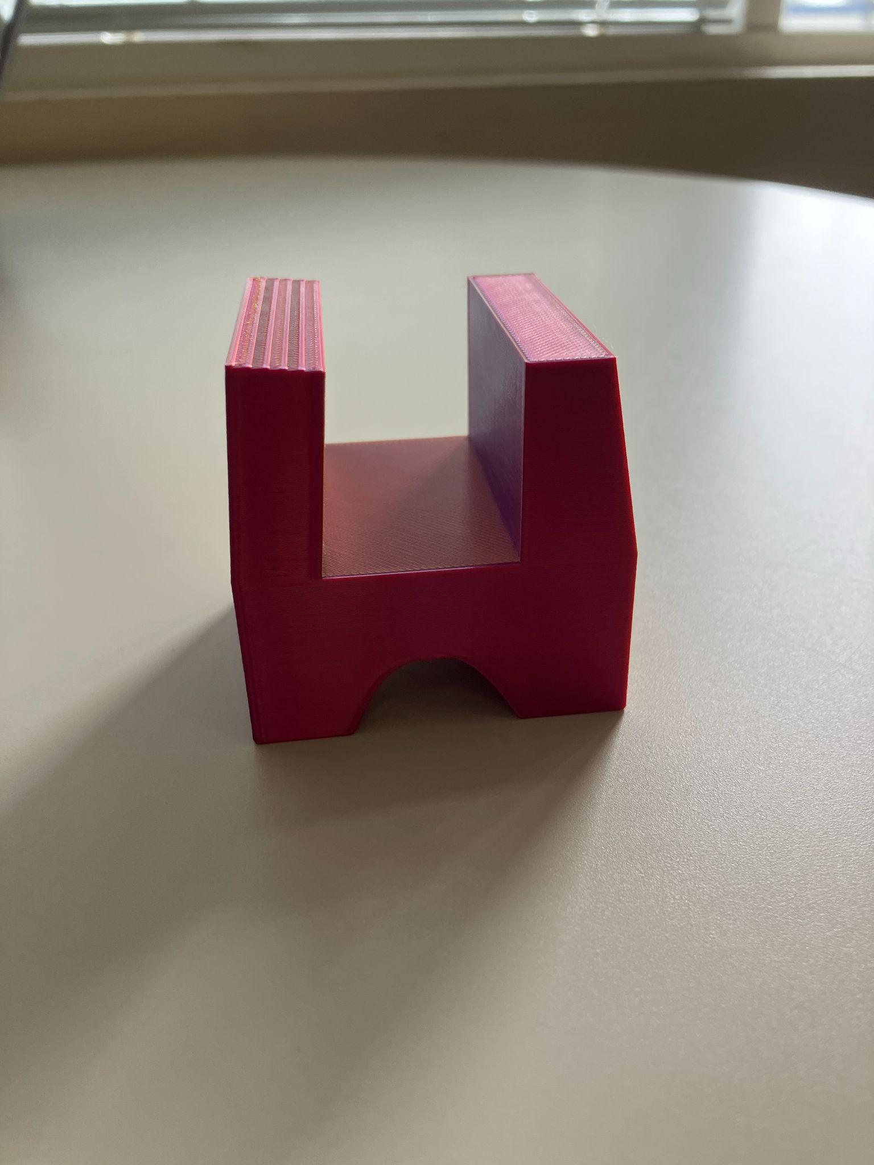
Details about all steps of construction (add step numbers as needed), including the tools and manufacturing methods used:
 | Details | Tools and Manufacturing Methods used
Step 1 | Measure the tilt for the legs
Step 2 | Draw design of prototype
Step 3 | Create 3D design in tinkercad | Tinkercad software
Step 4 | Transfer 3D design into other more advanced software
Step 5 | 3D print design | 3D printer

Notes of the progression from your blueprint to your (various) physical prototype(s), including why and how aspects of your design may have changed:
We wanted the stand to be easier to move and set up
List of material details, including item name, description, where it was purchased/obtained (include URL if applicable), cost per unit (if applicable), # of units, total cost (if applicable)

Material name | Description | Where material was purchased | Cost per unit | # units | Total cost per item
String
Duct tape
Cardboard
3D printer plastic

Detailed sketches, which might include CAD if you have learned it in your class:

Construction of the Final Prototype (G2)
When you’ve finished construction of your final prototype, you must be sure that your prototype allows sufficient functionality that you could collect objective, measurable data for all or nearly all of your design requirements. This requires you to look back at your design requirements from Element C. Copy all of your design requirements from Element C into this table and then add how your prototype will allow you to collect objective, measurable data. Note any weaknesses you find or details that will require expert review because they cannot be mathematically modeled or tested,
For example, if you have a design requirement that your design can "transport medicine a distance of 5 meters in 1 minute", is your prototype sufficiently functional such that you can test that? (e.g. can the prototype move the medicine at least a little bit?)
Design Requirement | How will this prototype allow you to collect objective, measurable data?

Testing or Modeling of Attributes (G3, G4) and Addressing Non-Testable Attributes (G4)
Describe all of your prototype's attributes (features, aspects, details, or subsystems). Demonstrate that your prototype is constructed with sufficient functionality that your prototype can test all attributes of your design. This requires you to look back at your initial proposed design details from Element D.
For example, if your initial design details called for wheels and motors, is your prototype sufficiently functional such that you can test out those wheels and motors?
If there are aspects of your design that you believe cannot be physically prototyped or mathematically modeled within the scope and limits of your class, you must later provide evidence that an expert has reviewed your justifications and that you have incorporated their feedback. You do not need to conduct that review in Element G. For now, enter “expert review required” for these attributes in the final column.

Attribute | Description | Describe your prototype’s functionality to test this attribute

Addressing Non-Testable Attributes (G4)
For all attributes that you listed “expert review required” in the table above, provide a justification for why that is true. "Field experts" are professionals who spend at least a portion of their time working in a field directly related to your project. These field experts are not permitted to double count as stakeholders.
Attribute | Justification for why this attribute cannot be modeled or tested with your prototype

