Element G

In this element you describe how your prototype will be made. Think of this as a set of directions like a recipe.

Initial thoughts - Can you build a testable prototype?

- The prototype should be built so three of the high-priority tests from Element C can be tested
- You should be able to get objective data on some of the design requirements.

Key Vocabulary
▪ “blueprint" is the full set of design details on paper for right before your start construction
▪ "initial prototype" is the first prototype that you construct
▪ "final prototype iteration" is the last prototype that you constructed and will test

Notes in Your Journals (Paper or Digital)
- Take pictures of your full construction process from day 1 of building through to the last day of constructing your final prototype iteration.
- Record details about all steps of construction, including the tools and manufacturing methods used.
- Take note of the progression from your blueprint to your (various) physical prototype(s), including why and how aspects of your design may have changed.

Construction of a Testable Prototype - Description

Explain how your final testable prototype is built by describing the initial prototype, any changes that were made and why those changes were made.

- Begin with a section on the materials you used including item name, description, where it was purchased/obtained (include URL if applicable), cost per unit (if applicable), # of units, total cost (if applicable)
- Describe the techniques you used and why you used them. (Cutting, adhesion with tape, hot glue, soldering…)
- Create step-by-step set of instructions to make your prototype.
- Describe how you iterated the initial prototype to create the 2nd, 3rd,...final prototype.
- Include detailed sketches, which might include CAD drawings.
- Ensure that photos are taken from multiple angles so that all sides and subsystems can be seen.
- All images should have captions and should be referenced in-text.
- What can be tested by using your prototype?
- List the aspects of you final prototype that cannot be tested mathematically or simulated

Images from building the prototype-
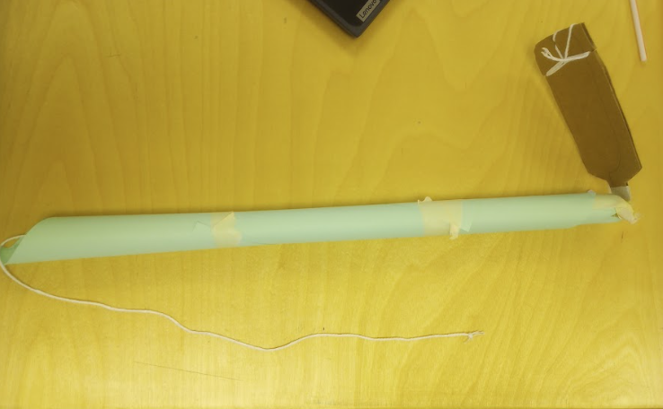

List of Materials Used in the Prototype-
- The tube is made of 2 pieces of paper taped together
- The head is made of 1 piece of cardboard
- ¾ yard of string
- ¼ of a plastic straw

Techniques Used to Create the Prototype-

- Taping
- Fabrication
- Cutting
- Cardboard work

Step-by-Step Instructions for Building the Prototype-

We started by taping together 2 pieces of paper in a long cylinder-like shape. Next, we attached a small section of a straw into the top of the paper too help with stability. We then made the cardboard head out of a small piece of cardboard. We connected the head too the tube using tape and the string that controls the direction the head moves in.

Any Additional Sketches-
N/A

Iterations on the Design -
Iteration 1
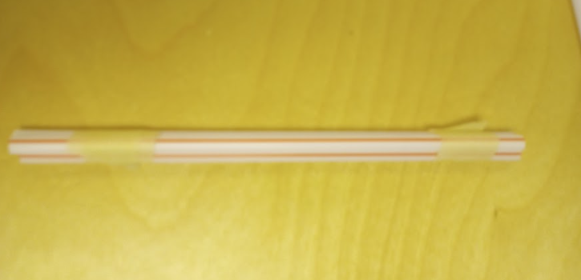

Iteration 2

Iteration 3

- Demonstrate that your prototype is constructed with sufficient functionality that you could collect objective, measurable data for all or nearly all of your design requirements. Check requirements from Element C.
- Medicine delivery example: Is your prototype sufficiently functional so that you can "transport medicine a distance of 5 meters in 1 minute" design requirement? (e.g. can the prototype move the medicine at least a little bit?)

- Demonstrate that your prototype is constructed with sufficient functionality that your can test all attributes of your design. This requires you to look back at your initial proposed design details from Element D.
- Medicine delivery robot example: If your initial design details called for wheels and motors, is your prototype sufficiently functional such that you can test out those wheels and motors (e.g. are they mounted to the robot and wired up)?
- Are there are aspects of your design that you believe cannot be physically prototyped or mathematically modeled within the scope and limits of your class?
- Provide evidence that an expert has reviewed your justifications and that you have incorporated their feedback.

