G
 | Details | Tools and Manufacturing Methods used
Step 1 | Rip seams | Seam ripper/exacto knife
Step 2 | Cut the bottom of the dress | Rotary cutter or scissors
Step 3 | Hem the bottom of the dress | Sewing machine, clothes pins
Step 4 | Attach pocket to the center of the right part of the chest | Sewing machine , clothes pins
Step 5 | Tie bow at the top of the slit of the shirt. | Fingers
Step 6 | Tuck in bottom of shirt into pants/shorts | hands
Step 7 | Put belt through loops on shorts/pants | hands
Step 7
Final Prototype Construction of Design #1 (pictures)
 | Details | Tools and Manufacturing Methods used
Step 1 | 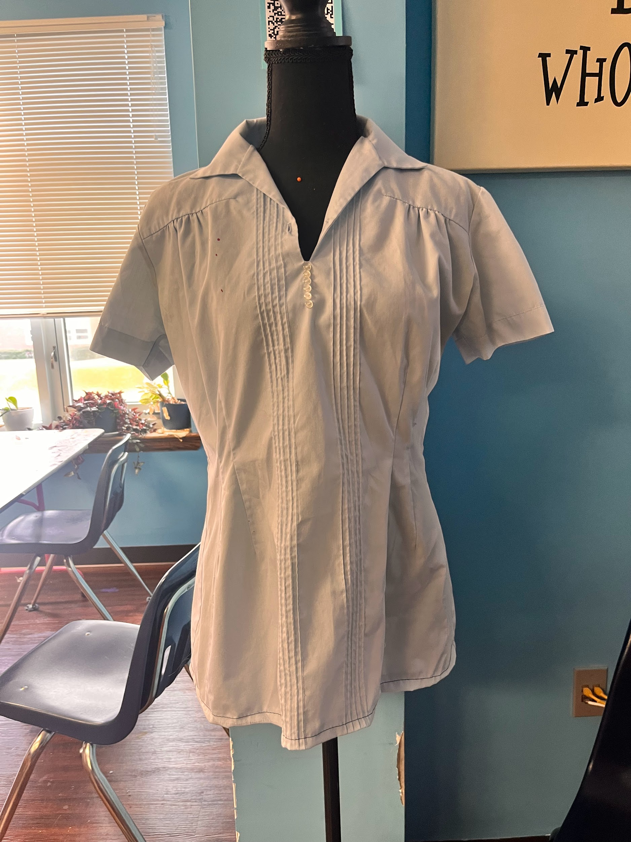 | Exacto knife
Step 2 |  | Rotary cutter/ scissors
Step 3 | 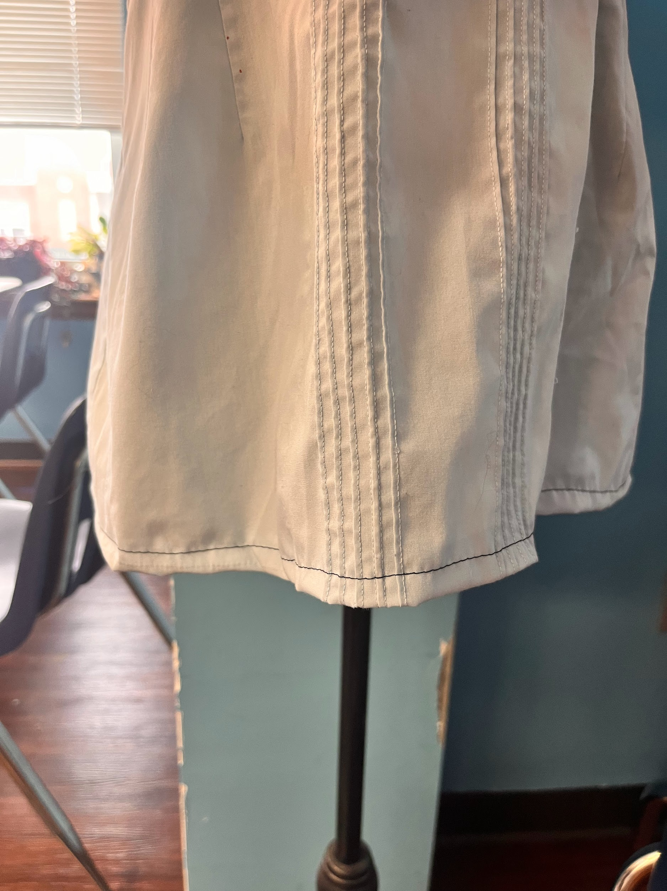 | Sewing machine, clothes pins
Step 4 | 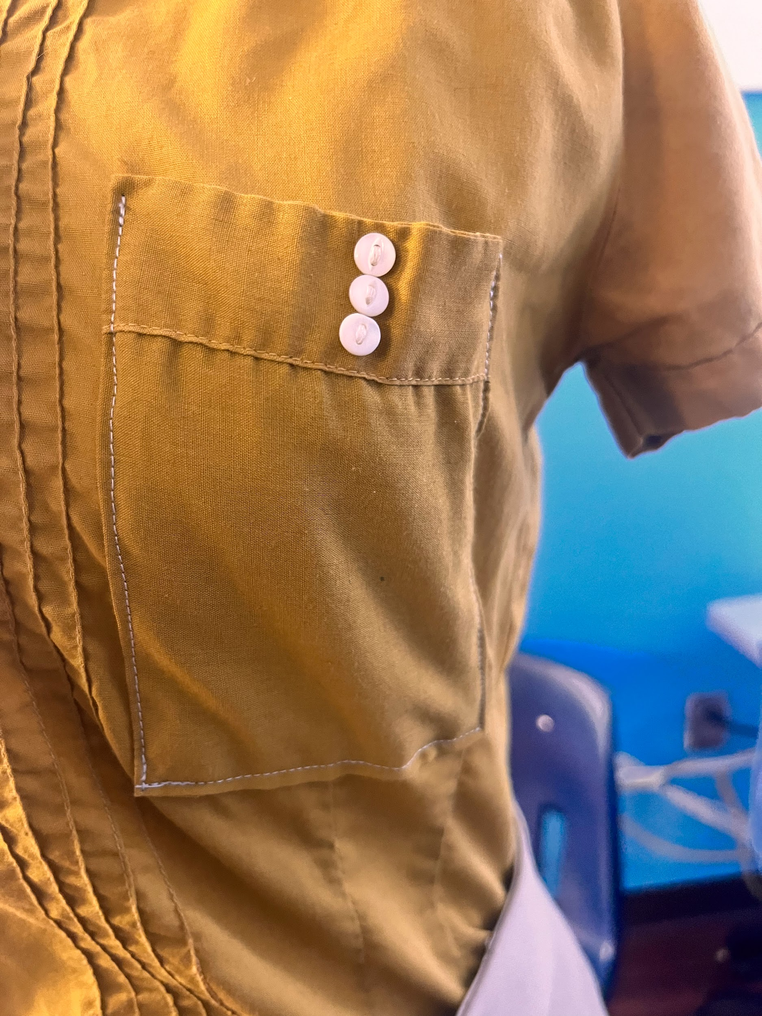 | Sewing machine, clothes pins
Step 5 | 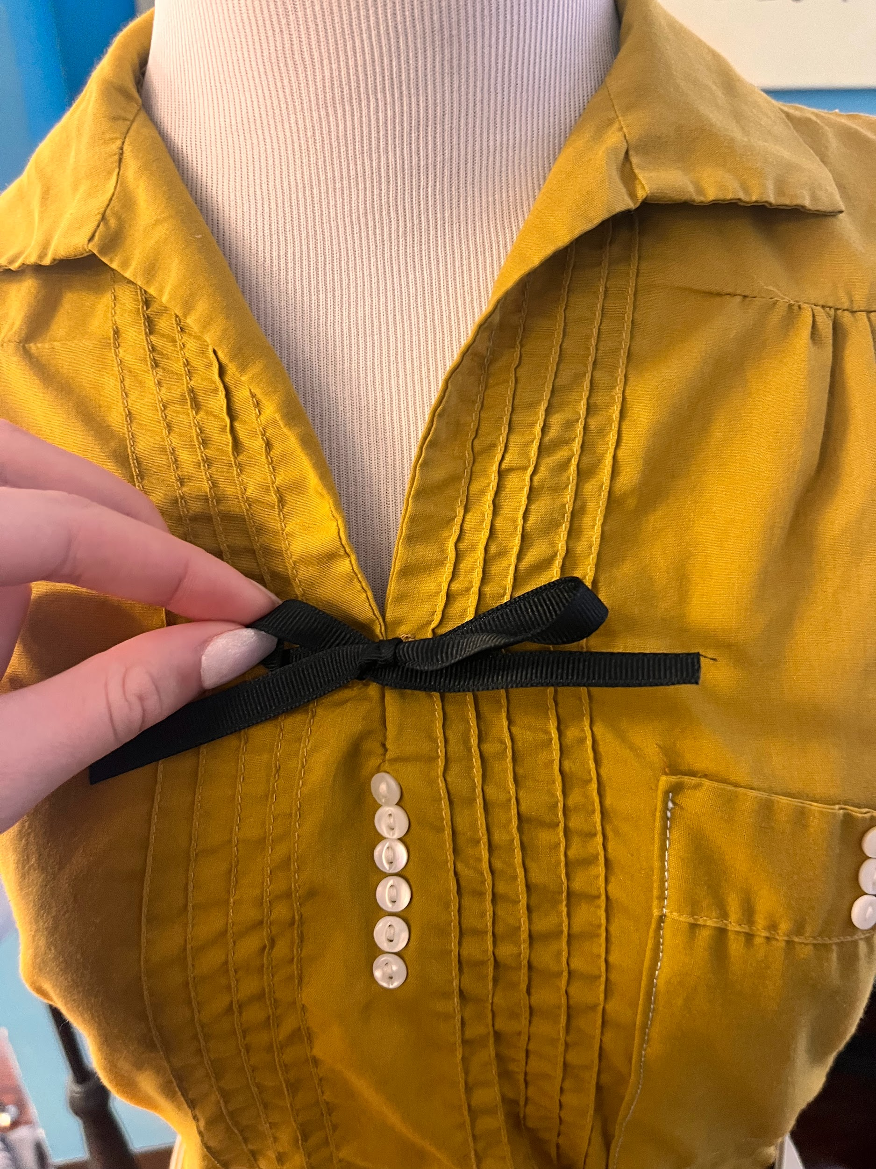 | fingers/hands
Step 6 | 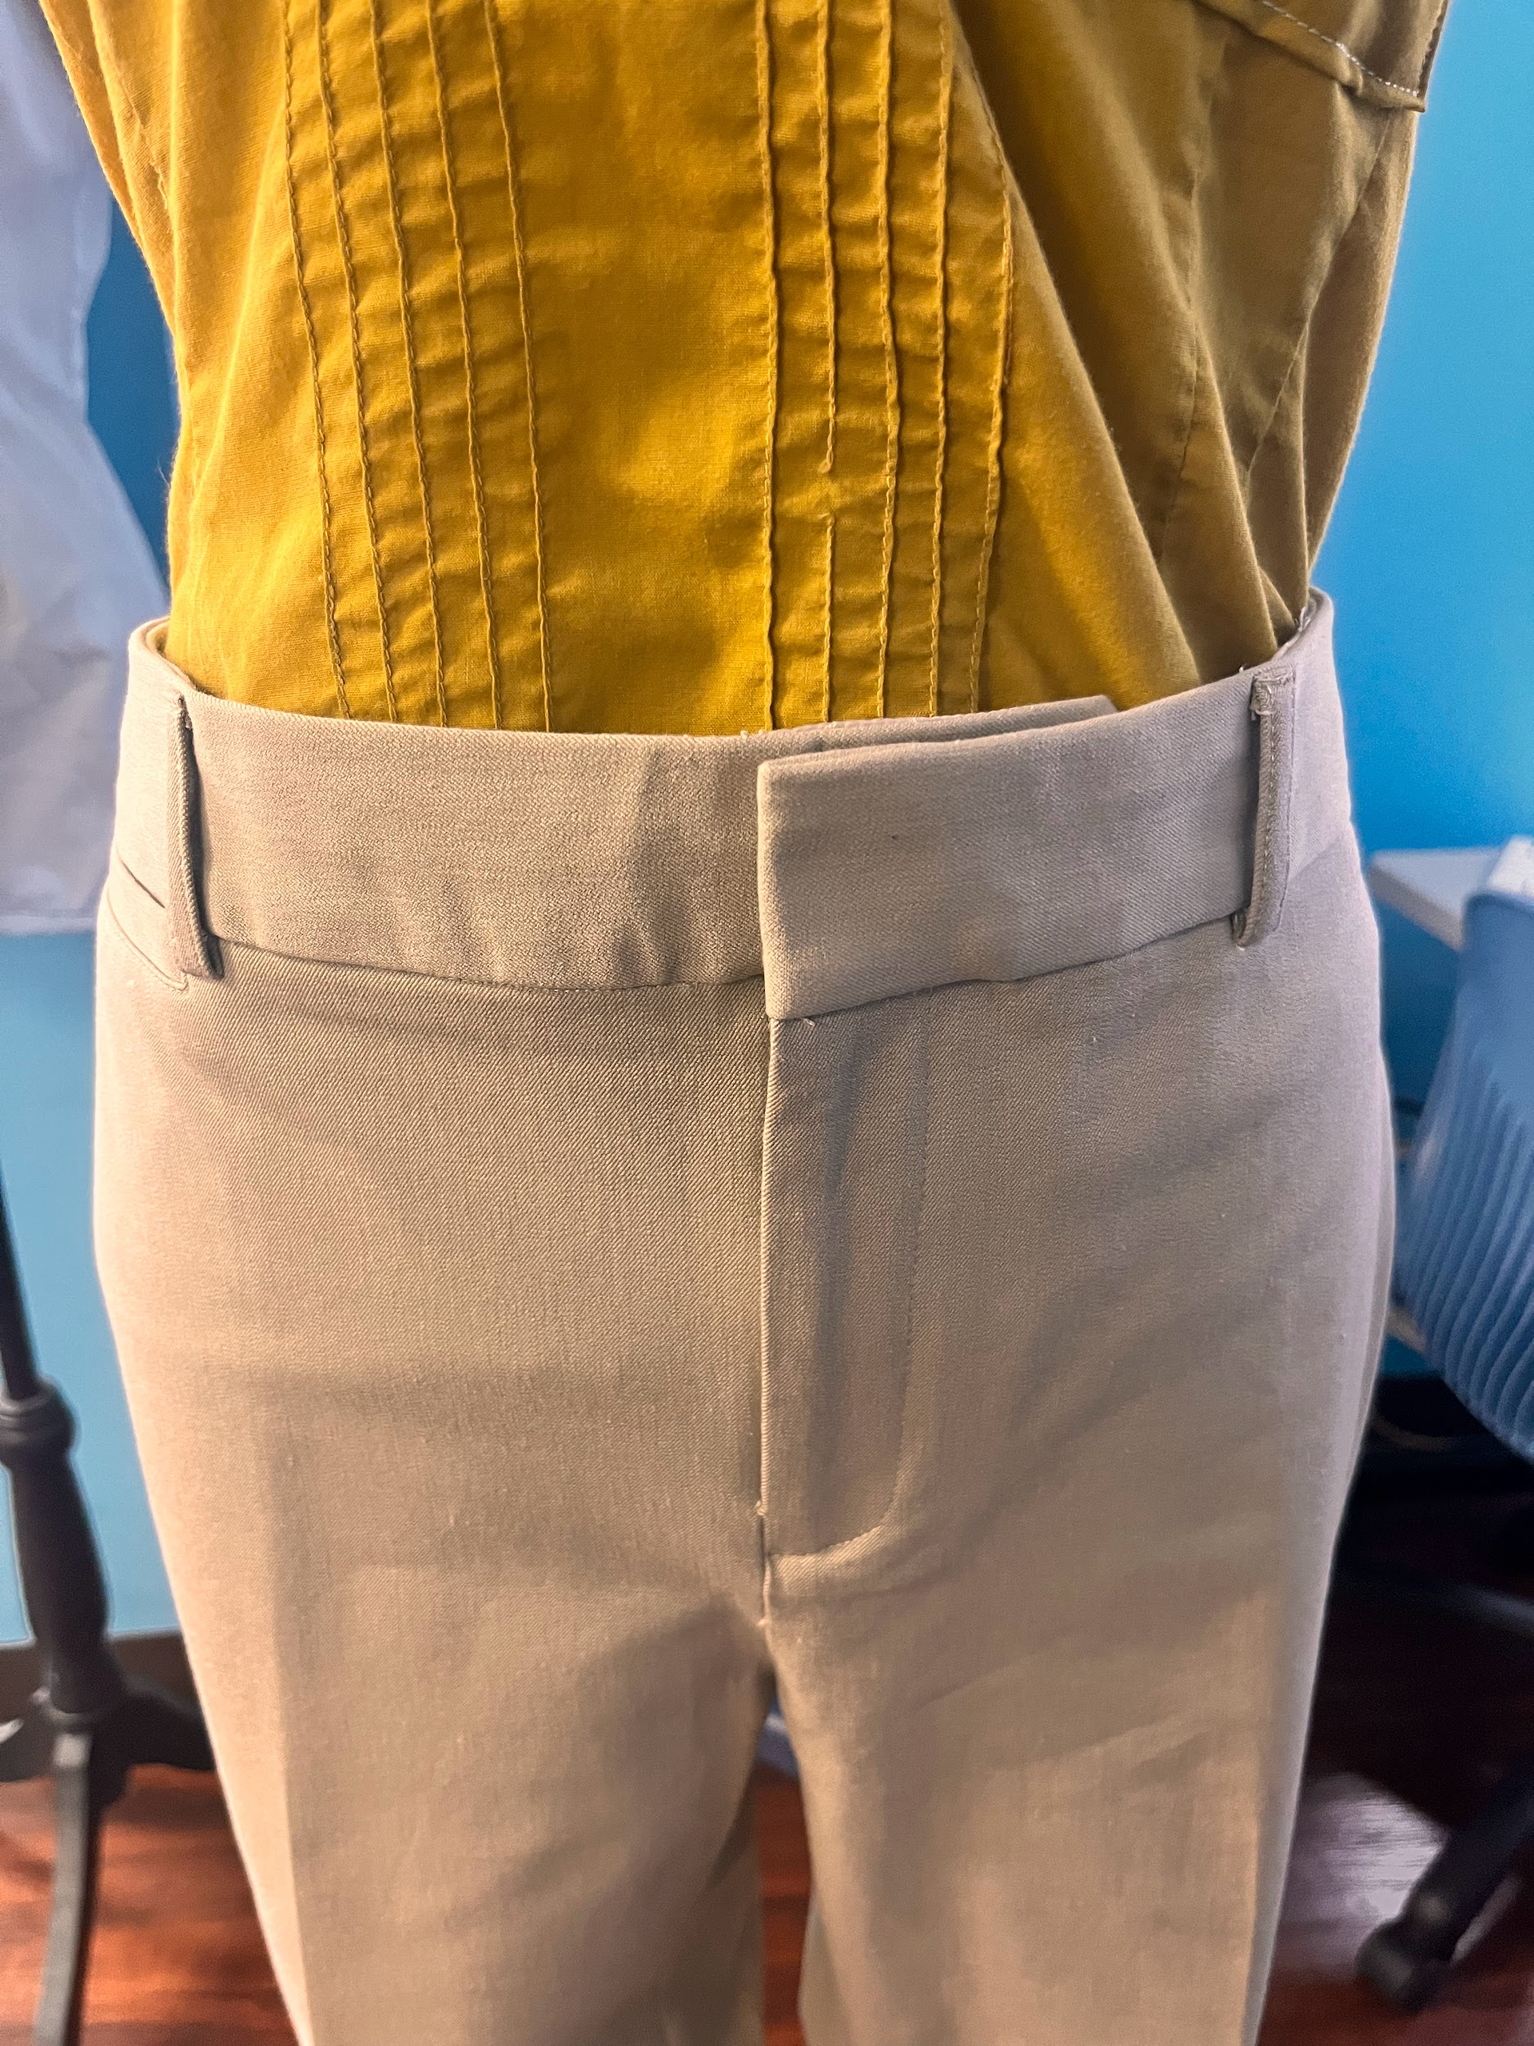 | fingers/hands
Step 7

List of material details, including item name, description, where it was purchased/obtained (include URL if applicable), cost per unit (if applicable), # of units, total cost (if applicable)

Material name | Description | Where material was purchased | Cost per unit
Gps dress | Oversized shirt | Golden Buckle/ Kameels | $30- $100
Khakis | Khaki colored pants | Golden Buckle/any clothes store | Around $20
Sewing thread | Thread for sewing | Hobby Lobby | $2
Belt | Faux Leather rope | Golden Buckle/Bow | $30-$60
Bow | Black lace tied into a bow | Mrs. Brottons/ hobby lobby | free

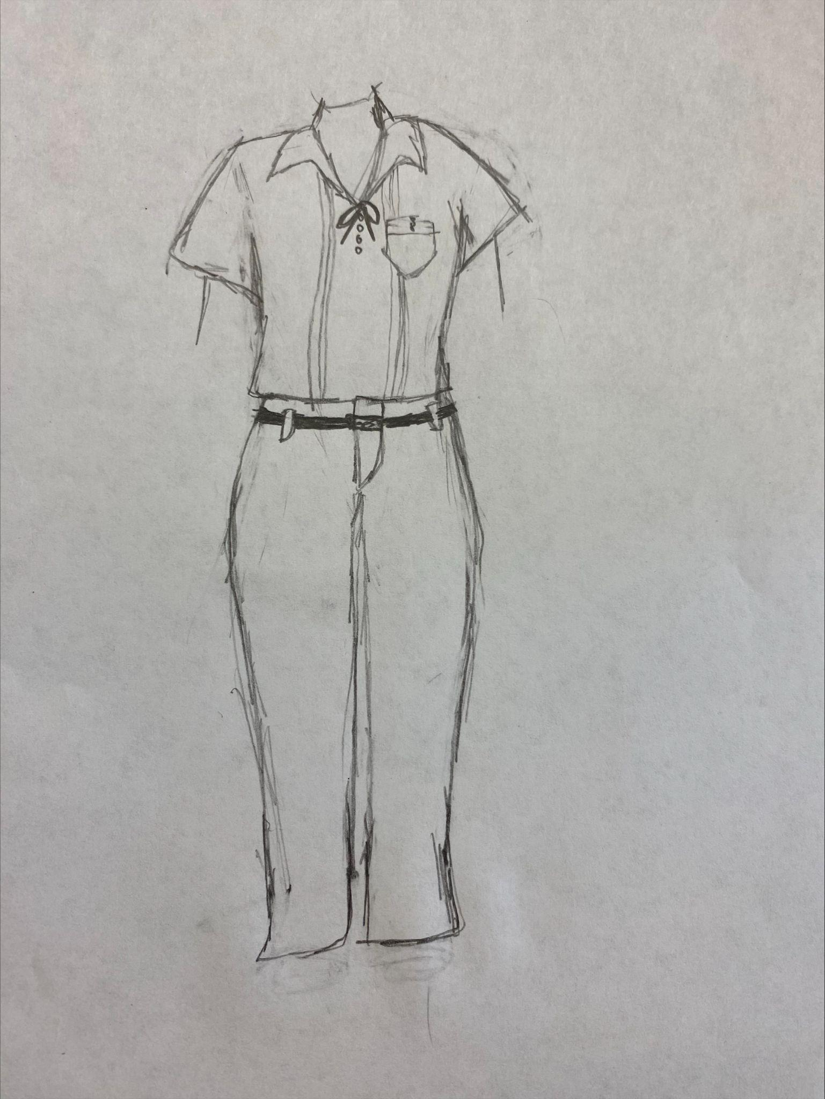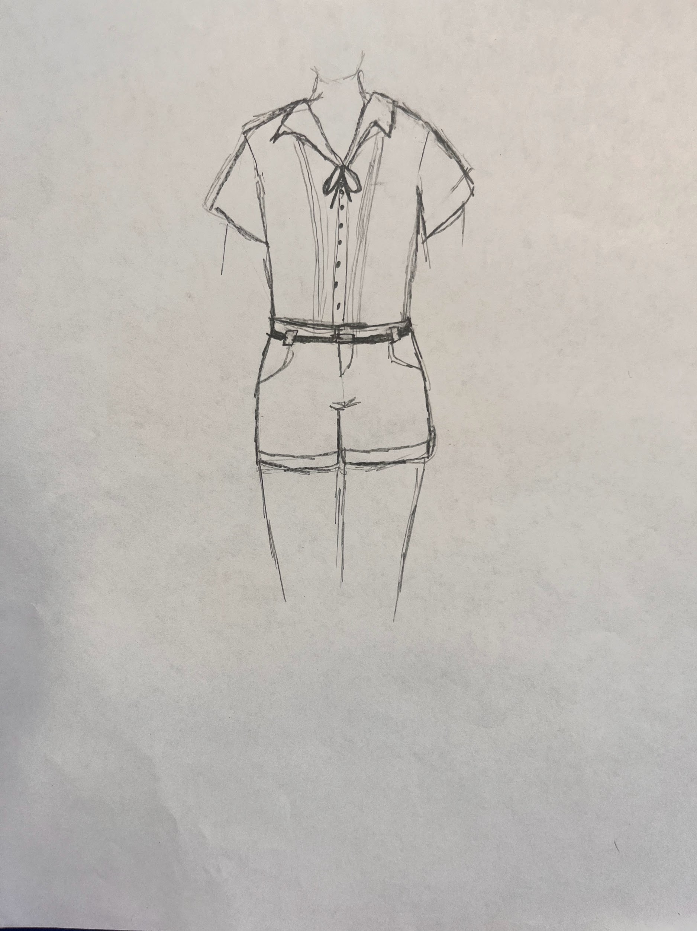
sketches:

Design Requirement | How will this prototype allow you to collect objective, measurable data?
Any design of the new and improved uniform must include the GPS belt- likely in the loopholes of the khaki pants/shorts. | Making the prototype allowed us to see which tools were needed in order to complete the uniform, it allowed us to see roundabouts where we needed to make cuts, and where we needed to make hems.
Any design of the new and improved uniform must include the traditional GPS Bow in the same place it would go on the traditional dress. | This will allow us to really see the amount of people who would like to wear a uniform that looks like the prototype.
The shirt design must closely resemble the top of the traditional GPS, with minimal to no changes (unless the pocket is moved up) | Allows people to see similar if not the same qualities within the prototype against the regular traditional gps dress.

