Element G

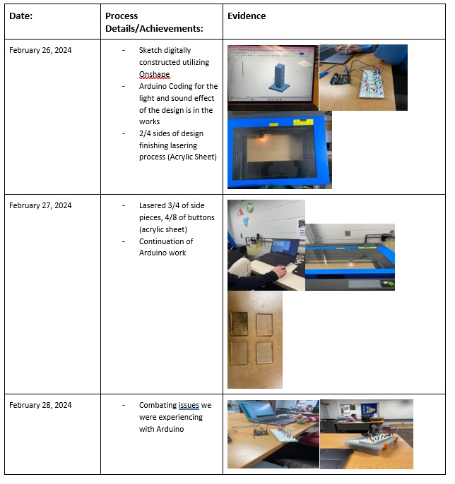

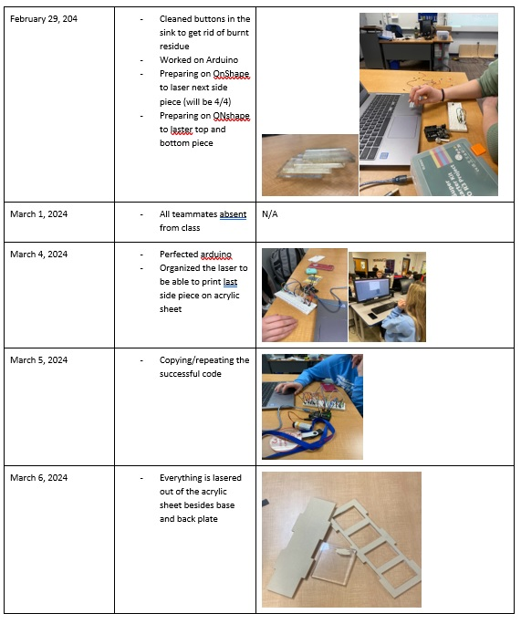

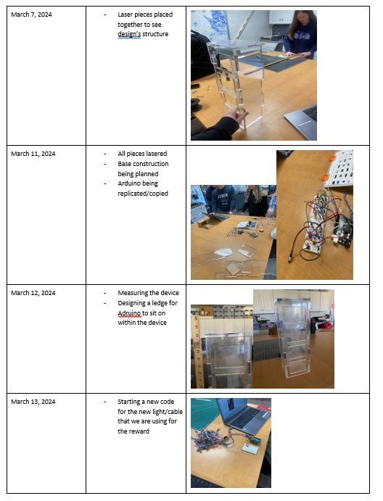

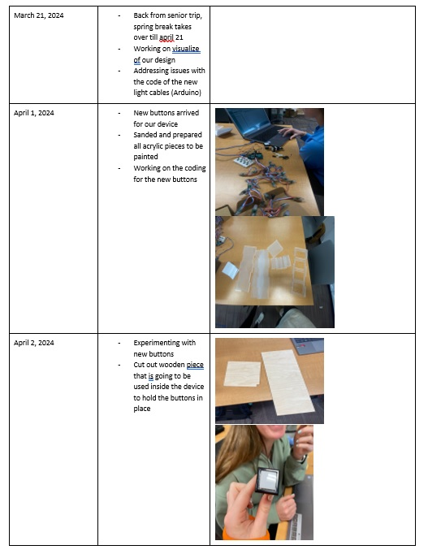

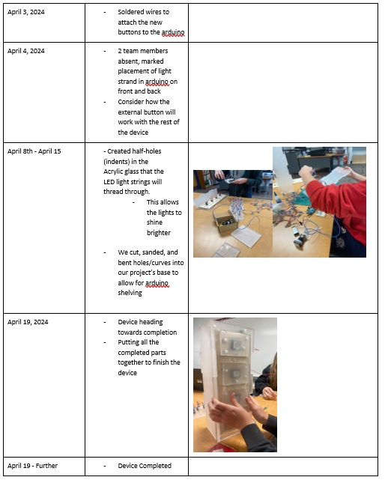

After completing the construction of our design, we realized the device had more weight than we had originally expected. To ensure the structure was secure, it ended up being more beneficial that the device was atop a firm, sturdy, and flat surface.

Final Prototype Material Details:

