MyDesign Portfolio
Element D Initial Template
How to use this template
Students: The template below is one way to present your design ideas, but the specific assignment given by your instructor may require a different structure or dictate different details. If you make a copy of this template to edit for your own design ideas, be sure to delete the instructions.
Guidance before filling out the template on the next page:
Because you will iterate on your design multiple times, you will need to create multiple copies of these sections. Think of Element D as a diary that you will date and keep adding to throughout your work until your final iteration. It’s critical that iteration shines through in this Element.
You should begin with many design ideas that reflect the individual ideas of your group members and then the group ideas. Number these ideas and include a date, description, drawing, and details for each.
After you have created an initial set of ideas, document your decision making on which design to include, ideally with a design matrix. Create a plan of work, ideally using a Gantt chart that may be housed in this document or in a different day-to-day document. Generate a design blueprint with enough details that someone else not familiar with your project could also build your design.
You will then proceed forward to build and test this design, returning to Element D afterwards when you are ready to create more design ideas. Fill out each of these steps again.
Element D: Design Concept Generation, Analysis, and Selection
Design Idea Generation (D1)
This section focuses on the process of generating solutions. The initial rounds should include every idea you come up with but the subsequent rounds of ideation should lead to viable options. Each idea should include not only words, but also a picture. Use as many copies of this sub-template as needed.
Design Idea #1
Date:
Description: air removal, a fan in a chamber pushes air up a tube to a ‘wind spread attachment’ that is at the height of the birdies and tennis balls. The attachment pushes air under the birdies and balls so that they fall to the ground
Drawing that includes distinguishing information such as scale, dimensions, and materials:
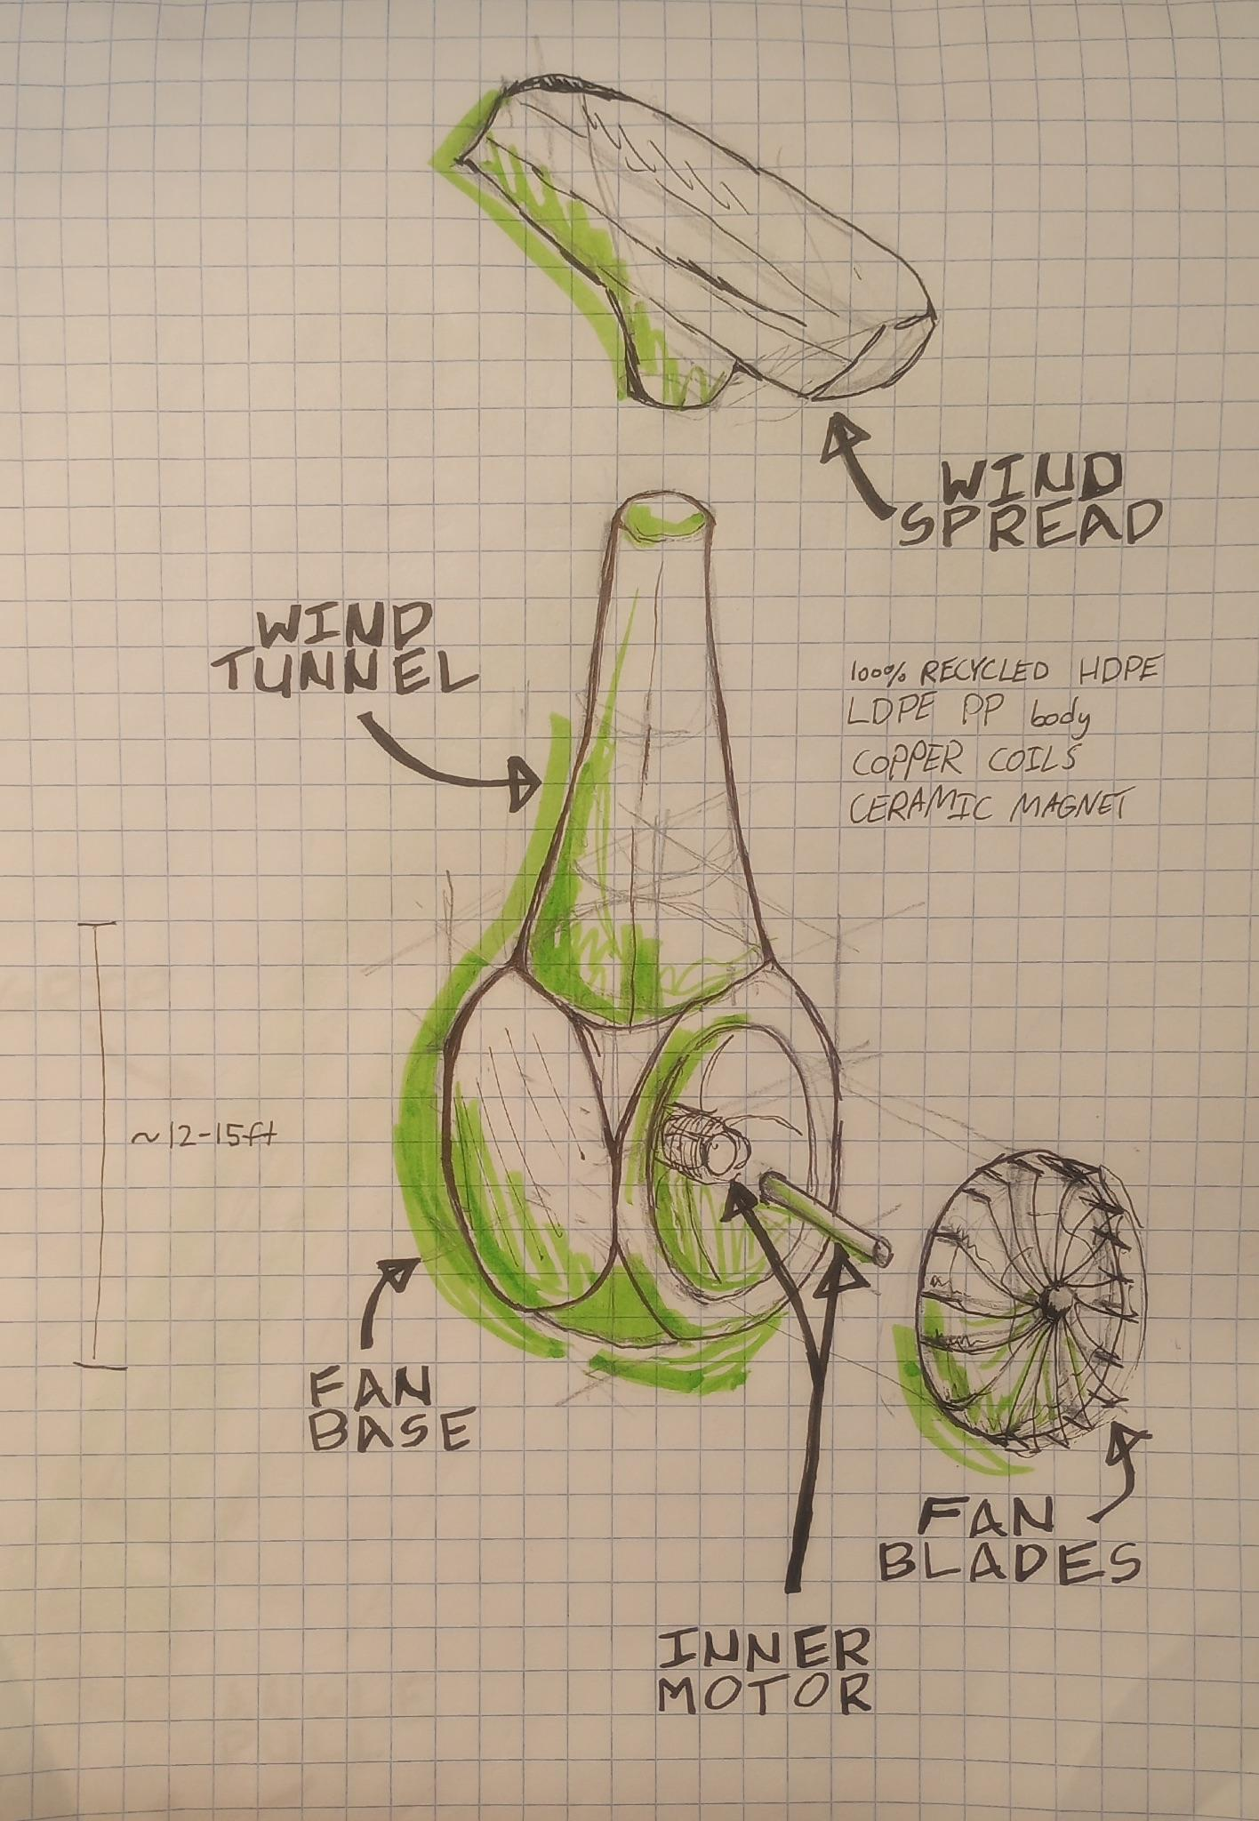
Design Idea #2
Date:
Description: movable long brush, a brush is on a hinge like attachment to a pole that reaches the birdies and tennis balls. The brush can be hinged with a string that reaches the bottom of the pole. The string acts as a tendon and can hinge the brush in order to not only remove the birdies and tennis balls, but anything else that is stuck on there or dirt and debris.
Drawing that includes distinguishing information such as scale, dimensions, and materials:
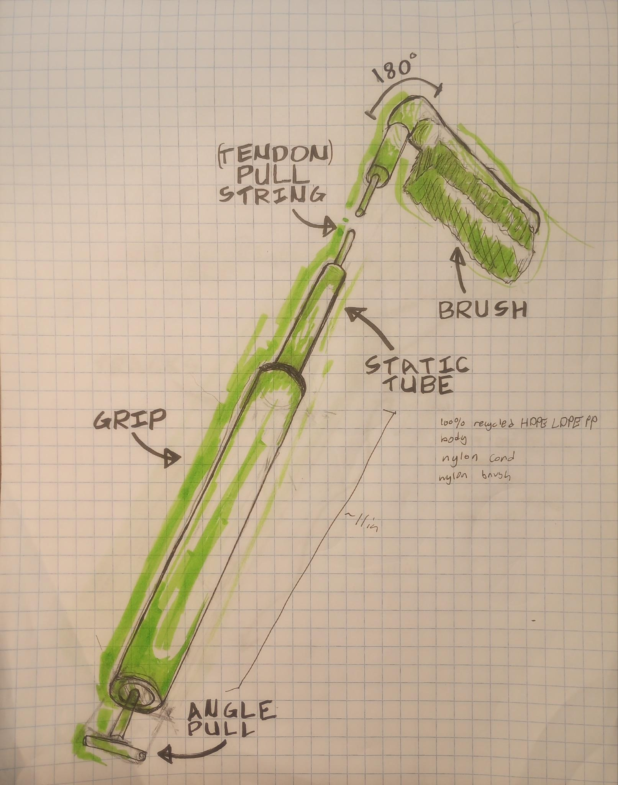
Design Idea #3
Date:
Description: a net launcher with a string to retrieve the captured items
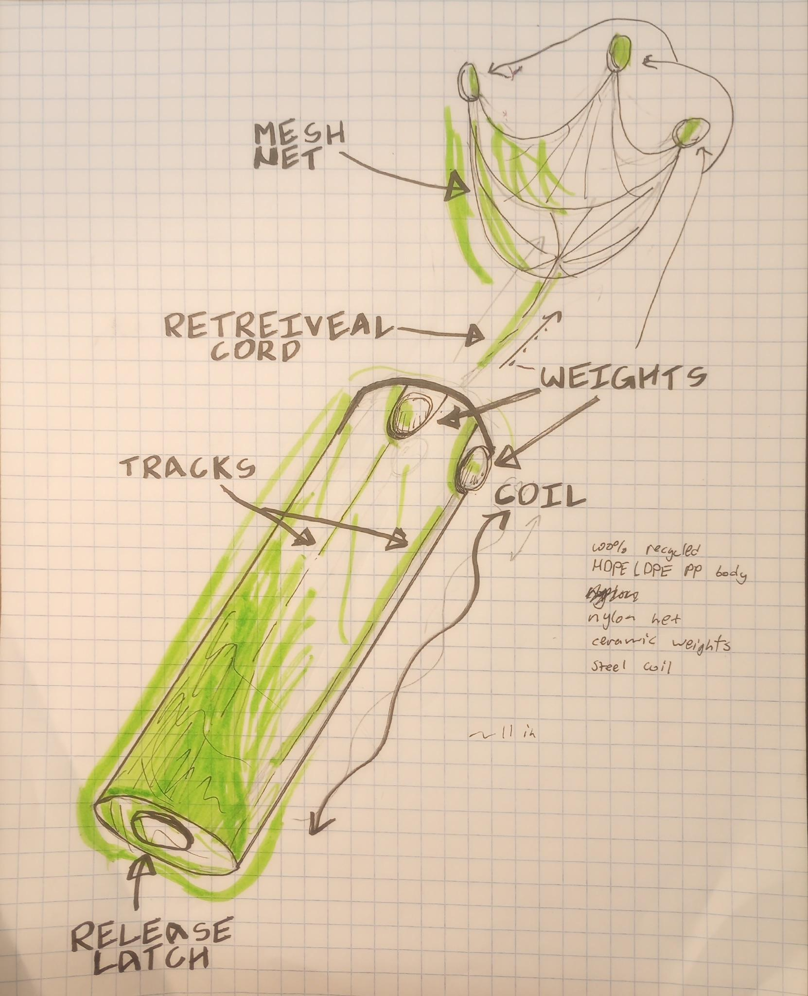
Drawing that includes distinguishing information such as scale, dimensions, and materials:
Design Idea Comparison and Selection (D1, D2)
When you’ve finished generating ideas, you must compare your design options according to all your design requirements. Incorporate the priority of those requirements when comparing design options. A decision matrix (perhaps a Pugh Matrix) is encouraged since it allows for systematic, weighted comparisons. If using weights in a decision matrix, be sure to explain and justify the weighting based on your design requirements. You may use the weighted design matrix template below, inserting your criteria and design options.
Design Matrix
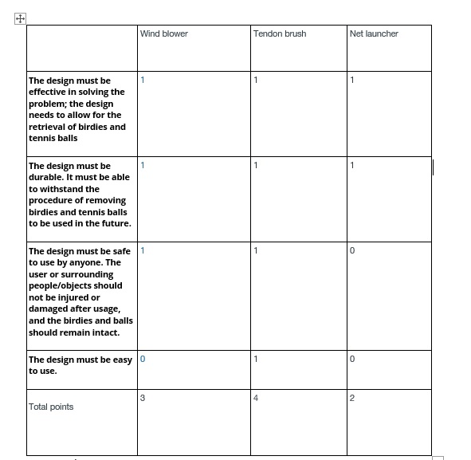
Design Blueprint (D4)
Describe all of your design's details such that someone unfamiliar with your project could build your prototype. Include sketches, dimensions, CAD (if taught in your class), manufacturing methods, material choices, supply lists, and costs.
Design Blueprint #1
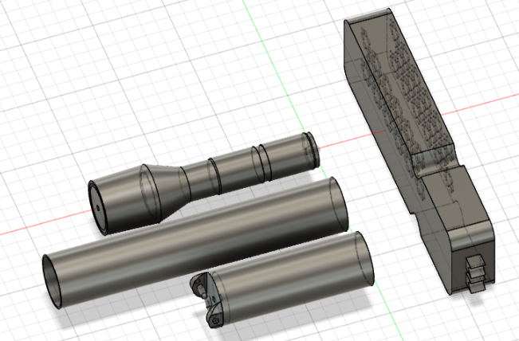

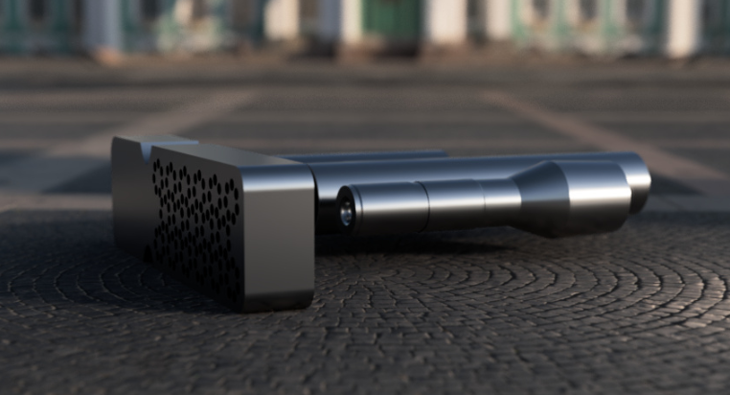

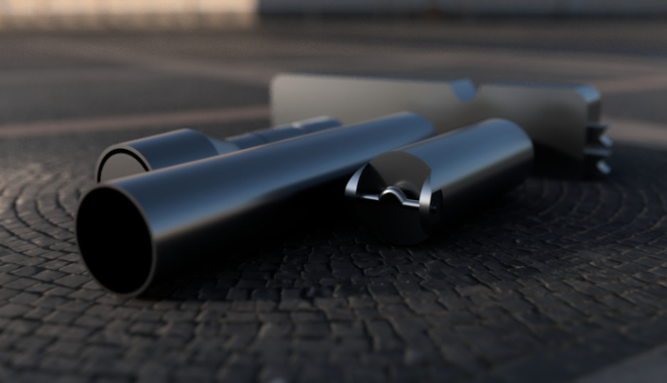
Date:
Sketch:
Manufacturing Methods:
Step 1: make molds out of 3d printing
Step 2: fill with recycled plastic
Step 3:
Supply List and Costs:
Supply List and Costs
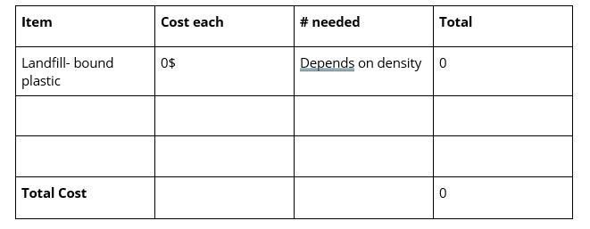
Plan of Action (D3)
A Gantt chart is encouraged to lay out the primary steps expected on a visual timeline. Larger tasks from the Gantt chart should be broken down further into detailed sub-tasks, which may be housed in a different day-to-day document. Discrete tasks should include enough detail such that others could replicate the efforts, such as procedures, materials, tools, status, etc.
Rubric

