Element D:
Design Idea #1
Date:1/26/24
Description: Customized straw that could pass peanut butter into Kong
Drawing:
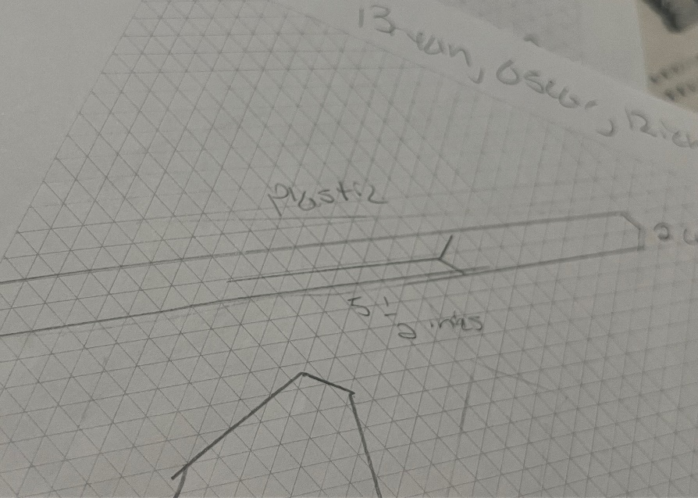

Image 1: Customized Straw Design
Drawing:
Design Idea #2
Date:1/26/24
Description: Ice cream like spoon that can grab peanut butter and push it out with the handle at the back
Drawing:
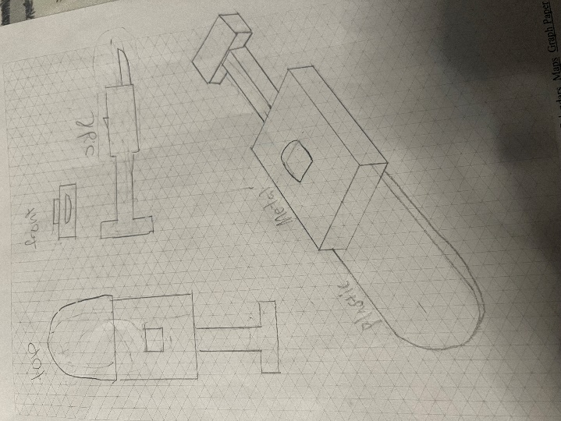

Image 2: Ice Cream Spoon Design
Drawing:
Design Idea #3
Date:1/26/24
Description: Suction object to absorb and release peanut butter into Kong
Drawing:
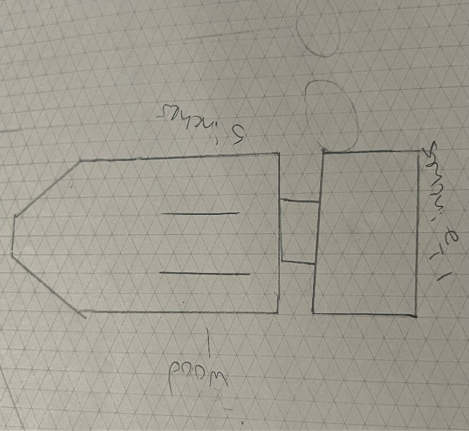
Image 3: Suction Design
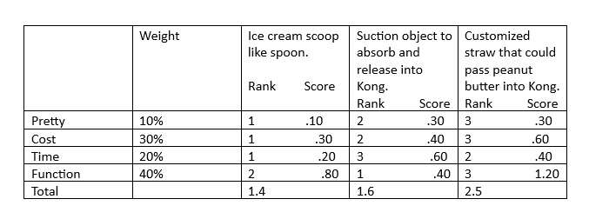
Table 1: Design Comparison Matrix
Date:1/26/24
Description: Suction object to absorb and release peanut butter into Kong
Drawing:
Design Blueprint #1
Date:2/8/24
Sketch
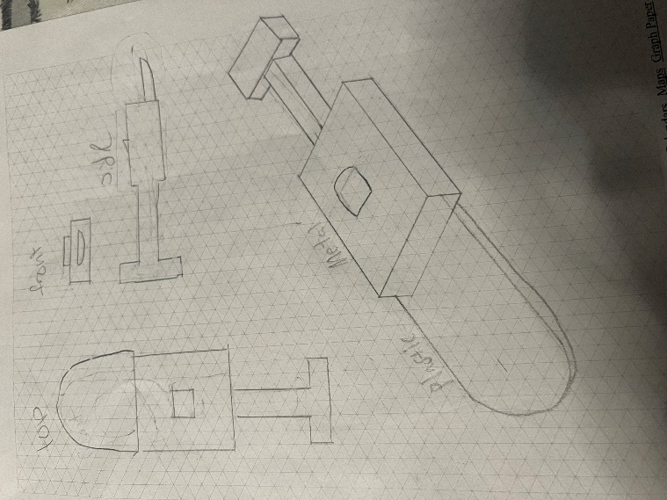
Image 4: Design Blueprint #1
Date:2/8/24
Sketch
Manufacturing Methods:

Supply List and Costs
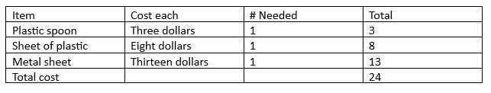
Table 2: Supply List and Costs
Step 1: Make the base of the design along with the push object.
Step 2: Make the part where it can go in and out and lock.
Step 3: Make the spoon effective and support weight.
Supply list and costs:

