Element D
Design concept generation, analysis, and selection
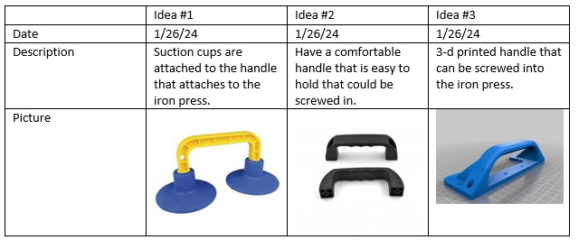
Design idea comparison and selection
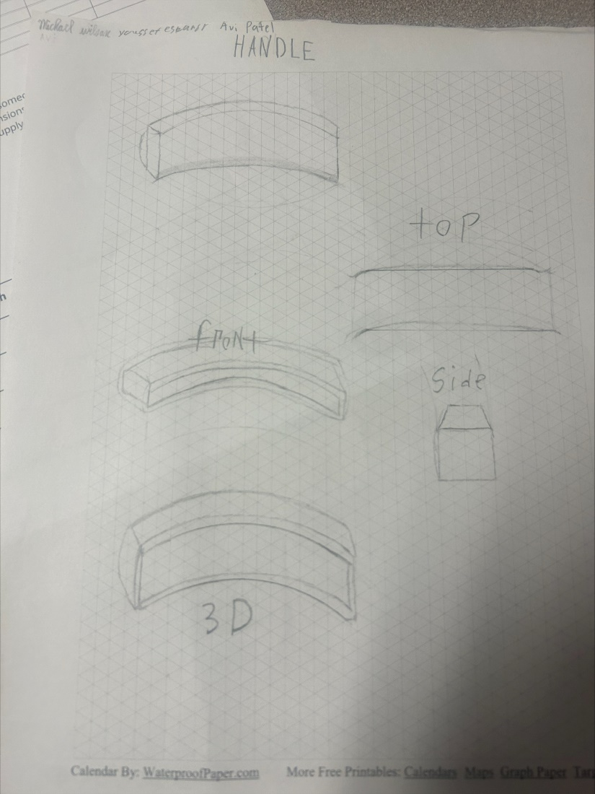
Image 1: Design Comparison
We decided to select the 3-d printed handle because it functions well, doesn't take a lot of time, and doesn't cost much. It also had the lowest total on the chart. It could also look pretty if we design it pretty.
Design Blueprint #1
1/30/24
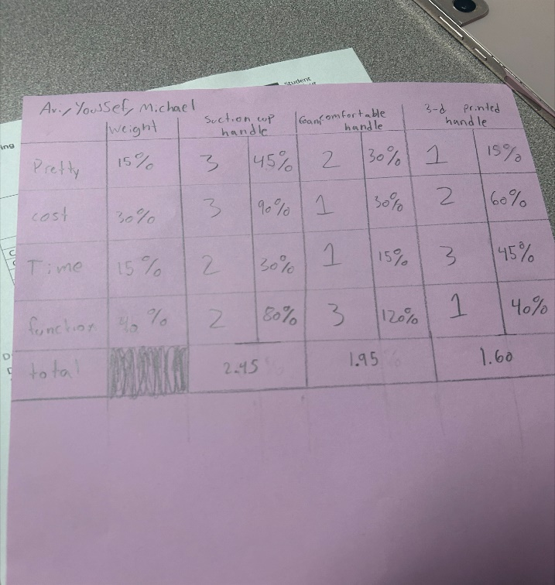
Image 2: Design Blueprint #1
1/30/24
Step 1: make ideas
Step 2: choose an idea
Step 3: sketch the idea
Step 4: tinker cad
Step 5: make the prototype

