Element I:
Our design was tested as we built and after it was built to make sure all criteria were met.
One of the first tests we ran, before we even had the final design idea, was a test to make sure we would have the correct height for the handle. We had Mr. Kiser hold the cart, and make a position he would prefer to keep his hands at. We measured that and came up with our criteria that it has to fit people from 5’ to 6”8’.
The second test we ran was after we got the parts, making sure that the pieces could fit on the cart, fitting the c-clamps onto the bottom of the cart and the vertical pipes through the handles.
The third test was a strength test for the PVC, making sure it could hold the weight of the cart, which is where we discovered a flaw of the design, or rather a flaw in the materials. To test the weight, we bent the assembled prototype, applying the amounts of force it would be expected to resist. During this test, the T joint for the middle crossbar cracked. To fix this, we reinforced it with spare steel tubes held in place with 3d prints.
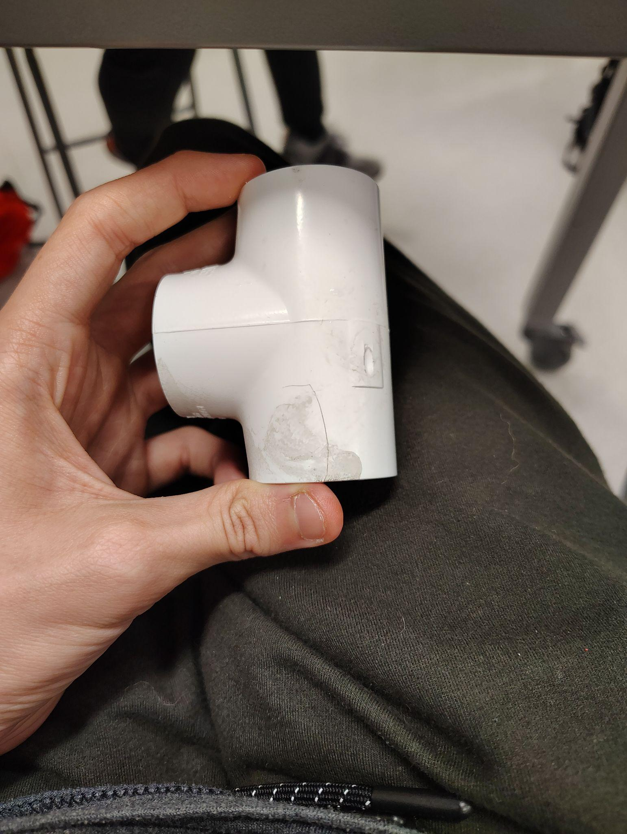
The fourth test was to make sure if the steel would provide sufficient improvements in strength, which more than tripled its tolerance until it yields (deformation or cracks). We did not test until failure as we had no extra PVC or steel.

