Maintaining optimal soil moisture levels is crucial for plant health and efficient water usage, particularly in agriculture and gardening. Overwatering can lead to root rot and nutrient leaching, while underwatering can cause plant stress and reduced yields. Traditional methods of checking soil moisture rely on manual observation, which can be inconsistent and time-consuming. This project aims to develop an Arduino-based soil moisture monitoring system using a moisture sensor LM393 to measure and track soil moisture levels in real-time. The system will provide instant feedback on soil conditions and potentially trigger an alert when moisture levels drop below a predefined threshold. By implementing this system, farmers and gardeners can optimize water usage, improve plant health, and reduce labor efforts in maintaining soil conditions.
In agricultural practices, maintaining optimal soil moisture levels is crucial for plant health. Traditional methods of monitoring soil moisture rely on manual checks, which are inconsistent and time-consuming. This project addresses the need for an automated system that can accurately measure and provide real-time feedback on soil moisture levels, which in turn helps optimize water usage and improve plant health. The high priority design requirements are accurate soil readings that the soil moisture sensor must provide precise and reliable moisture level readings. The real-time feedback is another which is the system must display immediate feedback on soil moisture, allowing users to monitor changes. Lastly, sustainable power, the system should be powered efficiently, ensuring it operates without needing frequent recharging.
These are the procedures for testing each of the three requirements:
Accurate soil readings:
- Insert the soil moisture sensor into the soil at different moisture levels, wet, damp, and dry.
- Plug the device into the laptop and open the Arduino code
- Monitor the output light on the sensor
- Repeat the test multiple times with varying soil types and conditions to verify consistent readings
Real-time feedback:
- After starting the code, the sensor continuously outputs soil moisture readings every few seconds
- Monitor the feedback, writing down immediate updates when the moisture level number changes
Sustainable power:
- Test the device by keeping it plugged into a laptop, ensuring it is running continuously
- Track the performance of the system over a few hours to confirm the power on the laptop
Data Collection:
Soil moisture levels: the readings will be observed through the light on the sensor
Test conditions: different soul types will be tested to verify consistent and accurate readings
Power usage: The device’s power performance while plugged into the laptop will be monitored

Our testing procedures aim to confirm that the system meets our three high-priority design requirements, which are accurate soil readings, real-time feedback, and sustainable power.

Average Sensor Reading LED ON Soil State
1023 | Red | Dry
491.9 | Green | Damp
386.5 | Green | Wet

Damp Soil:
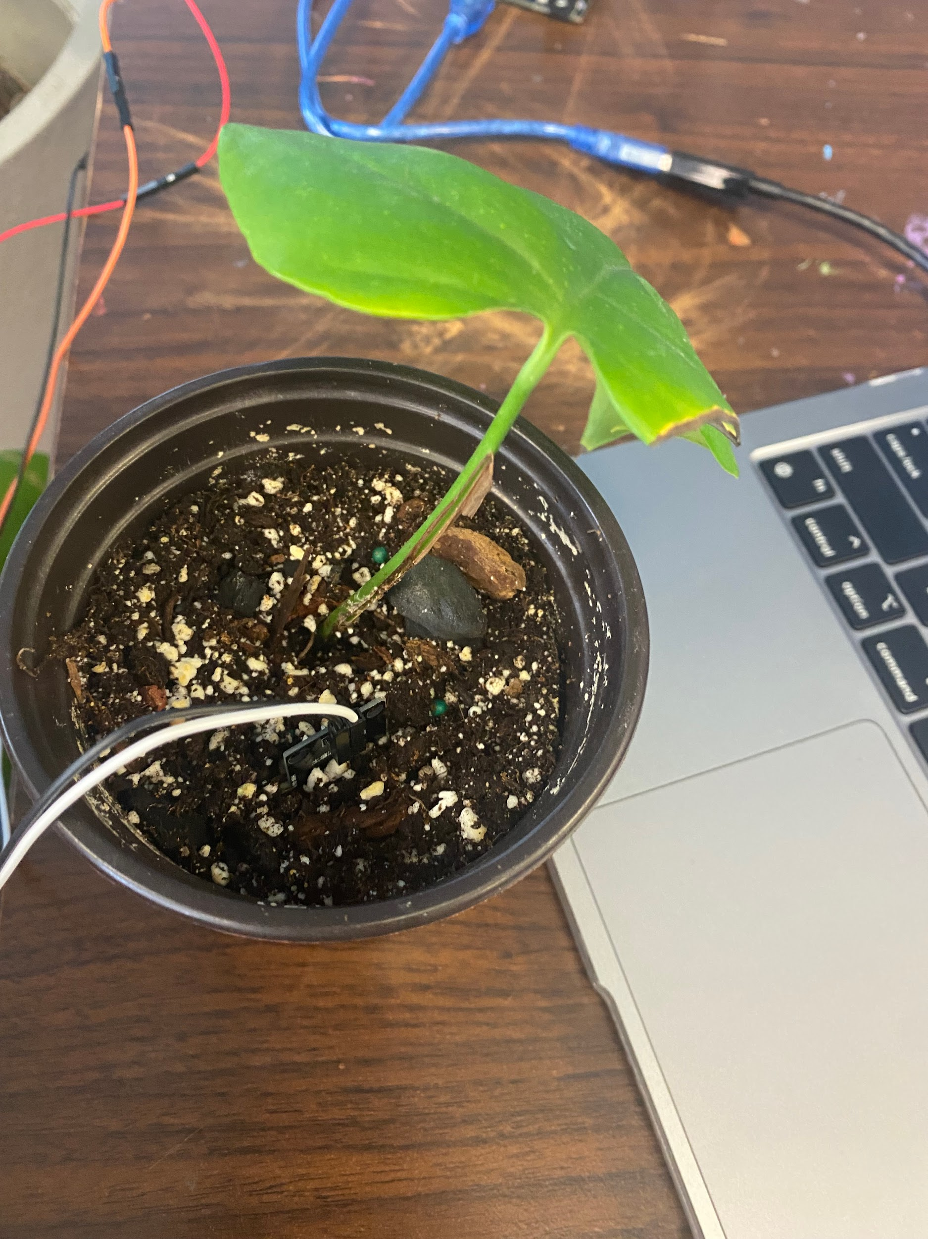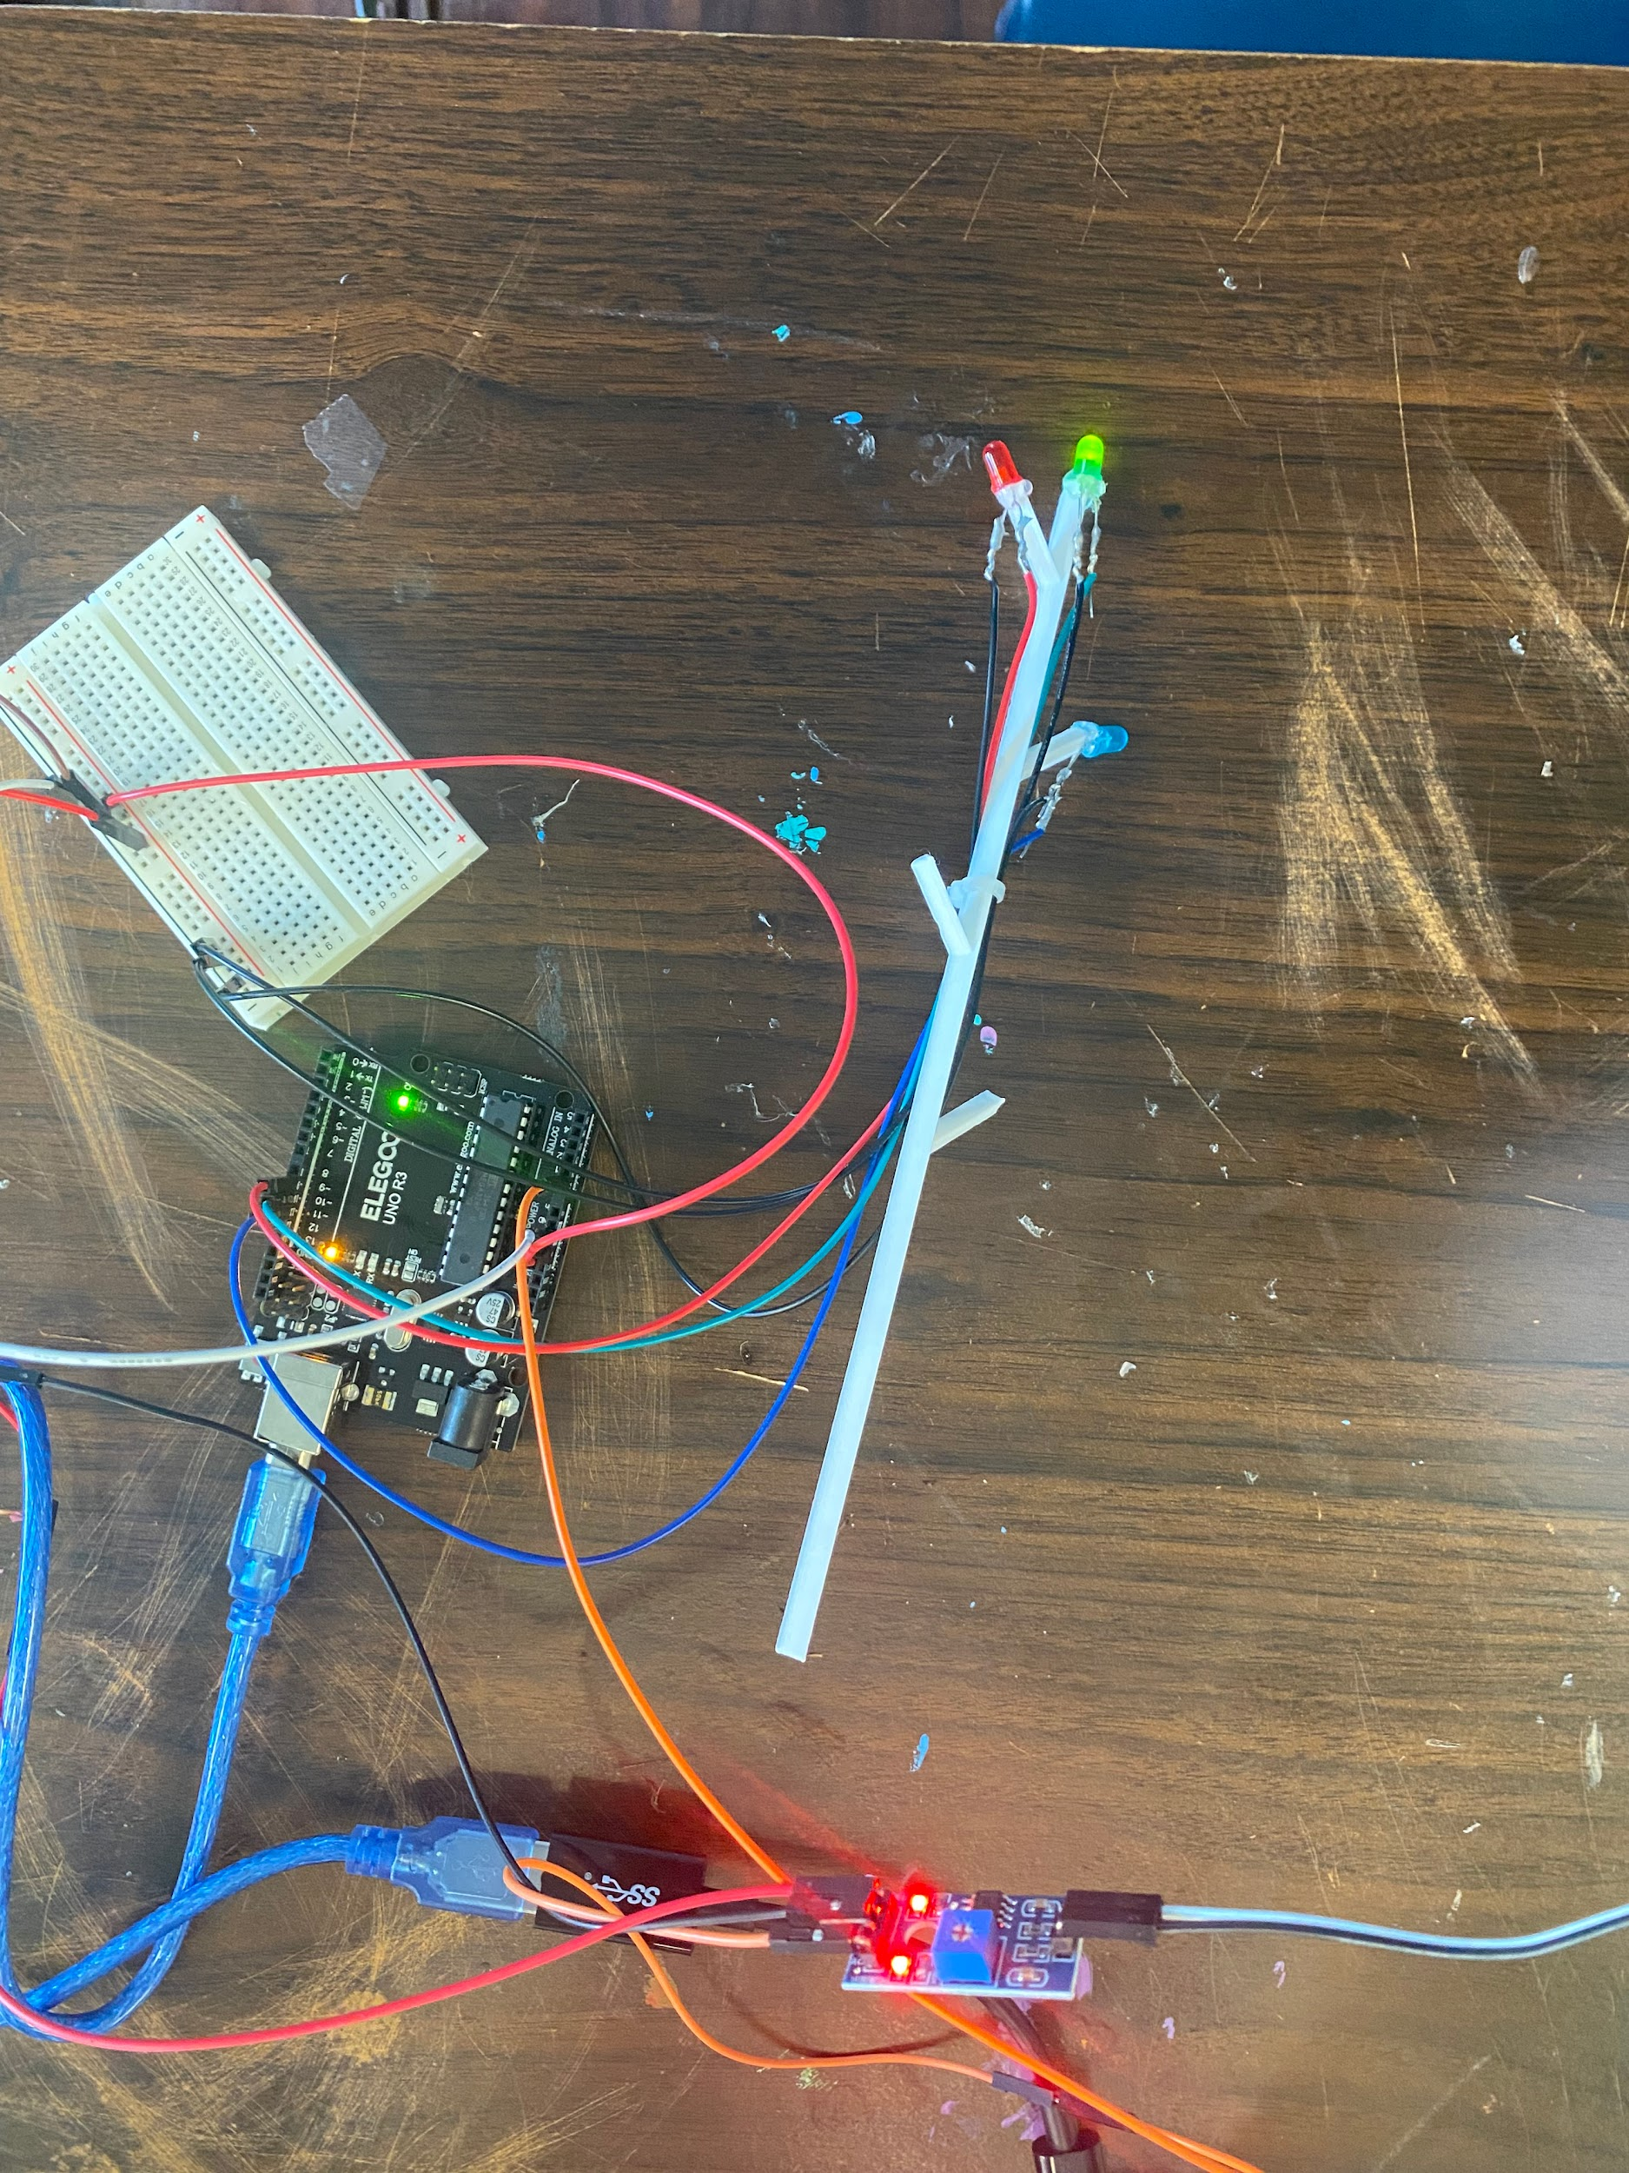
Wet Soil:
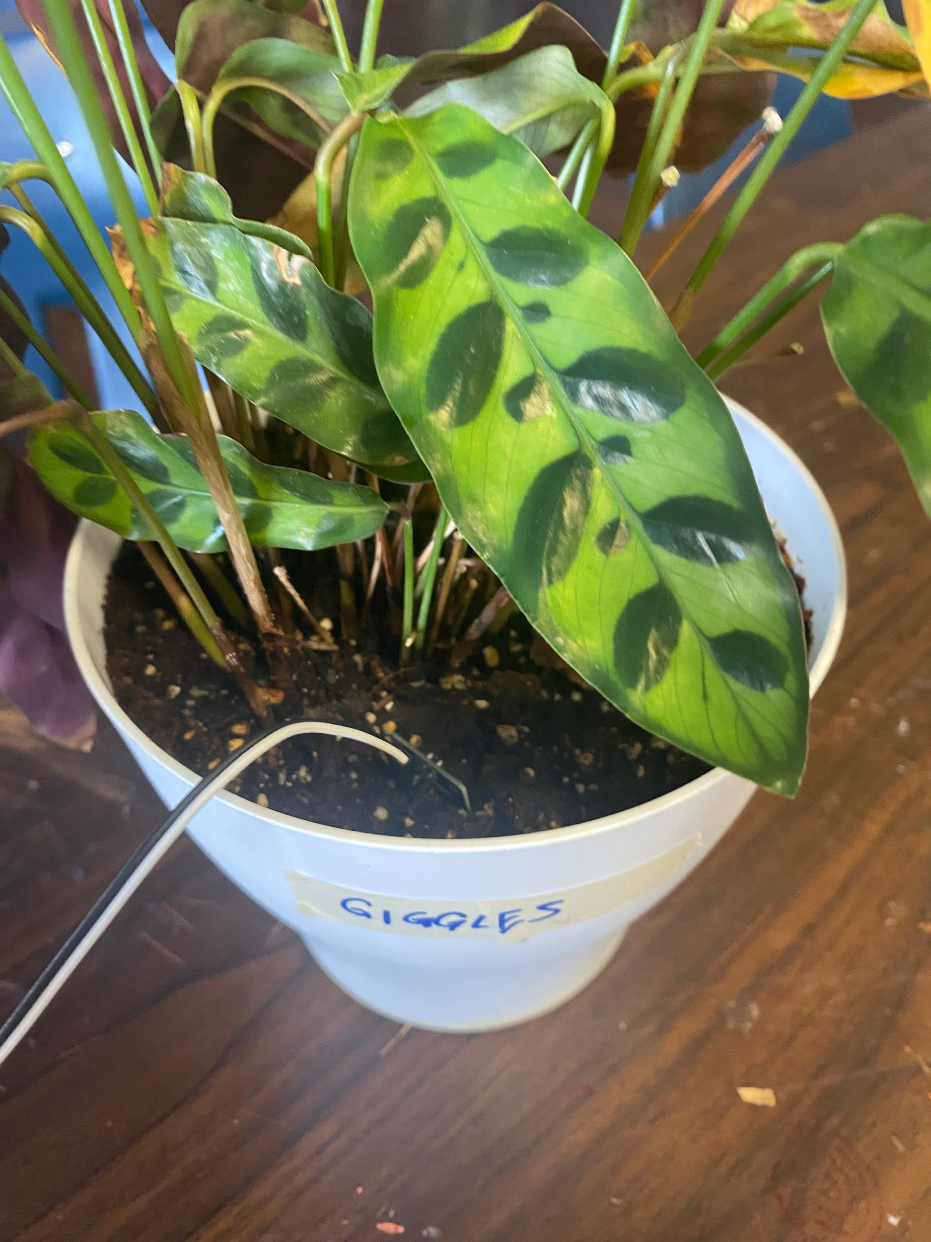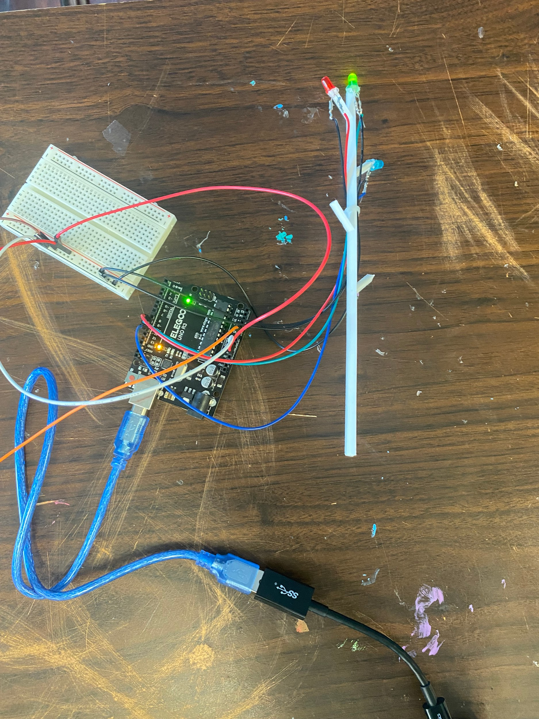
Dry Soil:
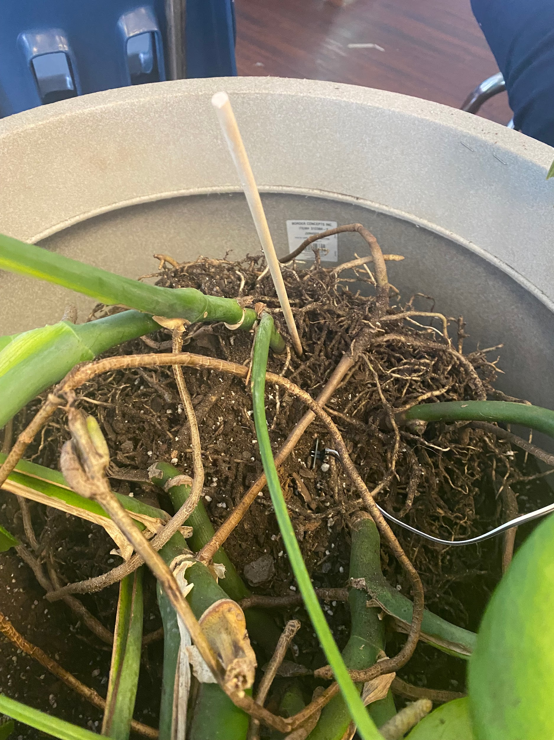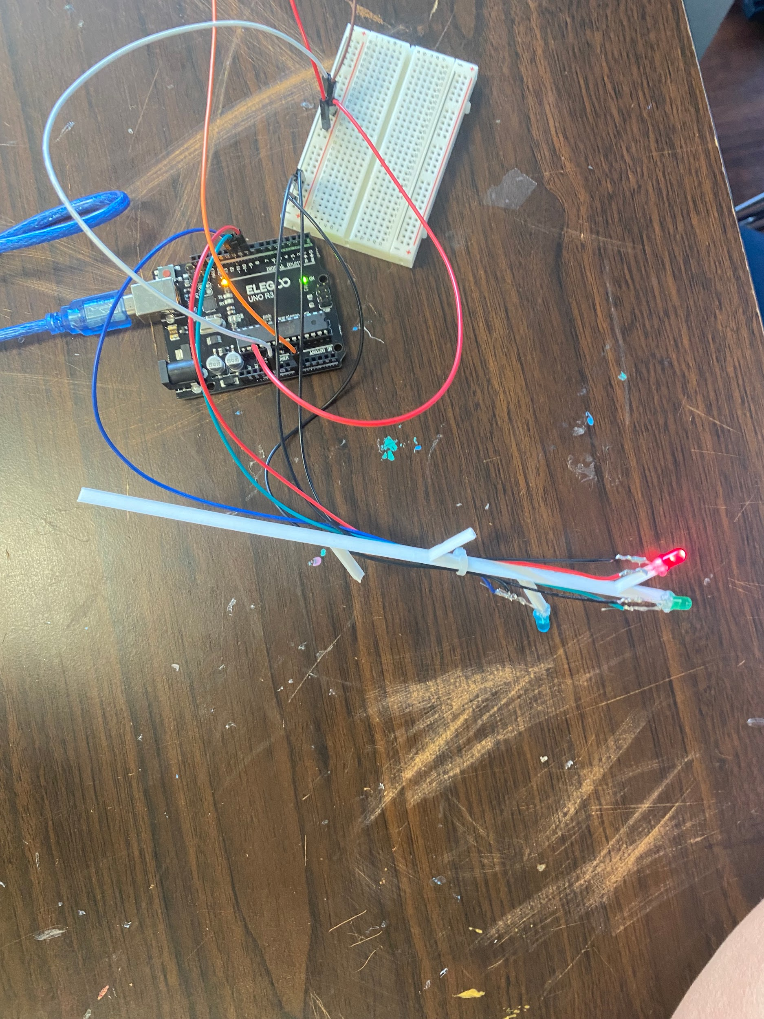
We learned that the soil readings from the sensor confirm that the system can accurately detect and display soil moisture levels. The data shows that the soil detector worked well. It met all the design requirements and also meets the needs of our teacher, who is using it. It works on dry, damp, and wet plants and can accurately detect. The next steps for improvement would be hooking up the data to an app on our phones so we can easily access and read the data.

