Section I: Testing, Data Collection and Analysis

Our tests will give us the information needed for our high priority design requirements of being easy to use, able to lock, and able to unlock. Putting the pin in without wiggling the desk will easily show us if people are able to put the pin into the hole with ease and therefore operate it easily. Our test of moving the desk around will show us if the pin falls out and successfully keeps the desk locked. We will also try to take the pin out to see if it is able to unlock without having issues.
A large part of our testing procedure was making sure the pin could go in and out of the hole, or lock and unlock. Through our data collection, we learned that the desk can unlock very easily but it’s harder to lock the desk as you have to wiggle it to get the pin in and actually lock the desk. Another part of our testing procedure was to spin the pole that the pin goes into to see if the pin is too loose and falls out. From doing that, we learned the pin is very stable and tight within the hole. We also wanted to make sure that all the other swivel mechanisms work, by actually trying to swivel them and through doing that we realized our mechanism is very successful and overall easy to use.
Level of Difficulty to Use
Tester | Difficulty to lock (scale of 1-10, 1 being easy) | Difficulty to unlock (scale of 1-10, 1 being easy) | Overall (scale of 1-10, 1 being the best)
1 | 5 | 3 | 4
2 | 10 | 1 | 5
3 | 3 | 2 | 3
4 | 7 | 2 | 5
5 | 3 | 1 | 2
Average | 5.6 | 1.8 | 3.8

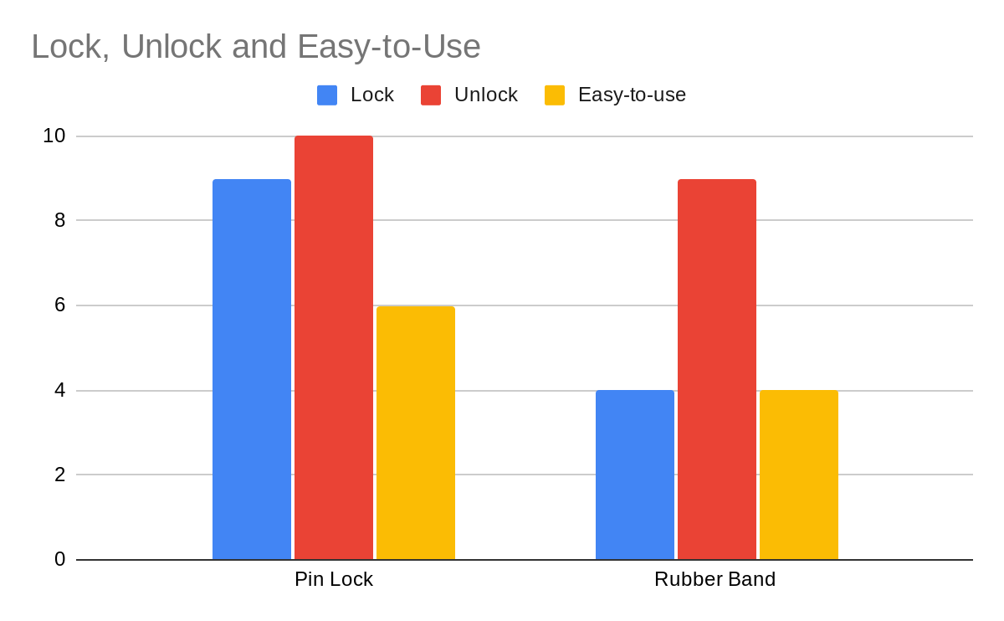
Success rate (front-back lock)
Test | Pin mechanism locks | Pin mechanism unlocks | Rubber band mechanism locks | Rubber band mechanism unlocks
1 | Yes | Yes | No | Yes
2 | Yes | Yes | No | Yes
3 | Yes | Yes | No | Yes
4 | Yes | Yes | No | Yes
5 | No | Yes | No | Yes
6 | Yes | Yes | No | Yes
7 | Yes | Yes | No | Yes
Total | 86% | 100% | 0% | 100%

From our data, we learned that while the pin method does work, it is slightly annoying to operate and some of our stakeholders and testers had difficulty using it. But we also learned that the rubber band mechanism does not lock at all. This data implies that in the future, we should drill a larger hole for the pin to go into so that sliding the pin in to lock the desk is easier and faster.
using it. But we also learned that the rubber band mechanism does not lock at all. This data implies that in the future, we should drill a larger hole for the pin to go into so that sliding the pin in to lock the desk is easier and faster.

