The Athletic Commons at GPS needs backpack organization because the backpacks cause safety issues, as well as creating a choke point which slows down everyone trying to use the athletic commons after school.
The tests that we took gave us information on what we need for stability, and how we needed to change how the structure was built. We needed to make sure we used acrylic glue, and had a good length and width of the walls and a good 3D printed hinge. We 3D printed different designs of hinges to test how each of them works. Then we had to choose a design that we thought would have the best result to make sure that the plexiglass panels are sturdy when put together. Then designed it with the measurements of a large, overstuffed backpack, so there is more room than needed for an average backpack. Then we worked with many different spaces some 23 feet long that can hold up to 36 cubbies.

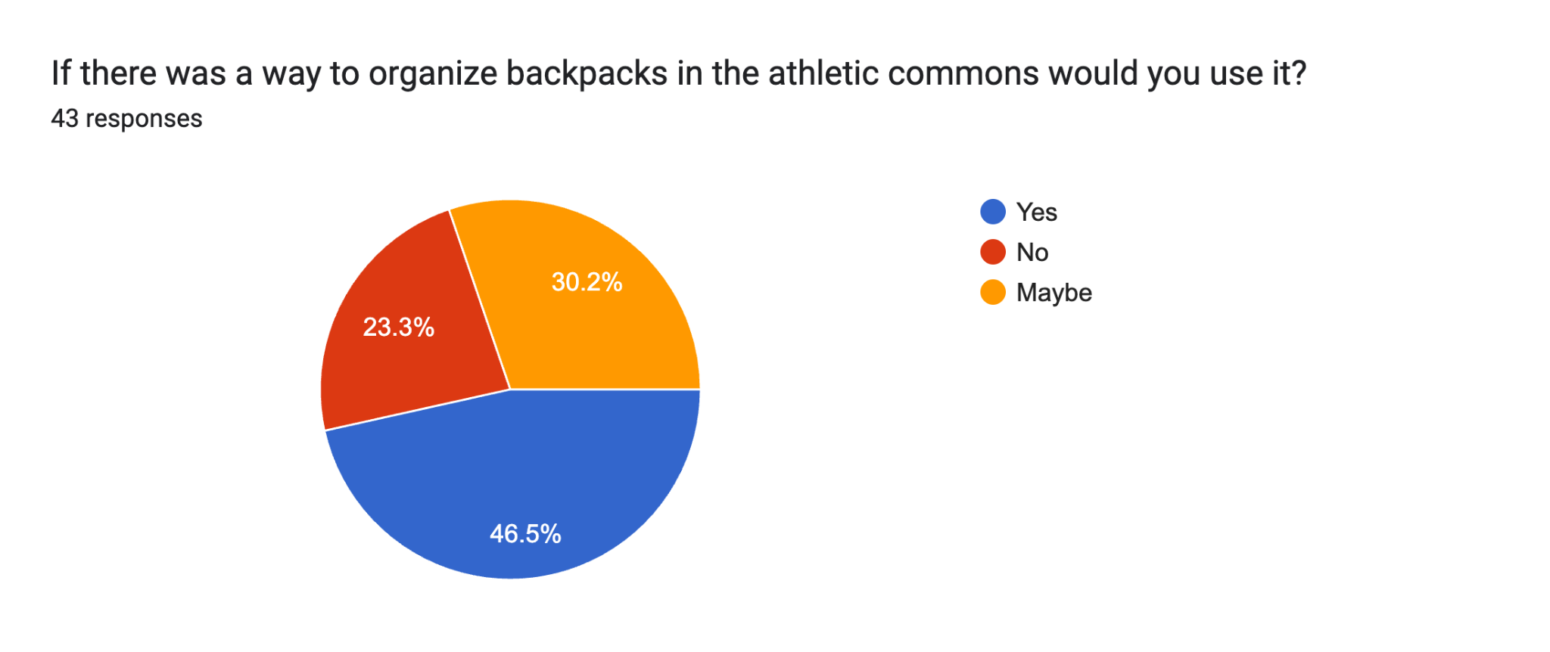
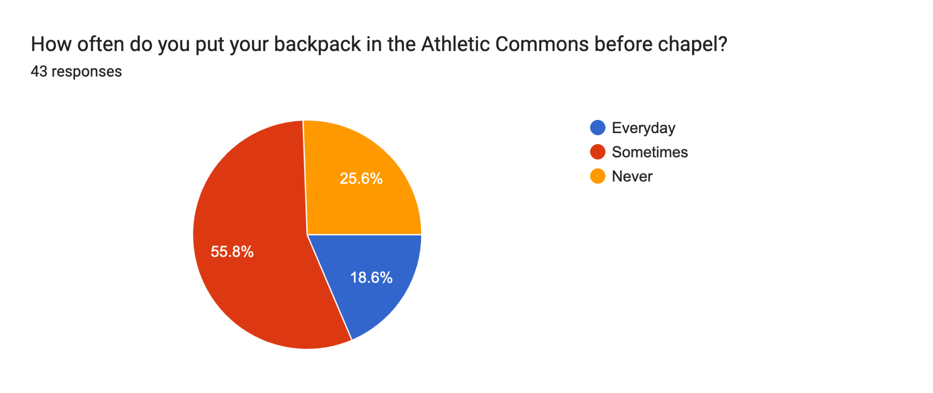
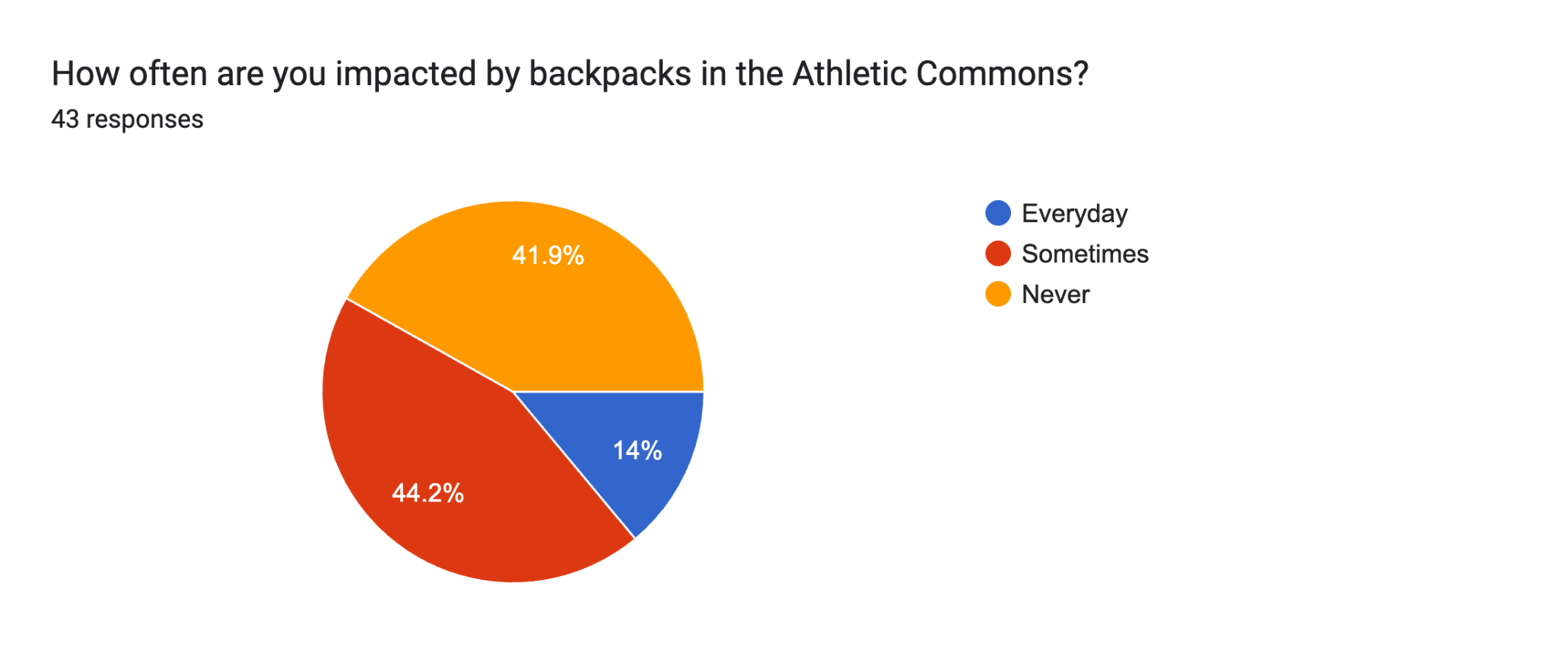
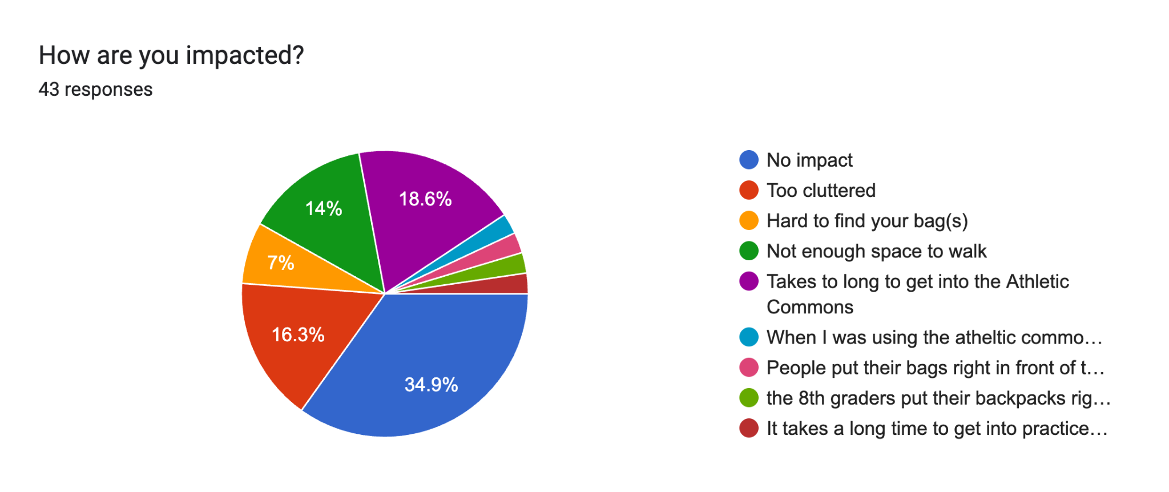
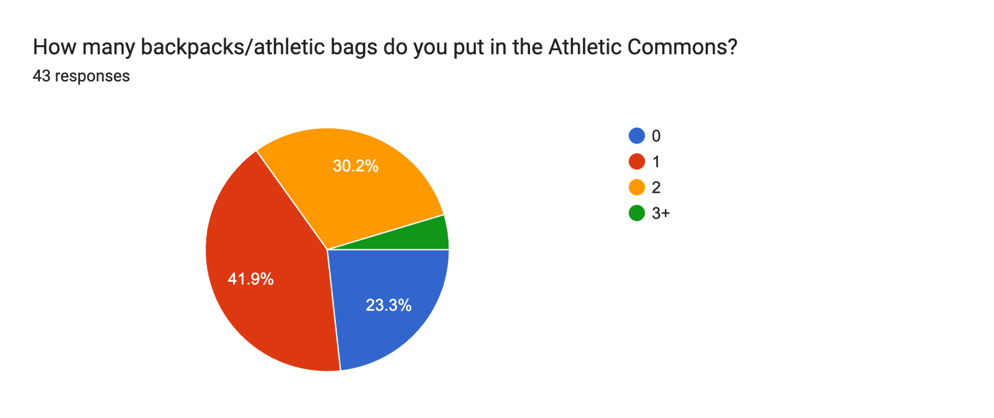

The data shows how many people go through the same problem when it comes to the backpack space in the athletic commons. And we also give free response answers as well. This shows that our solution would have a big impact on fixing and making space for others walking in and out, and fast and easy access to their bookbags. This implies that to take caution and separate upper school and middle school, a lot of people found it annoying how middle school things would get in the way. Vice versa.. So giving a grade a space would help as well.

