Name: _Tedros Redae Logan Lashley ________________________________ Date: ___________________ Class: 1_________________

MyDesign Portfolio
Element I Initial Template
The test number was 2 and the name of the test is firefighter. The priority of the test was medium, because we don’t have the product we need to get, the idea we have ways to have automatic doesn’t need fiscally. In our fire protection project, we conducted physical experiments following rigorous scientific methods. Experimental controls to ensure reliable results, such as room size and the type of materials used. Independent variable the type of fire extinguisher used, dependent variable: The time it took to extinguish the fire. Incremental changes we varied the concentration of each extinguisher by increasing the concentration to see trends. Multiple tests each variable increment was tested at least three times for statistical reliability. Data plotting the results were plotted using scatter plots to obtain continuous data, ensuring clear visualization of trends. Error recording was aware of both random and systematic errors, which improved the accuracy of our findings.
The project we build was entirely out of 8x12 card board using a box cutter and scissors and we start by measuring the with a plastic ruler with a length of 12 inches and a width 8 inch and cut it out with a box cutter this base should be big enough for it to fit two rooms. Based on our testing data, we found that using an 8x12 inch cardboard base means the design’s success hinges on precise measurement and cutting because it ensures the base can accommodate two rooms efficiently.
The first test was drawing the design.
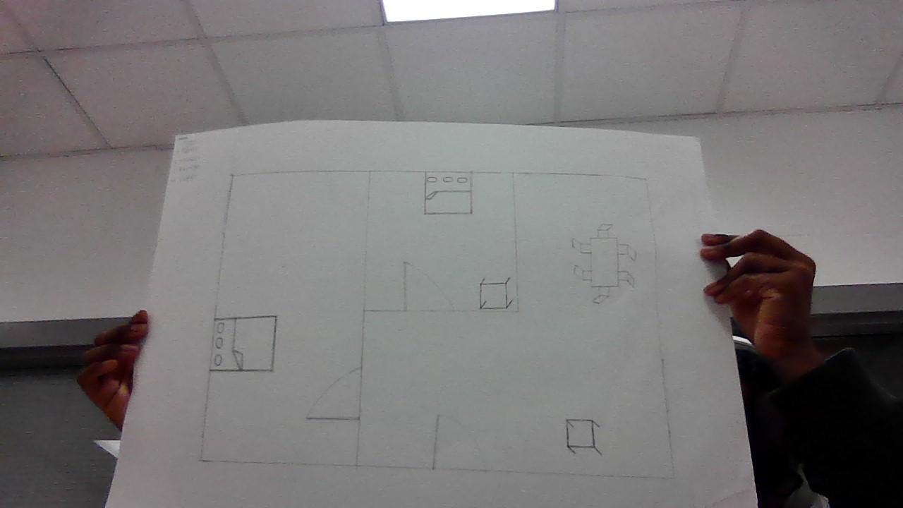
Cut the cardboard Cutting the cardboard 8x12 inch
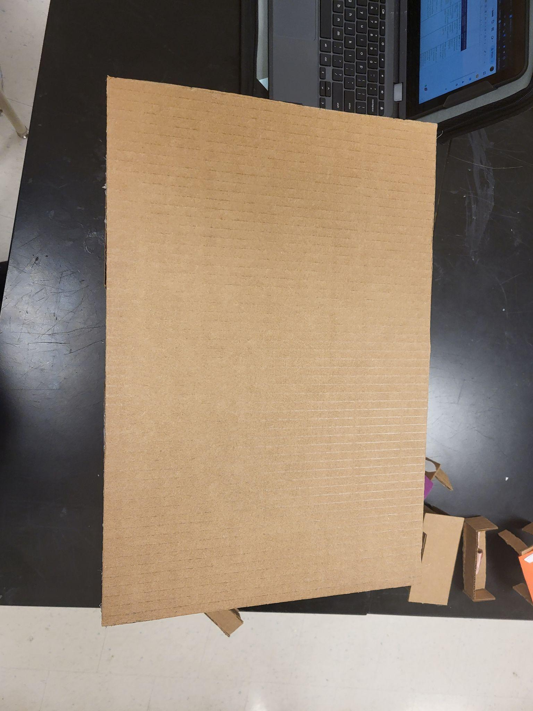
Build the house and cover the roof.
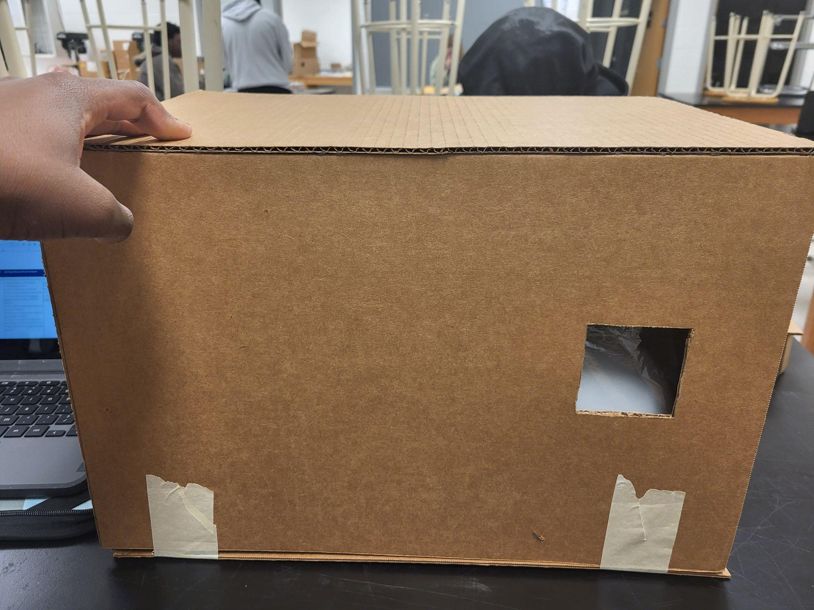
The priority of the test was very important and it works wall
Summary of the testing data: A lot of the house was tearing due to the first test being unsuccessful. Luckily the fire was put out before the fire spread.
Verbal Summary:
The goal of the project is to enhance awareness of fire hazards, improve safety measures, and educate on effective response strategies in case of a fire emergency.

