MyDesign Portfolio
Element I Initial Template

How to use this template
- number and name of the test (as referenced in Element H) 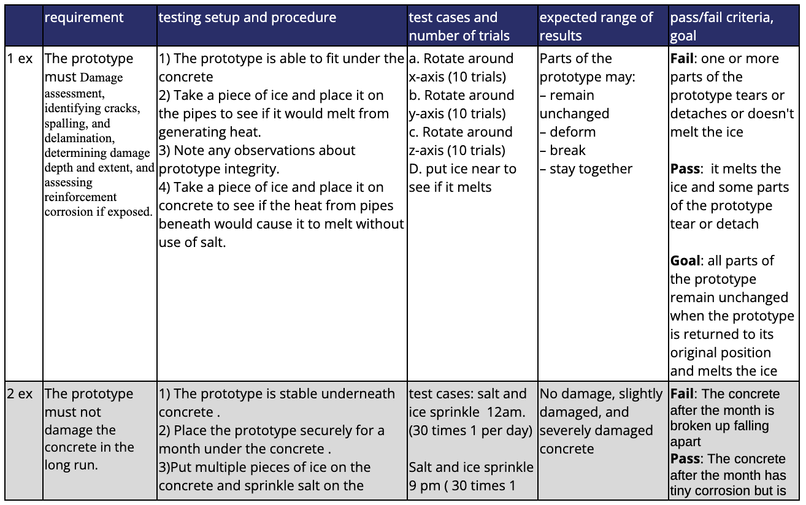
- indication of whether the test is high, medium, or low priority based on your requirements (as reference in Element C) The test is a high priority test based on our requirements in Element C.
- for physical tests, include an explanation of your process and the full set of raw data such that the following best practices for scientific testing and mathematical modeling will be evident:
  - creating experimental controls
  - defining independent and dependent variables
  - only changing one variable at a time and changing it in increments to find a trend
  - collecting at least FIVE trials for each variable increment
  - plotting data appropriately (e.g. scatter plot with trendline for continuous variables, bar charts/histogram for non-continuous variables, acknowledging and recording error as appropriate, and labeling random and systematic errors).
- summary of your data with appropriate charts, graphics, spreadsheets, etc., drawing on best practices in science and math for data display and analysis
- statement of what the data means and a summary of the implications of the data you collected
  - “Based on our testing data, we found that the increase in heat used to melt the ice means the design's success will have a better chance at succeeding because it will be able to melt the ice on the concrete without damaging the concrete.”
- discussions about each implication from the summary of your data
- next steps for your design and process from the new information from the test that was conducted

