Examples of testing Part I
Tests
1)
Swab tests from different feminine product disposals

Swab number | Amount of bacteria
Og bathroom design | In progress
Our bathroom design | In progress

2) Survey of senior class for experience in a bathroom
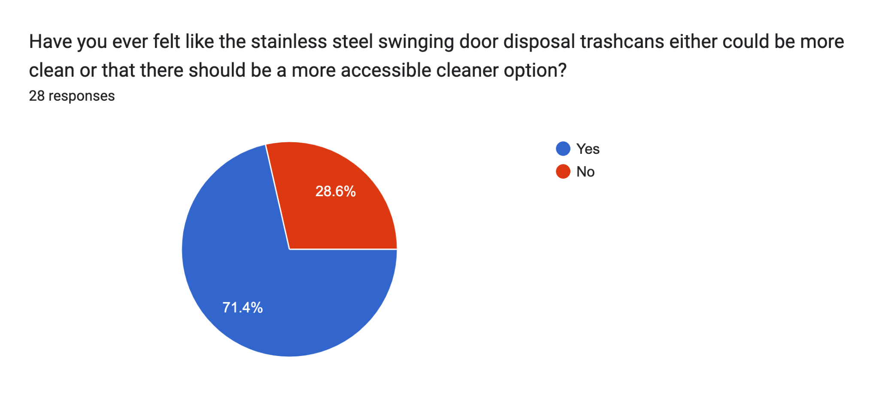
74 percent of the senior class say they feel that the stainless steel trashcans could be more clean or there should be a cleaner more accessible option.

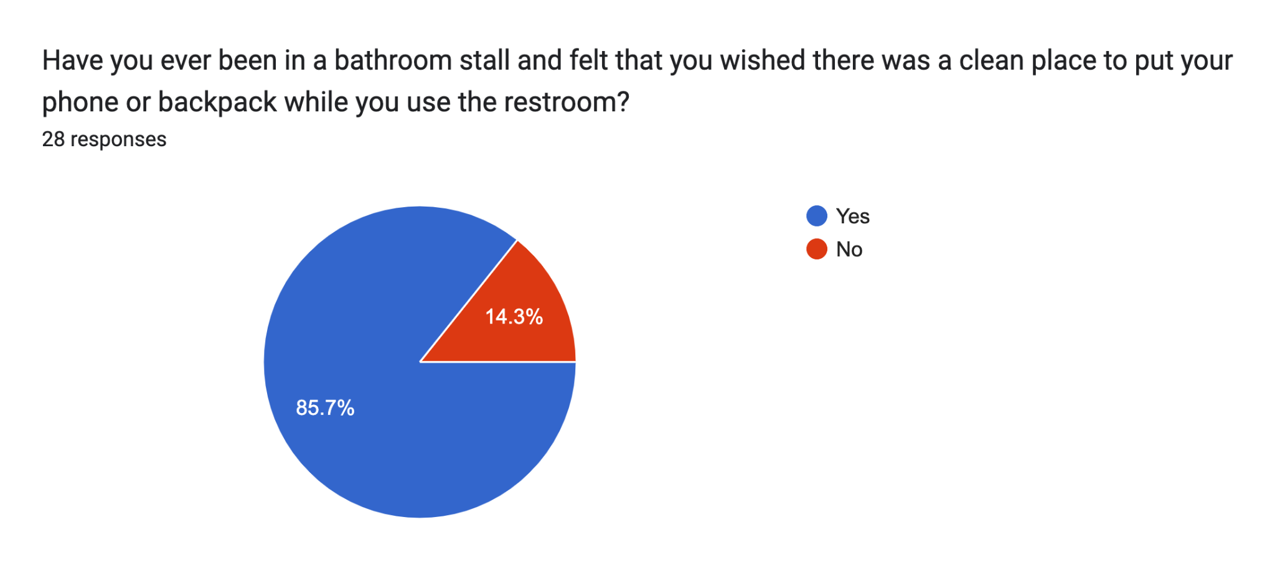
85.7 percent of the senior class feels like they wished there was a clean place to put their belongings in the stall.
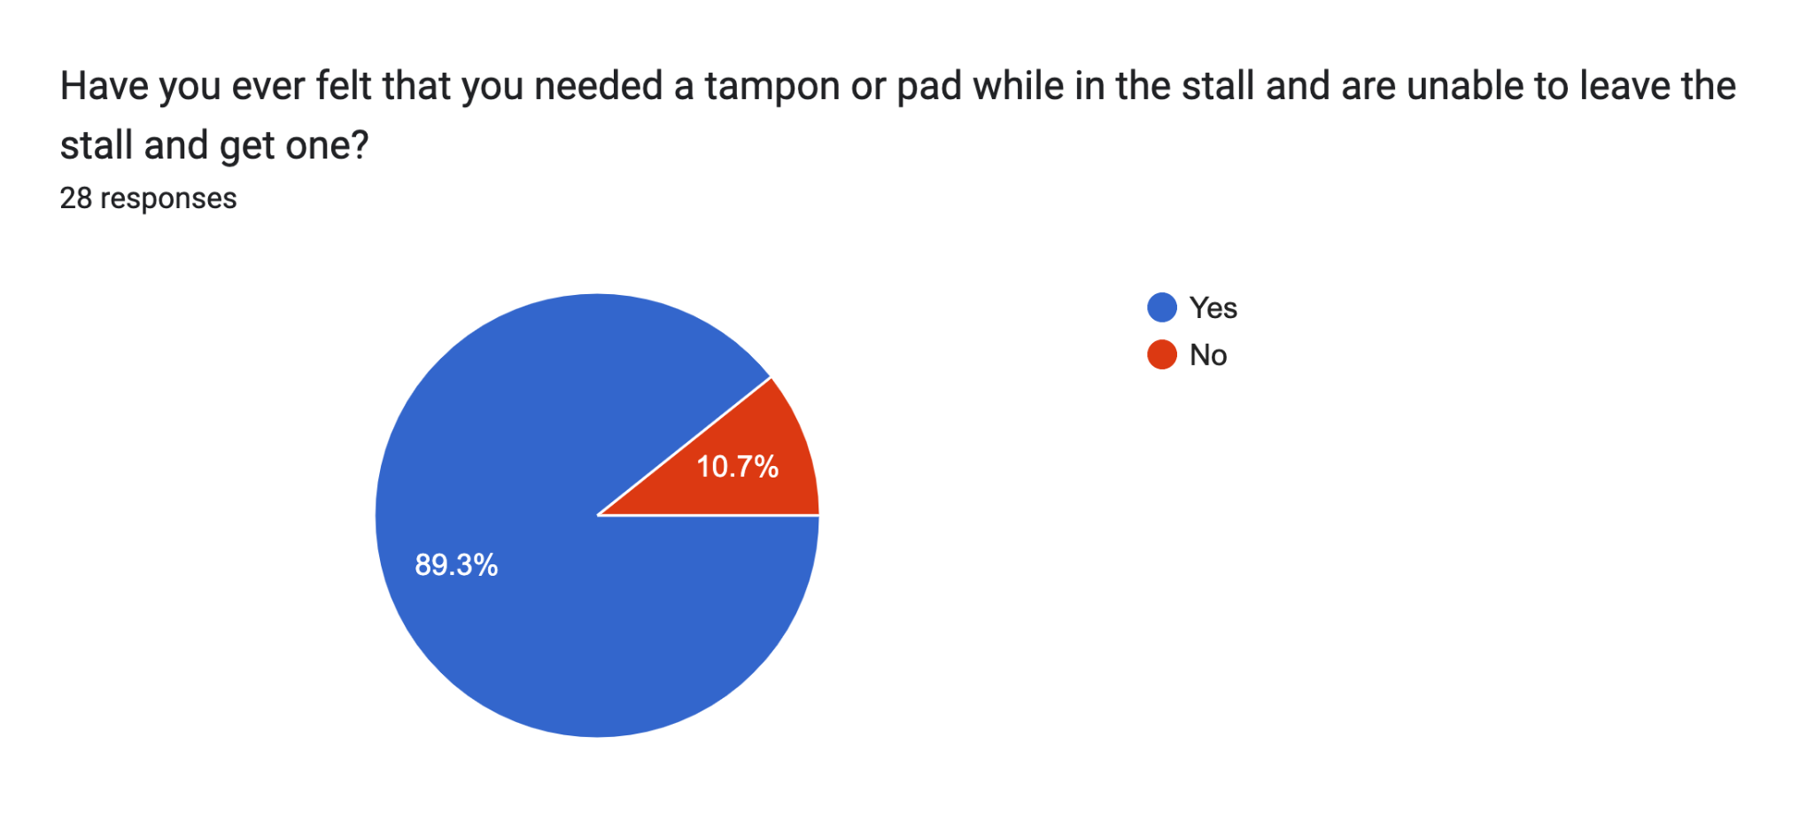
89.3 percent of the senior class says they have been in the bathroom stall and were unaware they would need a feminine product and then could not leave the stall to go get one.
Some quotes from the senior class expressing distaste for the bathroom stall disposal trashcans include, “the dinky lil plastic trash holders in the bathroom for tampon/pad disposal. IDK how we could efficiently and cheaply fix that, but it’s the nastiest thing to me”
“Bathrooms are freaking gross I don’t like the tampon trash can ”

3) Phone sizes

iPhone sizes | inches
iPhone 15 Pro max | 6.69 X 3.08
iPhone 15 pro | 5.77 X 2.78
iPhone 15 Plus | 6.33 X 3.06
iPhone 15 | 5.81 x 2.82
Samsung galaxy Z fold | 7.6 unfolded

