I
- The New Uniform Keeps Gps summer uniform Traditions(Design requirement #1)
- Test is high priority
- Get the traditional gps summer uniform and set it down beside the new gps summer uniform prototype, and see what qualities are shown in both uniforms.
  - Get traditional gps summer dress
  - Get gps summer uniform prototype
  - Set them beside each other
  - Compare each quality that they have in common/similar
  - Write down each quality that the new uniform prototype keeps.
  - Write down each quality that the new uniform replicates.
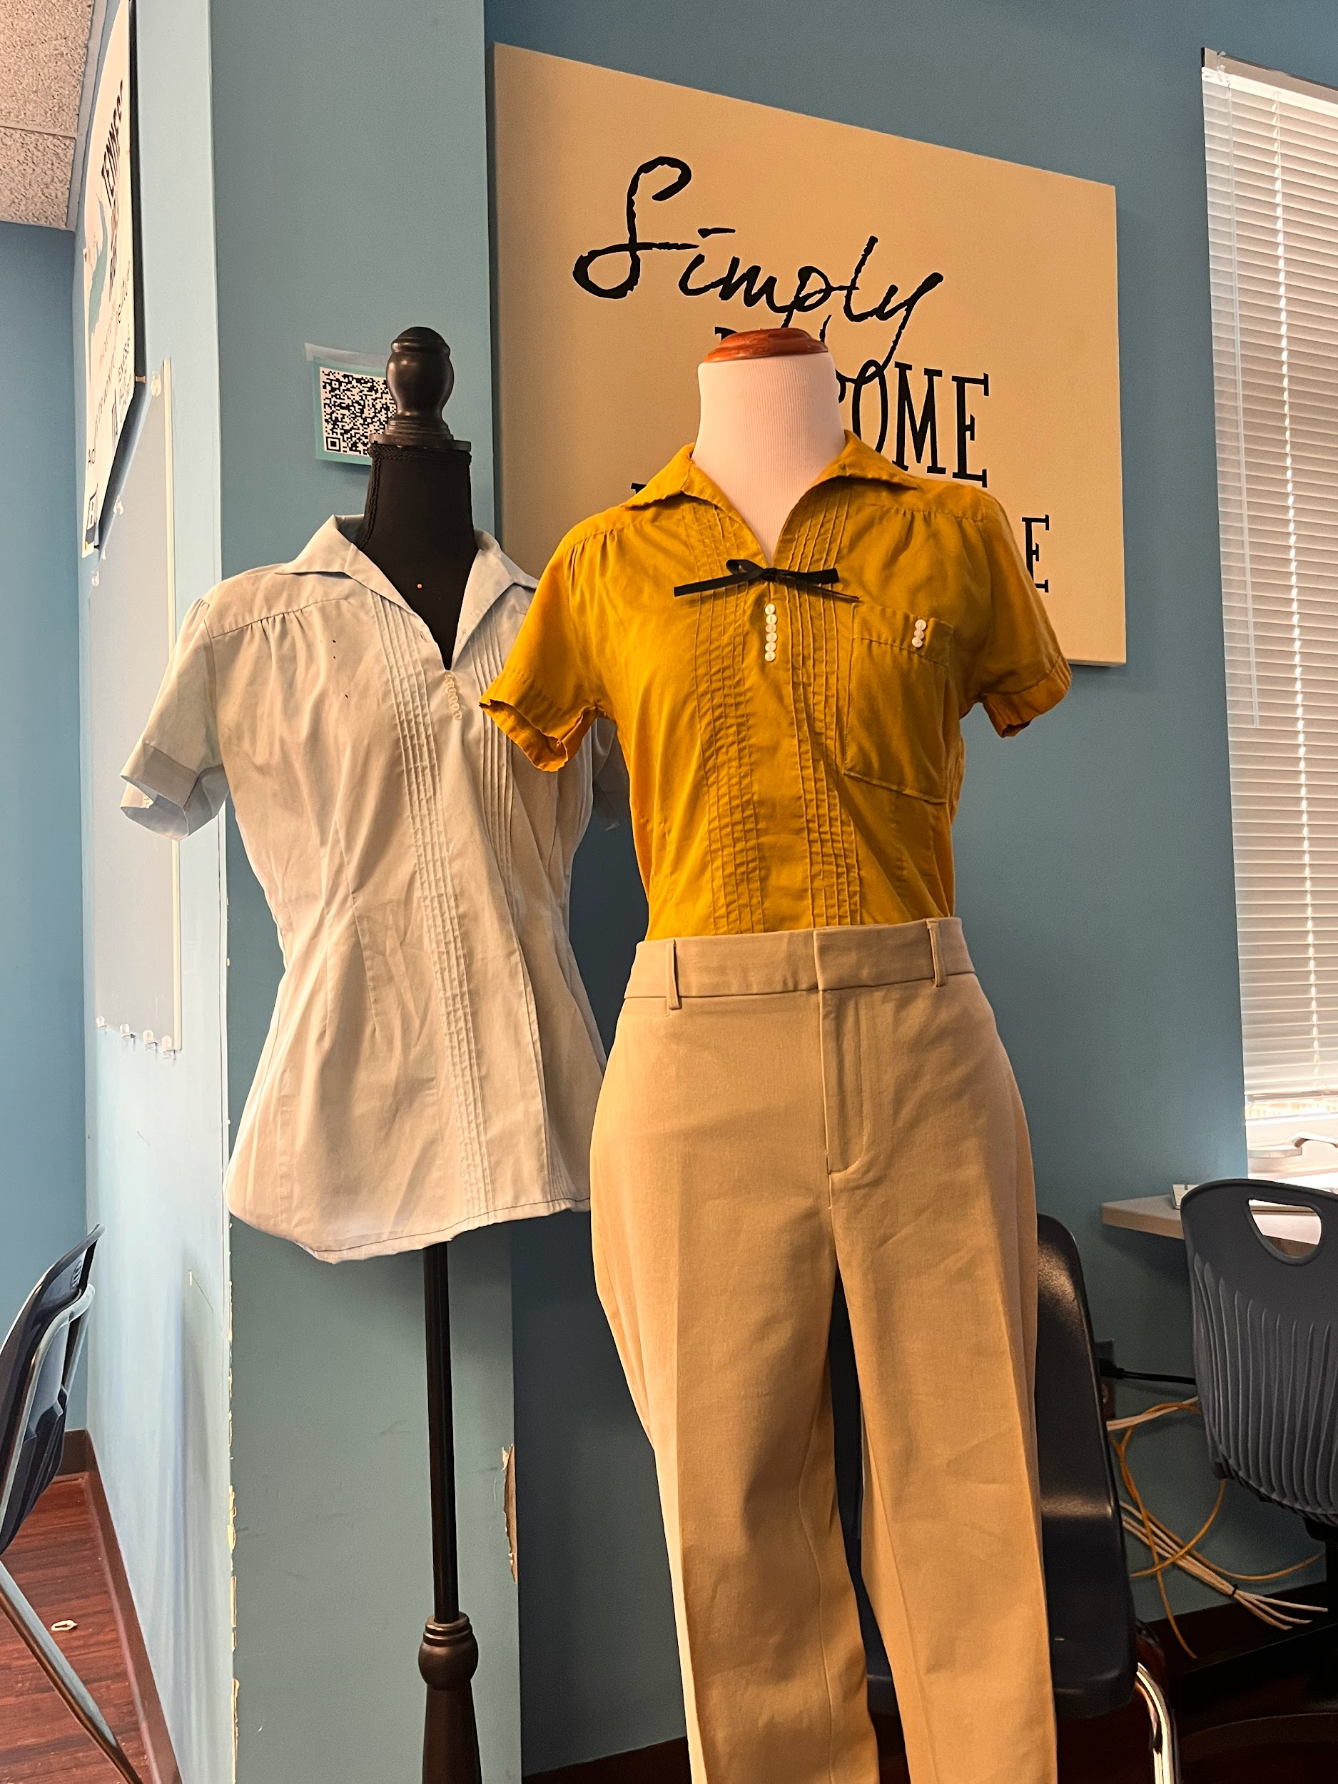
- The new uniform prototype has many of the same traditional qualities as the traditional summer uniform.
- Based on our testing, we found that the new uniform keeps qualities like, the belt, bow, pockets, and resembles a very similar look as the traditional uniform.
- The new uniform keeps the same pocket, belt, and bow just like the traditional uniform.
- Next step in the process would be to present the slideshow to the head of school.
- The new Uniform gets approved(Design requirement #2)
- Test is high priority
- Present slideshow to head of school and faculty, and get the new uniform approved.
  - Get a meeting scheduled
  - Get gps summer uniform prototype
  - Present our ideas
  - Get uniform approved
Presentation Link

- This slideshow shows why a new uniform option is needed.
- This data shows us if the new uniform is going to be finalized or not.
- discussions about each implication from the summary of your data
- The next steps for our design would be to get a professional uniform made at Kameels.

