MyDesign Portfolio
Element B Initial Template

How to use this template
Teachers: You may customize this document before providing it to students.
Students: The template below is one way to structure your research findings around past and current attempts to solve the problem, but the specific assignment given by your instructor may require a different structure or dictate different details. If you make a copy of this template to edit for your own research into prior design attempts, be sure to delete the instructions.

Element B: Documentation and Analysis of Prior Design Attempts

Prior Design Attempt #1 - <insert name of prior design attempt #1>
Source: https://www.trugreen.com/lawn-care-101/blog/lawn-care-tips/reviving-dead-grass
Image: 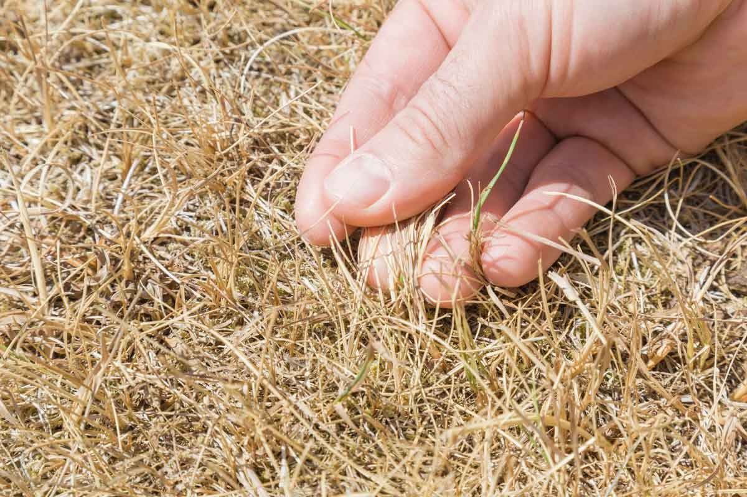

Details
Getting rid of the old grass and then putting down a fresh layer of fertilizer over the space would do wonders for not just the growth of the grass but the ecosystem as well
Analysis
The fertilizer could contain harmful preservatives, pesticides, and chemicals that greatly harm the soil and not allow grass to grow back.

Prior Design Attempt #2 - <insert name of prior design attempt #2>
Source Step-by-Step Guide on How to Fix Dead Spots in Lawn - Stauffers of Kissel Hill
Image
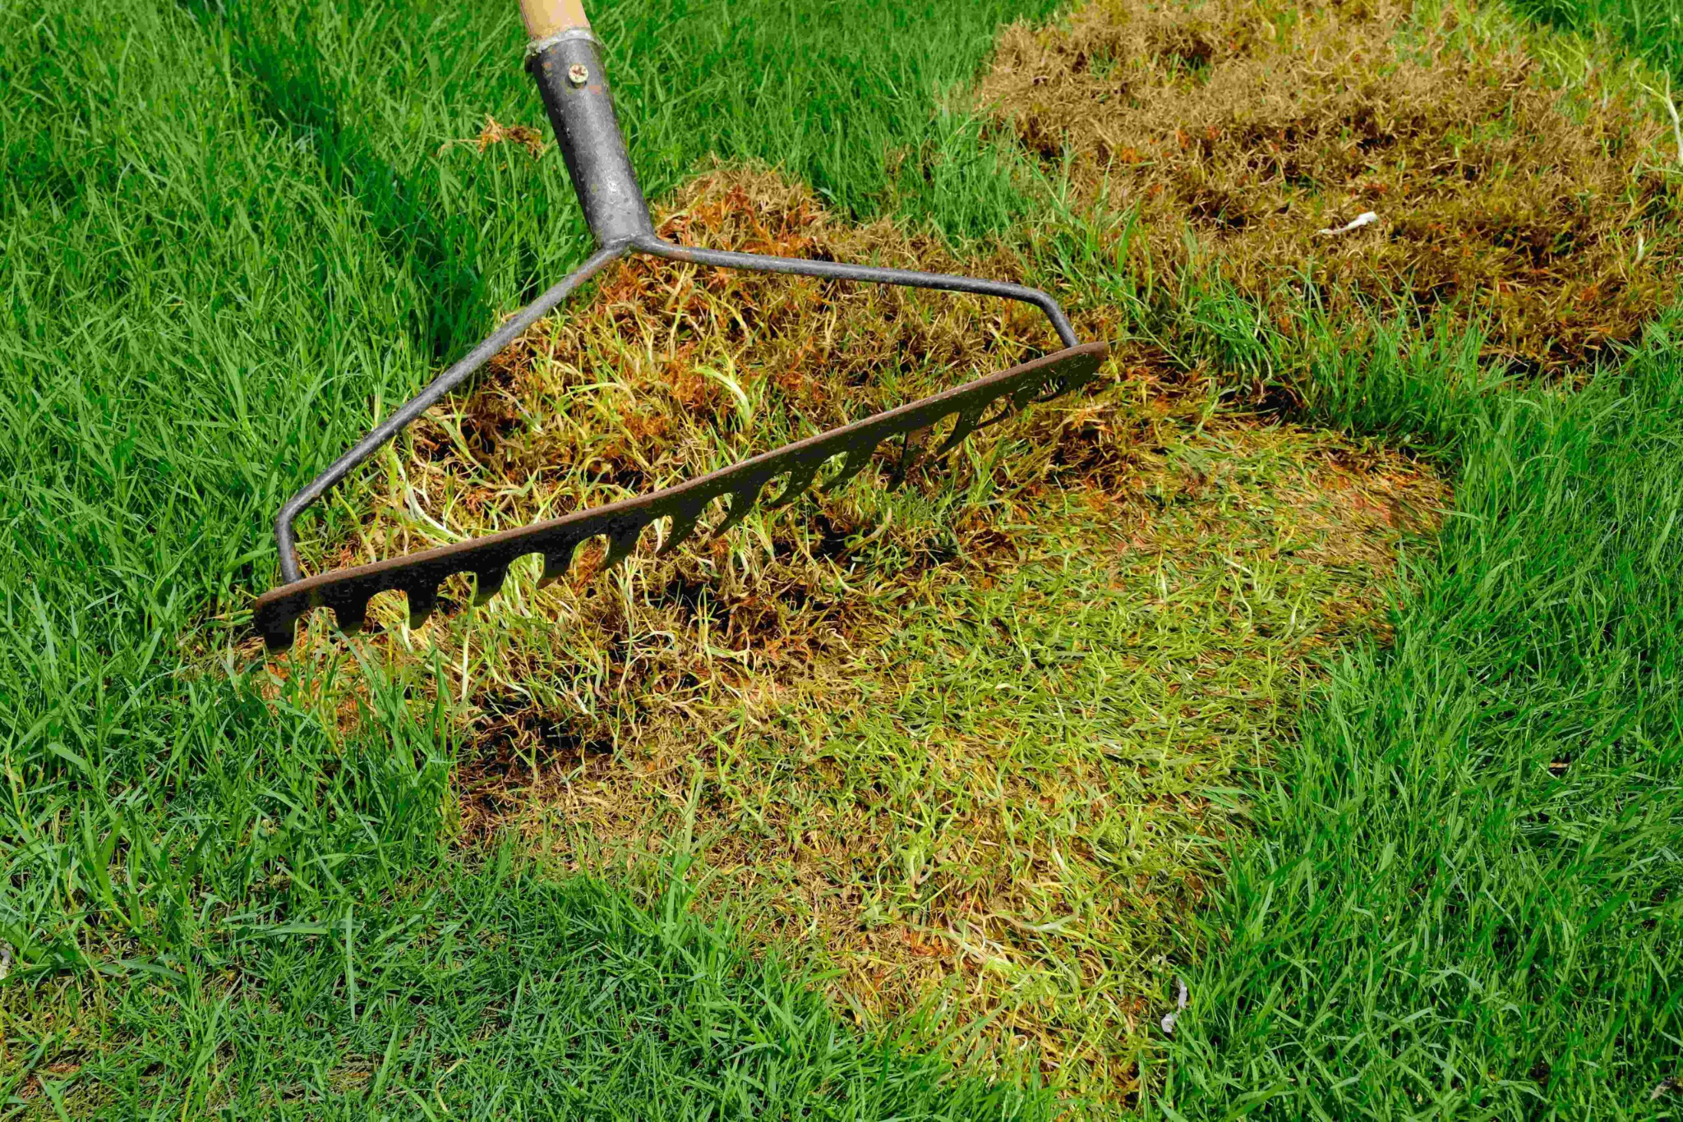
Details
Raking off dead grass is the first thing that should be done when discovering this problem. This will allow new grass to replace this area which will help create a better environment for native organisms and people.

Analysis
A flaw that takes part of the rake process is it can rip off the healthy soil that could be helpful for the new grass that would be grown.

Prior Design Attempt #3 - <insert name of prior design attempt #3>
Source How to Fix Dead Grass Areas: What to Do (and What NOT to Do)
Image
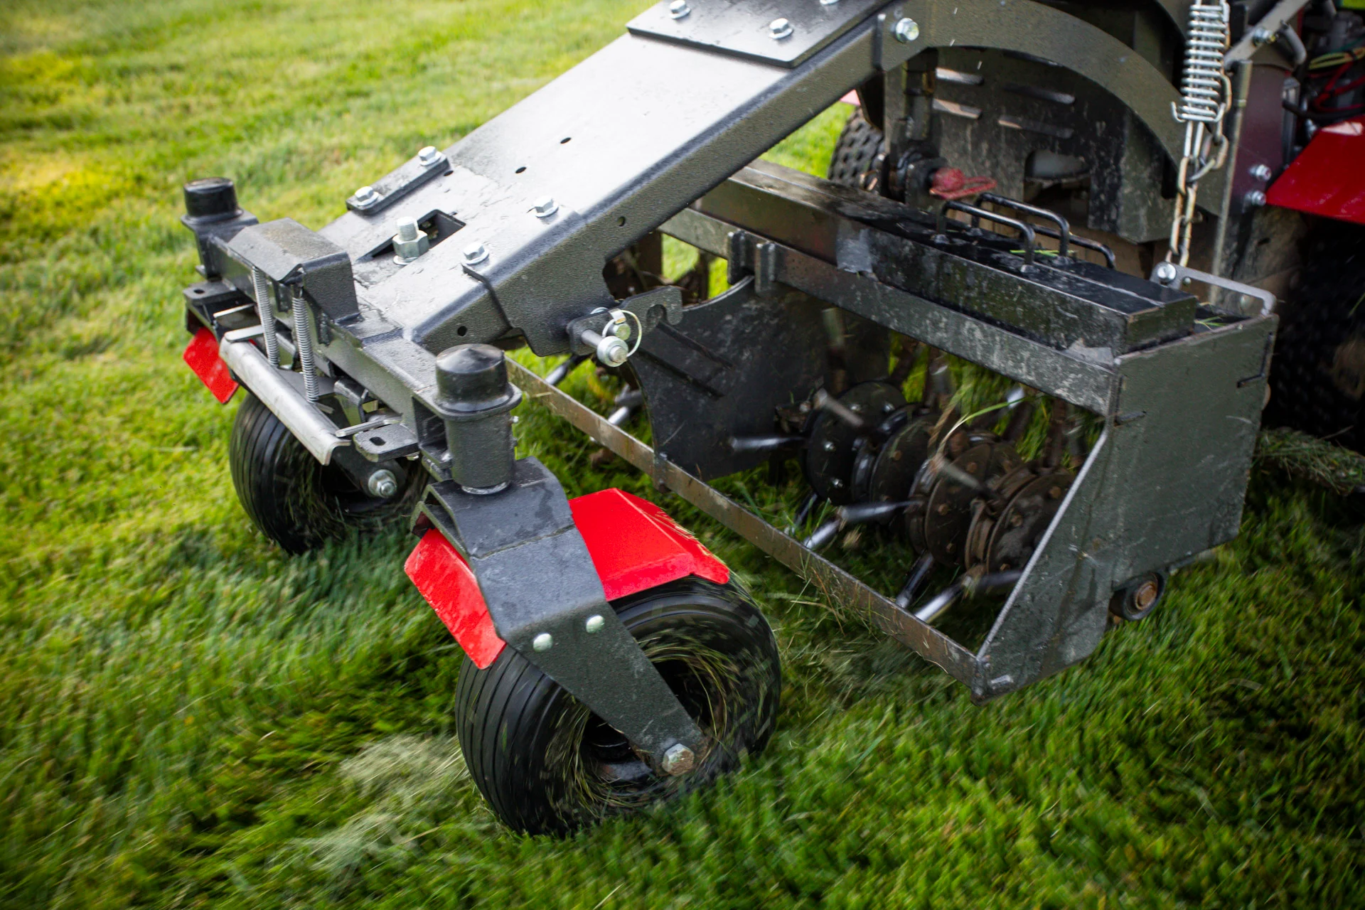
Details
Lawnmowing can make removing grass easier that would prevent any debris from being pulled out of the ground.
Analysis
The constraint is the limitation, how long the lawnmower will be able to last when cutting a large field of dead grass. Also even clogging up when trying to cut really thick grass.

Prior Design Attempt #4 - <insert name of prior design attempt #4>
Source: https://trysodpods.com/blogs/inspire/how-to-repair-patches-of-dead-grass-with-grass-plugs
Image: 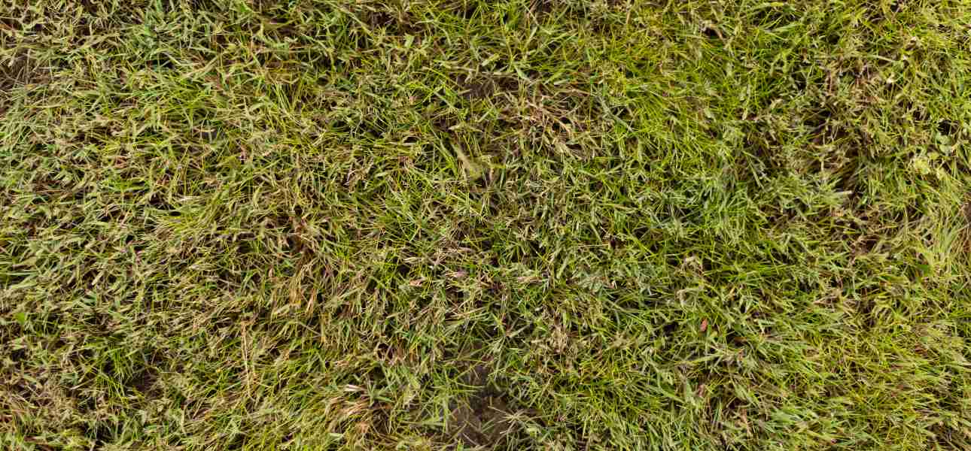
Details
There are variations of having this issue (dead grass). For example dog urine, other animal urine, waste, and etc. Using grass plugs is one way of treating dead grass.
Analysis
With using this method, grass plugs aren’t the most effective because it is #1 more costly (especially if you are repair bigger areas) and #2 doing certain grass treatments just for the plugs to work. With that, the lasting grass that isn’t dry and patchy might be affected with the grass treatments used for the grass plugs.

Prior Design Attempt #5 - <insert name of prior design attempt #5>
Source
Image:
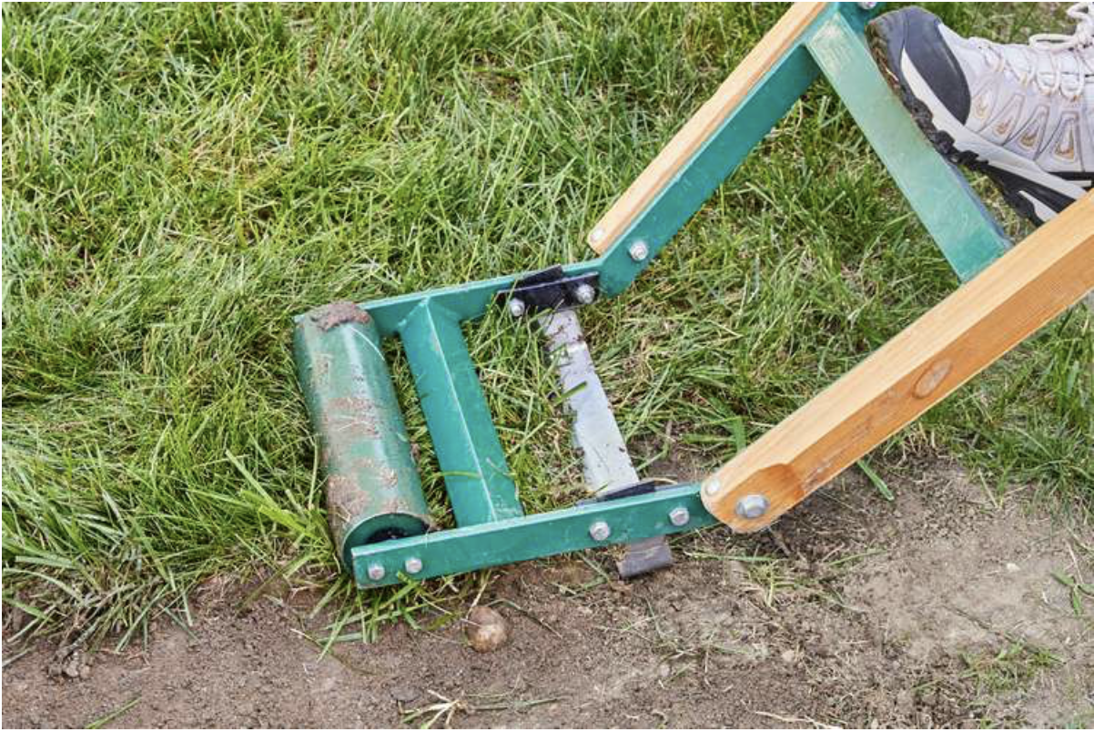
https://www.thespruce.com/sod-cutting-tool-for-new-seeding-2153074

Details: Turf removal involves taking out existing grass to replace it with something else, reducing water use, or making landscapes more sustainable and low-maintenance.
Analysis: Physical turf removal is considered the fastest way to remove the sod by cutting it into stripes with a sod cutter,rolling the strips up, and either taking them away or turning them over, allowing them to compost in place.

According to https://neograss.co.uk/18-artificial-grass-installation-mistakes-and-how-to-solve-them/#:~:text=Mistake%202:%20Failure%20to%20excavate,growing%20through%20your%20fake%20lawn. The design often stems from poor planning, improper installation techniques, and overlooking long term environmental factors like rainfall. And failing to remove existing roots or not installing a proper weed barrier that leads to regrowth.

