MyDesign Portfolio
Element B Initial Template

How to use this template
Teachers: You may customize this document before providing it to students.
Students: The template below is one way to structure your research findings around past and current attempts to solve the problem, but the specific assignment given by your instructor may require a different structure or dictate different details. If you make a copy of this template to edit for your own research into prior design attempts, be sure to delete the instructions.

Element B: Documentation and Analysis of Prior Design Attempts

Prior Design Attempt #1 - <Smart Juicer>
Source
State the source of the information about this prior design attempt, which should be taken from any of the following credible source categories: peer-reviewed journals (check out your public library for free digital access to journals; here are some free online journals and research databases), professional organizations, government agencies, local and national newspapers, patents (here is a patent search site for the United States Patent and Trademark Office), and reputable vendors and manufacturers. Make sure to incorporate in-text citations in the details section below (i.e. don't just give a list at the end of the element or footnote).
Image

Details
The Juicero was a Wifi connected juicer that used pre-packaged fruit and vegetable pouches. It was designed to make juicing easier, cleaner, and more modern. Users had to buy the expensive juice packs.
The design failed because it did not meet the requirement of cost or necessity. Bloomberg demonstrated that the juice packs could be squeezed by hand, meaning the machine did nothing unique. The design did not truly solve a problem better than the existing methods (Bloomberg, 2017).
Prior Design Attempt #2 - <Segway Transporter>
Source
State the source of the information about this prior design attempt, which should be taken from any of the following credible source categories: peer-reviewed journals (check out your public library for free digital access to journals; here are some free online journals and research databases), professional organizations, government agencies, local and national newspapers, patents (here is a patent search site for the United States Patent and Trademark Office), and reputable vendors and manufacturers. Make sure to incorporate in-text citations in the details section below (i.e. don't just give a list at the end of the element or footnote).
Image
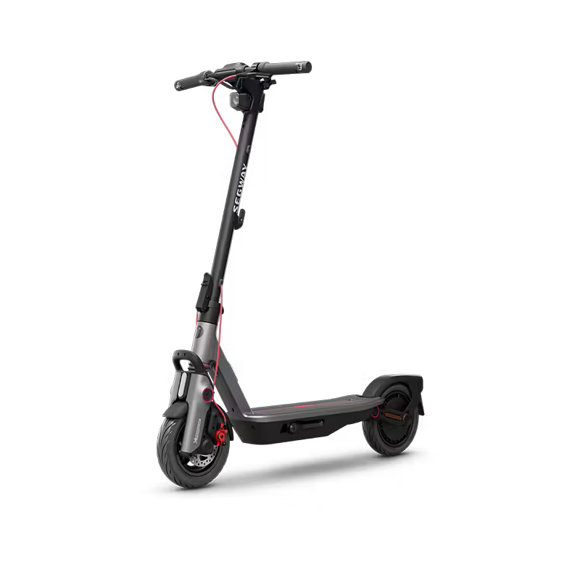
Details
The Segway was a self-balancing electric scooter meant to revolutionize personal transportation in cities. It was designed to be fast, efficient, and environmentally friendly. Many believed it would replace cars.
The Segway failed because it did not meet the design requirements of practicality and social acceptance. It was expensive, difficult to store, and not allowed in many public spaces. As a result, it did not become a common transportation solution (Smithsonian).
Prior Design Attempt #3 - <Google Glass>
Source
State the source of the information about this prior design attempt, which should be taken from any of the following credible source categories: peer-reviewed journals (check out your public library for free digital access to journals; here are some free online journals and research databases), professional organizations, government agencies, local and national newspapers, patents (here is a patent search site for the United States Patent and Trademark Office), and reputable vendors and manufacturers. Make sure to incorporate in-text citations in the details section below (i.e. don't just give a list at the end of the element or footnote).
Image
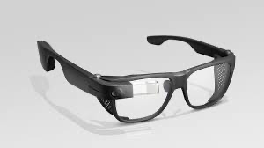
Details
Google Glass was a wearable headset that displayed digital information in the user’s vision. It was intended to give instant access to data, messages and photos without using a phone.

The product failed because it did not meet privacy and social comfort requirements. People were concerned about being recorded without consent. Users wearing Glass were sometimes banned from places or socially rejected. The design ignored public acceptance and privacy concerns, which led to poor adoption (BBC).

Provide evidence and explain what parts of this prior design attempt were unsuccessful at solving the defined problem and why based on design requirements.

Prior Design Attempt #4 - <Samsung Galaxy Note 3>
Source
State the source of the information about this prior design attempt, which should be taken from any of the following credible source categories: peer-reviewed journals (check out your public library for free digital access to journals; here are some free online journals and research databases), professional organizations, government agencies, local and national newspapers, patents (here is a patent search site for the United States Patent and Trademark Office), and reputable vendors and manufacturers. Make sure to incorporate in-text citations in the details section below (i.e. don't just give a list at the end of the element or footnote).
Image
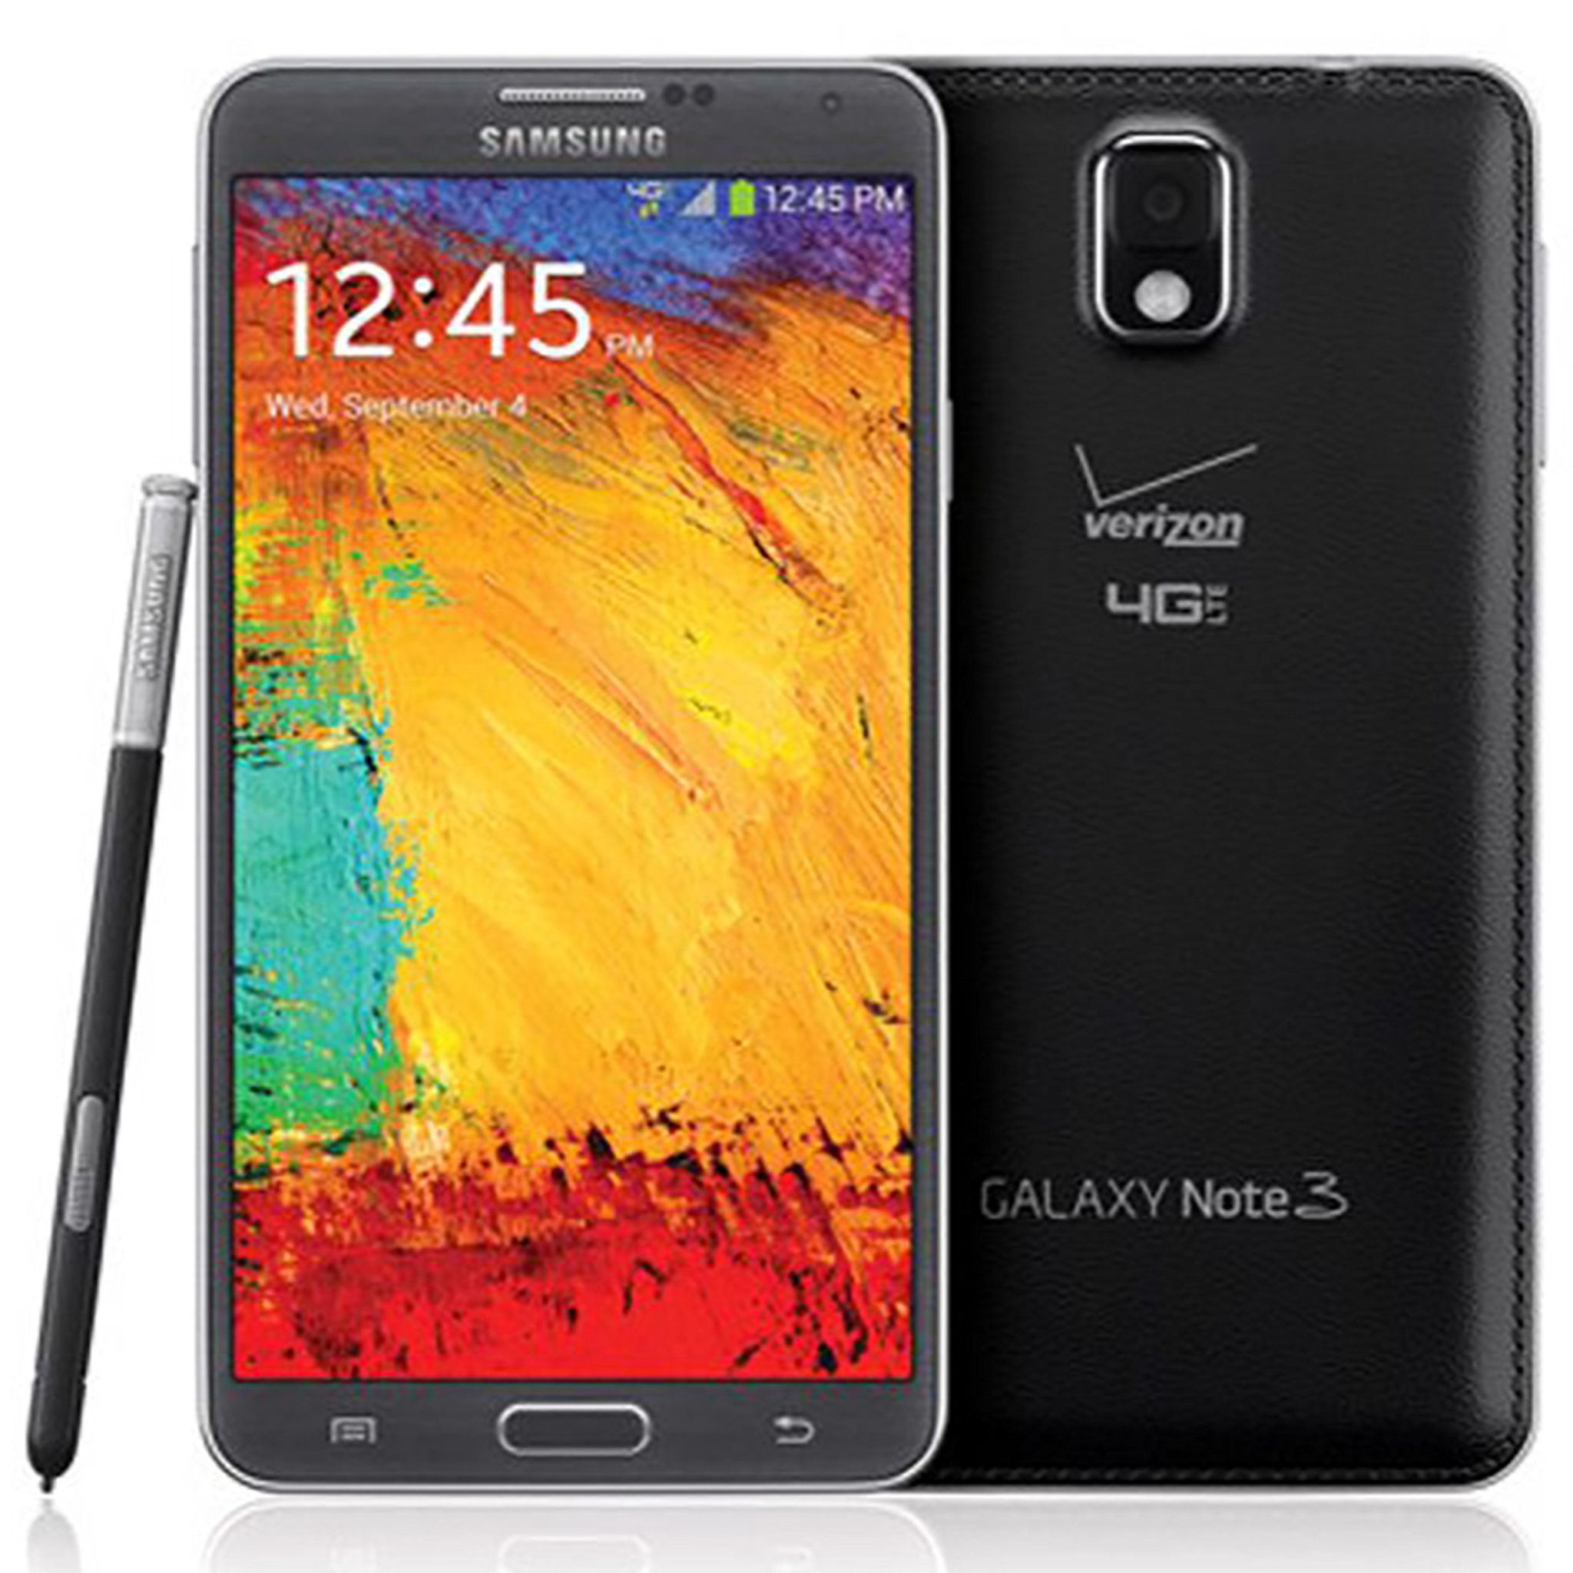.
Details
The Note 7 was a smartphone designed with high performance and a large battery. It aimed to compete with other flagship phones.
Analysis
The phone failed due to battery design flaws that caused overheating and fires. This violated the critical design requirement of safety. The phone was recalled worldwide, showing the design did not adequately consider battery stability (CPSC).

Prior Design Attempt #5 - <Ford Edsel>
Source
State the source of the information about this prior design attempt, which should be taken from any of the following credible source categories: peer-reviewed journals (check out your public library for free digital access to journals; here are some free online journals and research databases), professional organizations, government agencies, local and national newspapers, patents (here is a patent search site for the United States Patent and Trademark Office), and reputable vendors and manufacturers. Make sure to incorporate in-text citations in the details section below (i.e. don't just give a list at the end of the element or footnote).
Image
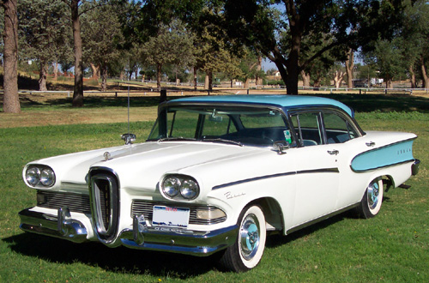.
Details
The Ford Edsel was introduced in the 1950s as a stylish new car model. It was meant to attract a wide range of customers.
Analysis
The Edsel failed because it did not meet the requirement of consumer appeal. Its design looked unusual to buyers, and marketing created unrealistic expectations. Poor sales showed that the product did not match user preferences (Smithsonian).

