Engineering For Us All

Bike Shed- Design Project Submission

Mr Robbins

5/18/2026

Chris Ankley, Brandon Eason, Nikyla Kokx, Michael Ankley

Element A: Presentation and Justification of Problem Homework

Engineering for the Needs of a Community

The problem we encountered for this project was that the auxiliary gym is too cluttered, and because of this clutter, Mr. Campbell’s cross country bike was tragically moved without his knowledge. However, Ralph moved this bike because it caused clutter in a space where there were a lot of moving parts, and it was deemed a safety concern. In a recent article by WebMD, a point of the article made was that “Mess equals stress.” (Brody). To expand upon this topic, it was concluded that because of the mess, it caused Ralph to stress, and so he had to declutter for the safety and room of equipment and people. However, because of this mess, and from Ralph's distress, he moved the bike without a second guess, and in not telling Mr Campbell about this exodus, it caused Campbell to stress because it made his life a mess with a long walk to get his bike through the treacherous outdoor conditions.
Mr. Campbell grew worried because he no longer had a safe and suitable spot to store his bike. Due to this new found issue, we talked to him and we realized that we could solve his problem by creating a shed to store the bike. A bike shed is a suitable place to safely store the bike so that it is out of the way from the clutter in the auxiliary gym and it is protected from being stolen or from being moved again. According to a blog written by David Hilscher, bike sheds can only be locked in one way, so there is “less variation, and ultimately less opportunity for error when they are secured” (Hirscher). Furthermore, in an article by “Cycling Weekly,” bike sheds rank as the best and overall most suitable ways to store a bike. Mr. Campbell was not the only one who had their bike moved. There are also assistants to Coach Cambell who ride their bikes along with the team, and their bikes were also being kept in the auxiliary gym and got moved without their knowledge. Furthermore since the issue of the bikes being falsely stolen and taken to a new place is so important we must take that into account. According to the Bike Theft Statistics in the US (2024) “An average of 175,200 bikes are reported stolen in the United States every year”(The Best Bike Lock), which proves that fact that it is very dangerous to keep a bike unattended, so our task of building a safe place for these cross country bikes is truly important nowadays.
Since there are multiple bikes in play, we should make the shed big enough to hold at least two bikes and tools to repair them if necessary.
Our plan is to design and build a good sized shed to hold at least two bikes and the tools to fix the bikes if it is needed. This shed would prevent clutter in the auxiliary gym and provide shelter and protection for the bikes. The use of the shed would prevent confusion for Coach Campbell due to the location of the bikes, so that he can get straight to work for practices instead of wasting time searching for it. The shed would make Coach Campbell’s, Ralph’s, and the assistant’s lives so much easier, as there would now be a convenient and safe spot to protect their cross country bikes to keep things going faster and simpler. Since the shed would be located outside of the auxiliary gym, the bikes would no longer be cluttering the gym and would not be in danger of being mysteriously moved. The shed is a perfect solution for Mr. Campbell’s issue with the disappearance of his bike and the overall problem of clutter in the auxiliary gym. Bike sheds or rooms have several advantages as well. The article “Top 12 Benefits of Adding Bike Rooms to Multi-Tenant Housing and Campus Living” explains the advantages of having a bike room. These include security, good storage, and accessibility to bike repair stations. The company Deru states, “Incorporating a bike room into multi-tenant housing complexes and campus environments not only addresses practical issues of storage and security but also enhances the overall quality of life by supporting sustainable practices and fostering community engagement.” (Deru)

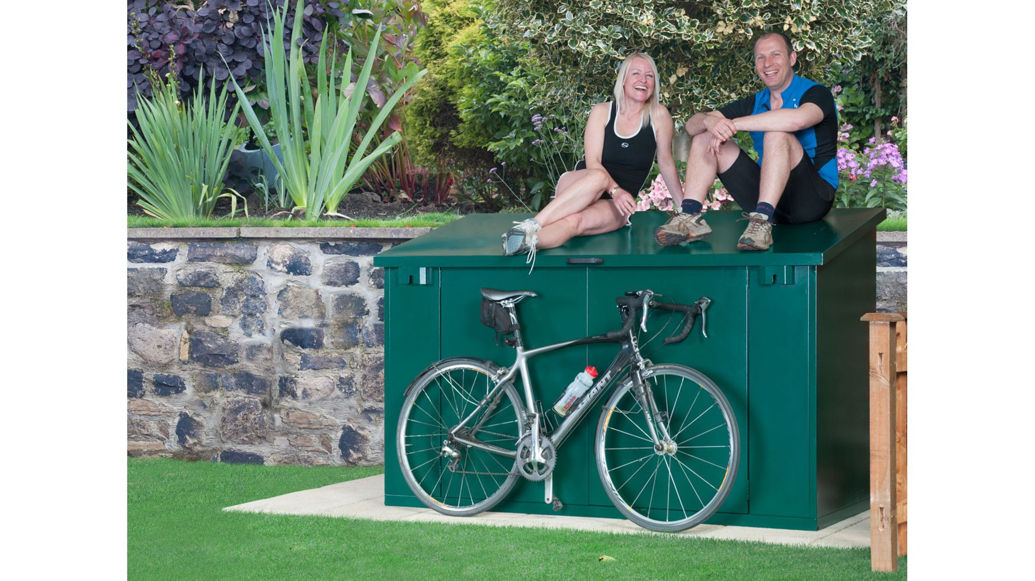

Works Cited

Brody, Barbara. "How Clutter Can Affect Your Health." WebMD, 23 June 2025, www.webmd.com/balance/ss/slideshow-clutter-affects-health. Accessed 7 Jan. 2026.

Hilscher, David. "Bike Lockers vs. Bike Racks | Bike Parking Blog." Reliance Foundry, June 2018, www.reliance-foundry.com/blog/bike-locker-vs-outdoor-bike-rack?srsltid=AfmBOophrfKfpz3ahFTFXMsn4XSDKvuZG-_8zuqy4qI6GHxIOETNgrWX. Accessed 7 Jan. 2026.

Deru. "Top 12 Benefits of Adding Bike Rooms to Multi-Tenant Housing and Campus Living." Top 12 Benefits of Adding Bike Rooms to Multi-Tenant Housing and Campus Living, Deru, 2025. DERU, www.dero.com/tips/top-12-benefits-of-adding-bike-rooms/. Accessed 7 Jan. 2026.

Ischt-Barnard, Matt. "Best Bike Storage Solutions 2025: Hooks, Racks and Sheds for Storage and Security." Cycling Weekly, 21 May 2025, www.cyclingweekly.com/group-tests/bike-storage-a-buyers-guide-326846. Accessed 9 Jan. 2026.
"Bike Theft Statistics in the US (2024)." The Best Bike Lock, 25 Jan. 2024, thebestbikelock.com/bike-theft-statistics-us/. Accessed 9 Jan. 2026.

Element B: Documentation and Analysis of Prior Design Attempt
Chris Ankley, Brandon Eason, Nikyla Kokx, and Michael Ankley

Mr Robbins, January 12th 2026

Homework 14, Documentation and Analysis of Prior Design Attempt

Prior Design Attempt #1: Bike Wardrobe 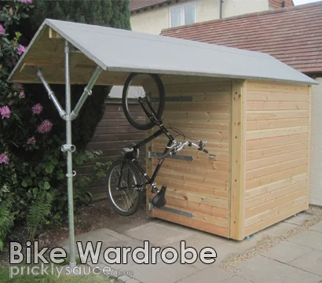
https://www.instructables.com/Bike-Shed/

This bike shed includes an indoor and outdoor bike storage rack made with high quality materials such as hardwood and metal scaffold poles. It features a large door and a long bar for stowed bikes to slide along. This feature makes it easy to store bikes and take them out. Bikes are stored by hanging the front wheel on a slidable hook resting on the metal bar.

During the first stages of creating this design, the designer tested several different methods of storing the bikes. Most of these methods, including basic bike racks and resting the bikes on the ground, failed because the space made it difficult to take different bikes out. The designer figured out that the best solution to this problem was a bar like you would find in a closet (wardrobe). The bikes could be stored on hangers and slide around like clothing in a wardrobe. While this bike shed was excellently made, one of the flaws, and it could be personal preference but this shed is very large and takes up a lot of space. This is something that in our design, we will have to build our shed in a limited amount of space, creating a good shed, but not taking up that much space.

Prior Design Attempt #2: Honey and Eggs Bike Shelter

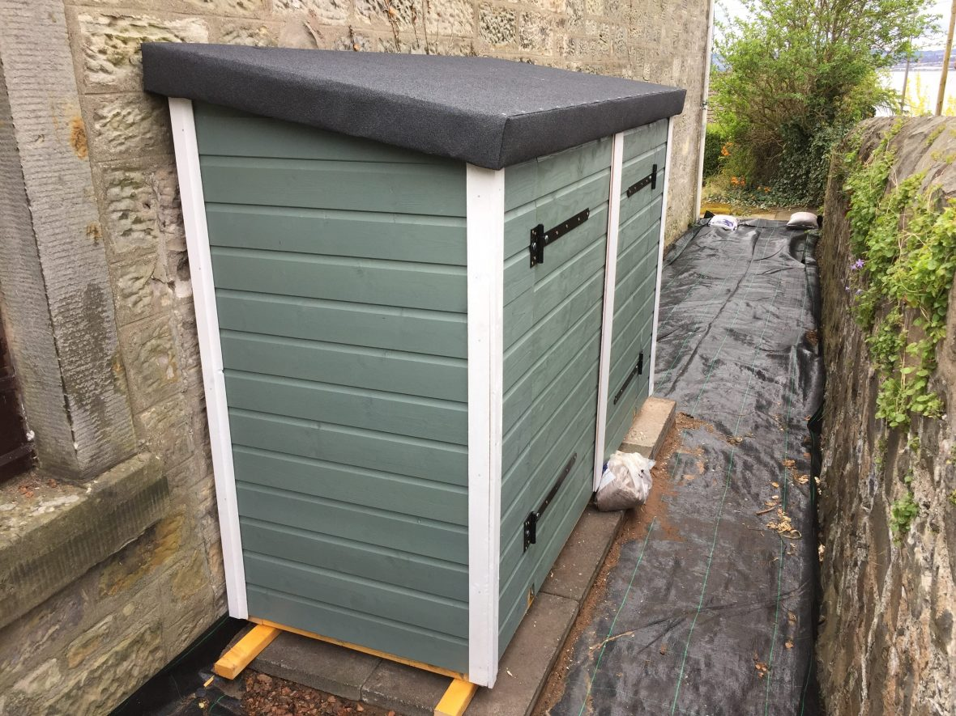
https://honeyandeggs.co.uk/designing-and-building-a-bike-shed/

This design pictures a silm and compact version of the bike shed which would be better for space issues when compared to the previous version above. To better protect itself from the weather and rough conditions, the designer put a protective covering on the wood to prevent corrosion. The shed is elevated from the ground so that nothing can get inside and rot it.

However due to its small shape and compactness it fails to give a more accessible opening point to place the bike inside. Although it is slim inside it does not have enough room for other things such as tools and other supplies. A better improvement could be to have the shed open from the front having doors there. That way you can place the bike easier and store things as well on the doors and inside.

Element C: Solution and Design Requirements
Shed design requirements
- Design Requirement #1 (HIGH Priority)
  - The bike shed must be able to fit at least 3 bikes.
  - This requirement ties into our previous research because it allows us to visualise how big the shed needs to be.
- After running through the options with the primary stakeholder, he agreed that at least 3 bikes should be able to fit in the shed and be hung up.

- Design Requirement #2 (HIGH Priority)
  - The shed cannot be any bigger than 80 inches by 45 inches by 10 feet.
  - A size like this would prevent clutter as we researched since that was one of the reasons we decided to build this.
- Our stakeholder agreed that this is a good size to fit the bikes and all other necessities for the shed.

- Design Requirement #3 (HIGH Priority)
  - The shed should be school colors (green roof or something like that).
  - It does not necessarily relate to our research but it is one of the details Mr. Campbell mentioned
- Our stakeholder seconded this idea because it will help create a sense of continuity across the buildings around the school property.

- Design Requirement #4 (HIGH Priority)
  - The Shed should have the ability to be locked if deemed necessary
  - This requirement ties into our previous research because it helps provide safety and protection for the bikes from being moved or stolen
- After talking with the stakeholder, he agreed that having a lock on the shed would be a good idea to protect the bikes if it is not already protected by a gate to the surrounding area

- Design Requirement #6 (LOW Priority)
  - A light bulb inside the shed
  - It does not necessarily relate to our research but it is one of the details Mr. Campbell mentioned
- After speaking with Mr. Campbell, he thought it may be a decent idea to have to have a better view of the bikes during night times, but it is not a huge issue as there is always access to natural light and phone lighting

- Design Requirement #7 (LOW Priority)
  - Dedication to the builders
  - It does not necessarily relate to our research but it is one of the details Mr. Campbell mentioned
- When we spoke to Mr. Campbell explained that he would want a photo or something along that line with the four of us so that he could remember our hard work and accomplishments.

Element D: Design Generation and Analysis

Homework 16 (Design Generation and Analysis)

Jan 15 2026 - Mr Robbins

Chris Ankley, MIchael Ankley, Brandon Eason, Nikyla Kokx

Design Blueprint #1

Date: 1/15/2026

Sketch: 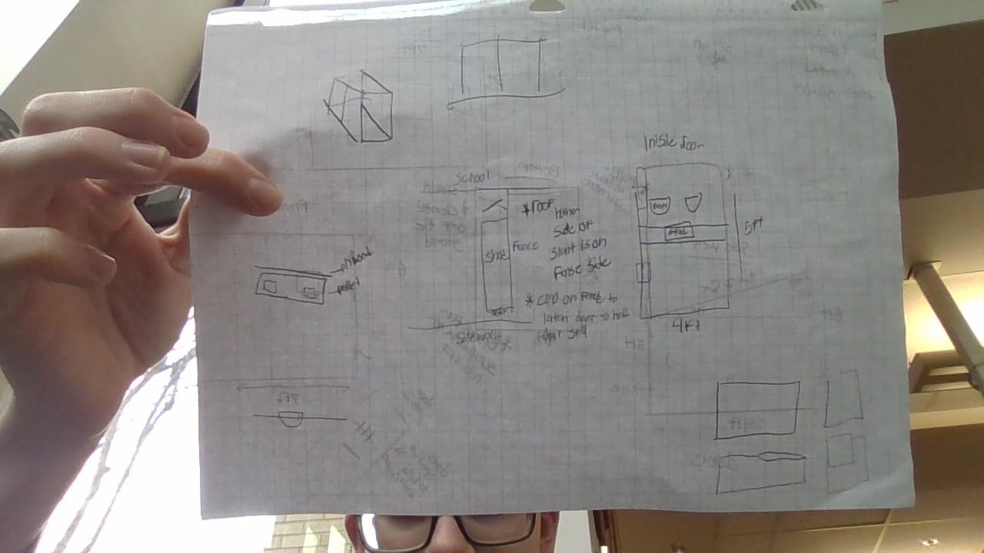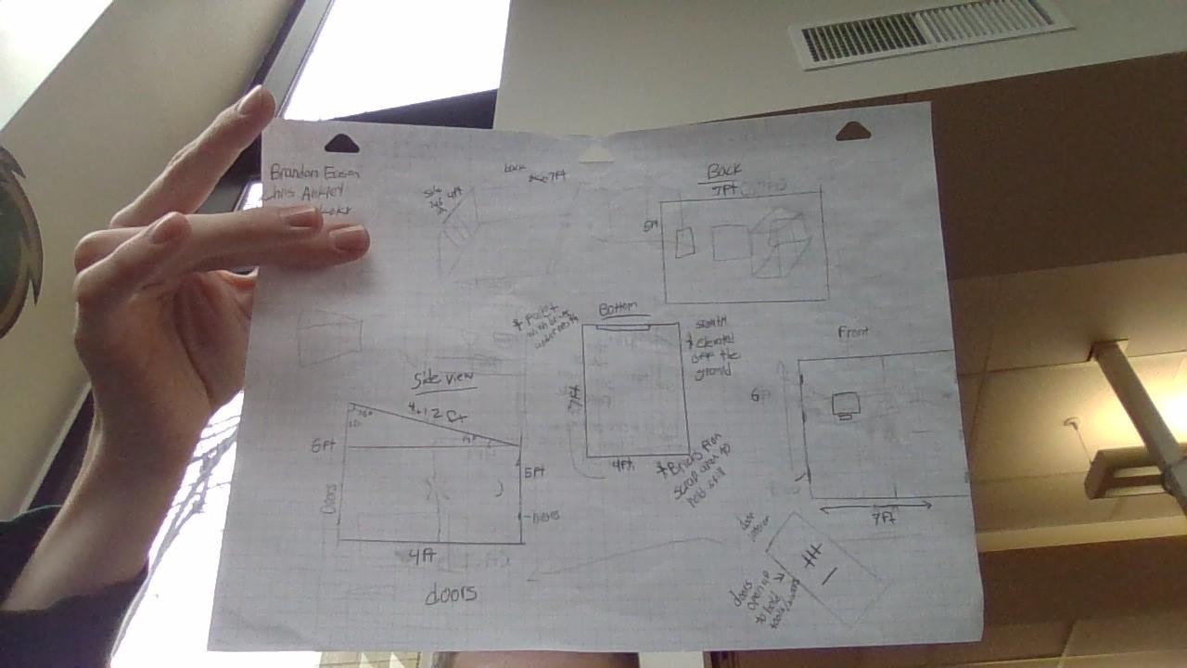

Manufacturing Methods:

Step 1: Converse with Stakeholder
Step 2: Sketch and Design
Step 3: Measure and scout out location
Step 4: Converse with Stakeholder again to confirm our design and research
Step 5: Finalize measurements and supplies
Step 6: Gather Supplies and materials
Step 7: Begin cutting
Step 8: Create foundation
Step 9: Screw Frame together
Step 10:Apply layers with plyboard
Step 11: create the slope for the roof and attach the roof
Step 12: Build and attach the door
Step 13: add roofing panels to protect the roof from weather
Step 14: apply finishing touches such as paint and shelves

Element E: STEM Principles and Practices

Materials
Item | Cost per | Amt needed | Total
2x4x6  https://www.homedepot.com/p/WeatherShield-2-in-x-4-in-x-6-ft-2-Prime-Pine-Ground-Contact-Pressure-Treated-Southern-Yellow-Pine-Lumber-253920/206967815 | 4.58$ | 6 | 27.48$
2x4x10  https://www.homedepot.com/p/WeatherShield-2-in-x-4-in-x-10-ft-2-Prime-Ground-Contact-Pressure-Treated-Southern-Yellow-Pine-Lumber-253920/206967803 | 7.28$ | 4 | 29.12$
Plywood 4x8ft  https://www.homedepot.com/p/OSB-7-16-Application-as-4ft-X-8-ft-Sheathing-Panel-386081/202106230 | 16.48$ | 6 | 98.88$
Door Hinges (3 pack)  https://www.homedepot.com/p/Everbilt-3-Pack-3-1-2-in-Square-Radius-Oil-Rubbed-Bronze-Squeak-Free-Butt-Door-Hinge-28406/314151904 | 9.93$ | 1 | 9.93$
Door Handles  https://www.homedepot.com/p/Everbilt-Black-Gate-Latch-24416/327599434?source=shoppingads&locale=en-US&fp=ggl | 6.38$ | 1 | 6.38$
screws(196 per pack)  https://www.homedepot.com/p/Grip-Rite-8-x-1-1-4-in-2-Phillips-Bugle-Head-Coarse-Thread-Coated-Exterior-Wood-Screws-1-lb-Box-PTN114S1/100170151 | 9.97$ | 1 | 9.97$
PVC Roof Panels  https://www.homedepot.com/p/Palruf-2-2-ft-x-8-ft-Corrugated-PVC-Roof-Panel-in-Green-101479/100052613 | 18.03 | 4 | 72.12
Bricks/Pallets for  base |  | 8-9 bricks / 2-3 pallets | Free behind the tennis courts
Paint (maybe) |  |  | We can Provide only if we need it
Wall Mounted Baskets for Tools |  |  | We can provide if necessary
Total Cost |  |  | 253.88

Tools
Drill
Circular Saw (Maybe Table Saw)
Level
Tape measurer
Brandon E, Nikyla K, Chris A, and Michael A.

STEM Principle for High-Priority Design Requirement #1 The bike shed must be able to fit at least 3 bikes.
STEM Concept: Math
We had to calculate and measure the exact measurements for the dimensions of the bike shed

TEM Principle for High-Priority Design Requirement #2 The Shed should have the ability to have a sloped roof to prevent weather issues
STEM Concept:Math
We had to calculate the angle of the roof to have the roof be attached in a certain direction and way to be sloped and not overhanging.

STEM Principle for High-Priority Design Requirement #3 The shed should be able to be off the ground so the wood does not rot.
STEM Concept: Engineering
It lifts the shed off the ground so that the bottom of the wood panelling does not get moisture, causing rot.

STEM Principle for Design Solution #1 the bike shed must be 7 ft long, 4 ft wide, and 5 and 6 ft to account for the 3 bikes.
STEM Concept: math
We used our brains and tape measurements to determine how large this shed should be and then we calculated the lengths to fit in the space provided.

STEM Principle for Design Solution #2 The roof should be slanted at 14 degrees to account for rain to slide off without getting the shed wet.
STEM Concept: Math
The roof allows for the rest of the shed to stay dry when it rains/snows.

STEM Principle for Design Solution #3 The bike shed must have footers to bring it above the ground to avoid wood rot on the floor.
STEM Concept: Engineering
From learning and experiences with outdoor wood rot because of the outdoor conditions, we were able to design our shed with this scientific knowledge in hand to avoid this breakdown.

Element F: Design Viability
Design Viability Description | Connection to Design  Requirement | Credible Evidence?
The Solution does not take up too much space in the aux gym | The design places the shed outside of the aux gym, therefore reducing the clutter and giving us ample room to make the desirable size. | After our measurements, we concurred that the shed will be 7x4 feet, which will fit in the given spot outside and not take up too much room.
The design is safe; keeps bike from being moved unknowingly | The design has the bikes gated in to a safe shed protected by the fences of the school, so the bikes will not be liable to movement and theft | Within our supply list we have included tools to successfully lock the door for the shed, therefore protecting the bikes from any outside interactions.
The design should be cost effective | The shed should be well designed, but also designed in account for the price, since the school has a limited budget. | After putting together our materials, our cost came out to be around $250 which seems like a lot at first but looking at prices of pre-built bike sheds of this size, the price does not seem too bad.
The shed should be able to fit in the designated space outside the aux gym | To further prevent clutter we decided to place the shed outside to give the shed enough space to be opened and used. | We have located a perfect spot outside the aux gym, which is out of the way from interruptions and large enough to fit the shed of our size.

Element G: Construction of a Testable Prototype
Group: Nikyla K, Brandon E, Chris A, Michael A

Prototype Construction of Design #1
Date: 3/27 & 3/31
Photos:
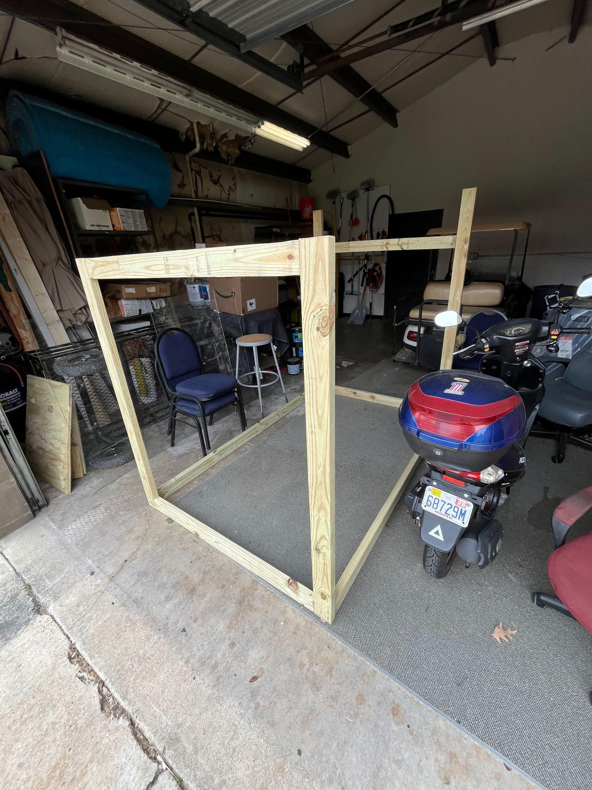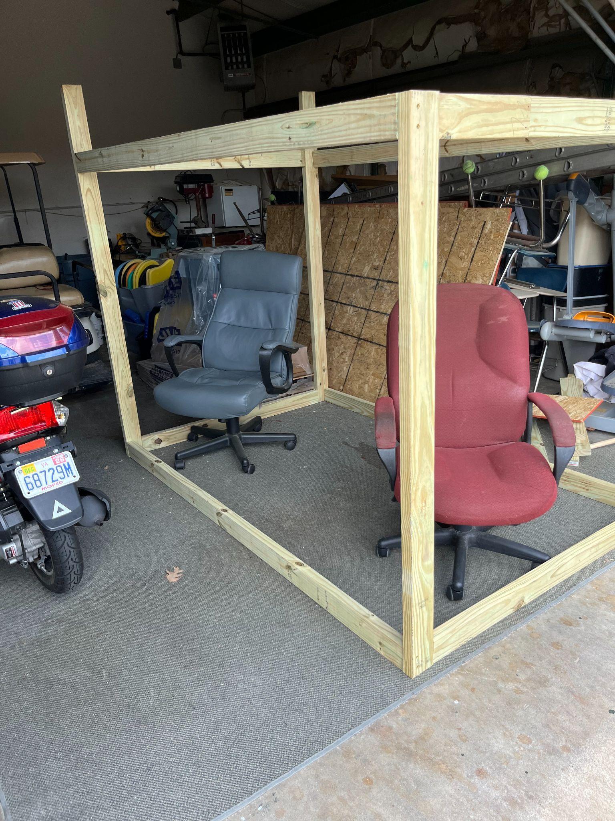
- Completed the bottom half of - Completed the whole frame
the frame & started the top
Details about all steps of construction

:
 | Details | Tools and Manufacturing Methods used
Step 1 | We measured the right length for each board and made marks so we could cut them properly. | Measuring tape & pen
Step 2 | We took the boards & lined them up on the table saw, making sure that we didn’t cut too much off of the boards. | Table saw & wood planks
Step 3 | Taking the 6ft & 5ft boards, we lined up the 4ft and 7ft boards on the bottom and screwed them together. | Drill, impact drill, screws, planks
Step 4 | We combined a 3ft board with a 1ft board to make 2 more 4ft boards because we didn’t have enough. | Drill, impact drill, screws, scrap planks
Step 5 | We screwed all of the boards together to complete the frame | Drill, impact drill, screws, planks
Step 6 | We started to measure out the plywood & cut one piece to size. | Plywood, table saw,Jigsaw

- Our original blueprint is being followed so far, when we start putting on the plywood I suspect it will start straying from the original plan.

Final Prototype Construction of Design #2
Date: 4/20
Photos:
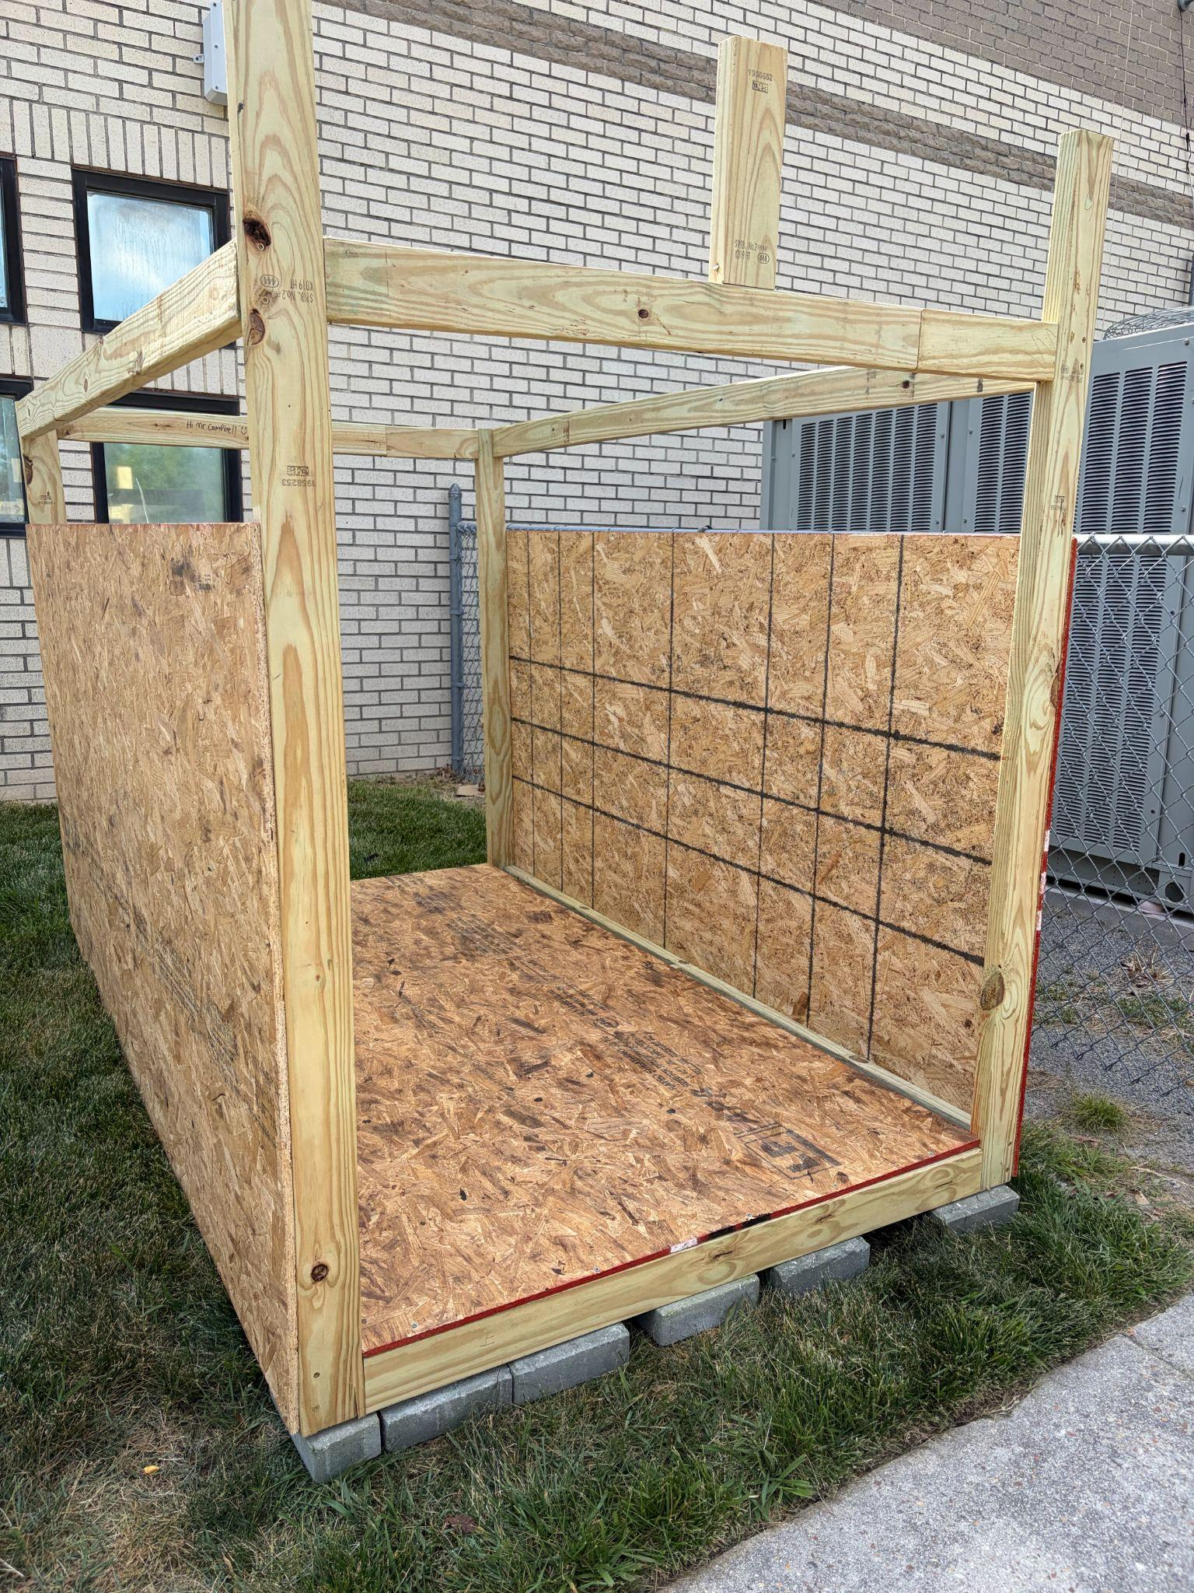
- we started putting the siding & flooring on
 | Details | Tools and Manufacturing Methods used
Step 1 | Cut the plywood based on our previous measurements | Table Saw
Step 2 | Screwed in 3 sections of the cut plywood | Screws, Impact Drill
Step 3 | Moved the shed over to its final position and placed bricks underneath | Furniture Movers.

- We had to cut the floor out of multiple pieces because we didn’t account for the width to not be met with one piece.
Final Prototype Construction of Design #3 Date: 4/22
Photos:
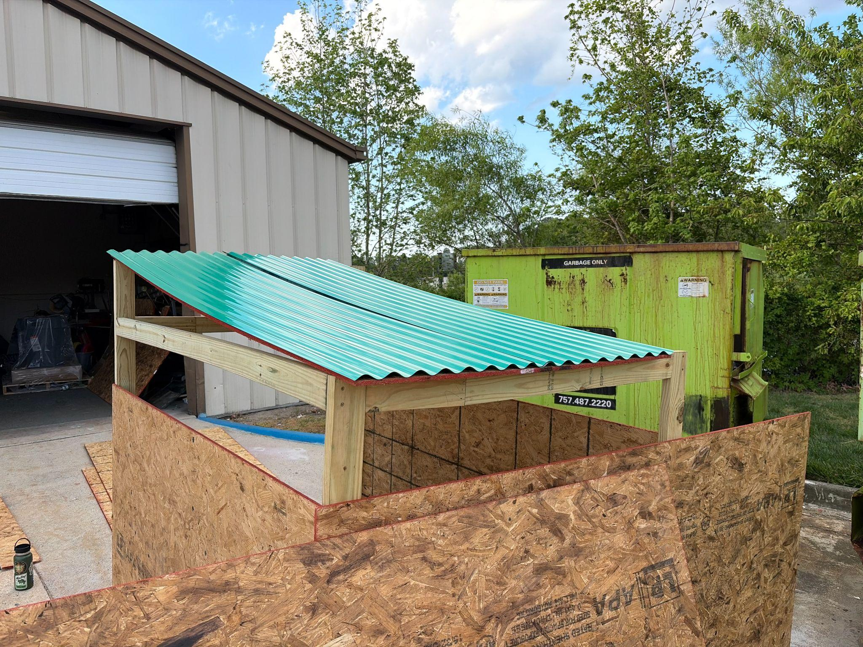
- We finalized the other pieces & cut them to fit, we also test fitted all the piece to confirm the size
 | Details | Tools and Manufacturing Methods used
Step 1 | Gathered materials from inside the garage | N/A
Step 2 | Measured plywood before marking the correct measurements for cutting | Measuring tape, marker
Step 3 | Cut out the back wall, roof, door, and front wall. | Circular Saw
Step 4 | Lined up the newly cut boards in the place they would go | n/a
Step 5 | Put supplies back into the garage | n/a

- We continued to follow the plans of where everything must go but since we did not take into account the frame’s actual shape before we had to make some adjustments for the plywood

Final Prototype Construction of Design #4
Date: 4/24
Photos:
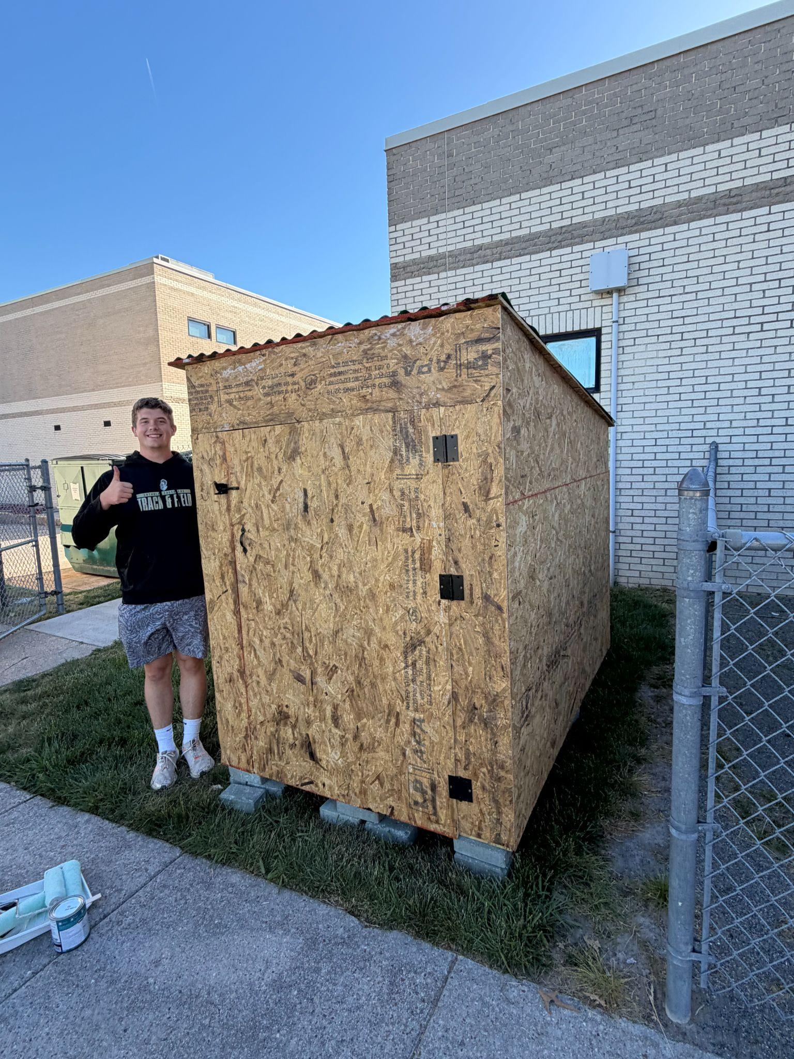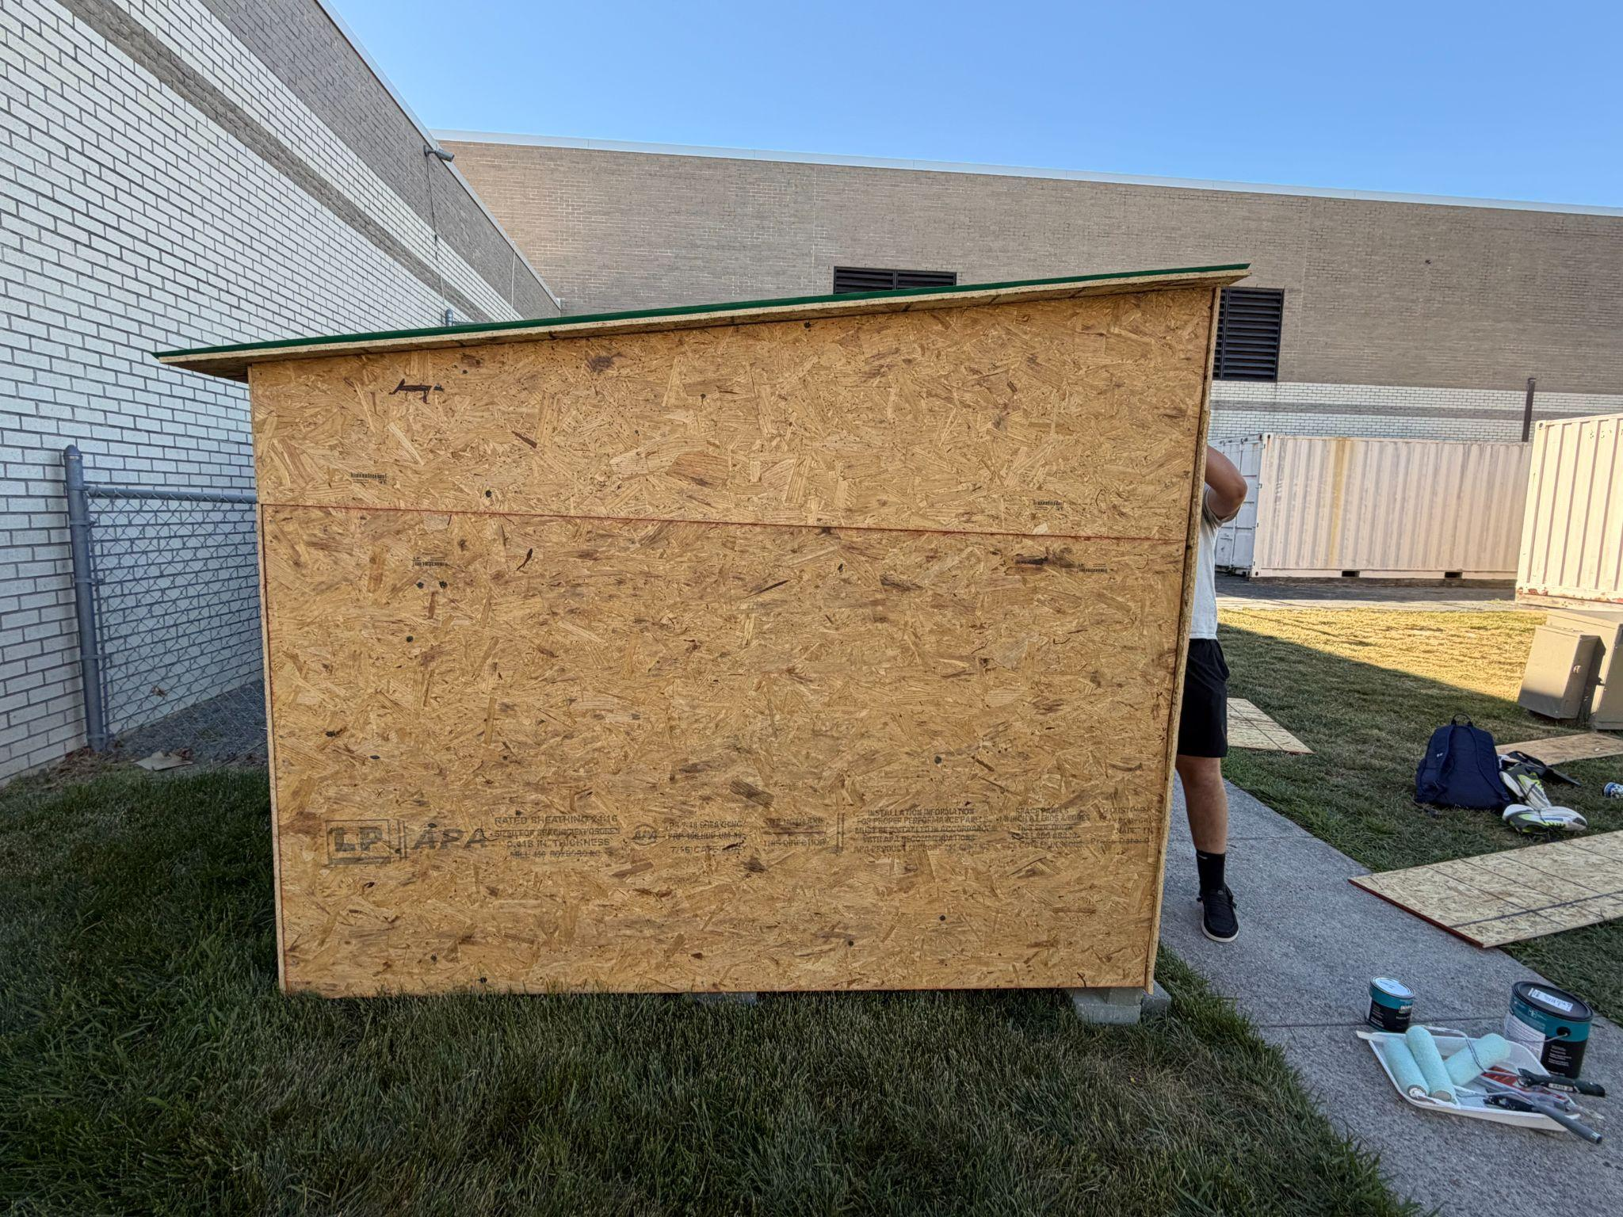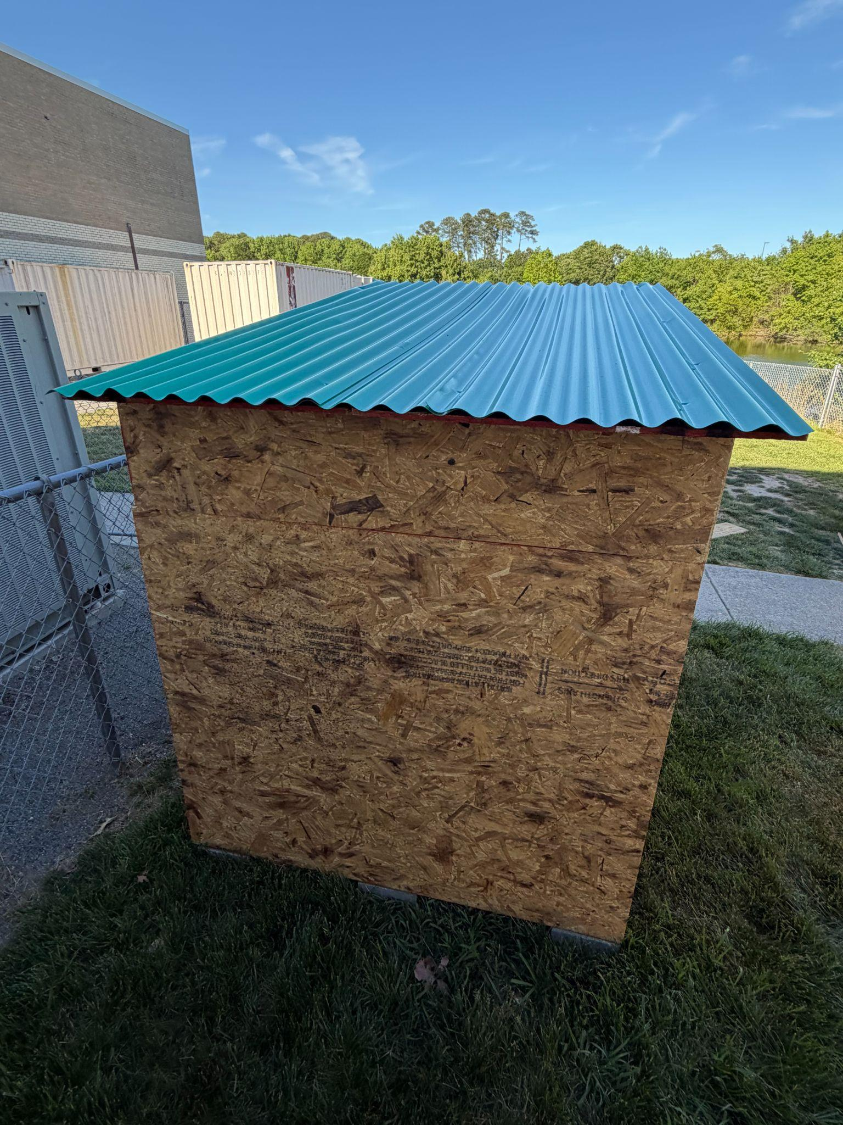
- Screwed everything on & finished the project
 | Details | Tools and Manufacturing Methods used
Step 1 | Gathered wood to screw in | N/A
Step 2 | Screwed in the back wall | Impact drill
Step 3 | Screwed and sawed the side components for the floor | Table saw, jigsaw and impact drill
Step 4 | Screwed the triangular walls into place | Impact drill
Step 5 | Screwed the wood roof into place and the green roof panels | Impact drill
Step 6 | Fixed measurements for the front wall and the door and then screwed it into place | Measuring tape, jigsaw, impact drill
Step 7 | Measured, sawed, and screwed in the the the panel that would be placed above the door | Measuring tape, jigsaw, impact drill

- We had to change how the door works because the way we originally had it would have put too much strain on the hinges
List of materials:
Material name | Description | Where material was purchased | Cost per unit | # units | Total cost per item
Jigsaw | Tool for easy use to cut small pieces of wood | Borrowed from a friend | n/a | 1 | 0
Table Saw | Tool to accurately slice the plywood and 2x4s | Borrowed from Mr. Robbins | N/A | 1 | 0
Measuring tape | Tool to measure out the sheets of wood to make it the right size | Borrowed from Mr. Robbins | N/A | 1 | 0
Hammer | Tool to fix the placements of screws | Borrowed from Mr. Robbins | N/A | 1 | 0
Impact drill | Tool to put all the screws in place | Borrowed from a friend | N/A | 1 | 0
Screws 2” | Screws to use for the plywood | Bought from Home Depot | $10.48 | 2 | $20.96
Screws 3” | Screws to use for the 2x4s | Bought from lowes | $12.98 | 1 | $12.98
2x4x6 | Wood for the frame | Bought from home depot | 4.58$ | 6 | $27.48
2x4x10 | Wood for the frame | Bought from home depot | 7.28$ | 4 | $29.15
Plywood | Sheets of wood to use for the exterior of the shed | Bought from home depot | 16.48$ | 6 | $98.88
Roofing panels | plastic (pvc) sheets to protect the shed and make it look better | Bought from Home Depot | 18.03$ | 4 | $72.12

Detailed sketches, which might include CAD if you have learned it in your class:
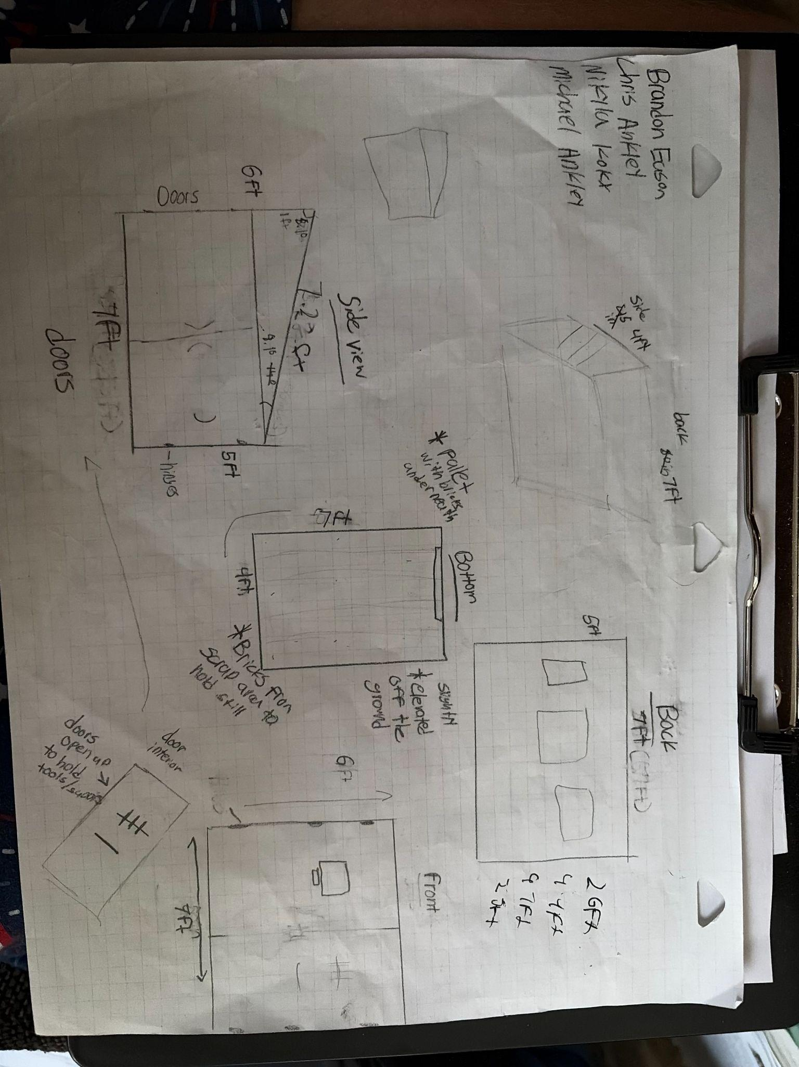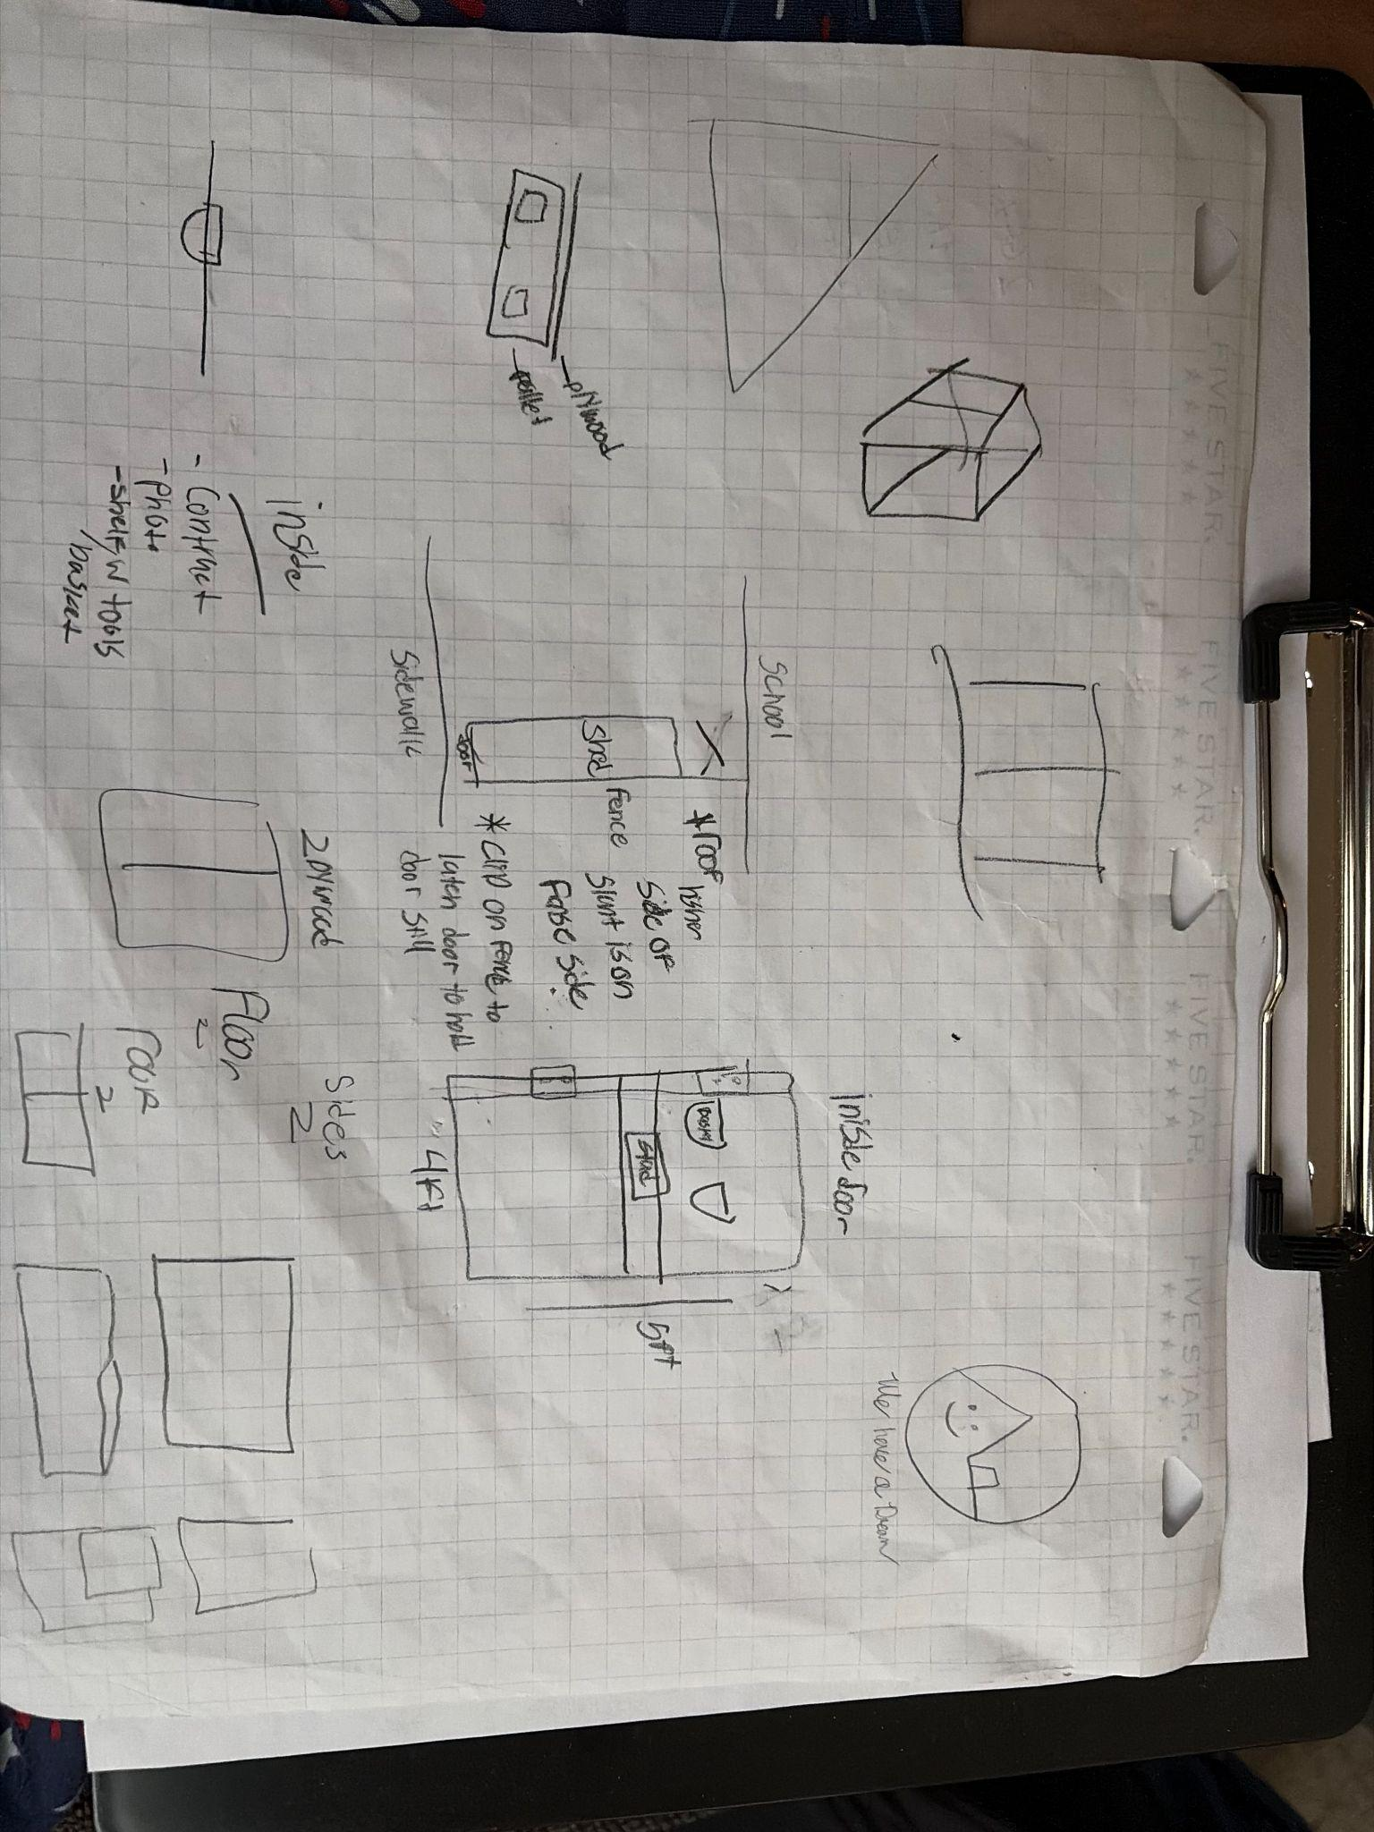

Construction of the Final Prototype (G2)

Design Requirement | How will this prototype allow you to collect objective, measurable data?
The bike shed must be able to fit at least 3 bikes. | It gave us a basis to the length, width, and height of our shed
The shed cannot be any bigger than 80 inches by 45 inches by 10 feet | It places holds on the length and width that we were able to build
The shed should be school colors | It gave us data on what colors and design to choose for the paint and roof
The Shed should have the ability to be locked if deemed necessary | Gave us the requirement to buy and install a system of a locking door.

Testing or Modeling of Attributes (G3, G4) and Addressing Non-Testable Attributes (G4)

Attribute | Description | Describe your prototype’s functionality to test this attribute
Ample size | Our shed has plenty of room to place 2-3 bikes for convenient and accessible use for the bikes | Shed properly fits the amount of bikes required to fit
Weather protection | Needs a roof and walls that do not allow water and wind to damage the bikes | Building a waterproof roof and weatherproof siding
Accessibility | The shed allows the smooth entrance and exit of bikes | The shed and door is able to fit bikes and it is easy for them to be stowed and taken out
Theft protection | Our shed is placed in a confined space protected by a closed fence and the shed itself contains and lock to keep the door closed | We made sure that there is a closing mechanism to the door for safety
Stability | Our shed is structurally sound and can hold at least the four of us | We made sure the frame of the shed was strong and we added wood branching across the plywood to make it even more secure, for the floor we added a beam and bricks to make sure the shed would be able to withstand different weights.

Addressing Non-Testable Attributes (G4)

Attribute | Justification for why this attribute cannot be modeled or tested with your prototype
Not applicable | Not applicable

Element H: Prototype Testing and Data Collection Plan

Testing Details (H1, H2, H3, H4)
 | requirement | testing setup and procedure | test cases and number of trials | expected range of results | pass/fail criteria, goal
1 | Ample Size | We rolled over the 3 bikes from the locker room and we put them inside the shed. After putting them inside the shed we discovered we had plenty of room for the bikes with more room to spare. | 1 | N/A | Must fit around 3 bikes and extra space for people walking inside
2 | Weather Protection | It's been outside in the weather for the last couple days, has experienced rain/wind, and help up nicely | 1 | N/A | The shed must be protected from rain and other weather occurrences, such that the shed is not damaged
3 | Accessibility | We set up the ramp, and rolled the bikes into the shed | 1 | N/A | It must be easy to get to the shed and it must be easy to get bikes in and out of the shed
4 | Theft protection | We tested the lock from both sides & it holds up to being pushed & pulled on | 1 | N/A | The door must be secure and stable so that bikes are not easily taken without permission
5 | Stability | We placed the 3 bikes inside and then we stepped inside and the shed was able to hold our combined weight alongside that of the bike. | 1 | N/A | The floor of the shed should be able to hold our weight alongside the weight of the bikes

Element I: Testing Data

1.
- Size
- High priority
- We rolled over the 3 bikes from the locker room and we put them inside the shed. After putting them inside the shed we discovered we had plenty of room for the bikes with more room to spare.
- 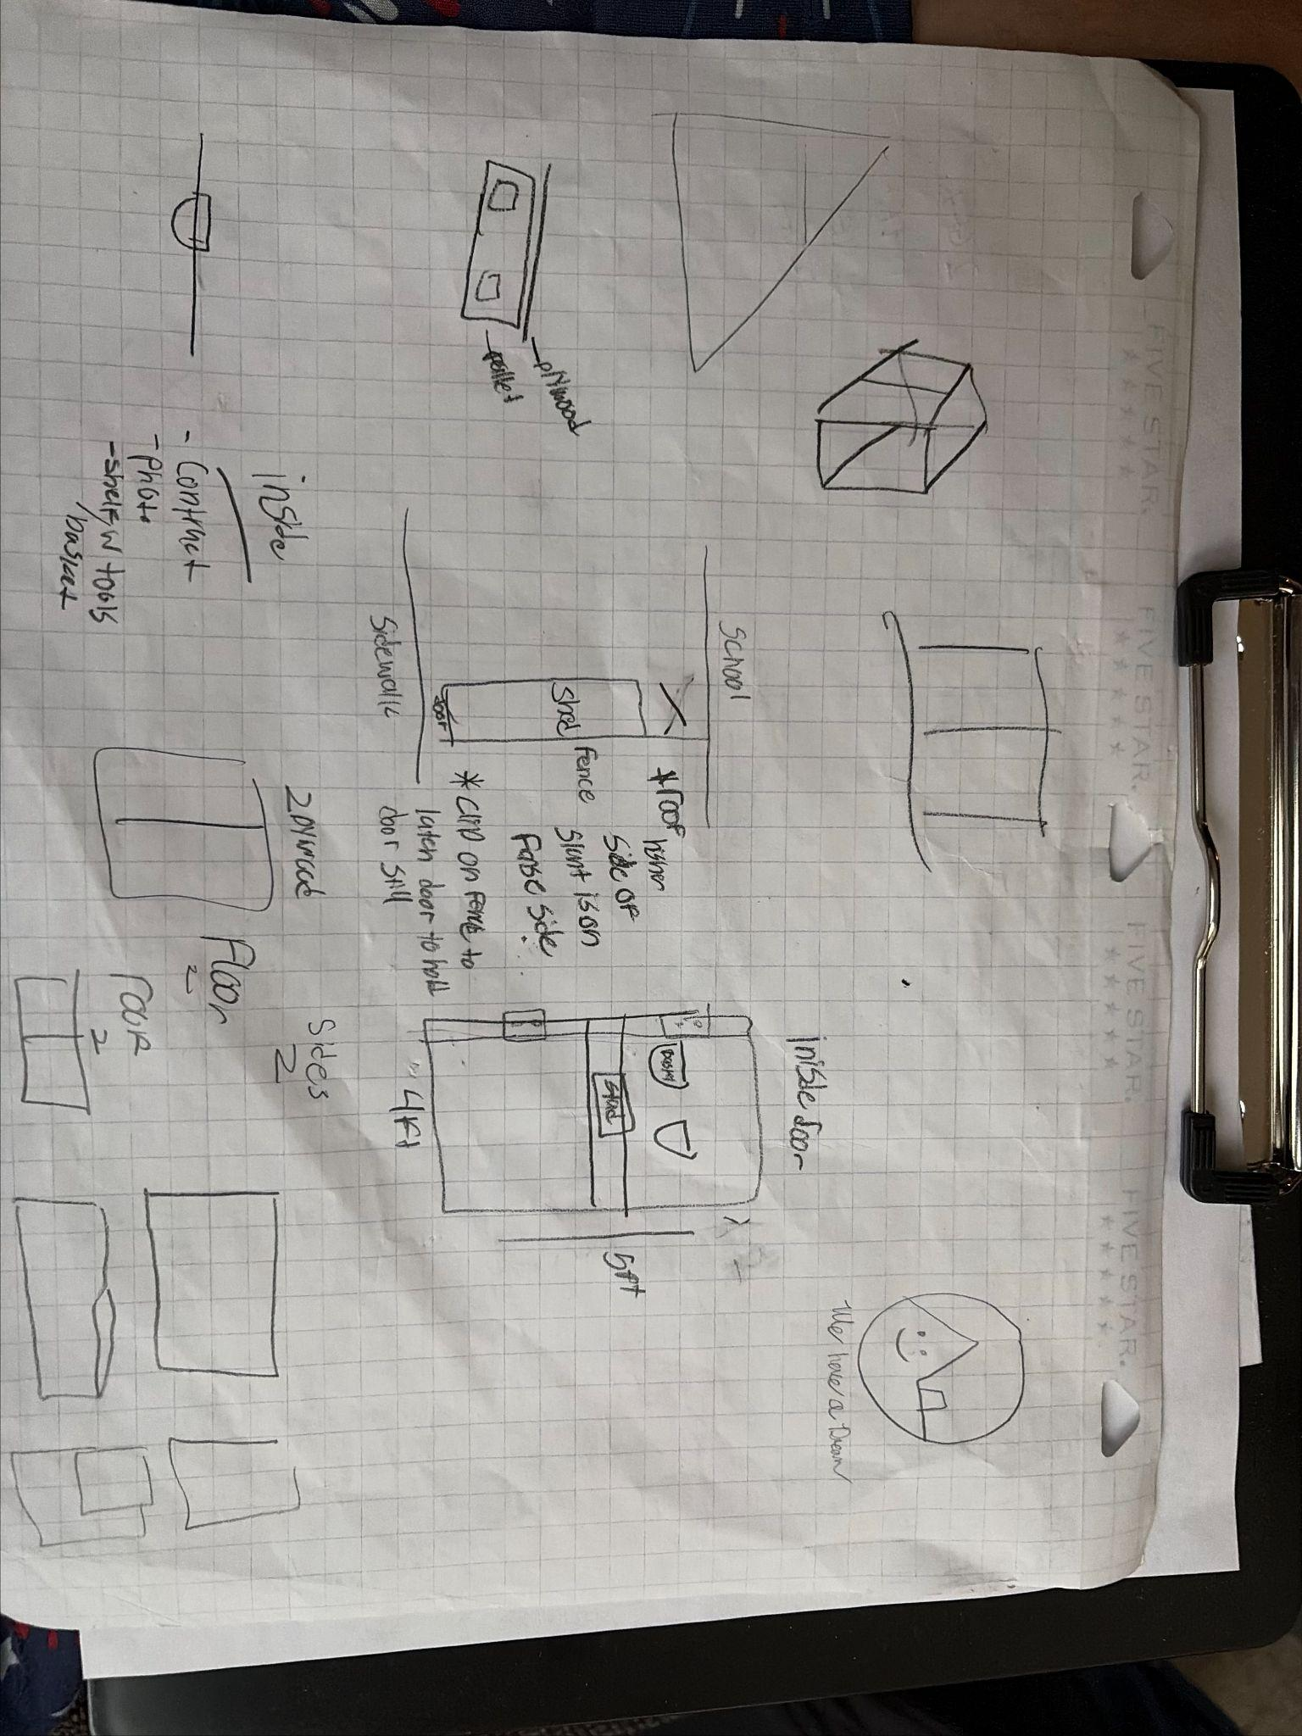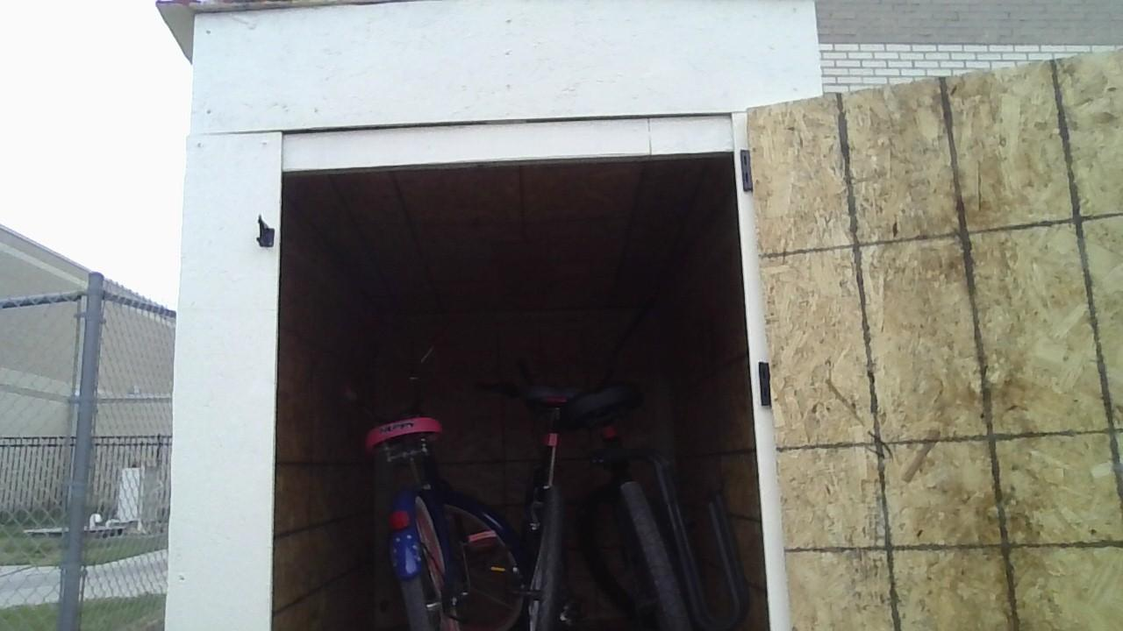
- The drawing shows the size requirements that we defined when we began the planning process for the shed. This data helped us define the accurate shape to be able to hold 3 bikes. The second photo shows us placing the three bikes inside the shed, proving that we had plenty of room.
- Our test passed the criteria, being able to fit three bikes with room to spare.

2.
- Weather Protection
- High Priority
- We left the shed outside with the bikes inside of it during the weekend. It rained and was windy over the weekend. On the Monday after the weekend, we checked on the shed and the bikes.
- 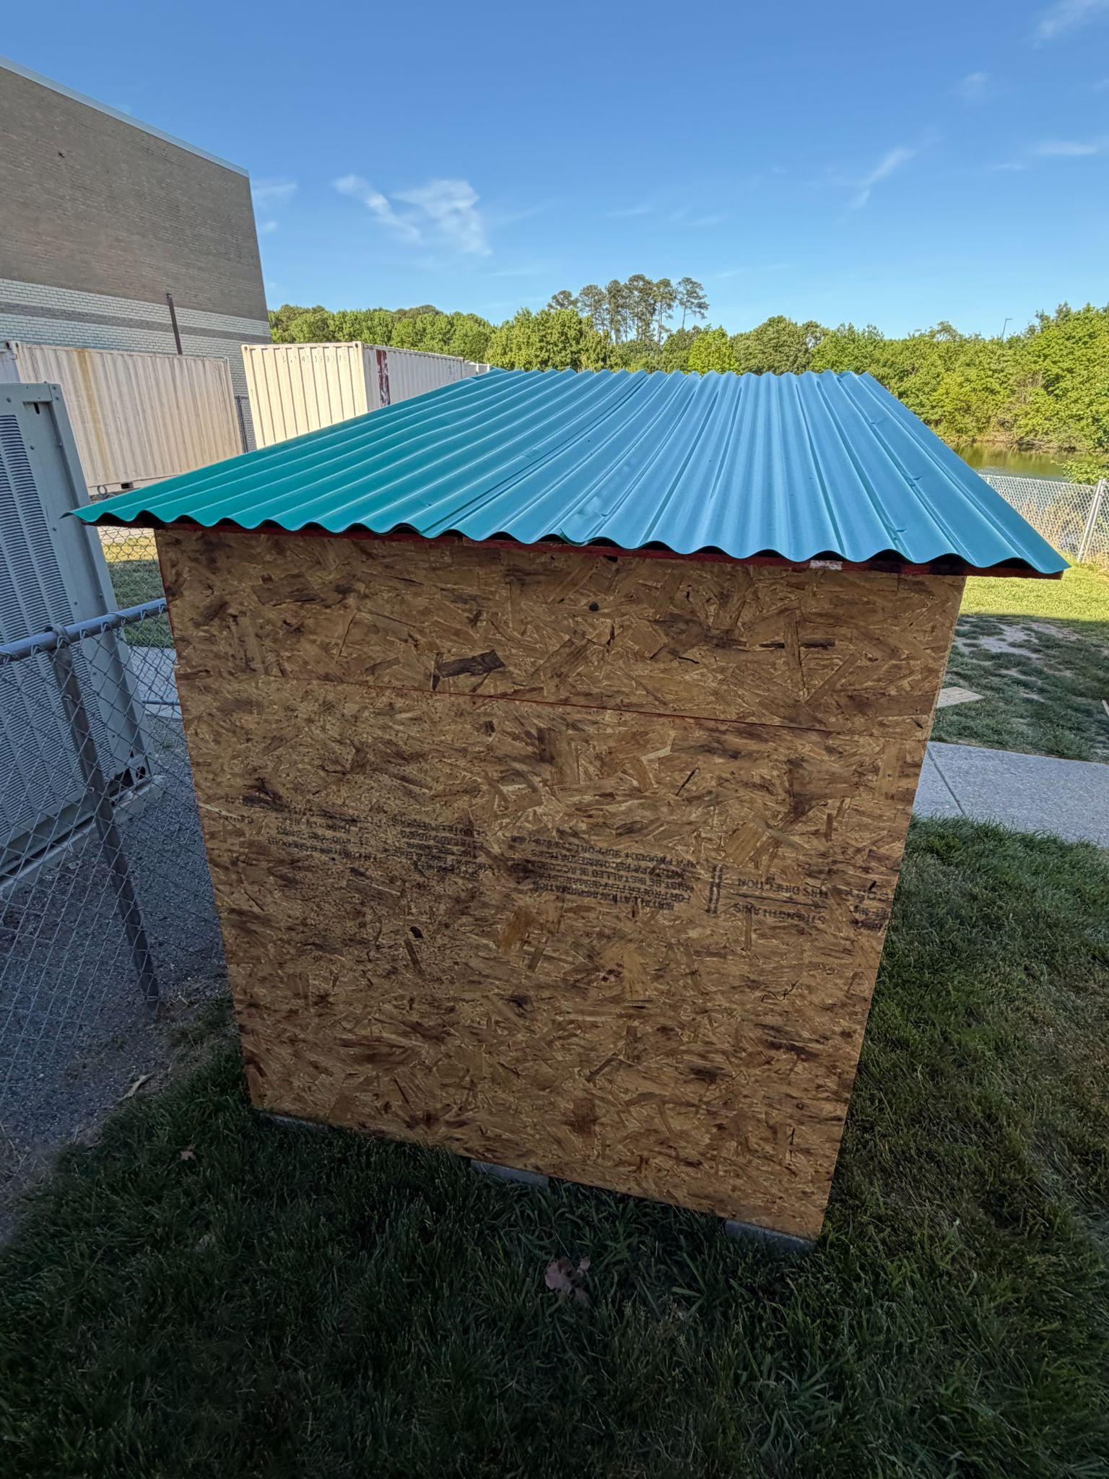
- The image shows the roof intact after the rain and wind. The data gives us enough evidence to leave the roof as it is in the picture because it protected the contents of the shed in stormy conditions.
- The roof makes the shed pass the criteria, since the rain flowed down the roof thanks to its sloped nature. The wood was not impacted by the rain thanks to our roof design.

3.
- Accessibility
- Medium Priority
- We placed the shed in a remote location and we made sure to include a ramp to easily roll bikes inside.
- We put a ramp made from plywood
- After learning from the simple machines unit, we realized that for easier access we should design a ramp to make for easier access to roll bikes inside.
- It passes, we made a ramp that allows easier rolling of the bikes into the shed

4.
- Theft Protection
- High Priority
- We tested the lock from both sides & it holds up to being pushed & pulled on
- 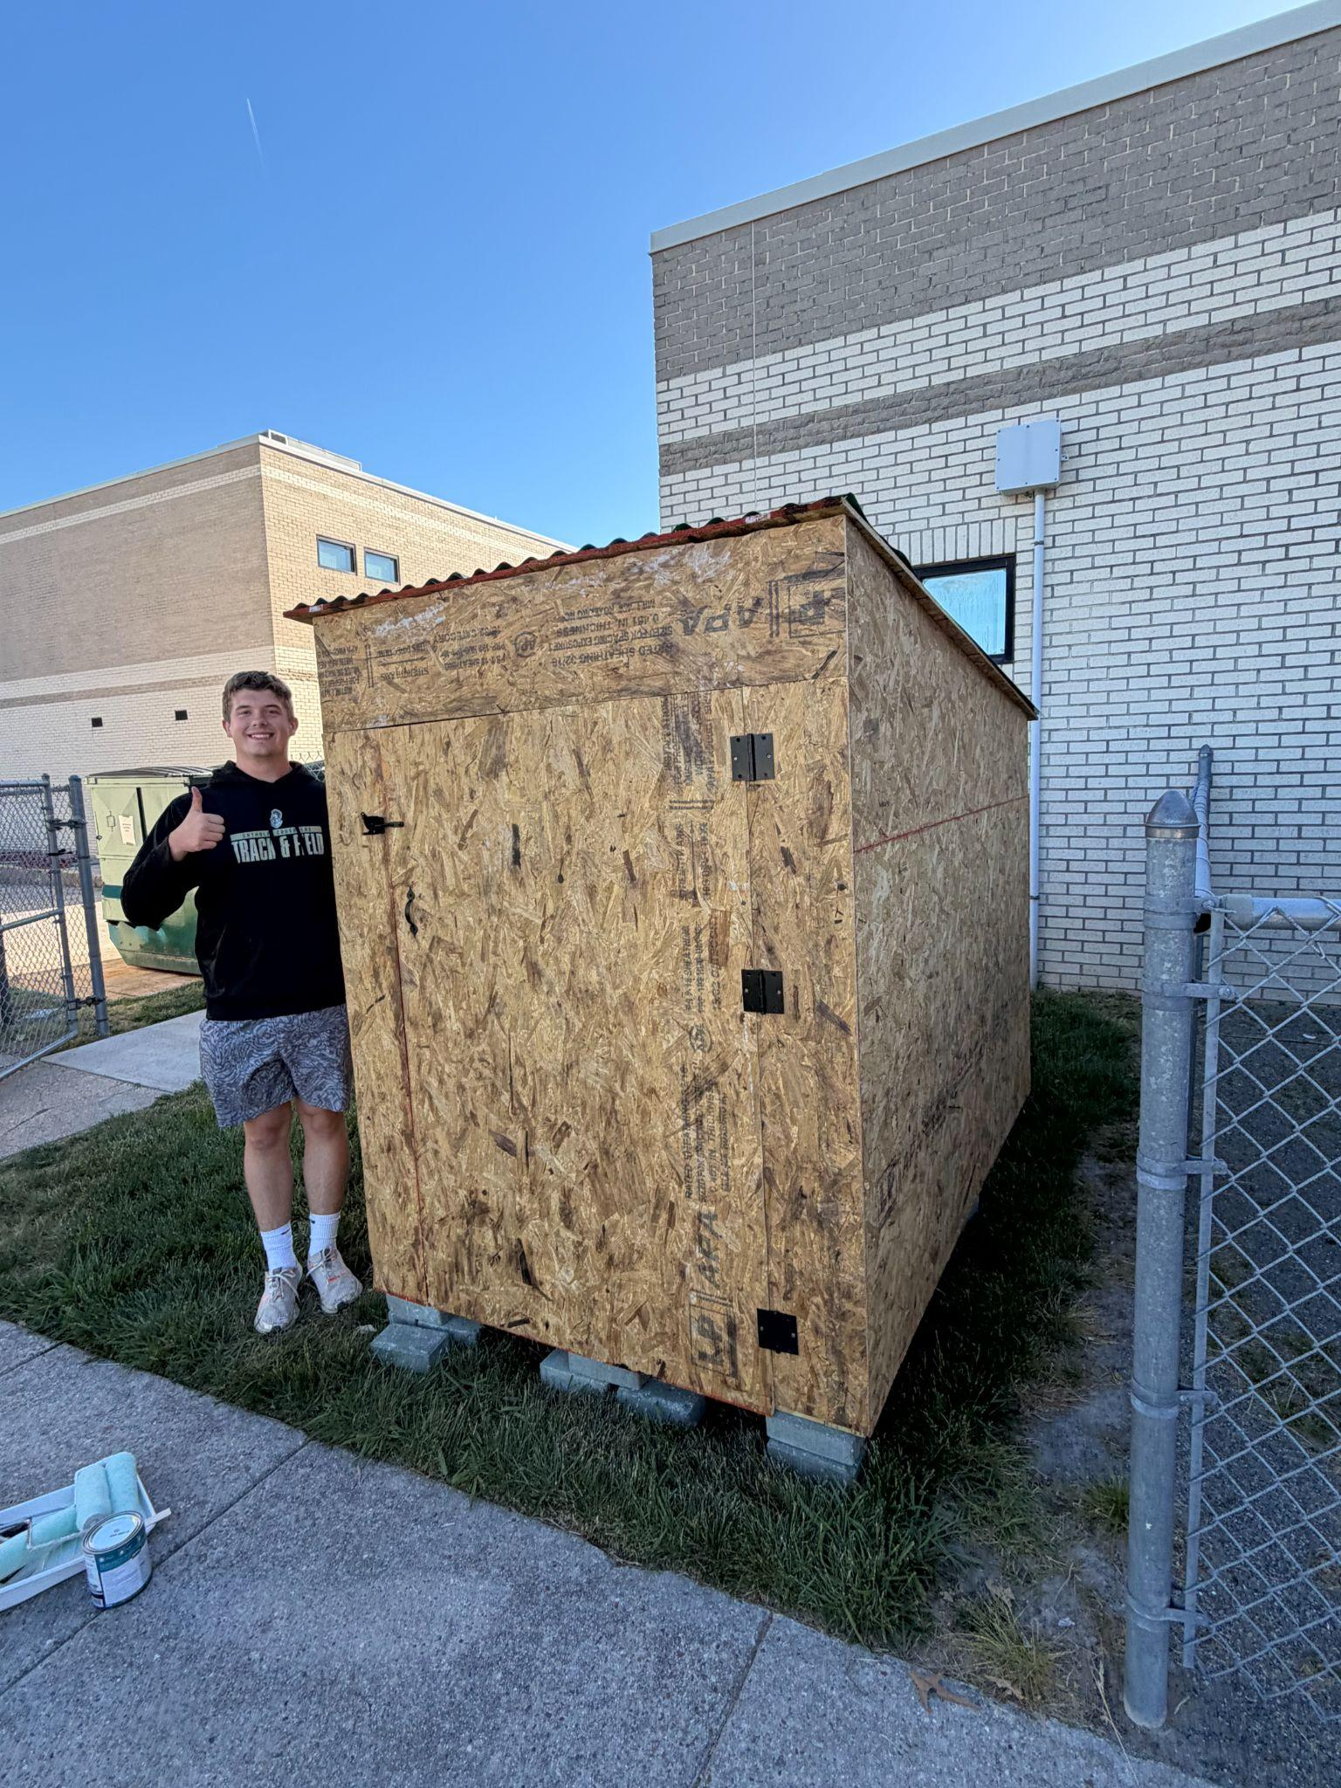
- We attached a simple lock to the door in order to keep the door shut & secure to prevent it from flying open on its own.
- It passes the criteria, the door locks & stays closed on its own & does not fly open

5.
- Stability
- High Priority
- To test this, we walked inside the shed to test the floor stability. We also put force on the walls and tried to move around the shed to see if the walls moved. Furthermore, the blocks underneath keep it level and keep it off the ground to prevent instability from rotting wood.
- 
- The picture shows the blocks that create stability to the shed on the ground, and there the structural stability of the walls are evident in the image as well.
- The shed passed, the floor can hold 3 bikes & over 500 pounds of people easily.

Element J: Documentation of Evaluation

Stakeholder Evaluation #1
- Name of evaluator: Mr.Campbell
- Justification for how this evaluator is a stakeholder: Mr. Campbell the stakeholder for this project, because he is the person that we constructed the shed for his bike.
- Documentation of the project evaluation: We spoke with Mr.Campell after school and he explained how satisfied he was with the shed and its design. He told us that it was well designed, and he was grateful that it was big enough to hold his bike and bikes for those who help him during the cross country season. He believes the process of retrieving and storing his bike will be much more convenient now with the shed. He explained how there is nothing we could have added differently, the shed was built according to exactly what he would have wanted and needed.

Synthesis of the Project External Evaluation
The external evaluation gives us feedback on our project and what we did good and what we did bad. Furthermore, this feedback could give us things to improve and fix to finalize a better product for the stakeholder and for any future projects.
Mr. Campbell’s evaluation gave us positive feedback on the accomplishments of our project, he really had nothing negative to say as he was very pleased with what we built for him. He brought up the details of painting the shed, and we have taken account of that and begun the painting process of the shed to perfect its exterior looks. His evaluation helps us for future projects to keep working how we have but to also take into account the final look as a finishing touch.

Element K: Reflection on the Design Project
- defining the problem (elements A-C): In these sections we talked with Mr. Campbell and discussed what kind of issues he had that could be made easier with a project. We concluded on the issue of his bikes not being stored correctly, which led us to the finalization on the Bike Shed.
- ideation (element D): The idea of this project was to give Mr Campbell a safe place to store his bike and the other bikes for the XC season as his had been stolen as it was left in an unsafe and unsecure area.
- selection & prototype design (elements D-F): During the pre-build process, we researched the dimensions that would comfortably fit the bikes and we also looked at the maximum and minimum dimensions based on the area of our build. Along with research and planning to make the shed functional, the previous details gave us the maximum and minimum dimensions to choose from for the shed.
- prototype building (element G): We completed construction on the project, using the previous elements to guide our work to the best outcome.
- testing (elements H-I): We went back to the elements necessary for our shed and tested things such as the weight capacity, size, and weather protection to confirm that the shed was well designed accurately for its purposes.
- evaluation (element J): We looked at the tests we conducted on our project and evaluated the results. We made sure the results were accurate and used the quantum data analytics transformation process to further add to our expertise in the field of engineering.

Lessons Learned About the Engineering Design Process (K3)
For future projects, designers should consider the importance of accuracy and time management. It is really important to focus on accuracy, because you have to make sure the measurements and plans are lined up. If you do not have the right accuracy you may end up making many mistakes and the project will not end up how you wanted it to be. Time management is just as important, being able to reach a goal by a certain time in order to guarantee the client’s needs are satisfied.

Element L: Presentation of Designer’s Recommendations
- What could be done next to go further?
  - We can paint the shed, or spruce it up in some way so it isn’t just an eyesore of wood. By painting it to match the schoolbuilding, it will blend in better than if we left it as plain wood.
- What would you keep if you did the project again?
  - We would keep the frame that we built, as it was sturdy & reliable enough to build the shed around. We constructed it well and would reuse it if we did the project again.
- What would you change?
  - If we were to restart the project, we would order more plywood in order to keep up with the size of the shed. We were a couple panels short & had to go buy some ourselves in order to finish the project.
- What would have made this project easier for you to complete?
  - It would have been easier to complete if we had taken into account the timeframe we had to spend on it. We took a little longer than expected to finish it, because we all had different schedules after school & sometimes not all of us could work on it.

