Enhancing Behavioral Enrichment for Captive Turtles: A MyDesign Engineering Project
This project sets out to improve the behavioral and environmental enrichment of the turtles housed in the Towson University Biology Department. Using the MyDesign engineering framework, our team researched reptile welfare, collaborated with field experts, and analyzed stakeholders needs to develop two enrichment solutions: a semi floating hollow log that supports hiding, swimming, and basking behaviors, and an interactive food wheel designed to promote natural foraging and slow rapid feeding patterns. Guided by expert feedback and multiple prototype iterations, the final design met key requirements for safety, environmental compatibility, and behavioral stimulation. Initial in tank testing showed that the turtles interacted with the device successfully, demonstrating meaningful engagement and validating the effectiveness of our design.
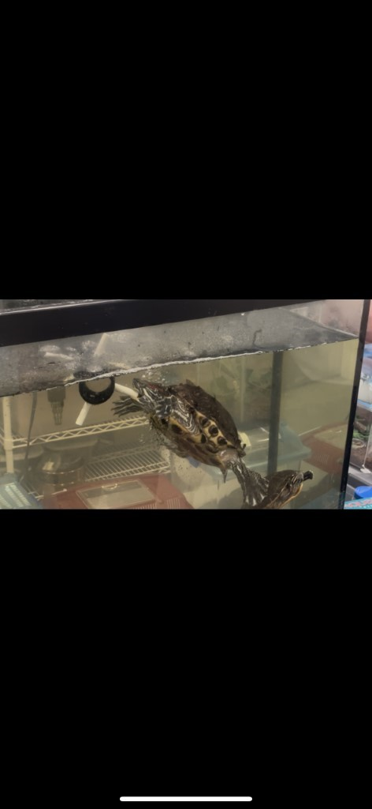

Element A: Presentation and Justification of the Problem
Behavioral Focus — Enhancing Turtle Enrichment and Engagement at Towson University
In the wild, turtles live in diverse ecosystems that constantly challenge their instincts and behaviors. They regulate temperature by basking, searching for food over large areas, and interacting with complex environments that encourage exploration and decision-making. These experiences are vital not only for their physical health but also for maintaining mental engagement and emotional well-being. However, in captivity, these natural challenges are significantly diminished. The stability and predictability of an indoor setting often result in reduced movement, limited behavioral variety, and signs of boredom or stress. This creates a significant issue for the turtles cared for by the Towson University Biology Department, where physical needs such as temperature, lighting, and nutrition are met, but behavioral and psychological needs remain under-stimulated. The goal of this project is to develop enrichment strategies that boost engagement and mood through behavioral stimulations as varied textures, interactive feeding, and movable habitat elements.
Turtles in the Towson Biology Department are kept in a controlled environment, overseen by Haley and other caretakers who ensure proper lighting, water quality, and feeding schedules. However, the environment’s predictability limits their behavioral opportunities. Caretakers have noted that “the turtles could use more entertainment,” indicating a lack of sufficient enrichment. Without new stimuli, the turtles may spend long periods inactive, show disinterest in food, or repeat the same limited behaviors. Research supports these observations and state that reptiles in static enclosures often exhibit lower activity levels and decreased curiosity, both signs of compromised welfare. Since captive turtles rely entirely on caretakers for behavioral opportunities, providing consistent enrichment is essential for their well-being and long-term health.
Enhancing behavioral enrichment for Towson’s turtles has broader impacts on both animal care and education. Reptiles are increasingly seen as capable of complex learning and environmental awareness, and enrichment efforts offer opportunities to showcase humane care standards in an academic setting. At Towson, this approach aligns with the principles of the Institutional Animal Care and Use Committee (IACUC), which focuses on promoting species-typical behaviors while maintaining physical health. A successful enrichment program at Towson could serve as a model for similar reptile habitats at other universities and classrooms, enhancing welfare across educational and research settings.
The main stakeholders in this project are Haley and the other members of the Towson University Biology Department responsible for the turtles’ daily care. They oversee health, feeding, and cleaning routines while making sure they follow humane care guidelines. These caretakers face challenges in balancing routine maintenance with the need to encourage natural behaviors. Secondary stakeholders include biology students who observe the turtles as part of their coursework. Enrichment not only boosts the animals’ welfare but also improves students’ understanding of animal behavior and husbandry. Lastly, Towson University itself has an ethical duty to uphold high standards of animal welfare that mirror the values of scientific integrity and humane education.
Research in animal welfare provides strong justification for this work. Researchers found that reptiles provided with environmental complexity exhibited increased exploration and feeding behavior, while animal behaviorists have concluded that enrichment reduces stress and supports physiological stability. The IACUC guidelines further state that all captive animals should have opportunities for species-typical behaviors. These studies emphasize that enrichment is not optional and is a measurable contributor to health. For Towson’s turtles, behavioral enrichment could include rotating habitat features, varying lighting cycles, and introducing objects that encourage play or foraging behaviors. These interventions are evidence-based, ethical, and practical within the constraints of the current habitat.
The success of enrichment efforts can be objectively measured using both behavioral and physical data. Caretakers can record activity levels, basking durations, feeding frequency, and weight trends before and after introducing new enrichment elements. An increase in activity or responsiveness indicates improved engagement and mental well-being. Tracking these indicators over time, such as weekly observations for several months, will help Haley’s team determine which enrichment techniques are most effective. By applying data-driven observation methods, the Towson Biology Department can ensure that the turtles’ behavioral and emotional health remains at the same high standard as their physical care.

