MyDesign Portfolio
Element B Initial Template

How to use this template

Element B: Documentation and Analysis of Prior Design Attempts

Prior Design Attempt #1 - William Congreve’s Manual Fire Sprinkler System
Source
https://www.certasitepro.com/news/fire-sprinkler-history
https://en.wikipedia.org/wiki/Fire_sprinkler_system
https://www.bacsecurity.com/sprinkler-systems-a-brief-overview/
https://radfiresprinklers.com/history-of-firesprinklers/
State the source of the information about this prior design attempt, which should be taken from any of the following credible source categories: peer-reviewed journals (check out your public library for free digital access to journals; here are some free online journals and research databases), professional organizations, government agencies, local and national newspapers, patents (here is a patent search site for the United States Patent and Trademark Office), and reputable vendors and manufacturers. Make sure to incorporate in-text citations in the details section below (i.e. don't just give a list at the end of the element or footnote).
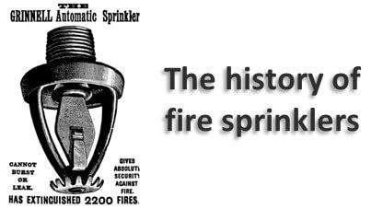
Include at least one image of this prior design attempt. Make sure to cite all images.
Details
It was built for the Theater Royal on Drury Lane in London (Certasite editor).A cylindrical airtight reservoir of 95,000 liters fed by a ten-inch water main which branched to all parts of the theater (bac security). A series of smaller pipes fed from the distribution pipe and were pierced with a series of half-inch holes which would dispense water (Wikipedia).
Analysis
Congreve’s design was manually operated. This means that it was entirely dependent on someone operating the valve from outside the theater (RAD fire sprinklers).

Prior Design Attempt #2 - H.S. Parmalees Automatic Fire-Extinguisher

Source
State the source of the information about this prior design attempt, which should be taken from any of the following credible source categories: peer-reviewed journals (check out your public library for free digital access to journals; here are some free online journals and research databases), professional organizations, government agencies, local and national newspapers, patents (here is a patent search site for the United States Patent and Trademark Office), and reputable vendors and manufacturers. Make sure to incorporate in-text citations in the details section below (i.e. don't just give a list at the end of the element or footnote).
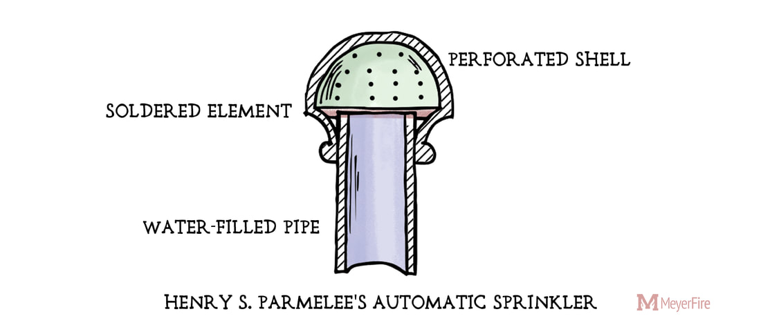https://www.meyerfire.com/blog/inevitability-of-the-fire-sprinkler
Include at least one image of this prior design attempt. Make sure to cite all images.
Details
After William Congreve's initial design of the first fire sprinkler system, Henry Parmalee made significant design changes that improved the initial design in 1878. The new design that he created contained a sealed cap and a perforated shell which was sensitive to temperature (Meyerfire).
Include main details about this prior design attempt
Analysis
Henry Parmelee's design was the first practical design of the fire sprinkler system. He created it in a piano factory and ever since then it has been used in commercial buildings protecting staff and ensuring the preservation of equipment (howeinc).
Provide evidence and explain what parts of this prior design attempt were unsuccessful at solving the defined problem and why based on design requirements.
Parmalees system was adapted from Congreve's own sprinkler system. Congreve's issue with the pipe system carried over to Parmalee's system with the plug holding dust and debris (Meyer-fire)

Prior Design Attempt #3 - Ambrose Godfrey Fire Extinguisher
Source
State the source of the information about this prior design attempt, which should be taken from any of the following credible source categories: peer-reviewed journals (check out your public library for free digital access to journals; here are some free online journals and research databases), professional organizations, government agencies, local and national newspapers, patents (here is a patent search site for the United States Patent and Trademark Office), and reputable vendors and manufacturers. Make sure to incorporate in-text citations in the details section below (i.e. don't just give a list at the end of the element or footnote).
Image
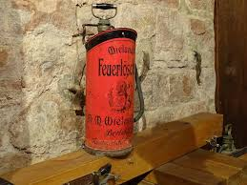

Include at least one image of this prior design attempt. Make sure to cite all images.
Details
Include main details about this prior design attempt
Analysis-It puts of any fires
Provide evidence and explain what parts of this prior design attempt were unsuccessful at solving the defined problem and why based on design requirements.

Prior Design Attempt #4 - Leonardo Da Vinci’s Sprinkler System
Source
https://radfiresprinklers.com/history-of-firesprinklers/
https://valleyfire.com/brief-history-of-fire-sprinklers/?doing_wp_cron=1770646826.1472580432891845703125
State the source of the information about this prior design attempt, which should be taken from any of the following credible source categories: peer-reviewed journals (check out your public library for free digital access to journals; here are some free online journals and research databases), professional organizations, government agencies, local and national newspapers, patents (here is a patent search site for the United States Patent and Trademark Office), and reputable vendors and manufacturers. Make sure to incorporate in-text citations in the details section below (i.e. don't just give a list at the end of the element or footnote).
Image
No available images
Details
This was constructed for one of Leonardo’s patron's kitchens. He had created a conveyor oven to serve a large amount of food at a party, but it led to burnt food and a small fire (Valley Fire). Da Vinci’s sprinkler system had been installed as a safety measure. However, the design generated so much water that it submerged most of the food and a portion of the kitchen (RAD fire Sprinklers).
Analysis
Provide evidence and explain what parts of this prior design attempt were unsuccessful at solving the defined problem and why based on design requirements.

Prior Design Attempt #5 - <Deluge water sprinkler system #5>
Source
State the source of the information about this prior design attempt, which should be taken from any of the following credible source categories: peer-reviewed journals (check out your public library for free digital access to journals; here are some free online journals and research databases), professional organizations, government agencies, local and national newspapers, patents (here is a patent search site for the United States Patent and Trademark Office), and reputable vendors and manufacturers. Make sure to incorporate in-text citations in the details section below (i.e. don't just give a list at the end of the element or footnote).
Image
Include at least one image of this prior design attempt. Make sure to cite all images.
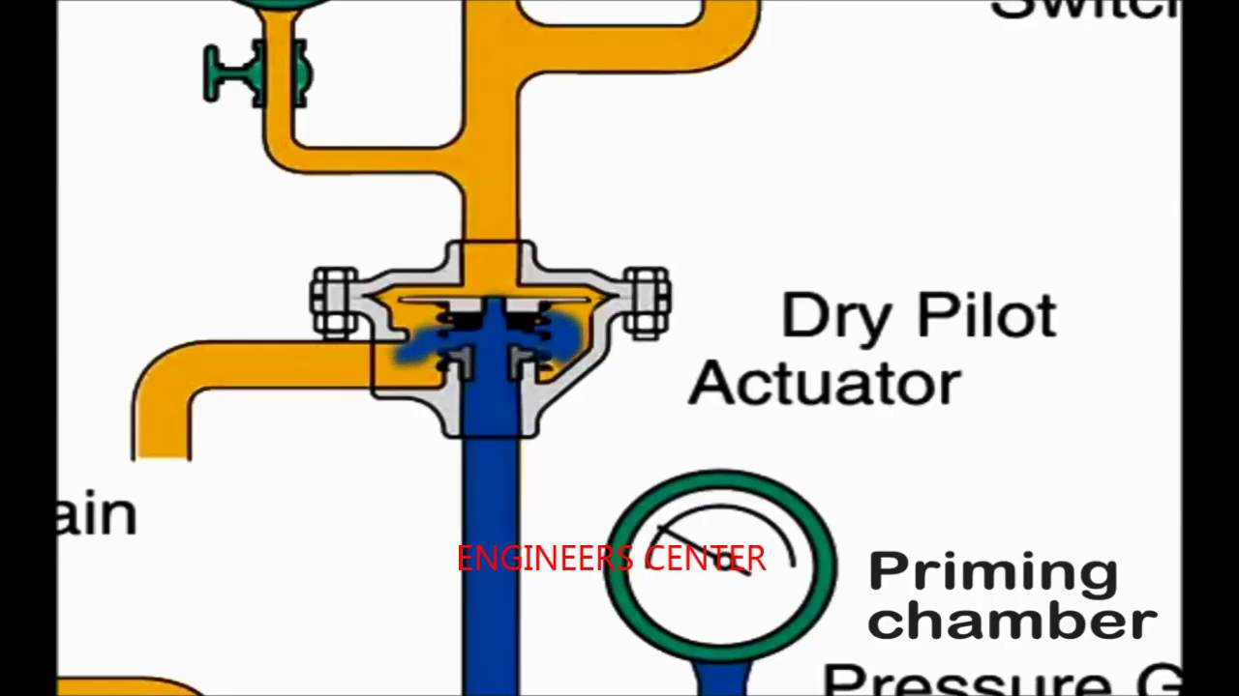
Include main details about this prior design attempt
It uses a system of cords and fuses to hold the valves that hold the water from releasing. When a fire happens the fuses ignite burning the cords and releasing the water.
https://www.reliablesprinkler.com/files/pdfs/Deluge.pdf?x10353
Provide evidence and explain what parts of this prior design attempt were unsuccessful at solving the defined problem and why based on design requirements.

The design was unsuccessful in the beginning because a certain heat level could trip the cords releasing the water when there was no fire in the building, resulting in everything inside being ruined and having to spend money to replace the cords just for the same problem to occur

