MyDesign Portfolio
Element B Initial Template

How to use this template

Element B: Documentation and Analysis of Prior Design Attempts

Prior Design Attempt #1 - < Automatic Fire Sprinkler System#1>
Source: Pros and Cons of Sprinkler Systems in Industrial Firefighting
Image:
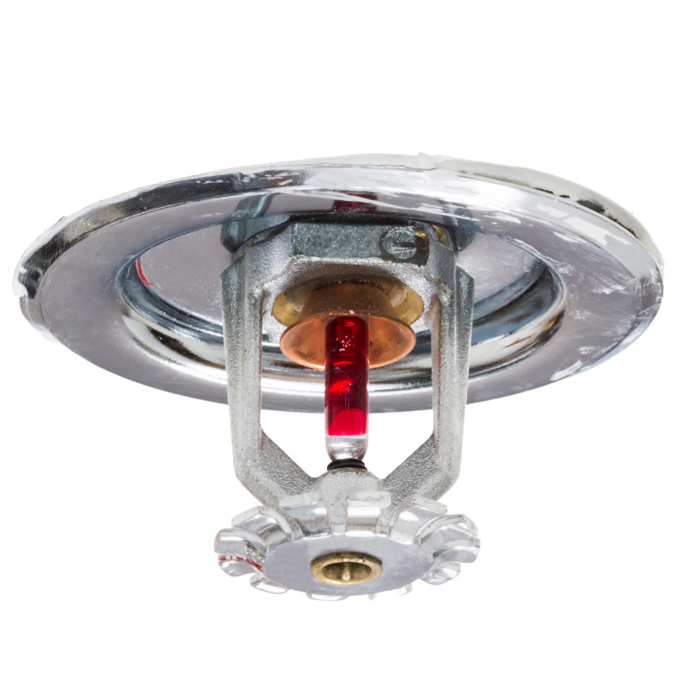
Source: Commercial Fire Sprinkler System Installation
Details: Having an automatic sprinkler system can help prevent fires from burning down buildings by putting out flames quickly. These sprinklers can stop damage before it hurts anyone or spreads. Fire sprinklers reduce the risk of dying in a fire by 82%. “https://superiorifs.com/pros-and-cons-of-sprinkler-systems-in-industrial-firefighting/#:~:text=Water%20Damage:%20One%20of%20the,modifications%20to%20the%20building's%20structure”
Analysis: Although fire sprinkler systems help prevent fires, they can sometimes activate due to false alarms. If the sprinkler releases too much water, it could damage property. Some fire sprinklers are limited to certain fires.

Prior Design Attempt #2 - < Portable Fire Extinguisher #2>

Image:
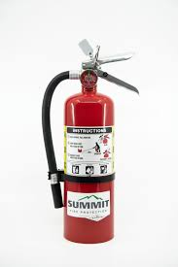

Details
A portable pressurized metal cylinder designed to put out small fires. It has a handle, a safety pin, a pressure gauge, and a hose to direct the extinguisher. It is bright red with instructions and fire classification.
Analysis
Handheld fire extinguishers are important because they allow people to control small fires quickly before any major damage is caused. They are simple and easy to use, but only effective for early-stage fires.

Prior Design Attempt #3 - < Fire Blankets #3>
Source: 3-ways-to-use-a-fire-blanket
Image: 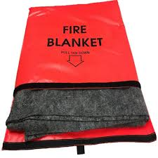
Include at least one image of this prior design attempt. Make sure to cite all images.
(Source: fire-blanket-with-red-carrying-bag
Details:
Fire Blankets are used to usually smother small kitchen fires in an apartment. They smother the flames by cutting off any grease fires from a pan. Be sure to be careful with your hand placement and how close you are to the fire when attempting to put it out by shielding yourself from the fan, because a fire blanket requires you to be 1-2 feet away from the flame. If you fail to do so, you can end up being burned. ( https://coastbiomed.com/product/fire-blanket-with-red-carrying-bag/?srsltid=AfmBOorEY8_laOaUFXkGsRTrjDOX_h38A2IV5f_WMHthknVKBDZU5Sto)
Analysis
The prior design was unsuccessful due to its failure to meet the multiple critical design requirements, specifically in the areas that focus on thermal resistance, oxygen being sealed, safety, and durability. As a result, the design doesn’t always reliably solve the defined problem of safely extinguishing small apartment fires.

Prior Design Attempt #4 - < Fire Department response #4>
Source: 3-fire-service-myths-data-response-times-and-coverage-equity-
Image: usfa.fema.gov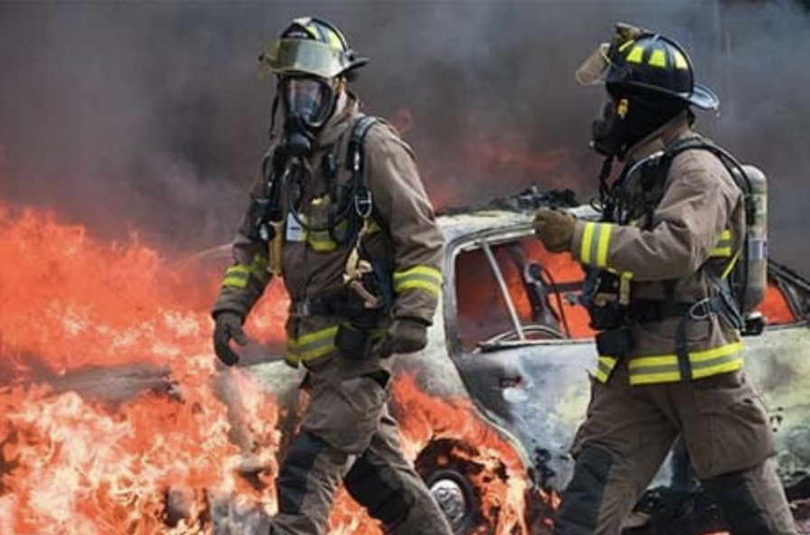

Details: Due to fire department responses, rapid arrival to high-stakes emergencies such as cardiac arrest and structural fires, there is an increase in survival rate in these situations. Fire response workers are professionals; therefore, their help can limit smoke and water damage to impacted buildings(impacted.https://www.firerescue1.com/response-time/articles/3-fire-service-myths-data-response-times-and-coverage-equity-GaCh6wfeKUDFrmqr/)

Analysis: Although Fire departments arrive at emergencies quickly, traffic, rural travel, and gearing up can create delays. This fails the “ early stage suppression” requirement because fire departments usually arrive at emergencies in 7-10 minutes, which is too late to stop the fire before “Flashover” Fires typically reach entire room involvement within 3-5 minutes, and the fire is out of control before the fire department arrives. The use of high-pressure hoses that the majority of fire departments use fails to limit property damage before the water often destroys items inside the building that the fire hasn't even impacted.

Attempt #5 - <insert name of prior design attempt #5>
Source
State the source of the information about this prior design attempt, which should be taken from any of the following credible source categories: peer-reviewed journals (check out your public library for free digital access to journals; here are some free online journals and research databases), professional organizations, government agencies, local and national newspapers, patents (here is a patent search site for the United States Patent and Trademark Office), and reputable vendors and manufacturers. Make sure to incorporate in-text citations in the details section below (i.e. don't just give a list at the end of the element or footnote).
Image
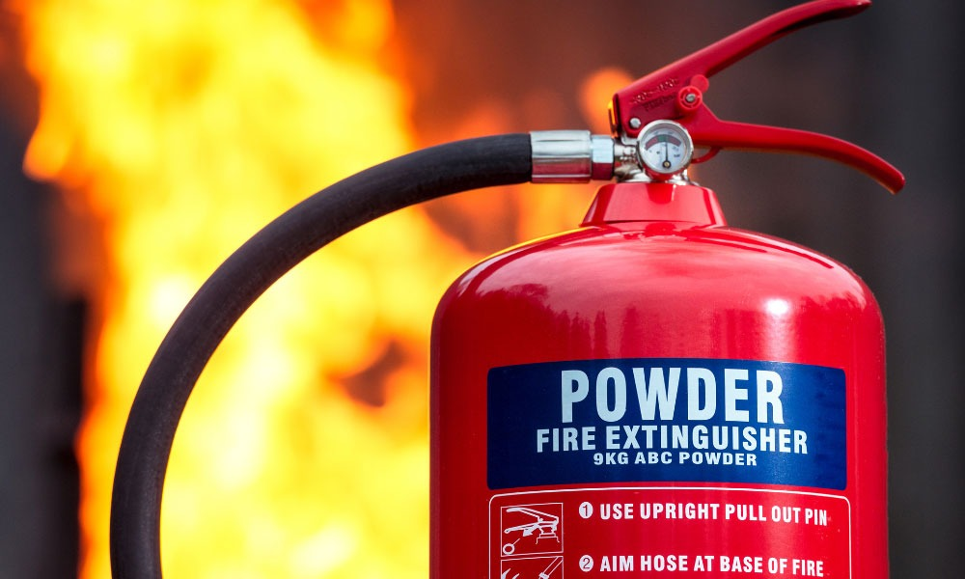
(https://integratedfire.net/dry-powder-is-the-new-go-to-for-putting-out-electrical-fires/)
Details
Dry powder fire extinguishers (ABC or multi-purpose) extinguish fires by smothering flames with a fine chemical powder—often monoammonium phosphate—which creates a barrier between fuel and oxygen while stopping the combustion chemical reaction. It interrupts 70% of the chemical reaction and smothers 20% of the fire. The powder (monoammonium phosphate) breaks the chain reaction happening in the flame. It also forms a layer over the fuel, helping block oxygen from reaching the fire. It has a 10% cooling effect, unlike water or CO₂ extinguishers. Dry powder does not significantly cool the fire; it is a small part of how it works.
Analysis

Powder fire extinguishers are very great at suppressing fires and smothering the flames, but aren't the best at addressing the underlying heat, which can lead to secondary problems. It doesn’t provide a cooling effect. For example, once the fire is put out, it can easily re-ignite if the heat source still remains.

