MyDesign Portfolio
Element B Initial Template

Element B: Documentation and Analysis of Prior Design Attempts

Prior Design Attempt #1 - <Menstrual heat patches >
Source; Thermacare
https://www.cvs.com/shop/thermacare-menstrual-pain-therapy-heatwraps-4-ct-prodid-312383?skuId=312383&cgaa=QWxsb3dHb29nbGVUb0FjY2Vzc0NWU1BhZ2Vz&

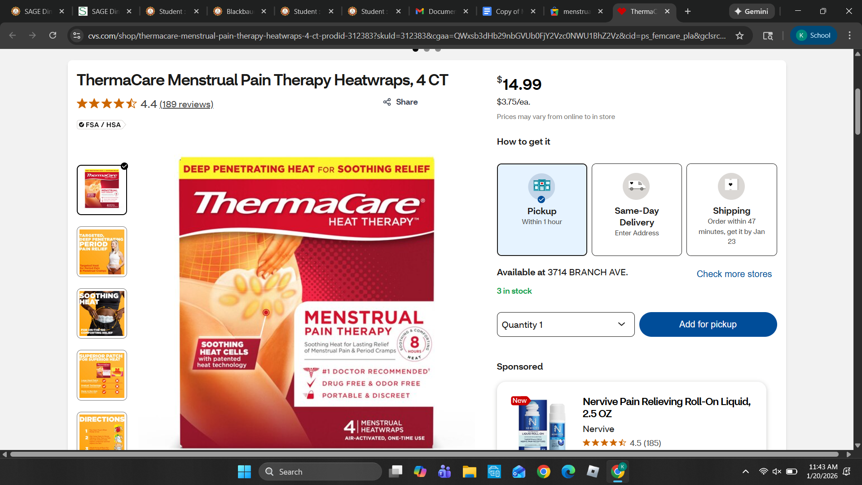
Details: ThermaCare Menstrual provides soothing heat that relaxes muscular contractions to relieve menstrual cramps. The ultra-thin design conforms to your lower abdomen for discreet comfort. ThermaCare Menstrual is thin enough to wear discreetly under clothing. It can be worn anywhere. Provides up to 8 hours of continuous, targeted heat therapy for menstrual cramps. The advanced X-shaped design allows for flexible, comfortable application to the lower abdomen. ThermaCare Heatwraps are thin and discreet enough to be worn under clothing while you go about your day. Clinically proven to be effective in relieving pain associated with menstrual cramps.
Analysis: This wouldn't work because it's a one use only heating pad meaning once all the heat is gone you have to throw it away.It also wouldn't work because sometimes the sticky side can slide around causing the pad to slide around and may cause discomfort around the area .If two people wanted to use the heating pad it wouldn't be sanitary because its going from one person skin to another.Since this heat pad is a one use only you would spend a lot of money each month on heating pads or buying them in bulk which is more expensive than 1 rechargeable heating pad .

Prior Design Attempt #2 - <Menstrual portable heat pad pink >
Source: Pink heating pad

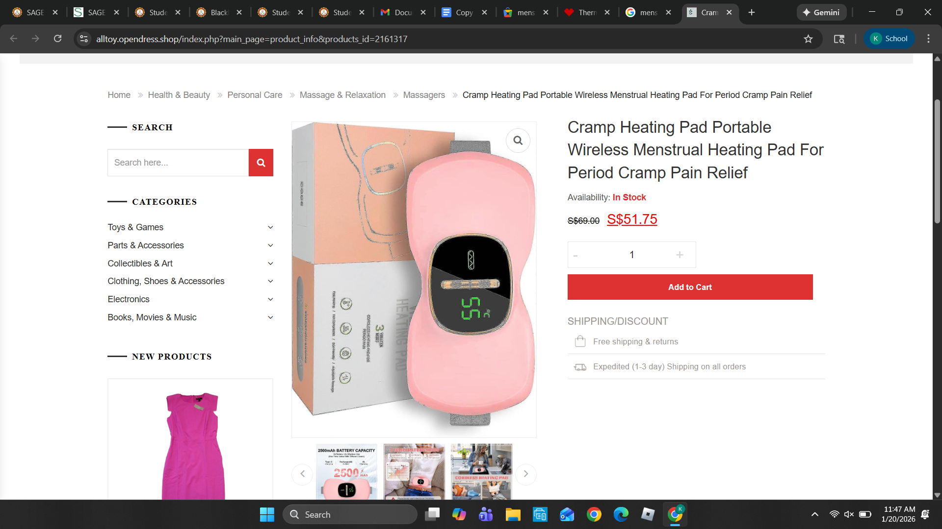
Main Details: The heating pads for cramps feature newly upgraded technology. It only takes 5 seconds to heat up and increase your body temperature. The heating pad has a built-in 2500 mAh rechargeable battery that can last for 3 hours when fully charged. This cordless heat pad is designed with a Type-C rechargeable. It features multiple adjustable modes, including 3 heating levels (122-140°F) and 3 vibration massage modes. It is ideal for menstrual cramps. In addition, the wearable heating pad comes with an adjustable elastic that stretches up to 55 inches, making it suitable for any waist size.
Analysis: Our original design was a bright color instead of neutral and wasn't discreet enough for students and staff to wear around school. If we were to use our original design, people would question it because of how distracting it would be. A vibrant color would be too distracting, while a neutral color or white would blend in better with the uniform, given that our shirts are white.

Prior Design Attempt #3 - <regular heat pad for all pains and ache >
Source ThermoTex
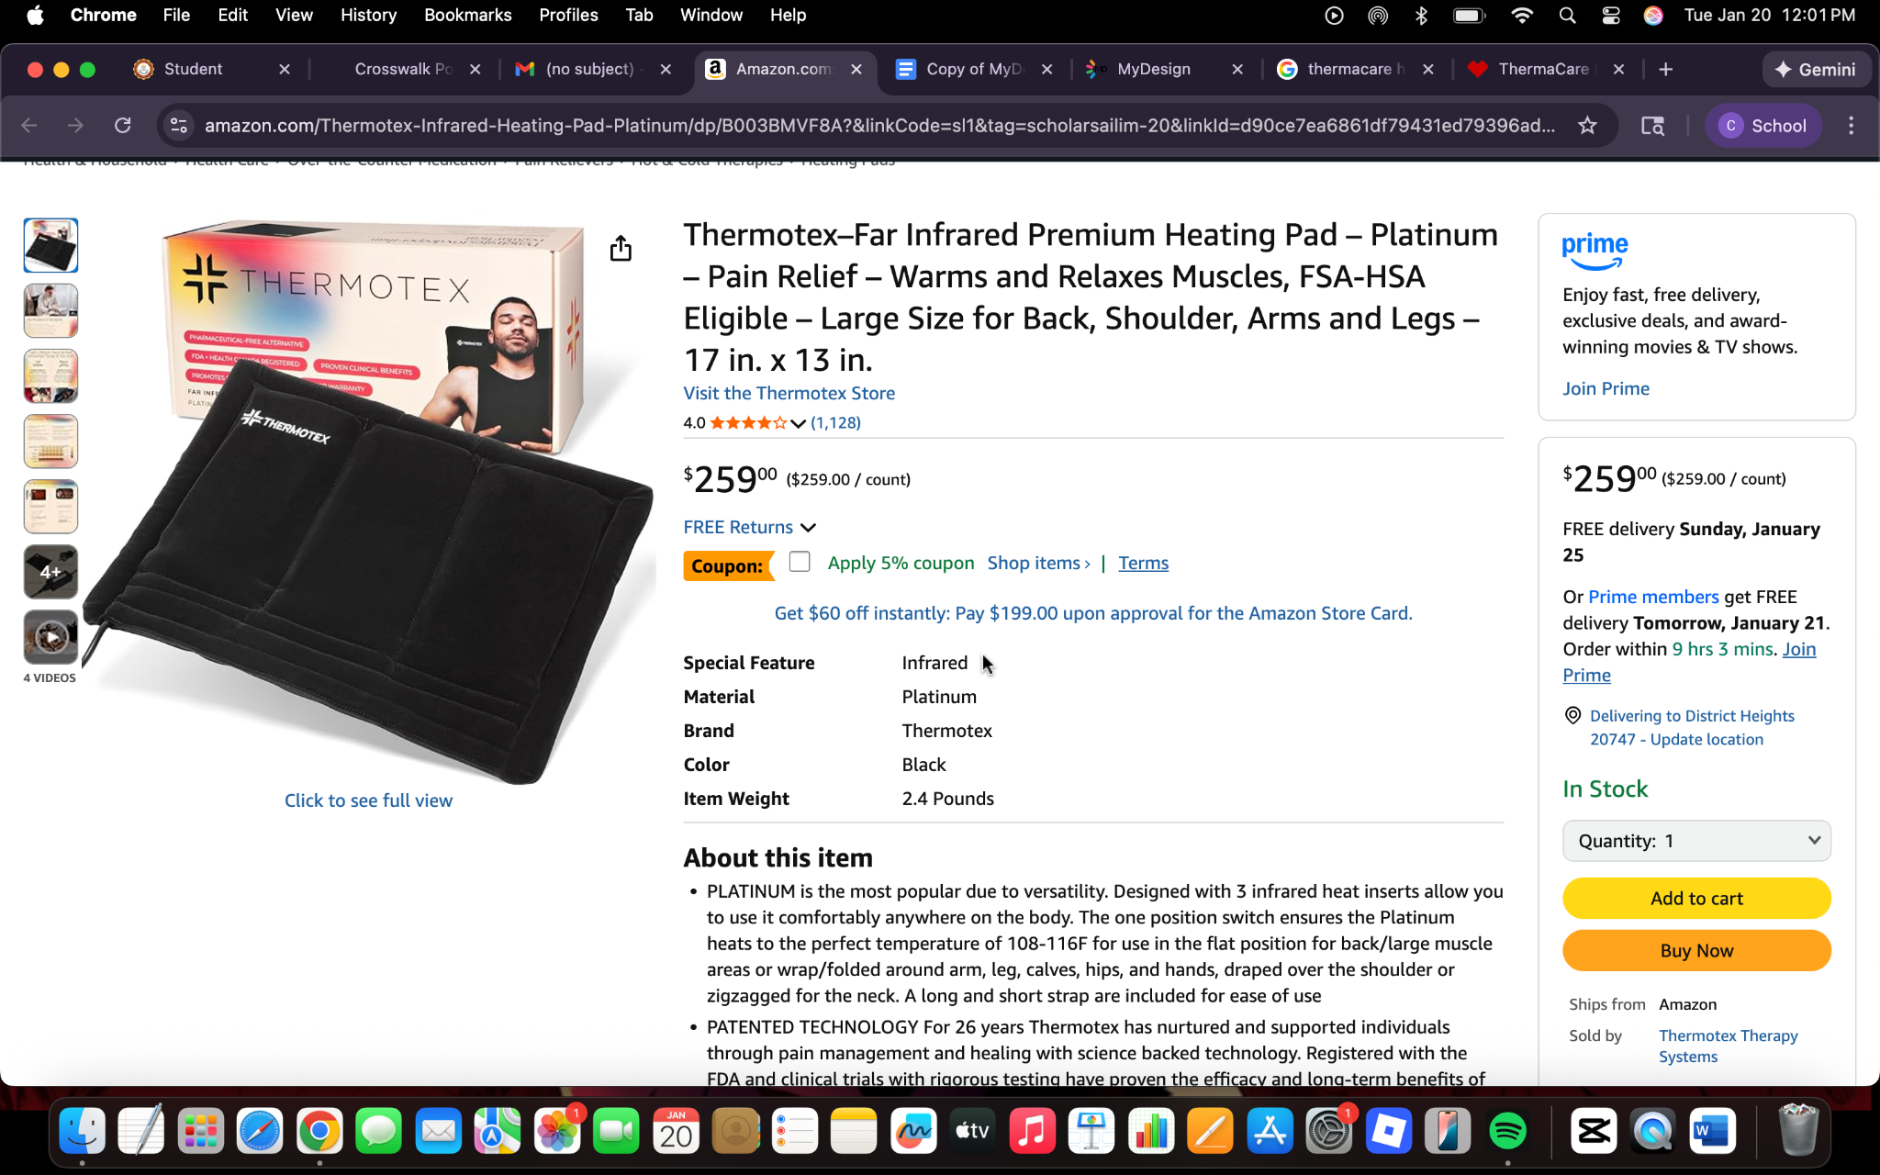
Details: It uses infrared heat, which leads to deep tissue penetration that gives relief for severe cramps. The infrared waves penetrate 2.63 inches into muscle tissue, allowing for increased blood circulation. It has an even spread of heat across the area of the body it’s on. Its temperature range is 108 degrees to 116 degrees Fahrenheit.
Analysis: This design attempt would have worked if it weren’t so large and had a lower cost. The size of the heating pad goes against what we are trying to do. We want the heating pad to be small and discreet, but this design isn’t. As for the price, it is way too expensive, it costs over 200 dollars, which for our school is way too expensive and out of budget ThermoTex.

Prior Design Attempt #4 - <warmies heat bottles>
Source; Warmies
https://warmies.com/collections/warmies%C2%AE-heat-pads/products/weighted-heated-marshmallow-gray-warmies-bottle

Image
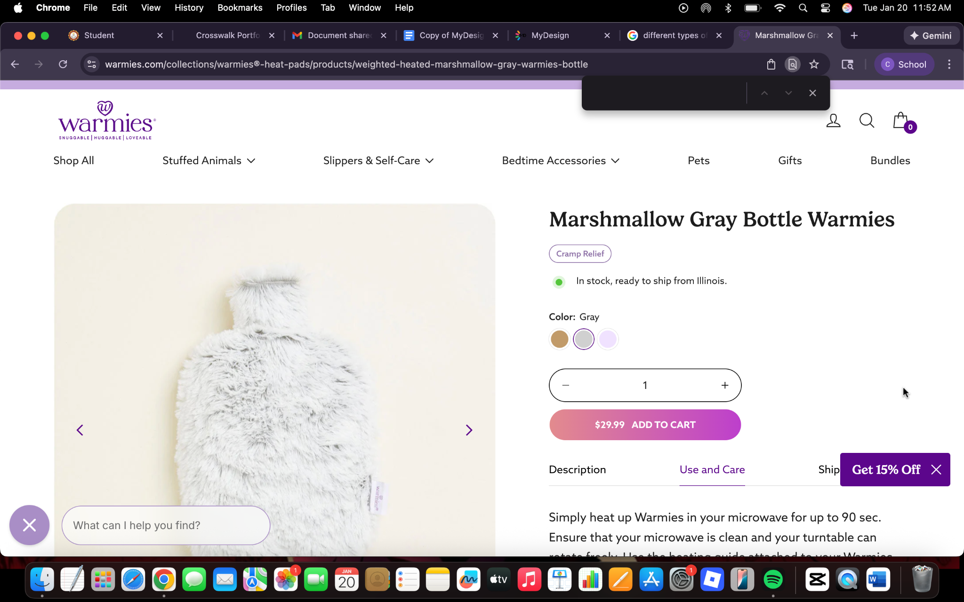
Details: Warmies bottle heat pads are cordless, no mess, and warming as needed heat pads. They give gentle and lasting comfort with a soothing lavender scent and soft plushy fabric. To use them you microwave or freeze them to relieve aches and cramps. Uses: heat up in the microwave for up to 90 secs. Check the heating guide to have the proper heating time. Lasts for up to 2 hours and can be reheated after it comes down to room temp.
Analysis; The product is too big and is not discrete enough to be used in class. Also, it is not very good for sanitary reasons such as cleaning the fur. In addition it is ineffective because you have to warm it up every time you go to use it .

Prior Design Attempt #5 - <Livia Menstrual device>
Source; Livia
https://www.cvs.com/shop/livia-menstrual-pain-device-prodid-7200352?skuId=645990&cgaa=QWxsb3dHb29nbGVUb0FjY2Vzc0NWU1BhZ2Vz&cid=ps_femcare_pla&
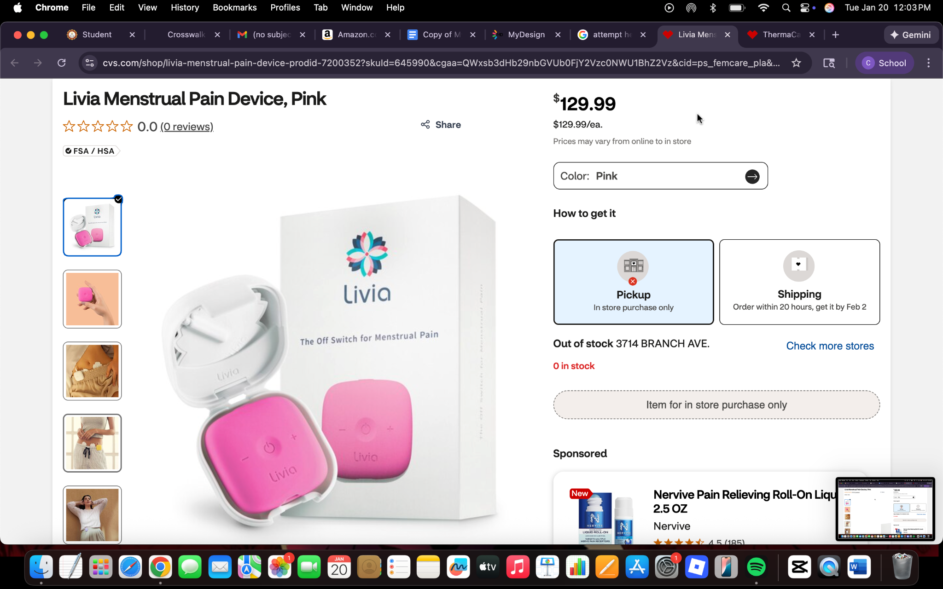
Include at least one image of this prior design attempt. Make sure to cite all images.
Details; The Livia heat machines are award-winning, FDA cleared wearable heat pads that use pain blocking technology that relieves pain within 30 to 60 seconds. It is a clinically tested, drug free, and trusted device. It is lightweight, compact, comfortable to wear, and customizable in color. It is rechargeable and convenient
Analysis; This device is too expensive and can be considered too small for some people who have cramps in different areas of their stomach or body at the same time.

