MyDesign Portfolio
Element B Initial Template

How to use this template
Teachers: You may customize this document before providing it to students.
Students: The template below is one way to structure your research findings around past and current attempts to solve the problem, but the specific assignment given by your instructor may require a different structure or dictate different details. If you make a copy of this template to edit for your own research into prior design attempts, be sure to delete the instructions.

Element B: Documentation and Analysis of Prior Design Attempts

Prior Design Attempt #1 - <Cheap cement pavers under 3d printer design attempt #1>
Source: https://www.cnckitchen.com/blog/reduce-your-3d-printing-noise-with-a-concrete-paver
Image: 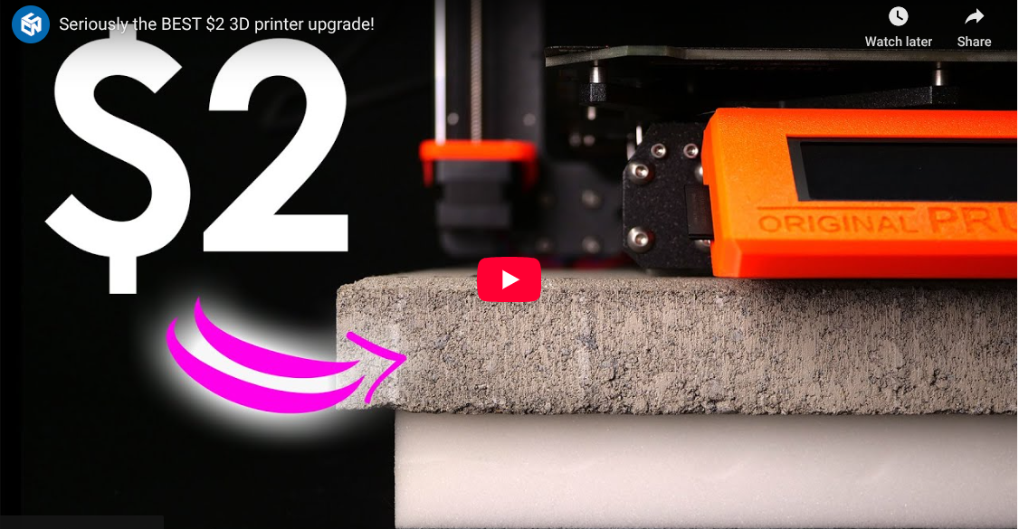

(The build was an overall success as shown by the quote below)
(“I got the best results from this really soft packing foam where we even got below 56 dB during the travel moves.”)

Prior Design Attempt #2 - <How to Build a Soundproof Box for Your Noisy Equipment #2>
Source: https://arrowzoom.com/blogs/news/how-to-build-a-soundproof-box-for-your-noisy-equipment?srsltid=AfmBOoojeTm9z8I64XLn8z24kZXmDSZtEV8azbdfURjqwrl2juG-BqRV
Image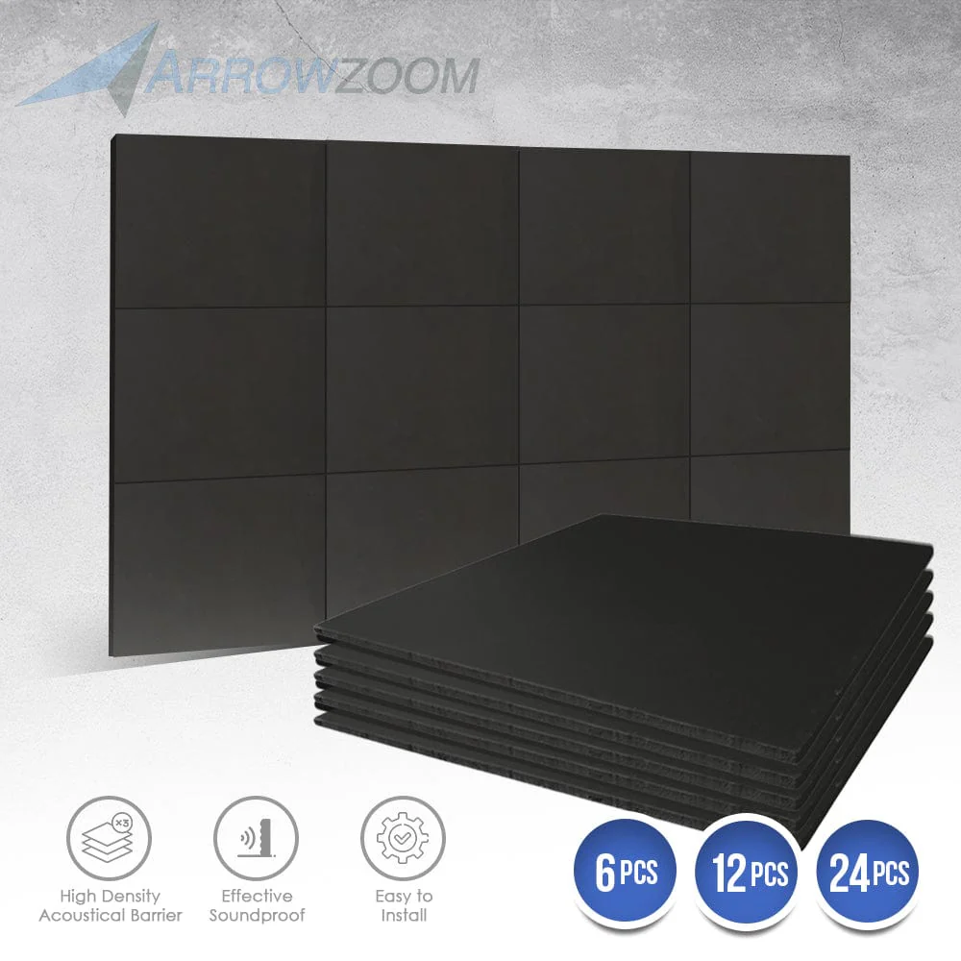
(This build has also shown to be a success)
(“Once everything is assembled, place your equipment inside, close the lid, and listen carefully. … With the right materials and setup, you should be able to reduce noise by 50% or more!”)

Prior Design Attempt #3 - <3D Printer Enclosure #3>
Source: https://www.instructables.com/3D-Printer-Enclosure-1/
Image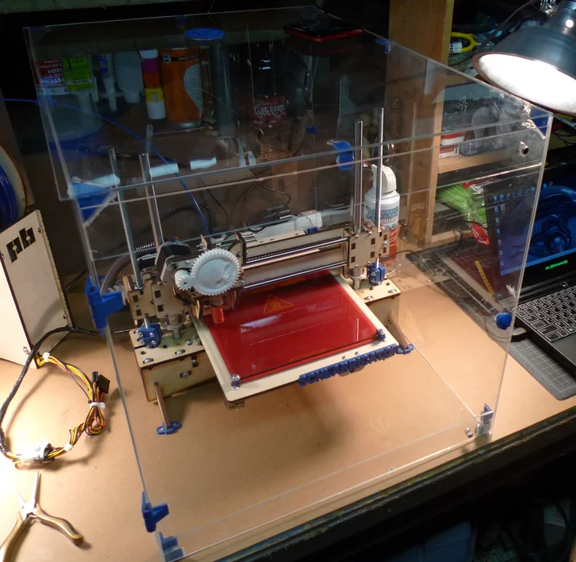
(Spent a lot of time constructing the objects together and eventually he built it successfully)
(“I've been using this enclosure almost daily since I built it and I can tell you two things: it works great at trapping heat and controlling the thermal environment around your printer…”)

Prior Design Attempt #4 - <Silencing A 3D Printer With Acoustic Foam Isn’t That Easy #4>
Source:https://hackaday.com/2023/09/20/silencing-a-3d-printer-with-acoustic-foam-isnt-that-easy/#:~:text=The%20foam%20did%20help%20cut,printer%2C%20acoustic%20foam%2C%20sound%20reduction
Image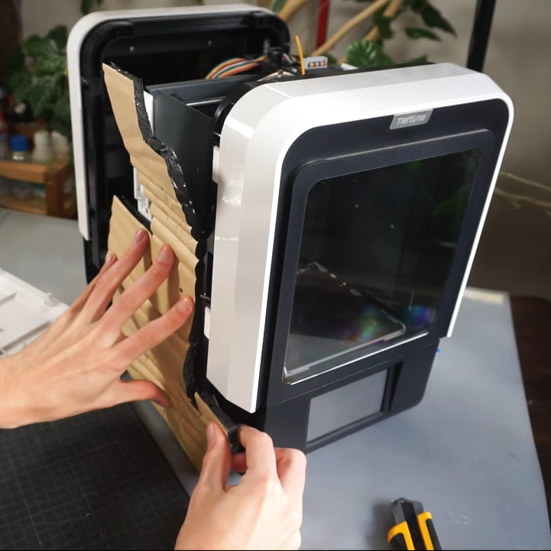
(They tried using foam to build a noise reducer for the printer and sadly failed at the task)
(“Unfortunately, the work didn’t have a great effect on the printer’s sound output.”)
Some parts of the printer, especially transparent panels, were left untreated and continued to leak noise. As being stated “That’s perhaps unsurprising, given it still has uninsulated panels like the front window which are still free to radiate sound”.

Prior Design Attempt #5 - <How to Make 3D Printing in Homes and Offices Safer, by Building an Enclosure That Filters Gases and Particulate Matter #5>
Source:https://www.instructables.com/How-to-Make-3D-Printing-in-Homes-and-Offices-Safer/

Image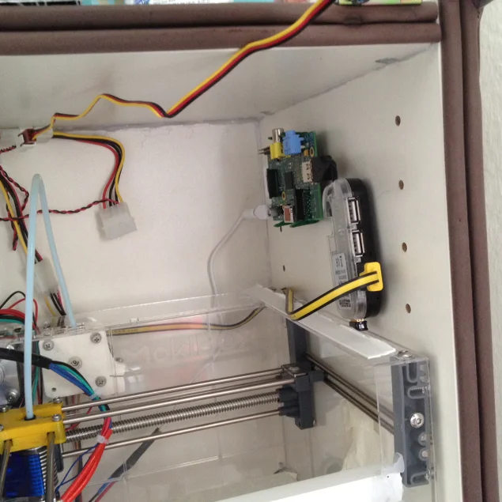
Include at least one image of this prior design attempt. Make sure to cite all images.
Details
(Long story short, this build was pretty successful as the materials provided for surroundings fulfilled the task.)
(“Overall, I am happy with the outcome of this project, given that it reduced the observable effect of the 3D printer on the ambient air drastically, because I cannot smell the 3D printer while and after printing.”)

