MyDesign Portfolio
Element B Initial Template

Element B: Documentation and Analysis of Prior Design Attempts

#1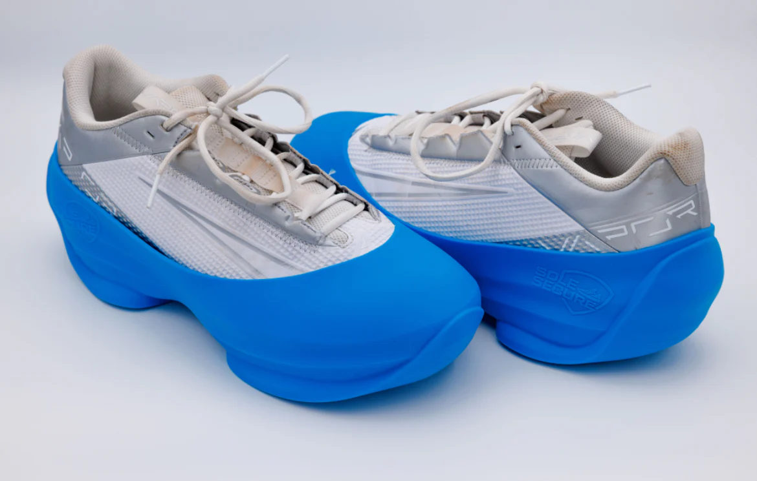https://solesecure.com/products/sole-secure
This Image is showing a silicone cover that goes over cleats or any shoe that is made for outdoor uses. It adds traction on the bottom of the shoe so you don't slip in an indoor area with tile
While reusable boot covers solve the main problem by adding friction and prevent slipping, they are not perfect.(OSHA, ANSI and ADA Regulations for Walkways and Surface) says “High-Traction (SCOF of 0.6+) Moderate Traction (SCOF of 0.4 – 0.6) Low Traction (SCOF of <0.4)”, when wearing cleats on tile the SCOF is anywhere between .1-.2 which is dangerous by wearing the covers it will greatly increase the SCOF. They can be inconvenient to carry around and can get lost. Some covers can be difficult to stretch over the cleats and take them on and off so It can be better to just take your cleats off than to spend time trying to put the covers on. They can also get worn down due to the spikes digging in them. They are a good solution but do not entirely remove the problem of sleeping because kids can forget to put them on or maybe it can't even fit on their shoes so they are unwearable.

#2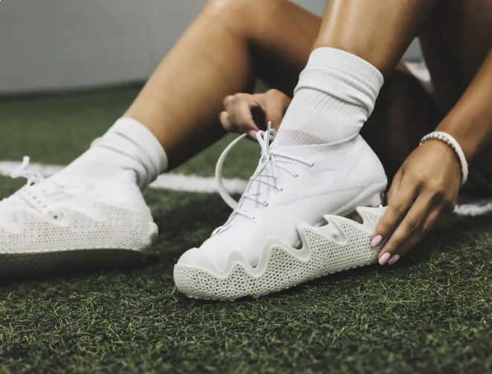https://hypsole.com/products/tidal3d-elite
This image shows a 3d printed cleat cover that goes over a football and soccer cleat. This is so you don't have to take your cleats off when you step inside. It also traps dirt and grass so when you step off the field there isn't dirt in an indoor area.
This will allow football players and soccer players to easily protect their cleats from getting messed up off the field. It will also trap dirt and protect the athlete from falling. It can be inconvenient because the sizes stop at 13.5 inches for the cleat guard. This can be a problem for bigger athletes with bigger feet because it costs more to get a custom one to fit their true size. Normal 3d cleat covers cost between 45-65 $ which makes them 2-3x more expensive than silicone cleat covers that were shown in #1 but they are more durable so you will be able to get more use out of them the last 6-12 month while silicone last 2-3 months.A New Use Case for Additive Manufacturing: Cleat Guards « Fabbaloo

#3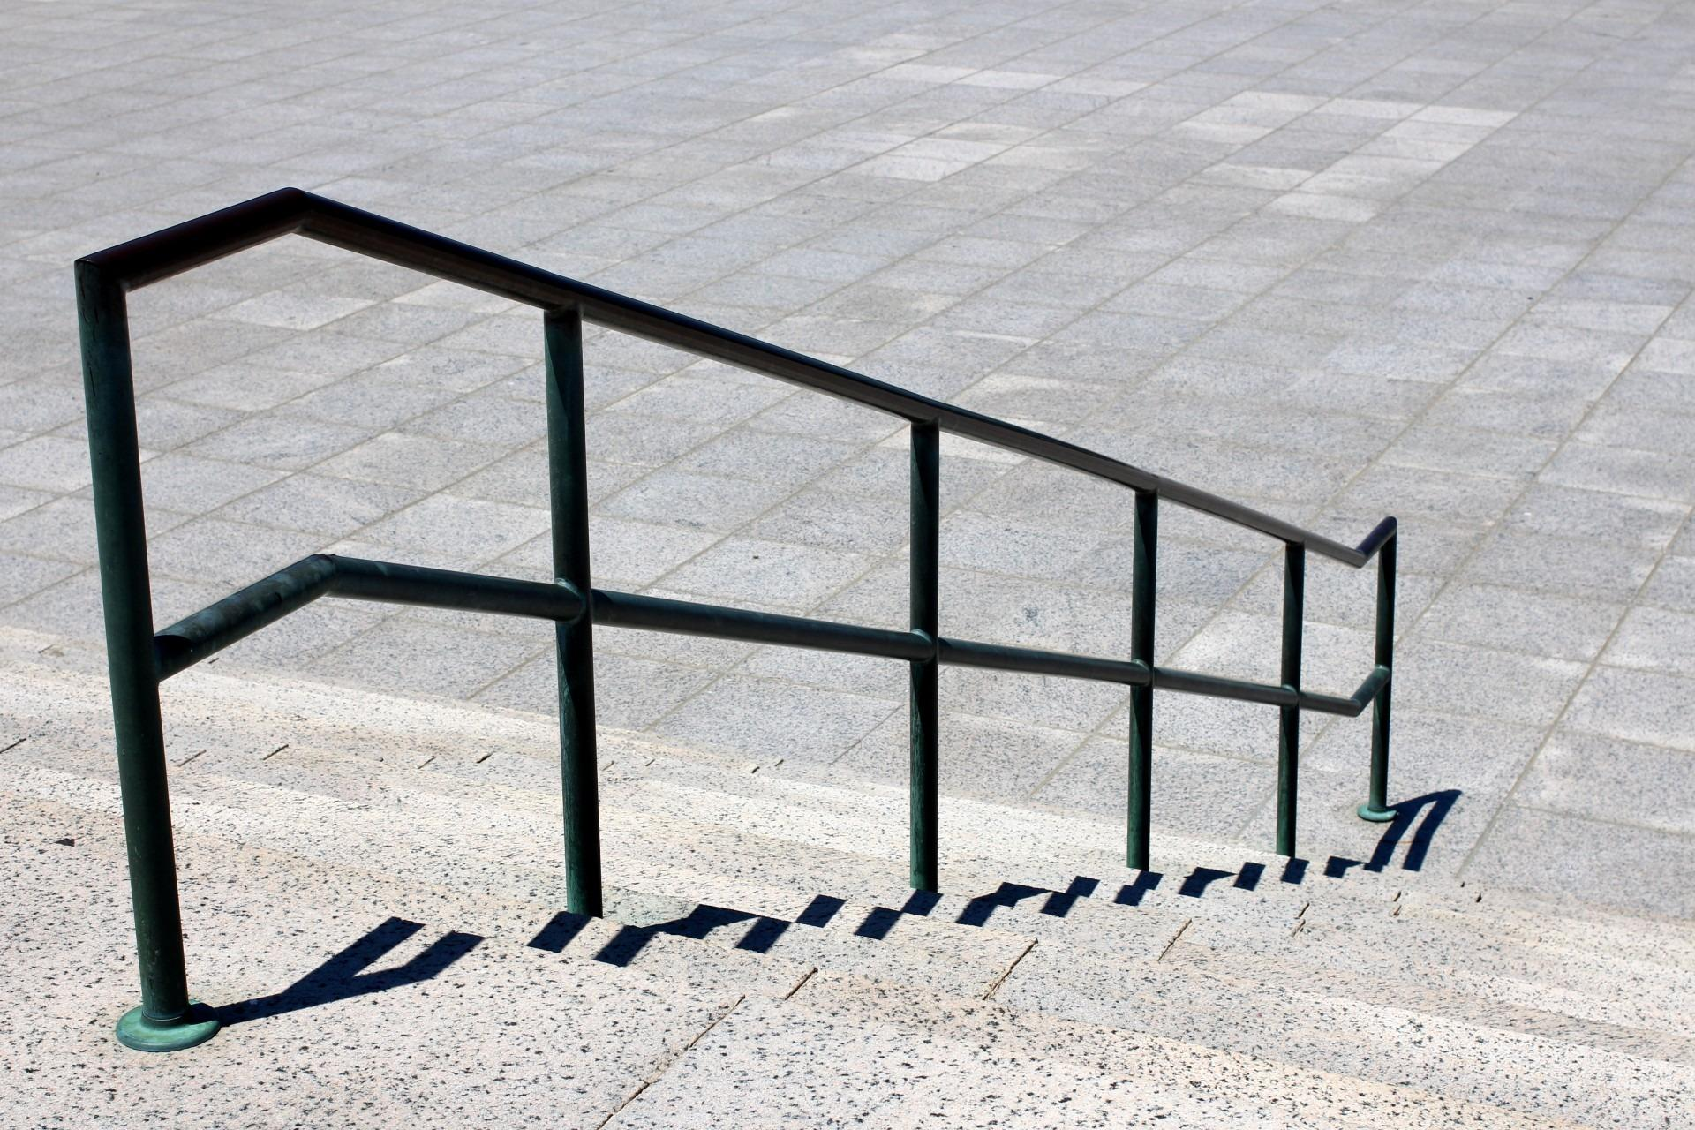https://www.artec-rail.com/the-importance-of-safety-handrail-systems-for-buildings/
Some schools install safety railing to prevent people from falling. The railings are normally made of metal or reinforced plastic and mounted to the wall. This only provides support and it does not stop the friction problem. This is probably one of the most simple solutions because it does not require athletes to put on or take off anything to walkin inside the building.
Railing can reduce the severity of the fall but will not stop people from falling. Walking with cleats exposed is a hazard. The railing will only help if the athletes are walking near them and close enough to grab it if they fall. This solution does not fix the problem of athletes sipping on the tile, or prevent the tile from getting damaged. Why Do Handrails Improve Accessibility and Prevent Falls? In this article they say, “handrails offer a crucial point of contact they can hold onto for stability. This support helps: Maintain balance, assist mobility, Aid transitions, Reduce fatigue” this further shows why a railing could help athletes from falling. This does not fix the friction problem but it can help people when they fall/stumble they can catch themselves. It also doesn’t prevent the floors from being scratched.

#4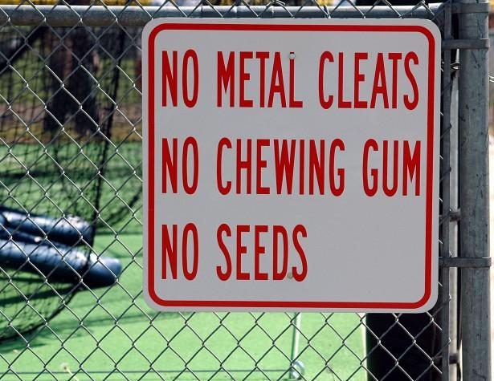Danger Vs Warning Vs Caution Vs Mandatory Signs — NZ & Australian Safety Standards Explained
Warning signs are placed at the front of buildings to remind our athletes to remove their cleats before they enter. It is a visual alert to remind them of a hazard.
Warning signs are good to alert people of a danger or hazard, data from (link) says that signs can increase compliance by up to 40 %. This will help athletes be alert to the danger of them wearing cleats in the building. Placing a sign where people can see will hopefully remind everyone to take their cleats off. This solution does not stop people from slipping if they choose to ignore the sign there is nothing we can do. This is an ok temporary solution because it does not fully prevent people from slipping risk how we want to.

#5
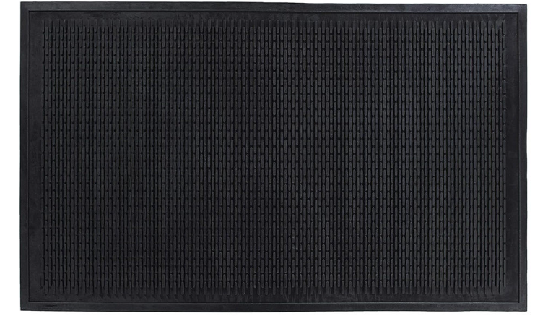
link-https://zogics.com/cleaning-supplies/clean-step-scraper-outdoor-floor-mat-natural-rubber?utm_source=chatgpt.com
High traction mats can be placed on the tile floor to prevent slipping. They can be laid out and create a path that reduces the risk of slipping.
These mats directly address the problem because they make the floor not slippery and safe to walk on while still wearing cleats. link this source says “These pads introduce a thick, high-friction layer between the two surfaces” this is a great thing because these mats add friction to the walking surface the risk of falling greatly decreases. One problem that might occur is that it could get worn down quickly or be difficult to clean. We would be able to make a path from the door to the trainer/ bathroom that would be way more safe than walking on the tile.

