MyDesign Portfolio
Element B Initial Template

Element B: Documentation and Analysis of Prior Design Attempts

Prior Design Attempt #1 - Hands free oreo dispenser
The Practical Engineer
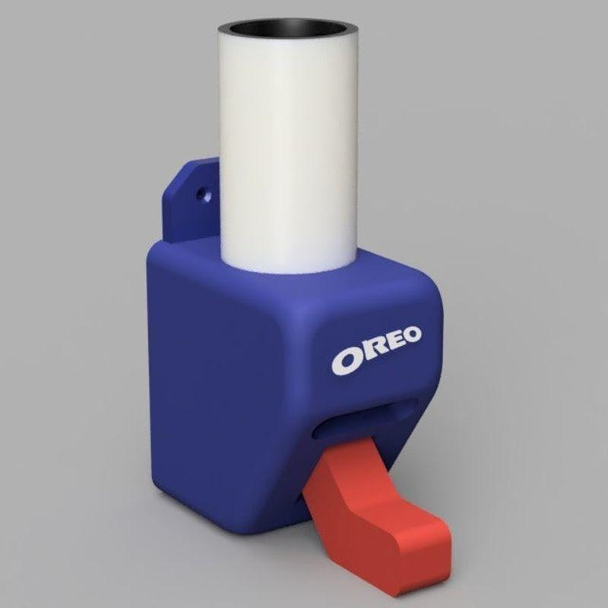
https://youtu.be/XjogNT3YSWo
https://thepracticalengineer.com/blog/oreodispenser
This design was created for people that allow them to receive cookies through a slot and tube like machine. Although, nothing is stopping them from getting as many as they want so this design doesn’t meet all the criteria needed in order to solve the problem of uneven distribution.
This design includes a slot for the cookies to come out of, a tube structure at the top to hold the cookies and enclose them. There is also a red piece that is pushed in by someone’s jaw. That lets the cookie slide out of the dispenser. This was initially designed as a way to get cookies dispensed into someone’s mouth without it touching their hands. This is inefficient to us, because the students would need to dispense it onto plates in order to meet health code standards. Additionally, this might not be able to support the sheer amount of cookies needed for the school-wide dispenser.

Prior Design Attempt #2 - Oreo Dispenser (command strip mount)
PSsomeone- licensed under creative commons attribute.
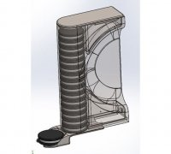https://www.thingiverse.com/thing:3083514
This is licensed under a creative commons license. This was made as a fun way to dispense oreos on a wall. There is no button though for dispensing.
This is designed to be mouthed to the wall, and as soon as you take one out it can be replaced. There is a main holder and support, and then there is a cap to prevent contaminants like dust from getting into your cookies. This was successful, though some people commented that it needs more support. This would not work for our problem though, as this is a fun dispenser for cookies at leisure, but would not work in a situation where multiple people could get cookies safely and following all regulations for school code. Additionally, it does not look like there is a safe stop for cookies, meaning an individual could get as many as they wanted.

Prior Design Attempt #3 - Cardboard dispenser prototype
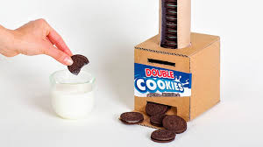
https://www.youtube.com/watch?v=vTy0nESBJf8
There is no way to limit the number of cookies the students receive. Cardboard is not durable enough for rowdy teenagers during a school lunch. The size is too small to fit the cookies they distribute at lunch. Even if scaled, this is only a prototype, and it could be taken into a larger scale but would need a way to prevent multiple cookies from flowing out.

Prior Design Attempt #4 - Cookie dispensing machine
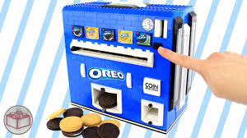https://www.youtube.com/watch?v=jqmKmFyXVw4
IThe coins are placed in the coin slot then the black button is pressed. The user would then slide the black tab to the type of cookie they want. Then the button near the coin slot would be pulled out and the cookie would be ejected from the bottom.
It is not big enough to hold the amount of cookies they provide at lunch. The compartment that ejects the cookies isn't big enough for the cookies we serve at school. The legos will not be the most stable material for rowdy teenagers who attack each other over cookies. The students will not have options as they only receive the flavor of cookies the lunch staff provide that day. The process to dispense the cookies will take too long.

Prior Design Attempt #5 - Cardboard cookie dispenser
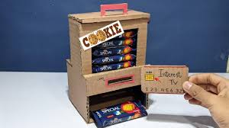.
https://www.youtube.com/watch?v=uYGcZ92vmCw
This design has a slot where a card with a chip can be inserted. Something inside the dispenser will recognize the chip on the card and the cookies will come out of the dispenser’s opening.
It is not big enough to hold the amount of cookies they provide at lunch. The cardboard will not be the most stable material for rowdy teenagers who attack each other over cookies. It might take too long for the dispenser to recognize the chip which would take longer then we need it to.

