MyDesign Portfolio
Element B Initial Template

Element B: Documentation and Analysis of Prior Design Attempts

Prior Design Attempt #1 – Shiffler PakRak Safety Backpack and Coat Hook
Source
This prior design is a commercial classroom hook system that helps keep bags off the floor in school environments by providing a mounted hook solution. Shiffler equip
Image
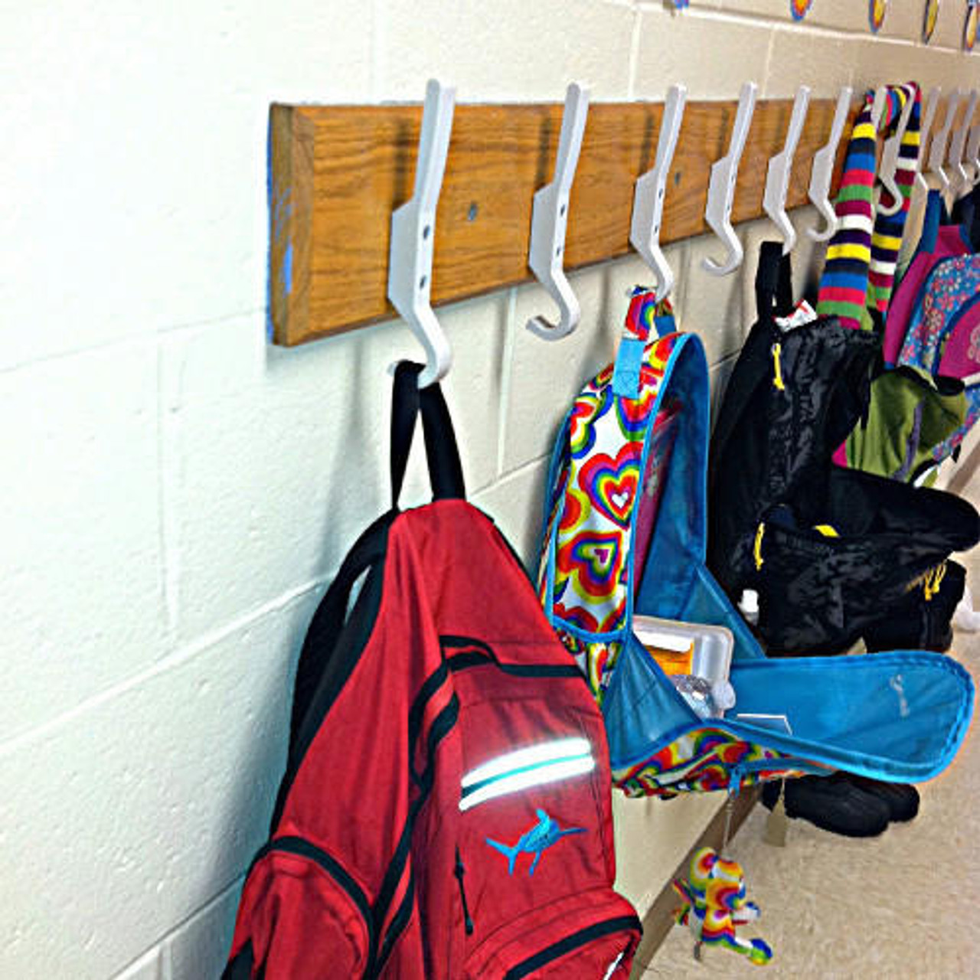Shiffler Equip
Details
The Shiffler PakRak is a wall‑mounted hook designed for backpacks, coats, and other student items. It is made of high‑density polyethylene plastic that resists rust and corrosion, and it promotes organized storage by offering a designated hanging point.
Analysis
Although this hook keeps bags off the floor and organizes space, it is not designed to attach to desks, the specific problem your design must address. Its wall installation requires classroom space and is less flexible than a desk‑mounted hanger.

Prior Design Attempt #2 – Portable Student Desk Backpack Hook (Anderr)
Source
A portable, detachable backpack hook designed for desks that students can install without tools, commonly sold online. Walmart
Image
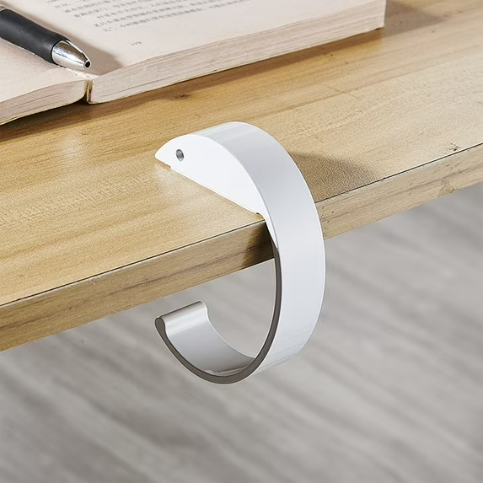Walmart
Details
This hook clamps or mounts to a desk edge and is made of stainless steel for durability. It can hold backpacks, umbrellas, keys, or other items.
Analysis
While this design attempts to hang backpacks from desks, it often does not provide enough stability for heavy textbooks and can slip off certain desk shapes. Additionally, its side mount design may interfere with students’ legs or chairs.

Prior Design Attempt #3 – Academia Backpack Hook for V2 Series Desks
Source
A steel backpack hook made to attach to specific desk models like the Illustration V2 Series, sold through educational supplies vendors. Schoolsin
Image
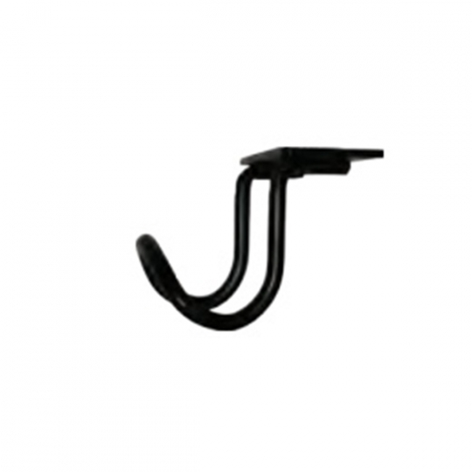Schoolsin
Details
This simple hook keeps backpacks off the floor by mounting directly on compatible desks and tables. It is steel and fits specific models.
Analysis
This design solves the problem of floor clutter, but is limited because it only fits certain desk models. Your design must be more universal for many desk shapes.

Prior Design Attempt #4 – Curriculum Backpack Hook (National Business Furniture)
Source
A ready‑to‑install metal hook designed to mount under desks or activity tables as part of classroom furniture sets. National business furniture
Image
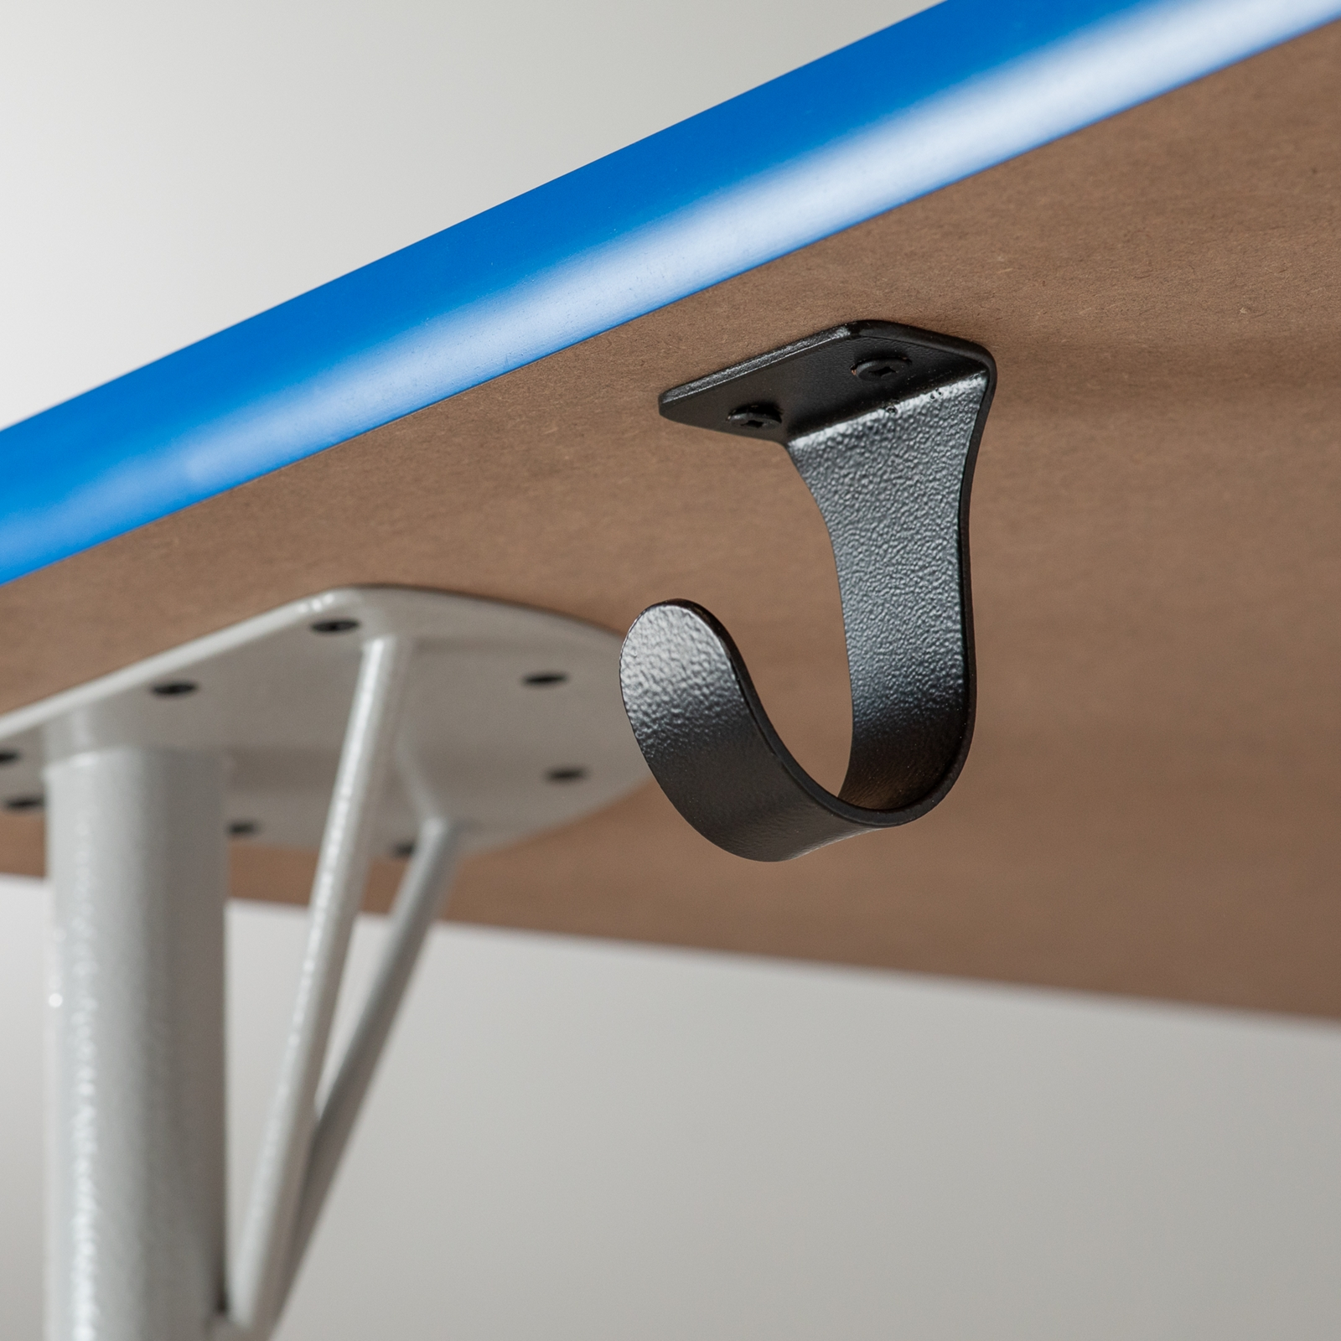National business furniture
Details
This metal hook attaches underneath a desktop to store backpacks, helping keep floors clear. It is part of a classroom furniture collection.
Analysis
While functional, this hook isn’t adjustable for all desk sizes or shapes. Some desks may lack the support needed for safe installation.

Prior Design Attempt #5 – Portable Desk‑Mounted Backpack & Headphones Hanger
Source
A clamp‑style desktop bag/backsack hanger that mounts to desks or tables, designed to hold backpacks and other items without permanent installation. Amazon
Image
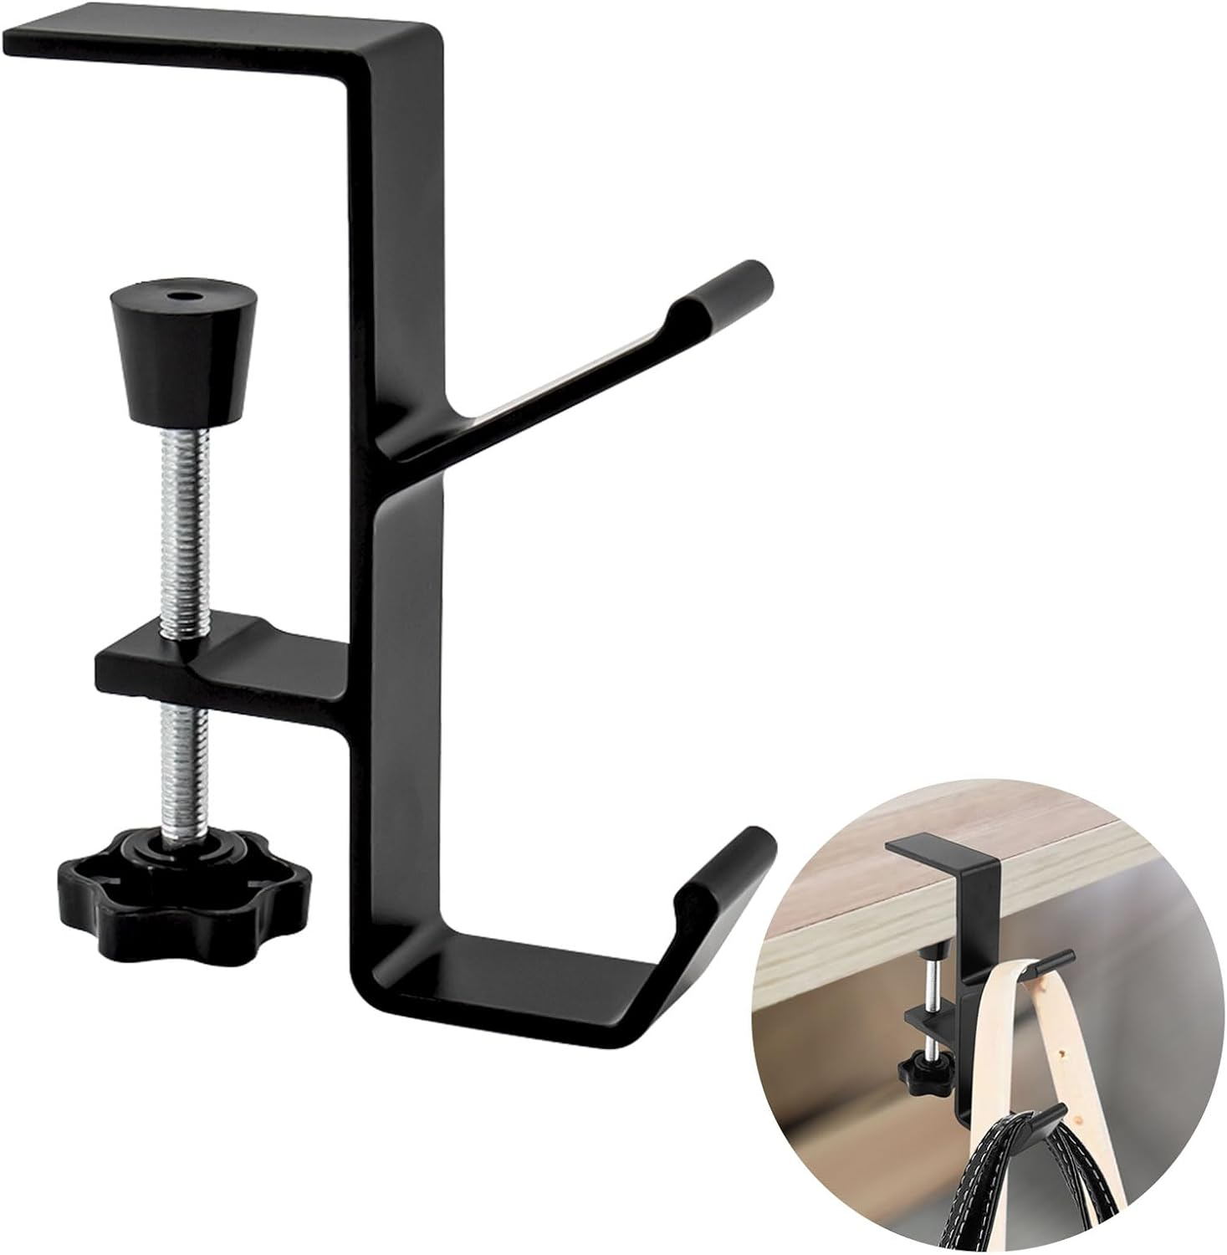Amazon
Details
This backpack hanger uses a clamp‑on design that tightens to fit various desk thicknesses. It is made of metal and can be attached under or to the side of a desk without tools. Because it is portable, it can be removed or moved as needed and does not require drilling or screws. The hook is strong enough to hold bags, backpacks, headphones, umbrellas, and other items.
Analysis
This prior design is closer to what our team needs because it attaches to the desk instead of the wall. However, it still has limitations: the clamp might not fit all desk shapes or thicknesses, especially desks with unusual frames. It also may not be stable enough for very heavy backpacks full of textbooks, and some versions are primarily marketed for lighter objects like headphones.

Summary

The prior designs above show multiple ways designers and companies have tried to solve the problem of backpacks on the floor. Some use screw‑mounted hooks that are strong but not easy to install on all desk types, while others use clamps or lightweight solutions that are easy to reposition but may lack the strength needed for heavy loads. Most designs either:
Require permanent installation that limits desk flexibility,
Don’t fit all desk shapes or thicknesses, or
Lack strength for heavy backpacks, especially full of textbooks.

Because of these limitations, there is still a need for a universal, adjustable, and strong backpack hanger that can fit different desks in your school and securely hold student backpacks without damaging

