MyDesign Portfolio
Element B Initial Template

Element B: Documentation and Analysis of Prior Design Attempts

Prior Design Attempt #1 - Joint Base San Antonio Portion Control
https://www.jbsa.mil/News/News/Article/1780732/variety-of-healthy-foods-portion-control-key-to-nutritious-eating/
This source comes directly from the official U.S. government website of Joint Base San Antonio.
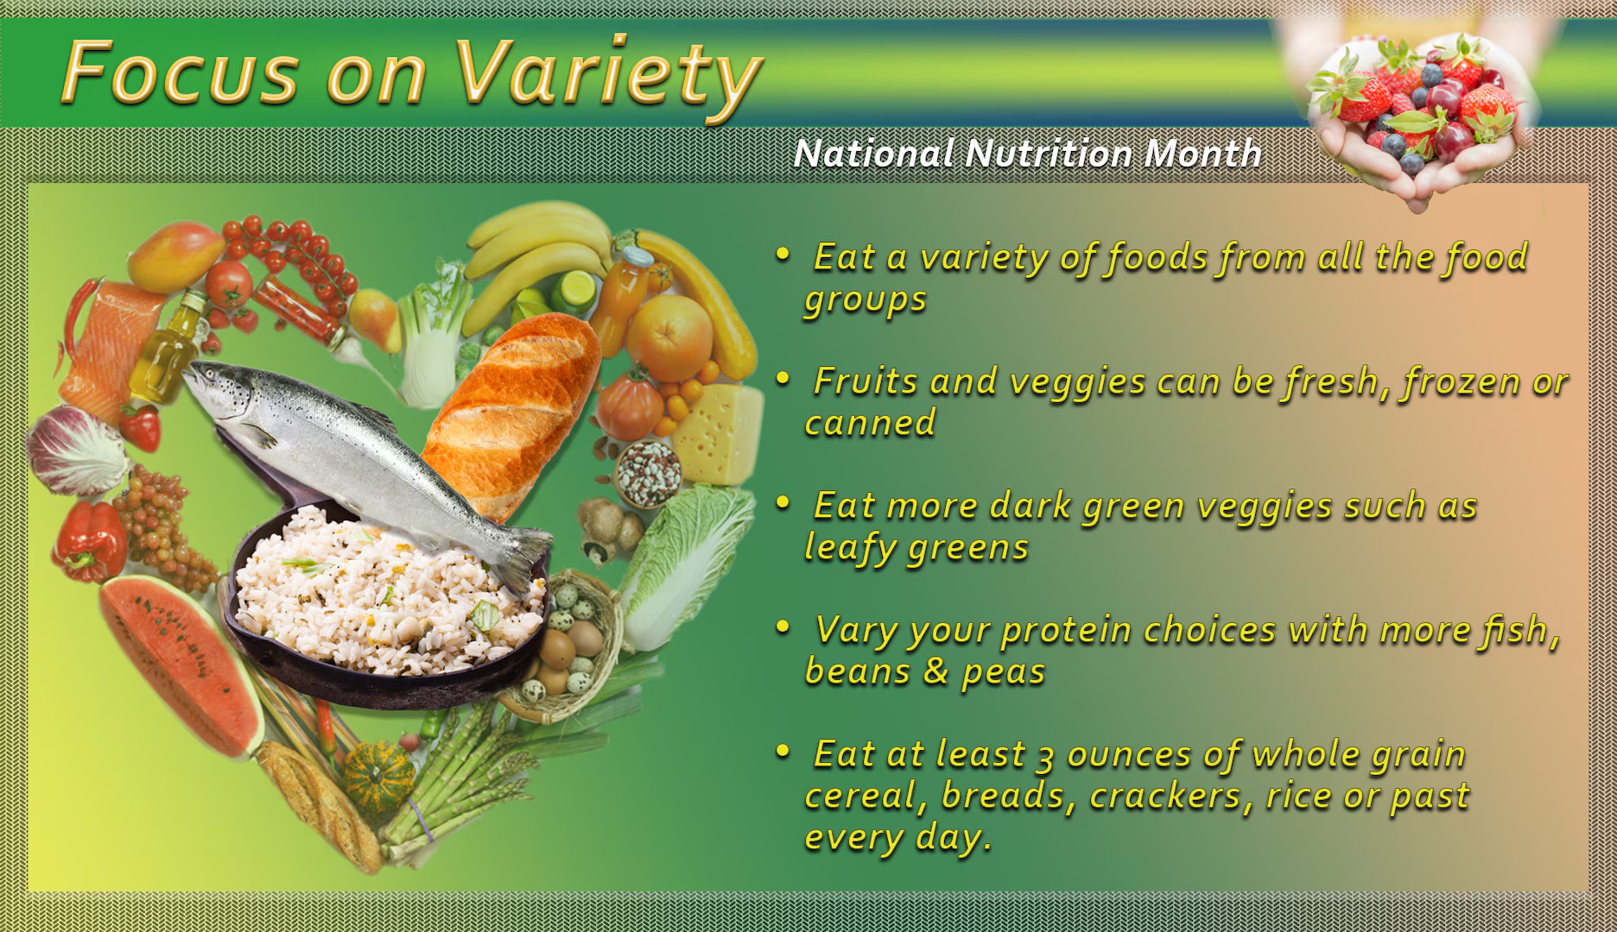
This program was created to encourage service members on base to eat a wide variety of healthy food from all food groups.
One flaw in this design is that it suggests you use your hand to measure how much food you put on your plate, and this is a flaw because peoples hands are different sizes.

Prior Design Attempt #2 - Pick Your Portion Food Program at Dickinson College < #2>
Pick Your Portion Food Program at Dickinson College
This source comes directly from the Dickinson College in Carlisle, PA.

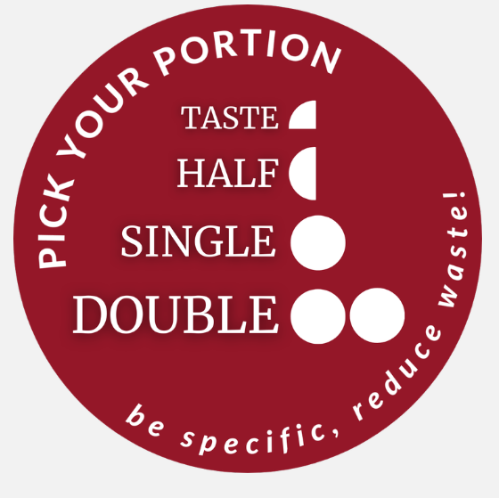

Pick Your Portion Program Graphic

Dickinson’s Dining Services rolled out the program as part of a greater initiative for the college to become carbon neutral by 2020 and the portions came in four sizes: taste, half-portion, single portion, or double portion.
The things that Pick Your Portion was unsuccessful at, while trying to solve excess food waste was just how even though the food is portioned and a student can think through how much they want or just want to sample. It still doesn’t cover the fact that humans still have a tendency to bite off more than they can chew, so there is still a possibility of food waste. This can be seen through the article itself, where it states, “The same is true, Huffman adds, for students with larger appetites—student-athletes among them—who may now ask for double portions, and those with smaller appetites, who may ask for half the standard amount,” Even though this seems bulletproof, it still doesn’t cover for the students who ask for a double portion thinking they’re so, so hungry and then realise they can’t finish what they got, what are they to do then? So there is still clearly a risk of food waste because of this little hole.

Prior Design Attempt #3 - Practicing Portion Control
https://bloodcancerunitednutrition.org/portion-control/#:~:text=What%20other%20ways%20can%20I,they%20are%20high%20in%20starch.
This source comes directly from the Blood Cancer United Nutrition organization.
This isn’t really a design attempt but a general explanation of what portion control is and how it can be applied.
Most people will put as much food as they want and won’t care if they waste any food. It’s like eating with your eyes and not thinking with your head and knowing your body well enough. And that’s a huge part of portion control that is not mentioned at all in the article by Blood Cancer United organization. The most it says is knowing your food pyramid and the size of your bowls & plate. But even if you know all of that, does it really mean much if you don’t really know how much your body can intake and be full?

Prior Design Attempt #4 - <Maine School Cafeteria Wasted Food Study>
This source comes from the University of Maine.
https://www.spsdme.org/o/brown/article/2111238
This comes from a school news article posted on the South Portland Schools website. the article gives information from the University of Maine and their sustainability research team. This is a good credible source because it comes from a public school district and a University.
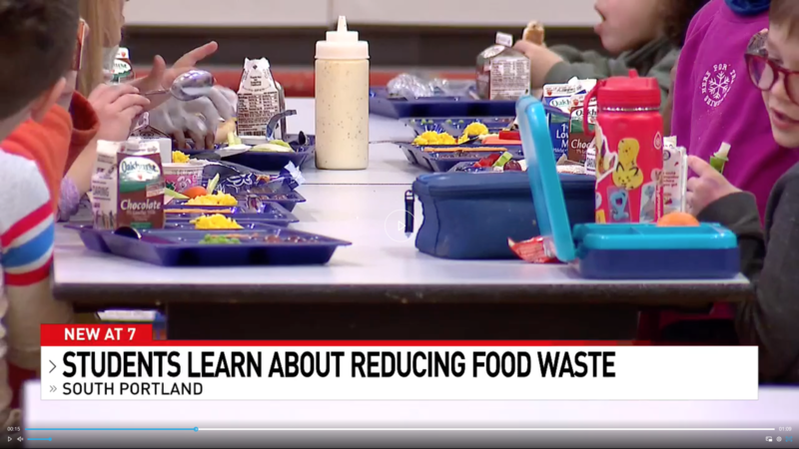
Share carts and fridges where students can place unopened foods
Food scrape bins where separate the leftover food from scrapes
Weighing food to see how much food is being thrown away
Providing lessons and activities to educate students on food waste
Composing food scraps and reusing them.

The design attempt was guaranteed to last long. But in the article, there is no proof given to prove how long the design attempt lasted. This design also relied too much on students. Given the fact that these are younger kids, it would be hard for students to remember. Or if the students started to not care or pay attention then the system would not work at all. Another problem was it would be hard for this solution to work everywhere. What had worked in one school might not work for another school.

Prior Design Attempt #5 - <insert name of prior design attempt #5>
https://www.niddk.nih.gov/health-information/weight-management/just-enough-food-portions
This source comes directly from the official U.S. government website of the National Institute of Diabetes and Digestive and Kidney Livers.
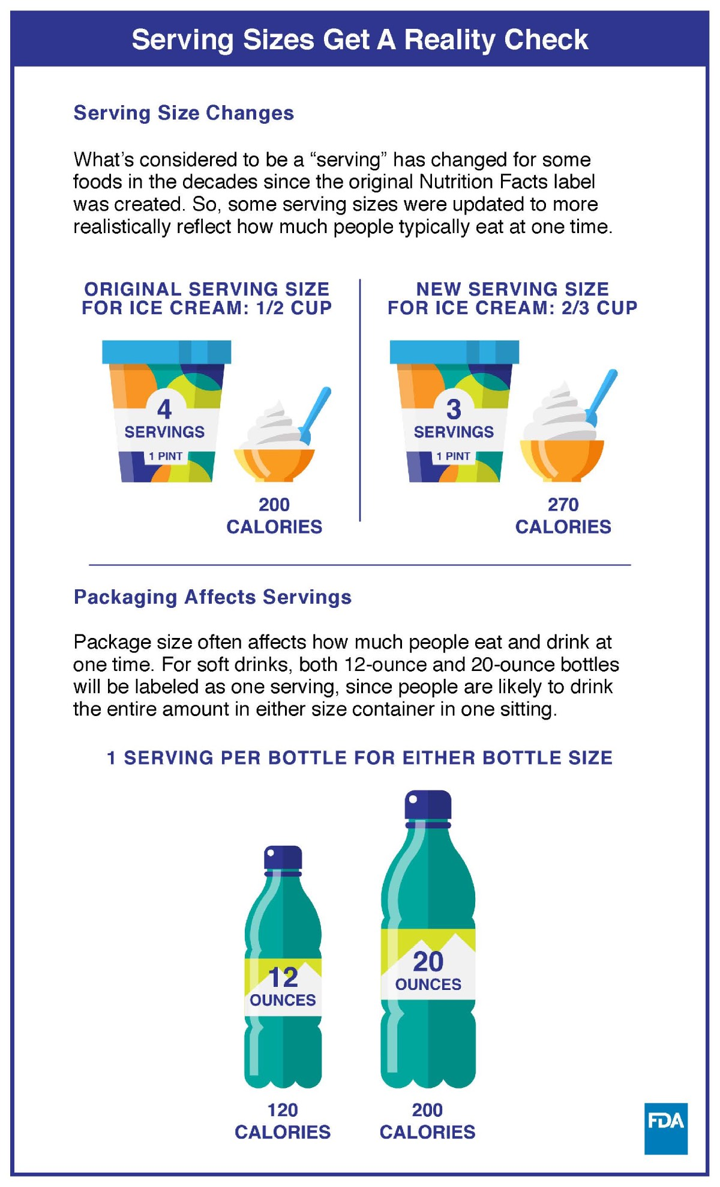
There is emphasis on looking at the nutrition label in the back of a product and keeping track of the size and quantity of food items to manage personal caloric intake.
The things that were unsuccessful at solving food waste through food portioning is how it fails when you go out to eat. The article does however provide many solutions, but even still when you go out you’re not worried about portion control because you trust that the kitchen will fix something up that is not a super big portion nor a small portion. You trust that they will dish out something that is a good sized portion that will fill you up and be tasty!

