MyDesign Portfolio
Element B Initial Template

Element B: Documentation and Analysis of Prior Design Attempts

Prior Design Attempt #1 - <EAS Tag>
Source: https://www.americanretailsupply.com/loss-prevention/eas-labels-tags/eas-tags.html?price=0.78-0.78
State the source of the information about this prior design attempt, which should be taken from any of the following credible source categories: peer-reviewed journals (check out your public library for free digital access to journals; here are some free online journals and research databases), professional organizations, government agencies, local and national newspapers, patents (here is a patent search site for the United States Patent and Trademark Office), and reputable vendors and manufacturers. Make sure to incorporate in-text citations in the details section below (i.e. don't just give a list at the end of the element or footnote).
Image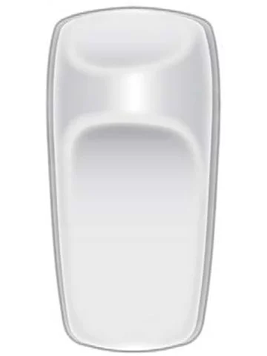
Include at least one image of this prior design attempt. Make sure to cite all images.
Details: This is the tag that they have in retail stores to make sure that you don’t steal anything without the authorities getting notified.
Include main details about this prior design attempt
Analysis: It would not work exactly but its a good idea. It wouldn’t work because all of the bottles are either glass or hard plastic. We would not be able to connect anything to this type of bottle.
Provide evidence and explain what parts of this prior design attempt were unsuccessful at solving the defined problem and why based on design requirements.

Prior Design Attempt #2 - <Ziptie>
Source:
https://www.iewc.com/resources/technical-guide/cable-ties-guide
State the source of the information about this prior design attempt, which should be taken from any of the following credible source categories: peer-reviewed journals (check out your public library for free digital access to journals; here are some free online journals and research databases), professional organizations, government agencies, local and national newspapers, patents (here is a patent search site for the United States Patent and Trademark Office), and reputable vendors and manufacturers. Make sure to incorporate in-text citations in the details section below (i.e. don't just give a list at the end of the element or footnote).
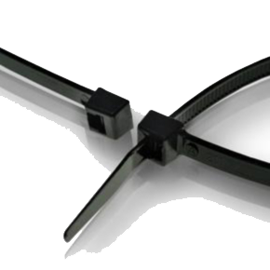
Include at least one image of this prior design attempt. Make sure to cite all images.
Details: We could zip tie the hot sauce to the condiment bar so they couldn’t just put it in their bag easily.
Include main details about this prior design attempt
Analysis: Unfortunately, they would be able to quickly cut it and take it, so we wouldn’t have the chance to check to see if our plan even worked.
Provide evidence and explain what parts of this prior design attempt were unsuccessful at solving the defined problem and why, based on design requirements.

Prior Design Attempt #3 - <Padlock>
Source:
https://elocksys-garage.com/padlocks-complete-guide/
State the source of the information about this prior design attempt, which should be taken from any of the following credible source categories: peer-reviewed journals (check out your public library for free digital access to journals; here are some free online journals and research databases), professional organizations, government agencies, local and national newspapers, patents (here is a patent search site for the United States Patent and Trademark Office), and reputable vendors and manufacturers. Make sure to incorporate in-text citations in the details section below (i.e. don't just give a list at the end of the element or footnote).
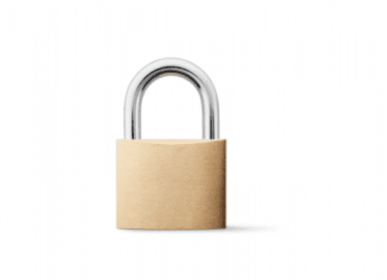
Include at least one image of this prior design attempt. Make sure to cite all images.
Details: We could put the hot sauces in a compartment and then lock it up with a padlock so they don’t steal.
Include main details about this prior design attempt
Analysis
This design is unsuccessful at solving the problem because it would limit the accessibility that we still want to keep and would make it a lot harder to get it, attracting a crowd of people and making a bigger problem then before.
Provide evidence and explain what parts of this prior design attempt were unsuccessful at solving the defined problem and why based on design requirements.

Prior Design Attempt #4 - <Hot Sauce Packets>
Source: https://kpfillingmachine.com/how-long-do-sealed-sauce-packets-really-last-shelf-life-storage-safety-tips/#:~:text=Not%20all%20condiments%20age%20in,at%20some%20of%20them%20now.

State the source of the information about this prior design attempt, which should be taken from any of the following credible source categories: peer-reviewed journals (check out your public library for free digital access to journals; here are some free online journals and research databases), professional organizations, government agencies, local and national newspapers, patents (here is a patent search site for the United States Patent and Trademark Office), and reputable vendors and manufacturers. Make sure to incorporate in-text citations in the details section below (i.e. don't just give a list at the end of the element or footnote).
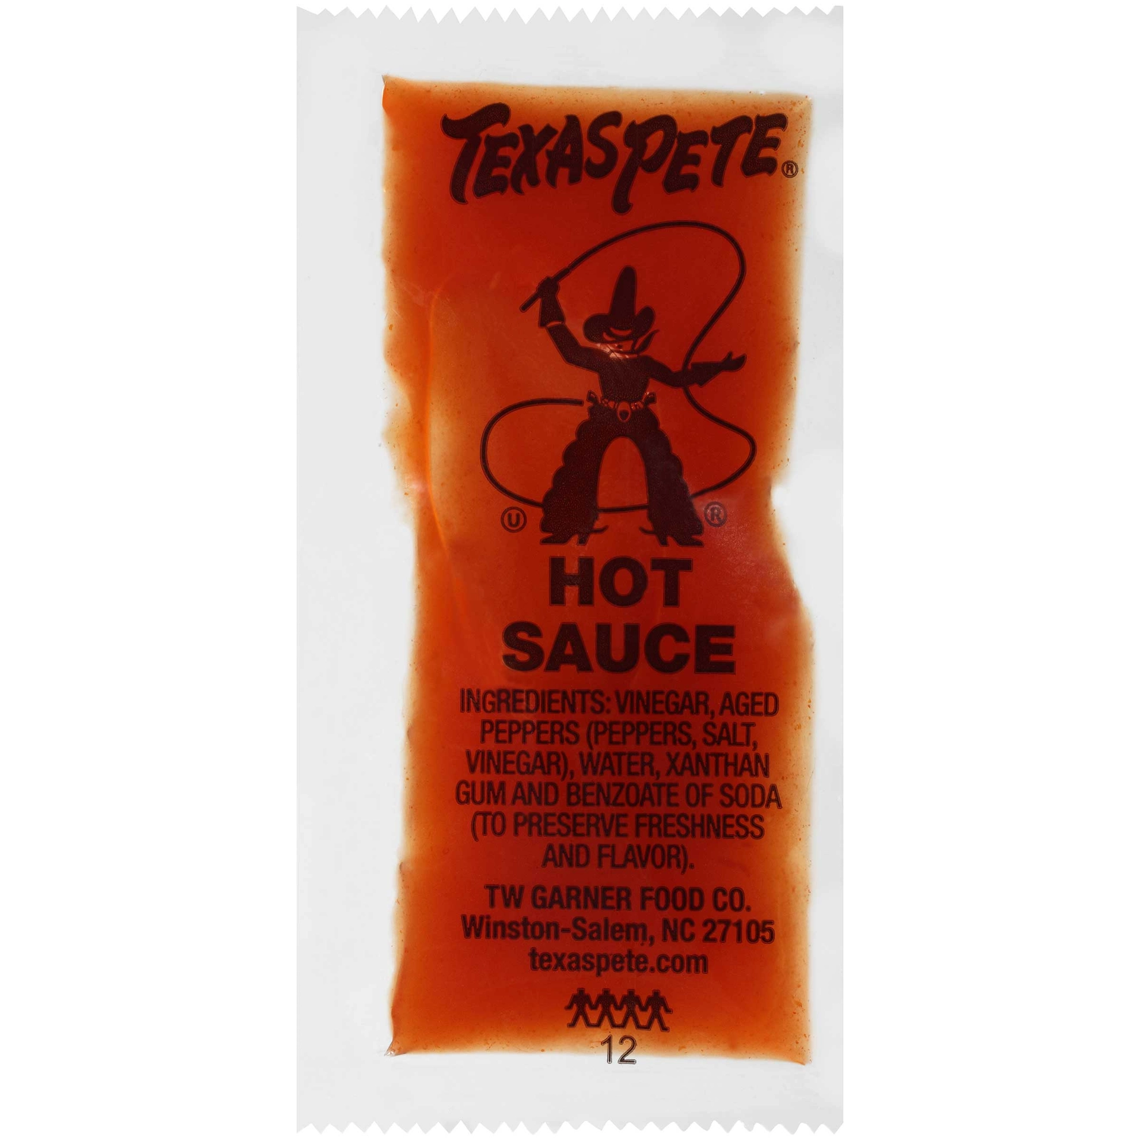
Include at least one image of this prior design attempt. Make sure to cite all images.
Details: We thought about switching all the bottles to hot sauce packets so that they can’t steal bottles.
Include main details about this prior design attempt
Analysis: This didn’t work because it would end up not being enough for the students at lunch. It would end up being easier to use the bottles than the packets.
Provide evidence and explain what parts of this prior design attempt were unsuccessful at solving the defined problem and why based on design requirements.

Prior Design Attempt #5 - <Pump Condiment Dispensers>
Source:
https://cambrianpackaging.co.uk/everything-you-need-to-know-about-pump-dispensers/#:~:text=Dispensing%20pumps%20are%20often%20a,but%20only%20in%20smaller%20sizes).

State the source of the information about this prior design attempt, which should be taken from any of the following credible source categories: peer-reviewed journals (check out your public library for free digital access to journals; here are some free online journals and research databases), professional organizations, government agencies, local and national newspapers, patents (here is a patent search site for the United States Patent and Trademark Office), and reputable vendors and manufacturers. Make sure to incorporate in-text citations in the details section below (i.e. don't just give a list at the end of the element or footnote).
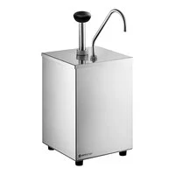
Include at least one image of this prior design attempt. Make sure to cite all images.
Details:
This is a larger sauce pump dispenser that you would not be able to steal, and if attempted it would be as obvious as the sky being blue to catch you. It also condenses the hot sauce all into one space so that there are not a ton of things to gather in one spot again and again for the SAGE dining cooks.
Analysis
Provide evidence and explain what parts of this prior design attempt were unsuccessful at solving the defined problem and why based on design requirements.
Although beneficial, this design is unsuccessful for what we are trying to achieve because it would again, draw a huge crowd into one area which is bad because it makes the traffic a mess in the lunchroom. This would also reduce the variations and accessibility of the individual hot sauce bottles, which is again, not something that we are necessarily trying to do in our solution.

