MyDesign Portfolio
Element B Initial Template

How to use this template
Teachers: You may customize this document before providing it to students.
Students: The template below is one way to structure your research findings around past and current attempts to solve the problem, but the specific assignment given by your instructor may require a different structure or dictate different details. If you make a copy of this template to edit for your own research into prior design attempts, be sure to delete the instructions.

Element B: Documentation and Analysis of Prior Design Attempts

Prior Design Attempt #1 - <insert name of prior design attempt #1>
Source
State the source of the information about this prior design attempt, which should be taken from any of the following credible source categories: peer-reviewed journals (check out your public library for free digital access to journals; here are some free online journals and research databases), professional organizations, government agencies, local and national newspapers, patents (here is a patent search site for the United States Patent and Trademark Office), and reputable vendors and manufacturers. Make sure to incorporate in-text citations in the details section below (i.e. don't just give a list at the end of the element or footnote).
Image 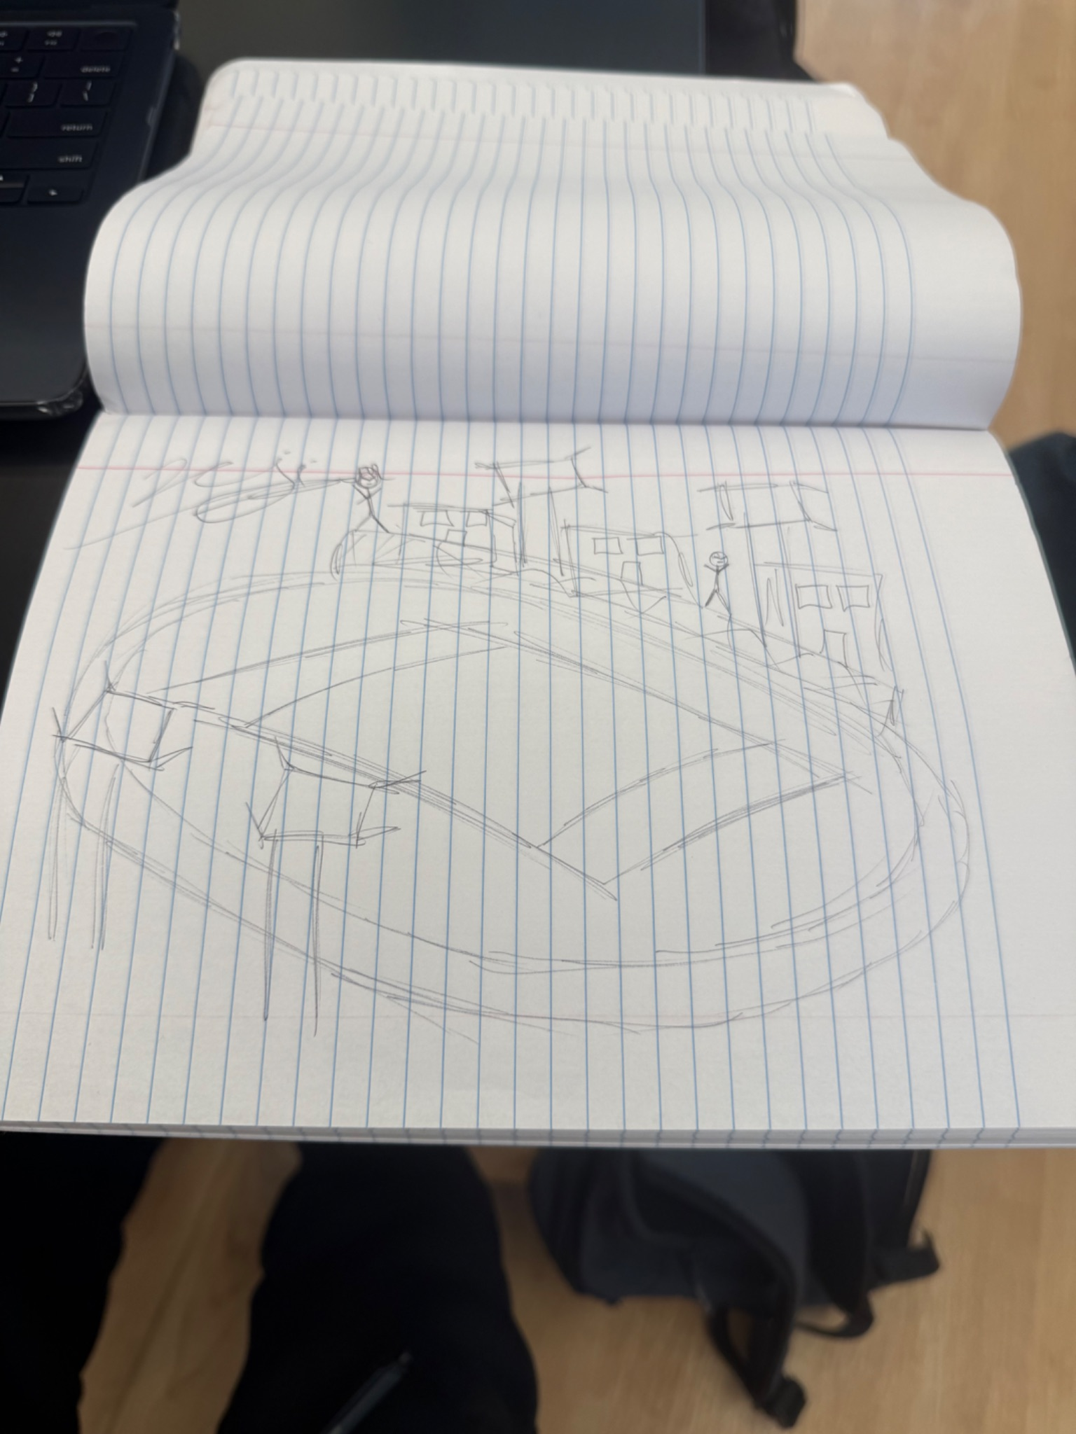

Include at least one image of this prior design attempt. Make sure to cite all images.
Details - This is a picture of a drawing that we constructed. It gives us a slightly accurate view from the northeast side of the field. On each side, there are the lights that we would try to add to the field, that also have the cups added.
Include main details about this prior design attempt
Analysis This may not be a solution that can work because of the western side of the field that would be shining directly at the neighbors of the field.
Provide evidence and explain what parts of this prior design attempt were unsuccessful at solving the defined problem and why based on design requirements.

Prior Design Attempt #2 - <insert name of prior design attempt #2>
Source - Glow sticks
State the source of the information about this prior design attempt, which should be taken from any of the following credible source categories: peer-reviewed journals (check out your public library for free digital access to journals; here are some free online journals and research databases), professional organizations, government agencies, local and national newspapers, patents (here is a patent search site for the United States Patent and Trademark Office), and reputable vendors and manufacturers. Make sure to incorporate in-text citations in the details section below (i.e. don't just give a list at the end of the element or footnote).
Image 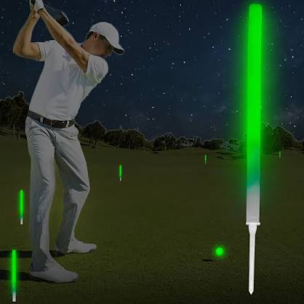

Include at least one image of this prior design attempt. Make sure to cite all images.
This is a high lumen glow stick that you are able to stick into the ground and place onto the surface you need it for.
Include main details about this prior design attempt
Analysis - This may not be able to work because of the field being very large and the glow sticks may not have a high radius of light, meaning we would need to have a very high quantity of them for it to work. This may be an issue with not only the area, but the cost since we would need a high amount of light.
Provide evidence and explain what parts of this prior design attempt were unsuccessful at solving the defined problem and why based on design requirements.

Prior Design Attempt #3 - <insert name of prior design attempt #3>
Source - construction lights
State the source of the information about this prior design attempt, which should be taken from any of the following credible source categories: peer-reviewed journals (check out your public library for free digital access to journals; here are some free online journals and research databases), professional organizations, government agencies, local and national newspapers, patents (here is a patent search site for the United States Patent and Trademark Office), and reputable vendors and manufacturers. Make sure to incorporate in-text citations in the details section below (i.e. don't just give a list at the end of the element or footnote).
Image 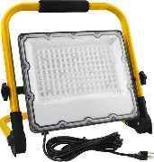
Include at least one image of this prior design attempt. Make sure to cite all images.
Details - This light does not work because it was too small and it will still be dark which can lead to athletes getting hurt. In the weather they also can not be bright enough like when it rains
Include main details about this prior design attempt
Analysis The light size is for construction and small zones for workers. They are also too weak to light up the full field. This leads to the field still being dark and could injure the athletes. They are also designed for construction only not to light up a high school track and field.
Provide evidence and explain what parts of this prior design attempt were unsuccessful at solving the defined problem and why based on design requirements.

Prior Design Attempt #4 - <insert name of prior design attempt #4>
Source lanterns
State the source of the information about this prior design attempt, which should be taken from any of the following credible source categories: peer-reviewed journals (check out your public library for free digital access to journals; here are some free online journals and research databases), professional organizations, government agencies, local and national newspapers, patents (here is a patent search site for the United States Patent and Trademark Office), and reputable vendors and manufacturers. Make sure to incorporate in-text citations in the details section below (i.e. don't just give a list at the end of the element or footnote).
Image 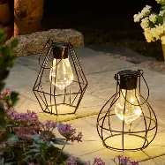
Include at least one image of this prior design attempt. Make sure to cite all images.
Details A hangable lantern that could be placed and hung up around all parts of the field.
Include main details about this prior design attempt
Analysis - Might be a safety hazard for lacrosse and football players for when they each throw balls and make contact that may lead them out of bounds. It also may not be good light for the distance that it would be placed at around the field, which may lead it to look like decor instead of a primary light source.
Provide evidence and explain what parts of this prior design attempt were unsuccessful at solving the defined problem and why based on design requirements.

Prior Design Attempt #5 - <insert name of prior design attempt #5>
Source
State the source of the information about this prior design attempt, which should be taken from any of the following credible source categories: peer-reviewed journals (check out your public library for free digital access to journals; here are some free online journals and research databases), professional organizations, government agencies, local and national newspapers, patents (here is a patent search site for the United States Patent and Trademark Office), and reputable vendors and manufacturers. Make sure to incorporate in-text citations in the details section below (i.e. don't just give a list at the end of the element or footnote).
Image 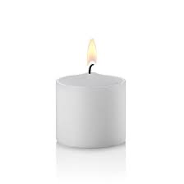
Include at least one image of this prior design attempt. Make sure to cite all images.
Details - Candles that could be placed in flasks all around the field.
Include main details about this prior design attempt
Analysis - This would not be able to work because of how small they are and how many candles it would take to be able to light an entire football field. Also, they may not be able to work because of how fragile they are, and how the wind could affect them by blowing it out and cause people to constantly relight them which would be a hassle.
Provide evidence and explain what parts of this prior design attempt were unsuccessful at solving the defined problem and why based on design requirements.

