MyDesign Portfolio
Element B Initial Template

Element B: Documentation and Analysis of Prior Design Attempts

Prior Design Attempt #1 - The Grooved Stainless Steel Scraper

Source
This information is sourced from data provided by Global Food Equipment Co.
Image
Webstaurant Store · In stock
Globe PANINI-SCRAPER Stainless Steel ...
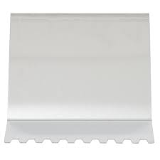
Details
- Material
- Built from heavy-duty, corrosion-resistant stainless steel.
- Geometry
- The cleaning edge is cut into tooth-like ridges.
- Handle
- Integrated metal handle, utilized for downward pressure onto the grill.
- Target residue
- Engineered to remove built up food that might be stuck.
Analysis
The main failure in this design is in the material choice of stainless steel and the spacing of the ridged edge. The hard metal surface doesn't work well with non-stick surfaces. The spacing on the tool might not fit for our specific type of panini press. This design solves the clean-up aspect of the problem, but it also creates a new problem. If the grooves on the grill don't match the specific spacing of the ridges on the tools, then it could cause damage to the grill and tool. Based on the design requirement of “material compatibility, this design fails due to it, going against the demand of non-stick material.

Prior Design Attempt #2 - Panini Press Brush 90052
Source
This information is sourced from data provided by Amazon: FryOilSaver Co - 90052.
Amazon: Panini Press Brush 90052
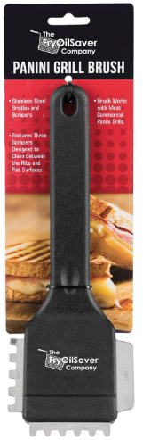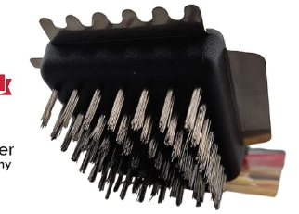
By: Amazon
Details
- Made out of stainless steel to get off tough grime and burnt on foods
- Strong, durable, brittles to get little crevices and stuck on food like a scrub bud
- Can be used for commercial electric grills, panini presses, and professional grills
- A flat scraper for flat surfaces, and grooved scraper for grooved plates or grooved panini presses
- Heat Resistant
Analysis
The main failure in this design is the spacing between the grooved sides. Some panini presses have deeper grooves than what the brush offers, which can result in improper cleaning. The spacing on the brush side is also ineffective because of how far apart each bundle of bristles are. That can cause wear and tear, and breaks within the brush which can lead to less bristles then to not as easy or effective cleaning. Some reviews say that the product was very nice and easy to clean, but had to be replaced often. One person said after only two months the scraper came off, so the durability of the product needed to be more solid and withstand the mess. Another one said that the bristles came off all the time, and my month two had to throw it away. The bristles are made out of stainless, so how could it be flexible? Some also believed that the bristles would destroy the coating of their grill and panini press. The product had to be suitable for all types of equipment, not just one, so it is not versatile.

Prior Design Attempt #3 - Electric grill & Panini Press Brush
Source
This information is sourced from data provided by OXO Good Grips.
Image
Electric Grill & Panini Press Brush by OXO Good Grips – Kooi Housewares
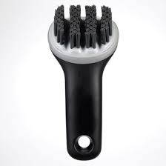
Details
- Material
- Flexible, heat resistant silicone bristles capable of withstanding temperatures up to 600°F
- Bristles
- Arranged in rows angled to reach into the deep valleys of the panini press
- Wiper Blade
- Includes a thin silicone scraper to push grease and residue
Analysis
The main failure in this design is the width of the product. The small product is hard to clean the press efficiently. It may get every spot necessary, but when there is five minutes between each lunch, they can not clean if fast enough and thoroughly. The bristles may also break, making it more difficult to clean.

Prior Design Attempt #4 - GRILLART Grill Brush and Scraper
Source
This information is sourced from data provided by Amazon: Grillart Store.
Amazon: GRILLART Grill Brush and Scraper
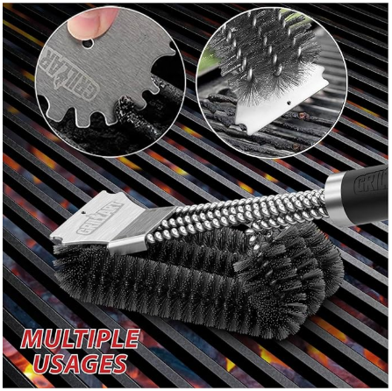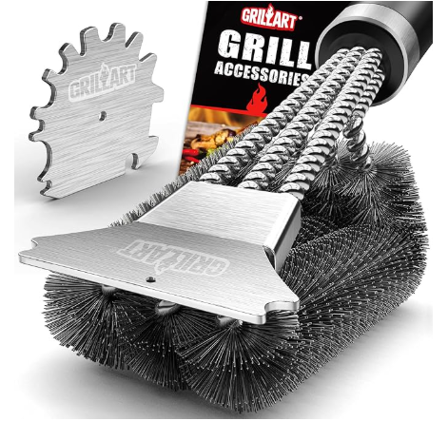
By: Amazon
Details
- Double headed to scrub better and cover more area
- For best results use water
- Wide to cover more area too
- Rotatable to fit most panini presses and grills
- Made out of Plastic and Stainless Steel
Analysis
The main failure in this design is the fact it is only useful with water. The product does not work, or damages the appliance being cleaned when it is not wet. Most products don’t need water to clean, which can be less efficient instead of just grabbing and cleaning.

Prior Design Attempt #5 - Flat Top Grill Brush with Nylon Bristles & Stainless Steel Scraper

Image
18" Flat Top Grill Brush w. Nylon Bristles and Stainless Steel Scraper - Walmart.com
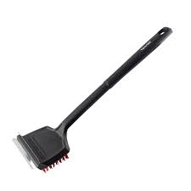
Details
- Soft Bristles
- Scraper made out of stainless steel
- Handle made out of plastic and easy to grip
Analysis
- The main failure in this design is the material compatibility. The two primary materials used in this design are nylon and stainless steel, which are intended for two different surfaces. Nylon is used for non-stick surfaces, while stainless steel is used for cast iron. Furthermore, the tool is large, flat, and includes temperature limitations. It is an 18-inch brush that was designed for large and open surfaces, which makes it awkward to use with the clamshell-like panini press. This design fails the requirement of surface specificity, it was not intended for clamshell shaped surfaces.

