MyDesign Portfolio
Element B Initial Template

How to use this template

Element B: Documentation and Analysis of Prior Design Attempts

Prior Design Attempt #1 - Home Smoke Detector

Source
State the source of the information about this prior design attempt, which should be taken from any of the following credible source categories: peer-reviewed journals (check out your public library for free digital access to journals; here are some free online journals and research databases), professional organizations, government agencies, local and national newspapers, patents (here is a patent search site for the United States Patent and Trademark Office), and reputable vendors and manufacturers. Make sure to incorporate in-text citations in the details section below (i.e. don't just give a list at the end of the element or footnote). https://www.det-tronics.com/products/flame-detection/
Image
Include at least one image of this prior design attempt. Make sure to cite all images.
Details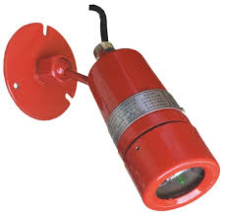 https://cnkmgq.en.made-in-china.com/product/AwhEuVMdrDkX/China-UV-2-IR-Explosion-Proof-Flame-Detector-Dual-Infrared-Single-UV-.html
https://www.crowcon.com/us-en/article/what-is-a-flame-detector-and-how-does-it-work/

Include main details about this prior design attempt
A flame detector is a type of sensor that can detect and respond to the presence of a flame. These detectors have the ability to identify smokeless liquid and smoke that can create open fire. For example, in boiler furnaces flame detectors are widely used, as a flame detector can detect heat, smoke, and fire.

Analysis
Provide evidence and explain what parts of this prior design attempt were unsuccessful at solving the defined problem and why based on design requirements. The flame detectors use Ultraviolet (UV) or Infra-Red (IR) technology to identify flames meaning they can alert flames in less than a second. The flame detector would respond to the detection of a flame according to its installation, it could for example sound an alarm, deactivate the fuel line, or even activate a fire suppression system.

Prior Design Attempt #2 - Smoke Detector
Source
State the source of the information about this prior design attempt, which should be taken from any of the following credible source categories: peer-reviewed journals (check out your public library for free digital access to journals; here are some free online journals and research databases), professional organizations, government agencies, local and national newspapers, patents (here is a patent search site for the United States Patent and Trademark Office), and reputable vendors and manufacturers. Make sure to incorporate in-text citations in the details section below (i.e. don't just give a list at the end of the element or footnote).
Image
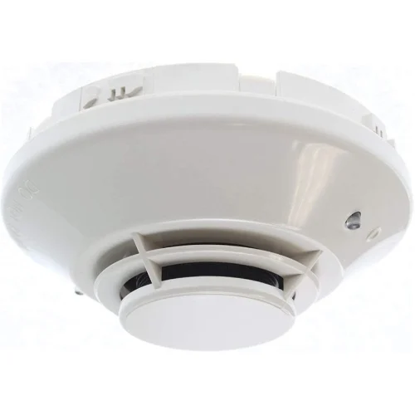
https://firealarm.com/product/notifier-fsp-851/?srsltid=AfmBOor2NFaokhZttlgtzdjS3cuo_P3pVE6ggsUwbmyfoC7dL40XG6KT
Details
The modern smoke detector can be found in any household in America. The design essentially works as an alarm; Ionization sensors create an electrical current using radioactive material, and when smoke enters the system, it disrupts the current which triggers the alarm. The other way Smoke detectors operate is through Photoelectric sensors which use light beams that scatter when in contact with smoke, setting off the trigger. https://www.nist.gov/how-do-you-measure-it/how-do-smoke-detectors-work
https://www.nfpa.org/education-and-research/home-fire-safety/smoke-alarms
Analysis
Provide evidence and explain what parts of this prior design attempt were unsuccessful at solving the defined problem and why based on design requirements.
Smoke detectors are very effective at detecting smoke and alerting. But that's it, they are unable to prevent a fire in a scenario where it is present. All it would be able to do is alert of its presence. For the defined problem, you must be able to detect, alert, and prevent a fire. A smoke detector only does two, therefore would not fit the design requirements.

Prior Design Attempt #3 - Fire Sprinkler Systems

Source
State the source of the information about this prior design attempt, which should be taken from any of the following credible source categories: peer-reviewed journals (check out your public library for free digital access to journals; here are some free online journals and research databases), professional organizations, government agencies, local and national newspapers, patents (here is a patent search site for the United States Patent and Trademark Office), and reputable vendors and manufacturers. Make sure to incorporate in-text citations in the details section below (i.e. don't just give a list at the end of the element or footnote).

Image
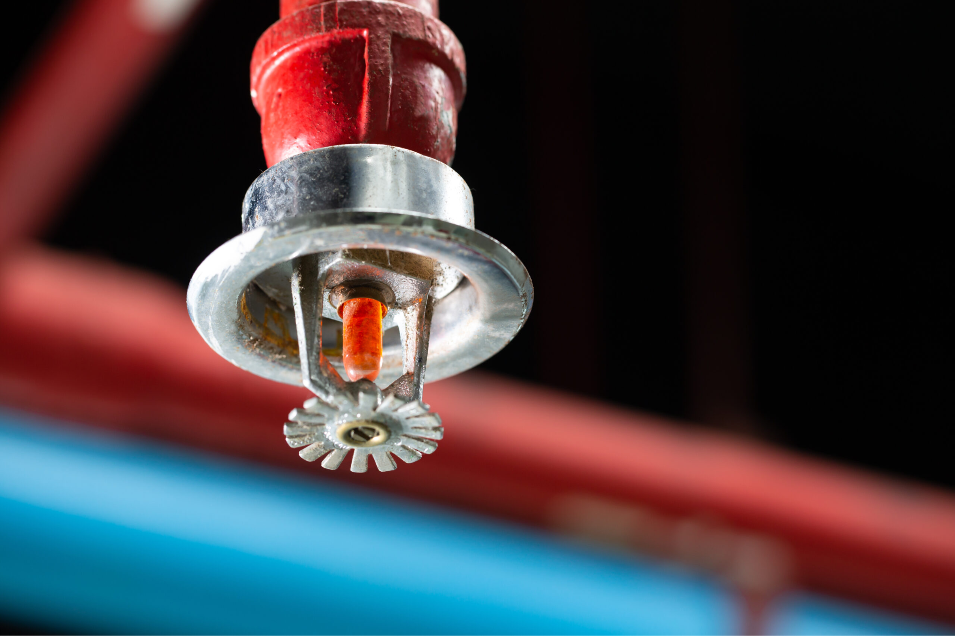https://www.actionfireandalarm.com/uncategorized/a-fire-sprinkler-system/
Details
A common misconception with fire sprinkler systems is that they detect through smoke like other systems. The difference is, they actually detect fires through extreme levels of heat. A small lightbulb attached to the sprinkler contains a liquid that expands as the temperature rises and reaches a certain temperature, often within 135 F to 165F . Once this liquid has expanded far enough the glass breaks and releases the valve seal containing the water. https://www.charleston-sc.gov/653/How-Fire-Sprinklers-Work
Analysis
Provide evidence and explain what parts of this prior design attempt were unsuccessful at solving the defined problem and why based on design requirements.
Fire Sprinkler Systems do a phenomenal job at detecting a fire present and suppressing the fire from spreading. What they lack is a clear and blatant alarm system that alerts when a fire is present. In some cases, you could say the sprinklers going off is the very alarm itself. But many systems isolate the fire in the area it is present, so if you are not present in that area there is no way the system could have alerted the fire was present. For this reason, the Fire Sprinkler System does not fit the design requirements for the defined problem.

Prior Design Attempt #4 - Kitchen Fire Suppression Systems
Source
State the source of the information about this prior design attempt, which should be taken from any of the following credible source categories: peer-reviewed journals (check out your public library for free digital access to journals; here are some free online journals and research databases), professional organizations, government agencies, local and national newspapers, patents (here is a patent search site for the United States Patent and Trademark Office), and reputable vendors and manufacturers. Make sure to incorporate in-text citations in the details section below (i.e. don't just give a list at the end of the element or footnote).

Image
Include at least one image of this prior design attempt. Make sure to cite all images.
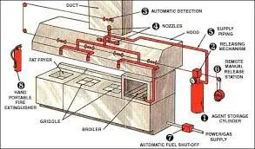
https://www.kellerfire.com/commercial-kitchen-protection/
Details
Kitchen Fire Suppression Systems are incredibly effective. They work by fusible links that are designed to melt at specific temperatures, often 350 F to 450 F, triggering the liquid mechanism. The system spits out chemical agents that smothers the fire, preventing it from reignition. It is a great way to get rid of fires in an environment where they are very likely to occur.
Analysis
Provide evidence and explain what parts of this prior design attempt were unsuccessful at solving the defined problem and why based on design requirements.
While being effective and efficient, they lack the element of alarm and alteration. The system both detects and prevents fires but does not have a way of alerting that a fire has been detected in the first place. A large part of this is because the system is designed to be automatic and quick, needless of any real reaction or manual response to the fire which is the intended purpose of an alarm. The lack of an alarm mechanism disqualifies Kitchen Suppression Systems from being within the design requirements.

Prior Design Attempt #5 - <Heat and Smoke Vent also known as Rauchabzug>
Source
State the source of the information about this prior design attempt, which should be taken from any of the following credible source categories: peer-reviewed journals (check out your public library for free digital access to journals; here are some free online journals and research databases), professional organizations, government agencies, local and national newspapers, patents (here is a patent search site for the United States Patent and Trademark Office), and reputable vendors and manufacturers. Make sure to incorporate in-text citations in the details section below (i.e. don't just give a list at the end of the element or footnote).
Image
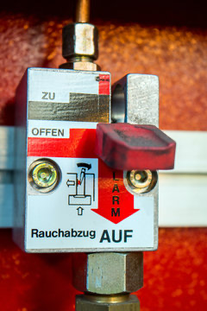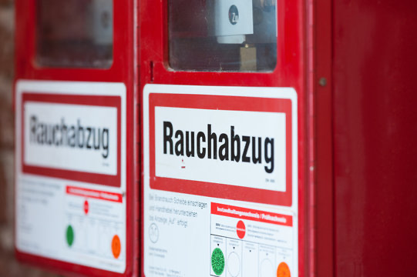
Include at least one image of this prior design attempt. Make sure to cite all images.
Details
This was unsuccessful because it can detect fire but it can't suppress fire. So this would be good but also not as fully helpful because we do need to detect the fire but we also need to suppress it.This would be more helpful it could both suppress and detect the fire. Fire alarms

Include main details about this prior design attempt
Analysis Fire alarms are brilliant to detect a fire. But they lack a few things they can't successfully put out a fire. Some are able to contact emergency services but they would also be too big for our fire build.fire alarms also make sounds up to 200 feet away.fire alarm links
Provide evidence and explain what parts of this prior design attempt were unsuccessful at solving the defined problem and why based on design requirements.

