MyDesign Portfolio
Element B Initial Template

How to use this template

Element B: Documentation and Analysis of Prior Design Attempts

Prior Design Attempt #1 - <insert name of prior design attempt #1>
Source
State the source of the information about this prior design attempt, which should be taken from any of the following credible source categories: peer-reviewed journals (check out your public library for free digital access to journals; here are some free online journals and research databases), professional organizations, government agencies, local and national newspapers, patents (here is a patent search site for the United States Patent and Trademark Office), and reputable vendors and manufacturers. Make sure to incorporate in-text citations in the details section below (i.e. don't just give a list at the end of the element or footnote).
Image
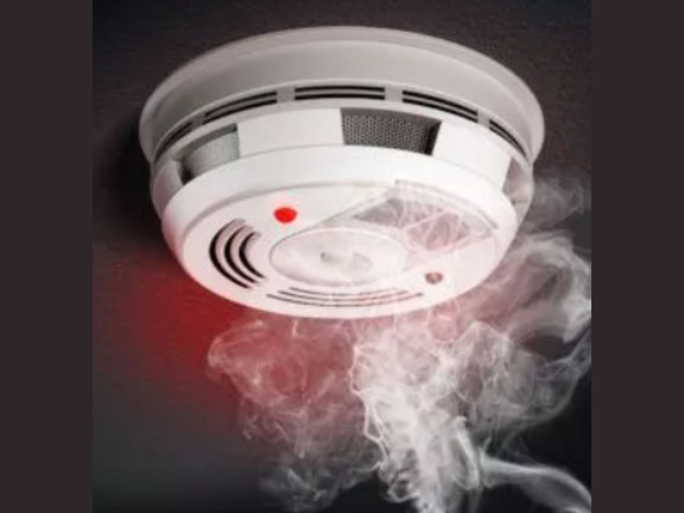 A prior design attempt for a fire safety device is the conventional smoke detector, which functions by detecting particles of combustion in the air to trigger an alarm.
Include at least one image of this prior design attempt. Make sure to cite all images.
Details
Include main details about this prior design attempt

Analysis

Provide evidence and explain what parts of this prior design attempt were unsuccessful at solving the defined problem and why based on design requirements.

Prior Design Attempt #2 - <insert name of prior design attempt #2>
Source
State the source of the information about this prior design attempt, which should be taken from any of the following credible source categories: peer-reviewed journals (check out your public library for free digital access to journals; here are some free online journals and research databases), professional organizations, government agencies, local and national newspapers, patents (here is a patent search site for the United States Patent and Trademark Office), and reputable vendors and manufacturers. Make sure to incorporate in-text citations in the details section below (i.e. don't just give a list at the end of the element or footnote).
Image 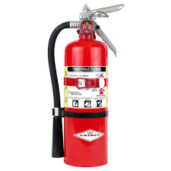essential safety devices designed to extinguish small, contained fires using agents like dry chemicals, CO2, or water
Include at least one image of this prior design attempt. Make sure to cite all images.
Details
Include main details about this prior design attempt
Analysis “US fire administration “
Provide evidence and explain what parts of this prior design attempt were unsuccessful at solving the defined problem and why based on design requirements.

Prior Design Attempt #3 - <insert name of prior design attempt #3>
Source
State the source of the information about this prior design attempt, which should be taken from any of the following credible source categories: peer-reviewed journals (check out your public library for free digital access to journals; here are some free online journals and research databases), professional organizations, government agencies, local and national newspapers, patents (here is a patent search site for the United States Patent and Trademark Office), and reputable vendors and manufacturers. Make sure to incorporate in-text citations in the details section below (i.e. don't just give a list at the end of the element or footnote).
Image 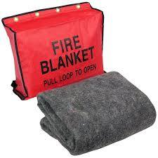 A fire blanket is a safety device made of woven fiberglass or other fire-resistant materials designed to extinguish small kitchen, grease, or wastebasket fires by smothering them, cutting off oxygen, and preventing flames from spreading
Include at least one image of this prior design attempt. Make sure to cite all images.
Details
Include main details about this prior design attempt
Analysis “ safelincs.co.uk”
Provide evidence and explain what parts of this prior design attempt were unsuccessful at solving the defined problem and why based on design requirements.

Prior Design Attempt #4 - <insert name of prior design attempt #4>
Source
State the source of the information about this prior design attempt, which should be taken from any of the following credible source categories: peer-reviewed journals (check out your public library for free digital access to journals; here are some free online journals and research databases), professional organizations, government agencies, local and national newspapers, patents (here is a patent search site for the United States Patent and Trademark Office), and reputable vendors and manufacturers. Make sure to incorporate in-text citations in the details section below (i.e. don't just give a list at the end of the element or footnote).
Image 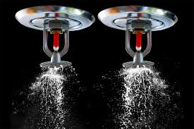 Fire sprinklers work because high heat triggers the sprinkler system. When a blaze ignites, the air directly above it heats rapidly
Include at least one image of this prior design attempt. Make sure to cite all images.
Details
Include main details about this prior design attempt
Analysis “https://www.guardianfireprotection.com”
Provide evidence and explain what parts of this prior design attempt were unsuccessful at solving the defined problem and why based on design requirements.

Prior Design Attempt #5 - <insert name of prior design attempt #5>
Source
State the source of the information about this prior design attempt, which should be taken from any of the following credible source categories: peer-reviewed journals (check out your public library for free digital access to journals; here are some free online journals and research databases), professional organizations, government agencies, local and national newspapers, patents (here is a patent search site for the United States Patent and Trademark Office), and reputable vendors and manufacturers. Make sure to incorporate in-text citations in the details section below (i.e. don't just give a list at the end of the element or footnote).
Image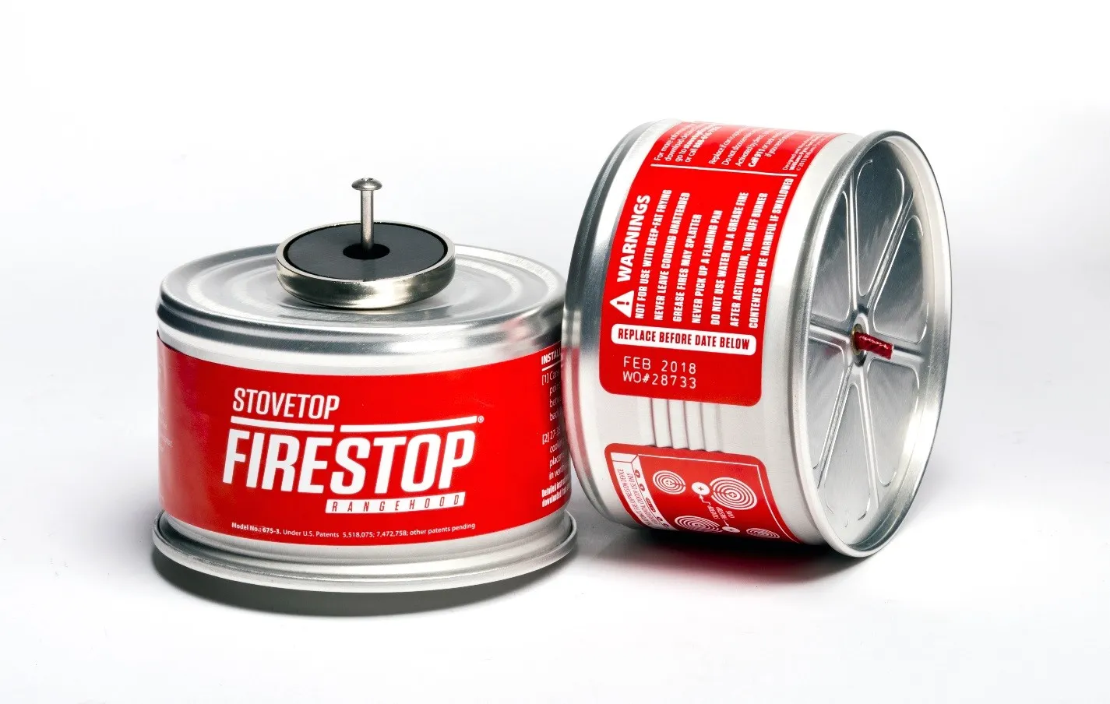
Include at least one image of this prior design attempt. Make sure to cite all images.
Details: Devices like FireBot that attach to range hoods to automatically extinguish kitchen fires.

Include main details about this prior design attempt
Analysis Prevent Cooking Fires with the StoveTop FireStop on youtube

Provide evidence and explain what parts of this prior design attempt were unsuccessful at solving the defined problem and why based on design requirements.

