MyDesign Portfolio
Element B Initial Template

How to use this template

Element B: Documentation and Analysis of Prior Design Attempts

Prior Design Attempt #1 - Photoelectric Detector
How Do Smoke Detectors Work? | NIST
Smoke Alarm Types
Photoelectric Smoke Detector
New York Hearing Doctors
Image
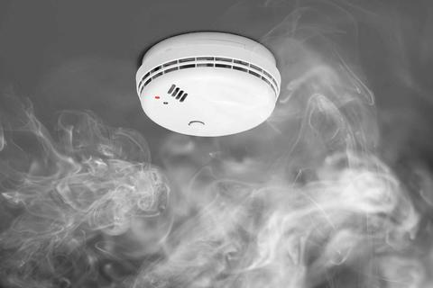
Credit: Nikkytok/Shutterstock
Details
A Photoelectric detector has a sensing chamber with a light beam inside, as well as a light sensor that is placed in a separate chamber. If there is no smoke, the light sensor does not pick up on any light. Once smoke particles enter the chamber, the light is reflected, and the light sensor is hit with light. (“Photoelectric Smoke Detector”) Once the light reflected into the detector crosses a certain threshold, the auditory alarm goes off. This form of light detection works best for highly reflective particles, mostly emitted by slow-burning fires.
Analysis
Photoelectric detectors are best at detecting larger and more reflective particles, which are formed from smoldering fires. The type of fire in the apartment we are building is not going to be a smoldering fire. It will light the fabric in the surrounding area, and will quickly gain size, emitting black soot. This type of fire is called a flaming fire, and while the photoelectric detectors are able to detect this type of fire, they are not able to detect it immediately. (“How Do Smoke Detectors Work? | NIST”) The other fail in this design is the type of alert it gives the surrounding area: this type of smoke detector gives an auditory warning. For inhabitants that may be hard of hearing, or have fully lost their hearing, this type of alert is ineffective. In fact, hard of hearing individuals typically lose the ability to hear high-pitched sounds first. (“Why are high frequency sounds typically the first to go in hearing loss? – New York Hearing Doctors”) Smoke detectors emit sounds in the 3,150-Hz range. One study showed that 43% of the hard of hearing adults studied did not wake at the high-pitched sounds of the smoke detectors. If one of these inhabitants is not near the fire, or cannot see the detector’s small flashing light, they will be unaware of the fire until it is too late. (“Sounding the Alarm: Hearing-Impaired Individuals at Higher Risk in Fires”)

Prior Design Attempt #2 - Ionization Smoke Detector
Source
“Americium in Ionization Smoke Detectors.” US EPA, https://www.epa.gov/radtown/americium-ionization-smoke-detectors.
Mahoney, Shawn. “What Kind of Smoke Alarm Should I Buy?” NFPA, 06 September 2024, https://www.nfpa.org/news-blogs-and-articles/blogs/2023/03/06/what-kind-of-smoke-alarm-smoke-detector-should-i-buy.
Erickson, Andrew. “Pros and Cons of Ionization & Photoelectric Smoke Detectors.” Digitize, 30 July 2023, https://www.digitize-inc.com/blog/ionization-vs-photoelectric-smoke-detector.php.
Smedburg, Erik; Ronchi, Enrico; Lund University. “Review of Alarm Technologies for Deaf and Hard of Hearing Populations.” NFPA, 01 August 2021, https://www.nfpa.org/education-and-research/research/fire-protection-research-foundation/projects-and-reports/review-of-alarm-technologies-for-deaf-and-hard-of-hearing-populations.
Image
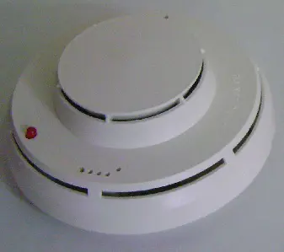
Credit: Life Safety Consultants

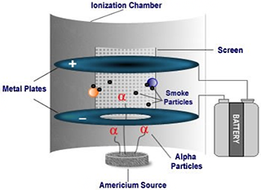
Credit: Environmental Protection Agency
Details
Ionization smoke detectors use a small amount of americium-241 to detect smoke. The americium-241 emits alpha particles that ionize air molecules, this makes some particles positively and negatively charged. They flow between the charged plates inside the smoke detector. When smoke is introduced to the smoke detector, it interrupts the flow of the ions and the alarm triggers.
Analysis
An ionization smoke detector would be ineffective in our design because ionization smoke detectors make noise when they are set off, deaf or hard of hearing people will not be notified of the fire. According to the National Fire Protection Association, around 14 out of 100 Americans over the age of twelve experience hearing loss, so having a smoke detector that sounds off will not alert the occupants of the apartment. Another issue is that ionization smoke detectors are sensitive, for example, they can be set off by cooking smoke or shower steam, which means they are very prone to false alarms.

Prior Design Attempt #3 - Wind Control Device
New York University- School of Engineering
NIST
Safely Walking on Different Roofing Materials
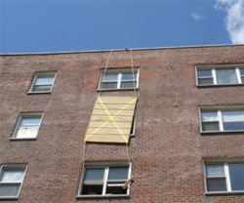
Source: NYU School of Engineering
Details
A Wind Control device, or WCD, is a portable, fireproof curtain that is lowered over a window in which wind is entering the apartment, or house, that is on fire. The objective of this device is to prevent wind from fueling a wind driven fire, as well as prevent it from spreading the fire at an accelerated pace. This attempt was a 8”x6” curtain lowered by firefighters from the roof (New York University- School of Engineering).
Analysis
This type of fire control technique would not be successful in extinguishing the fire, which is the main objective. While employing a device to stop a wind driven fire may allow time for escape, it will not prevent the fire from spreading, nor will it suppress it completely. Fires fueled rapidly by wind, whose velocity is increased by wind are called wind driven fires. These WCDs do lower the temperature of the surrounding area by more than 50%, within 120 seconds (NIST). However, this would only allow a greater escape time, and would not suppress the fire. This device is only deployed by people, so if the fire fighters were not able to get there quickly, then it would not have any effect on the fire (New York University, School of Engineering). Even if the firefighters were able to get to the building or apartment on fire very quickly, this device is only applied from the roof, or an above apartment. If the roof was compromised, if the angle was unfit to stand on, or the roofing material was unfit for walking on, it could not be deployed. Skylights and Fiberglass windows, as well as many other types of roofing, can be unsafe to walk on, as their constant exposure to the elements weaken them over time (“Safely Walking on Different Roofing Materials”). This could be a significant danger to the firefighters trying to deploy this device.

Prior Design Attempt #4 - <insert name of prior design attempt #4>
Source
State the source of the information about this prior design attempt, which should be taken from any of the following credible source categories: peer-reviewed journals (check out your public library for free digital access to journals; here are some free online journals and research databases), professional organizations, government agencies, local and national newspapers, patents (here is a patent search site for the United States Patent and Trademark Office), and reputable vendors and manufacturers. Make sure to incorporate in-text citations in the details section below (i.e. don't just give a list at the end of the element or footnote).
Image 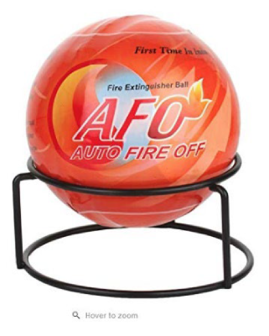
Source: CPCS
Include at least one image of this prior design attempt. Make sure to cite all images.
Details: These fire extinguisher balls were made in the late nineteenth century. These balls were specifically designed to be light weight fire suppression tools that are easy to access and to get the job done. (Museums association of saskatchewan) The usual creation of fire extinguisher balls is that an activation or trigger is made into the balls outer casing, which securely holds the fire extinguishing agent inside. When the activator or trigger is exposed to fire for more than a few seconds then the casing will burst open and disperse a cloud of chemical powder in the immediate vicinity. (Fire Extinguisher 101)
Include main details about this prior design attempt
Analysis: In recent years there has been somewhat of a recall for fire extinguisher balls. It has been stated that these products can fail to disperse fire suppressing chemicals and fail to extinguish a fire. These fire extinguisher balls also do not have a pressure gauge, pressure indicator, or locking device to reduce the risk of unintentional discharge, or a nozzle to direct the discharge. These products also fail to make the requirements of UL 299 Dry Chemical Fire extinguishers. (CPSC). These products are extremely non trust worthy to the point that CPSC is advising people to stop using them in general and to dispose these extinguisher balls at a fire department or a hazardous waste disposal facility.
Provide evidence and explain what parts of this prior design attempt were unsuccessful at solving the defined problem and why based on design requirements.

Prior Design Attempt #5 - fire blanket #5
Source:https://www.fireprotectiononline.co.uk/info/3-ways-to-use-a-fire-blanket/#:~:text=Fire%20blankets%20are%20nothing%20more,the%20likely%20size%20of%20fires.
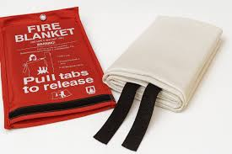

details: Fire blankets are nothing more than blankets made from fire-resistant materials. When used correctly, they smother the flames of a small fire, cutting off the oxygen supply and preventing the fire from spreading. Fire blankets can also be used to protect individuals from flames, either by wrapping them around a person whose clothes are on fire or as a shield when escaping a burning area. They’re a cleaner alternative to fire extinguishers and are especially useful for grease fires, clothing fires, and electrical fires.It is important to know how to use fire blankets safely. The most important thing is to consider the likely size of fires. A smaller blanket is best suited for kitchens or smaller office environments where you are unlikely to get larger fires, while a larger blanket is better suited to more industrial environments where you are likely to need to smother a larger fire quickly.
How to use it(step by step from source)?
- Turn off the gas or electricity supply immediately. (If you are unable to switch off the gas or electricity supply, then leave the room, close the door, and phone the fire brigade.)
- Remove the blanket from its container by pulling the fabric straps.
- While holding the straps, wrap the top edge of the blanket around your hands so that they are protected when placing the blanket over a fire.
- Roll your sleeves up so they are not caught by the flames.
- Stretch the blanket out so that it is large enough to cover the whole flame. Remember to cover the entire area of the fire in order to extinguish all the flames.
- If the fire is bigger than the blanket, DO NOT try to put it out.
- Once the fire has been extinguished, do not touch it or anything underneath the blanket for at least an hour as it will still be hot and could damage your hands.

A fire blanket would drop from the ceiling and distinguish the fire.It was hard to make sure that the blanket would drop at the correct time to distinguish the fire and stop it from spreading more.

