Element B: Documentation and Analysis of Prior Design Attempts

Prior Design Attempt #1 -
https://permies.com/t/209413/Pillow-Mounds-Rabbit-Islands-Ancient
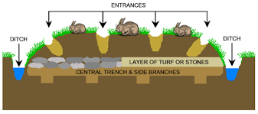w

There are 4 entrances and 2 ditches

They don’t have enough space to live inside of the area.

Prior Design Attempt #2

https://www.omlet.us/guide/rabbits/rabbit_hutches/rabbit_tunnels/

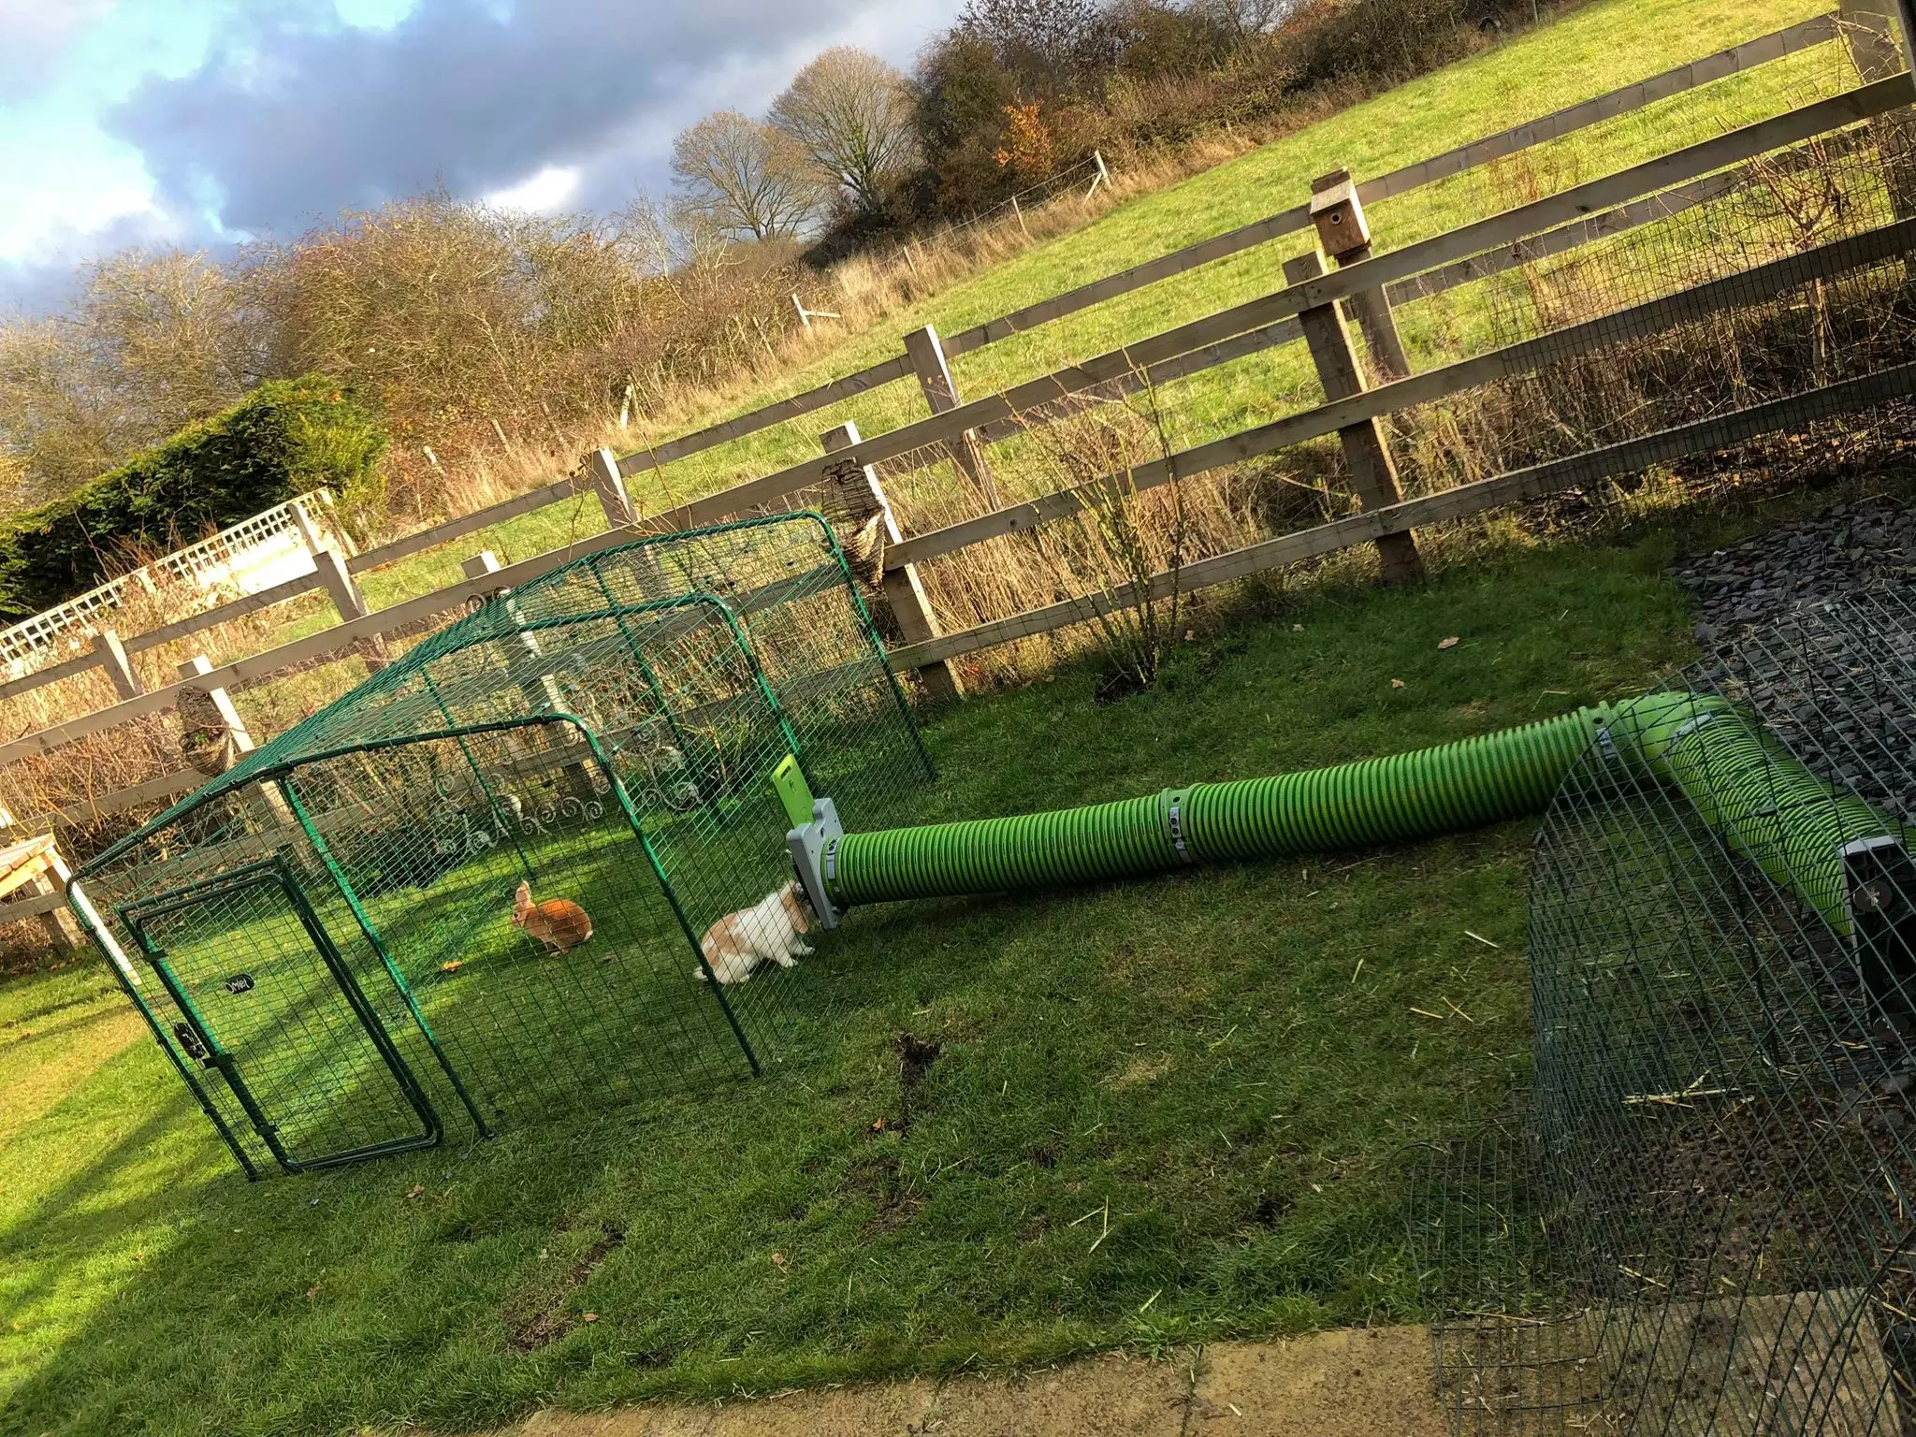
Travelling through burrow pipes and tunnels satisfies a rabbit's natural instincts. Giving pets what they instinctively need - something that mimics the lives of their wild ancestors - is one of the keys to keeping them happy.
They have tunnels and two cages connected to them.

Prior Design Attempt #3

https://www.tumblr.com/newbunnydiaries/89185110676/diy-rabbit-toys-the-bunny-tunnel

- 2 pop-up laundry bins (or however many you need to make the length you want)
- A good pair of scissors
- Needle & thread (optional)

“I've seen a few ideas using laundry hampers floating around on Pinterest on my hunt for a bunny tunnel, but the only examples I've seen are the mesh ones being used for cats and kids. Mesh tunnels are no good for bunnies, as their claws might get snagged, and I wanted something pretty to look at.”

Prior Design Attempt #4

https://www.bunbrary.com/enrichment/the-pandemic-rabbit-tunnel/

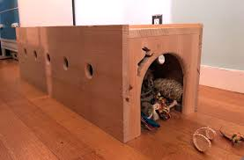

That first “COVID tunnel” was rigged up by taking a lot of different sized boxes and taping them to each other. You can put them in any configuration that creates a through-path for the rabbit. Our rabbits enjoyed that tunnel, but taping boxes together isn’t ideal. For one thing, rabbits might start chewing too much of the sticky tape. If that happens, I would get rid of the tunnel. (What’s wrong with eating sticky tape? Maybe nothing. I’m no vet. Just seems like the kind of thing that could gum up a sensitive bunny’s gut.) It can also be tricky to tape things securely enough to make a solid structure. Mine was a little rickety. Thus, it eventually did get broken down for recycling.
A few weeks later I tried again. We were getting weekly deliveries from a place that used the same size box every time. After a little experimentation I figured out that with a few simple, well-placed cuts I could create an interesting zig-zag tunnel from box to box that would hold itself together without tape. That tunnel is much more stable, and a big hit!
I’ll show you how to make a tapeless tunnel in the video below. If you don’t already have access to a bunch of boxes the same size you could try doing this with some that are similar in size, or you could check with a local store to see if they have a lot of cast-off boxes about the same size.

Prior Design Attempt #5

https://www.therabbithouse.com/blog/2010/10/02/rabbit-toys-paper-tunnels/

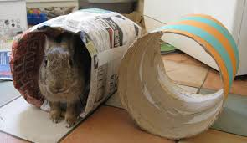

I’ve been experimenting with tunnels for Scamp, here is a really easy to make newspaper tunnel….
Step 1: Lay out a row of sheets of newspaper, overlapping each sheet by approximately a third. I used 4 sheets.

Step 2: Roll the paper around something round, such as a cake tin. I use a shop bought tunnel.

Step 3: Roll over the ends to stop the tunnel unravelling. Fold outwards, like turning up trousers. You only need to fold over about an inch, do it twice to keep it secure.

That’s it – you should have a rabbit tunnel, as demonstrated by Scamp:

Of course, it’s easy to chew to pieces but it’s quick and free to make so shredding is just part of the fun. I used a local paper but if you pick something bigger like the telegraph you could get a lovely long tunnel.

