MyDesign Portfolio
Element B
Element B: Documentation and Analysis of Prior Design Attempts
Prior Design Attempt #1 - This has the fundamentals, but might not be durable, and is not contained in one piece, which could cause potential mishaps.
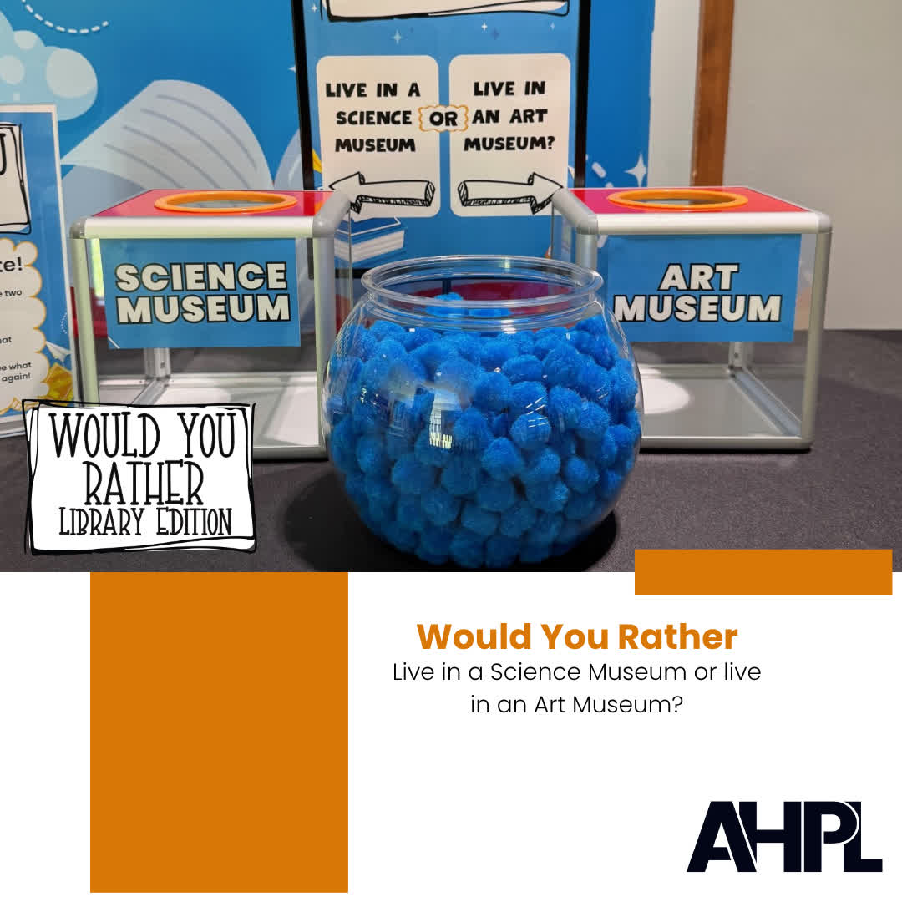See details at: https://www.facebook.com/AHPLibrary/photos/-would-you-rather-live-in-a-science-museum-or-an-art-museumdo-you-dream-of-sleep/1142970897871369/
Prior Design Attempt #2 - This design has locked boxes, which prevents mishaps with the already cast votes. It is not all in one piece and the bowl with the tokens could potentially spill.
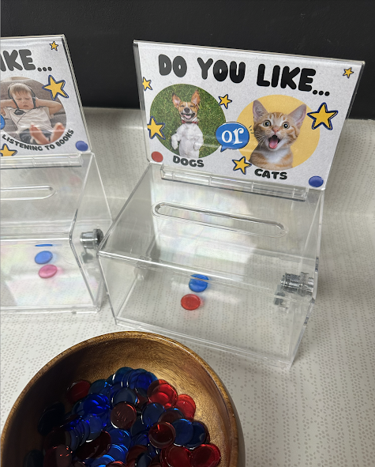See details at: https://vanmeterlibraryvoice.blogspot.com/2025/08/30-do-you-likewould-you-rather.html
Prior Design Attempt #3 - Has two bins for votes and a basket for uncast votes, similarly to the first Prior Design listed.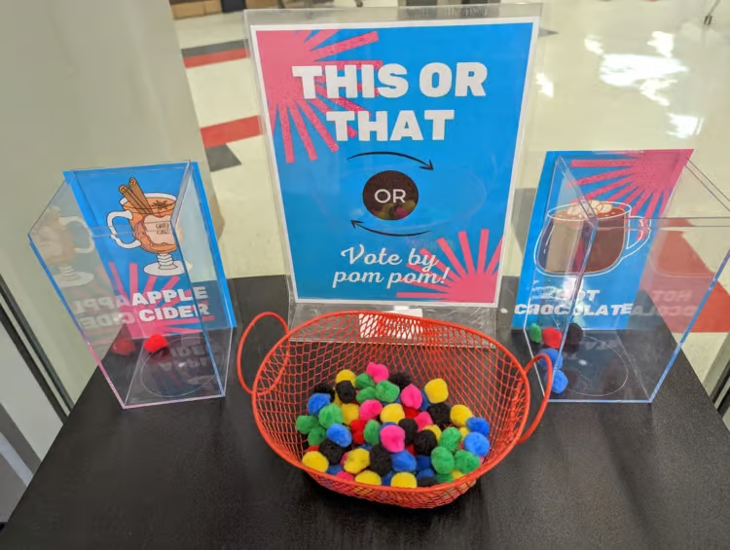See details at: https://www.teacherspayteachers.com/Product/This-or-That-Passive-Programming-for-the-Library-or-Classroom-9317417
Prior Design Attempt #4 - This has visible votes and easy use, but it is temporary, rather than being able to be used several times.
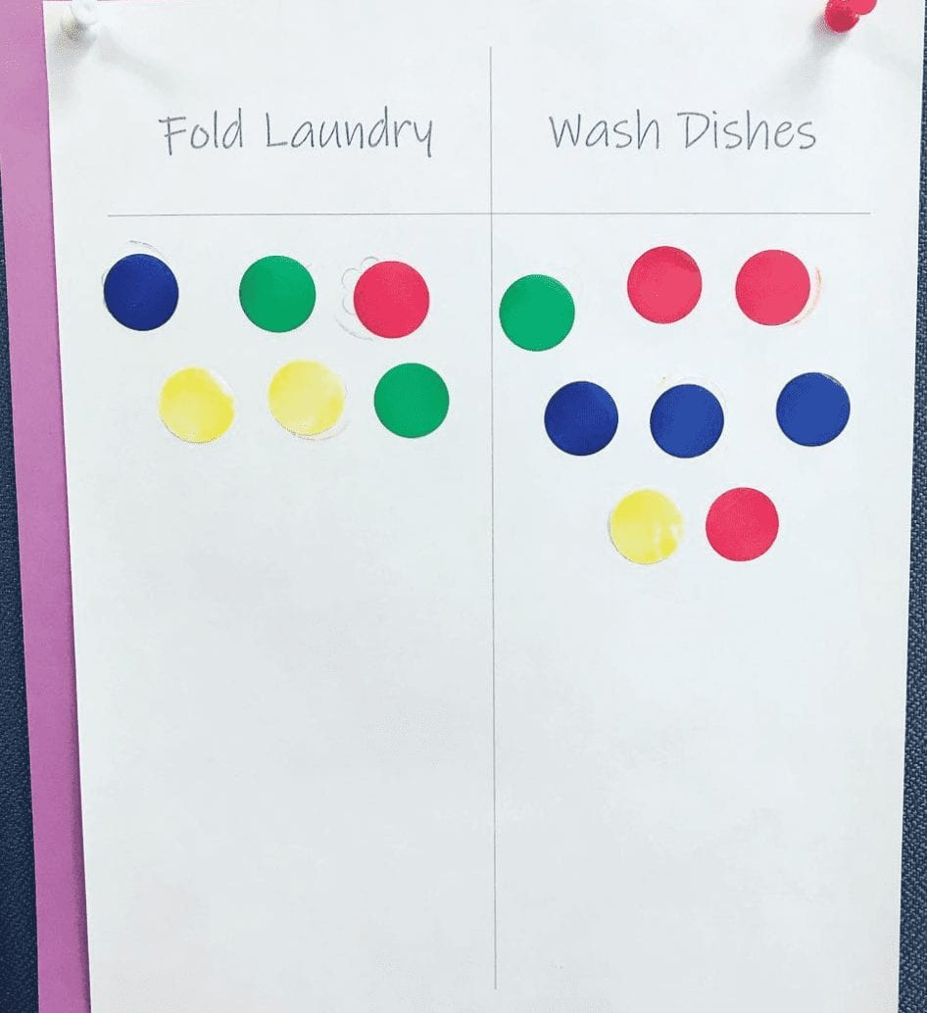See details at: https://new.boredteachers.com/wp-content/uploads/2021/04/image-225.jpg

Prior Design Attempt #4 - Similarly to previous designs, this consists of two clear boxes and a container for tokens. This does not fit the requirement to be contained in one piece and the glass could be harmful if it gets knocked down and breaks.
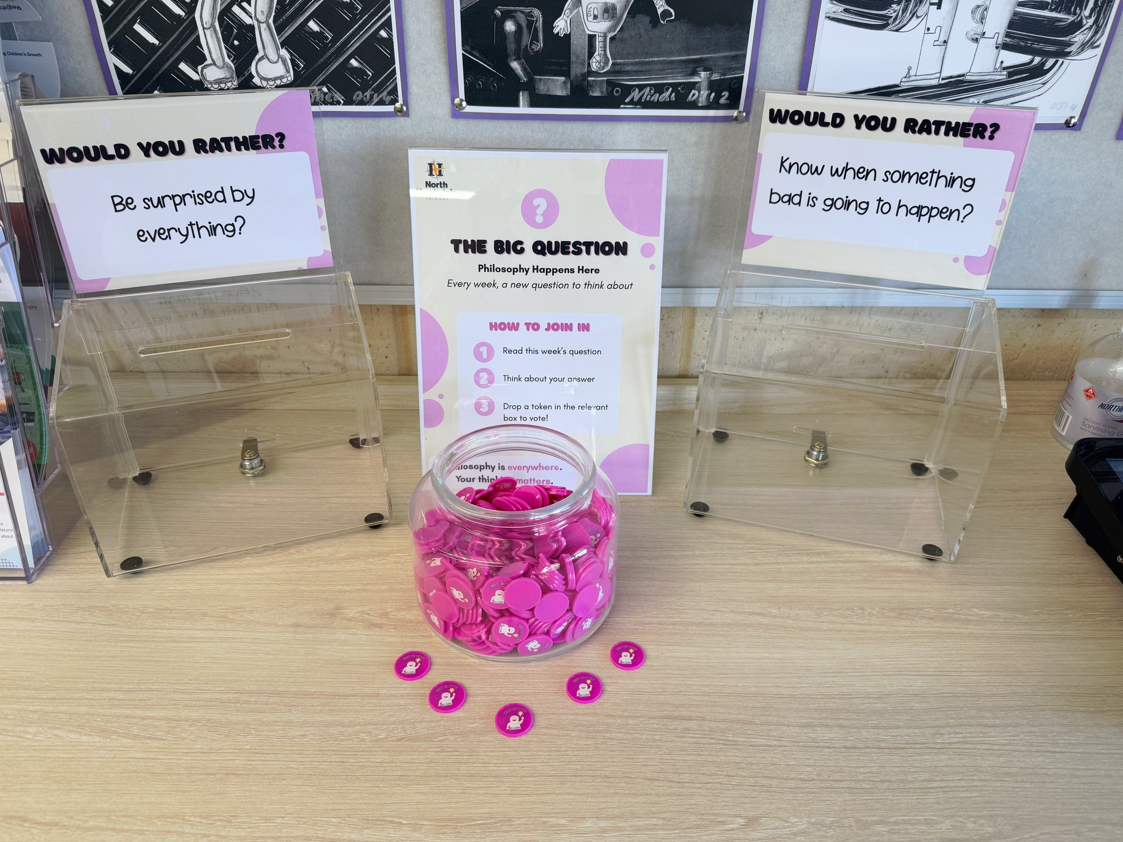See details at: https://www.facebook.com/northharrisdaleprimary/posts/weve-got-something-new-in-the-administration-area-its-called-the-big-question-an/1482217003692921/

