Name: _________________________________ Date: ___________________ Class: _________________
MyDesign Portfolio
Element B Initial Template
Element B: Documentation and Analysis of Prior Design Attempts
Prior Design Attempt #1 - <insert name of prior design attempt #1> Encyclopaedia Britannica https://www.britannica.com/technology/balance-measuring-instrument
Our group originally had the idea of a scale when we were brainstorming. We wanted something that allowed for 2 simple choices but was also fun and engaging. The scale idea was neat because it would move based on which choice was winning. Scales have historically been used to compare two options side-by-side through visible movement and weight distribution (Encyclopaedia Britannica https://www.britannica.com/technology/balance-measuring-instrument). Our group used the same idea to our this or that machine by making a scale to show two choices.

Our first prototype was made-up of a long bar connected to a base which had two bars that extended horizontally across the base bar then connected to those two joints the ends was two jars with bars coming from the bottom with holes for joints to connect them to the horizontal bars So that it could move with the weight of the pom-pom sitting in the jars instead of a meter needing to be used to show how much is on each side just like a traditional scale. In the jars was a poll with a slide similar to what you would see in a gumball machine that the pom-pom would slide down into the jar.

Make sure to incorporate in text citations in the details section below (i.e. don't just give a list at the end of the element or footnote).
Original CAD Drawing of our first prototype
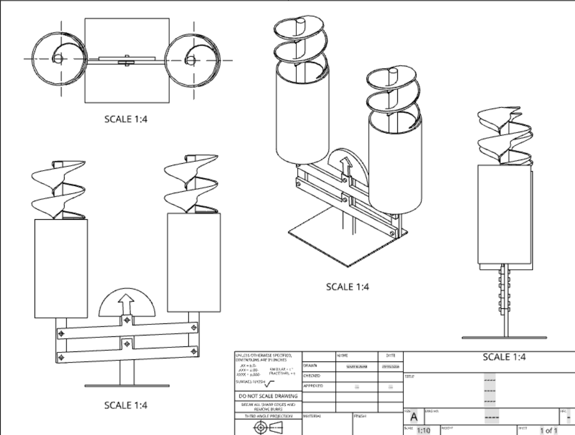

Original Prototype 3D image
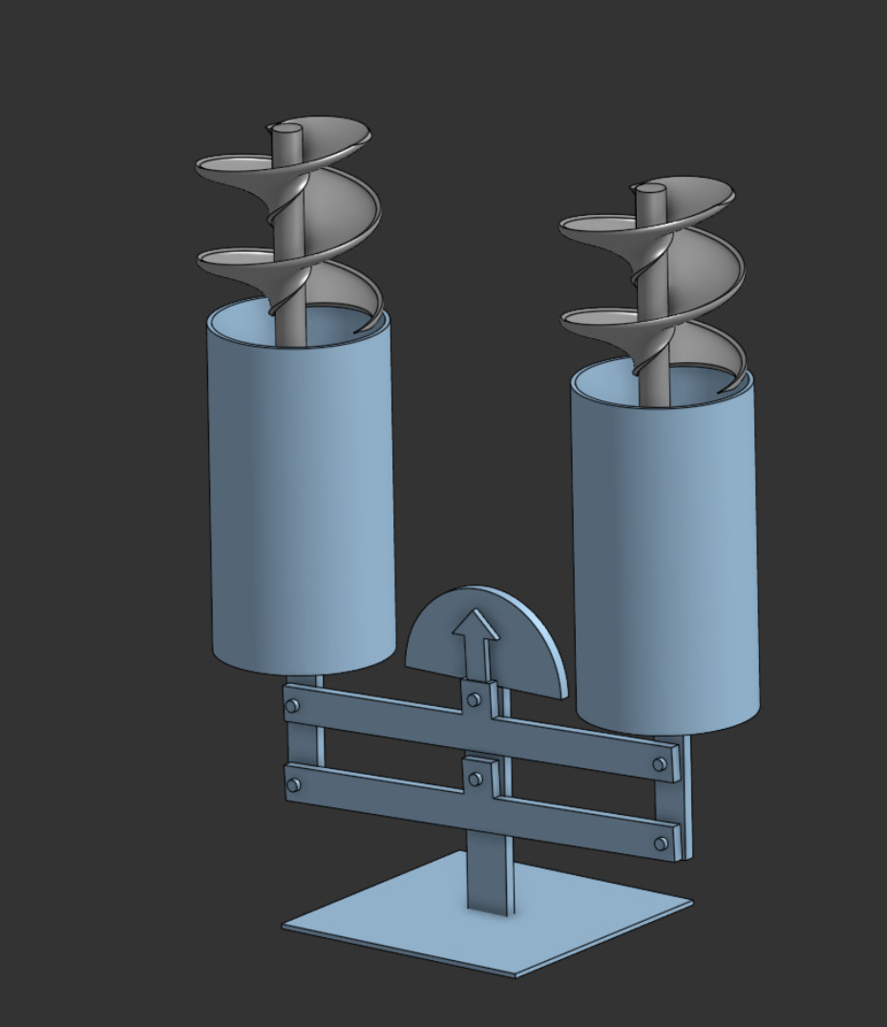

Analysis
The original design was good however the slides that were connected to the inside of the base of the jar were too heavy and slightly too tall for the design because we needed to lengthen the bottom bar which would go over our height restriction, and the pom poms weren't heavy enough to slide down the slide how we intended it to. Also our horizontal bars weren't sturdy enough to hold are jars with the pom poms in it and the base bar needed to be taller so that the horizontal bars and the jar can tip more when the pom poms are added to make it tip more so that our arrow indicator could more clearly show which option is winning.
4

