MyDesign Portfolio
Element B Initial Template

Element B: Documentation and Analysis of Prior Design Attempts

Prior Design Attempt #1 - Standard Manila Folder>

Source - https://www.dreamstime.com/manila-craft-folder-cut-tab-isolated-white-paper-case-archive-document-reports-grainy-texture-beige-blank-kraft-image269594385

Image

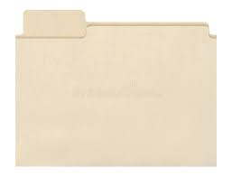

https://www.dreamstime.com/manila-craft-folder-cut-tab-isolated-white-paper-case-archive-document-reports-grainy-texture-beige-blank-kraft-image269594385
Details: A simple folder for your work, but it can lose your papers easily or destroy them and it can also be torn easily or lost easily
Analysis
Pros: Cheap and easy to use
Cons: Flimsy and not water-resistant for paper, incredibly weak
Made out of paper and will degrade faster

Prior Design Attempt #2 - <Product Design with Retention Flaps>

Source Five Star Built Strong product page

Image
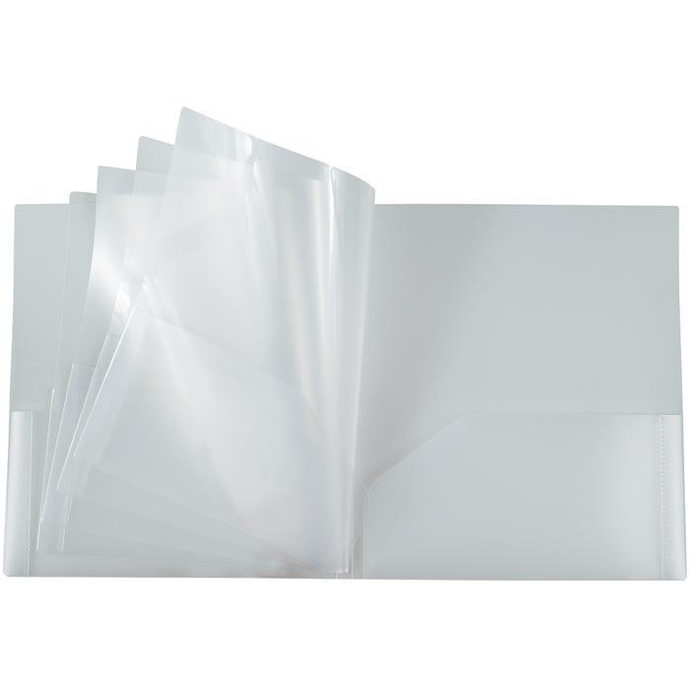Five Star Built Strong product page
Details
Includes internal flaps or tabs to hold papers in place
Analysis
Strengths:
Prevents papers from falling out
Increases retention security
Weaknesses:
Does not address insertion friction/buckling
Flaps obstruct quick removal
Increased internal obstruction increases edge catching

Prior Design Attempt #3 - 3 Ring Binder
Source
Origins of the Three-Ring Binder - SBDPro Blogsbdpro.comhttps://www.sbdpro.com › Blog › Business Articles
Image
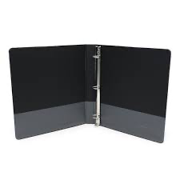
Details
This is one of the most popular and used methods of storing papers for students.
Analysis
This design requires papers to be perfectly hole-punched, making its ability to store papers limited.

