MyDesign Portfolio
Element B Initial Template - AT - 6 points

Element B: Documentation and Analysis of Current and Prior Design Attempts

Current or Prior Design Attempt #1 - Traditional Paper Hall Pass / Sign-Out Sheet
Source | Tech Teacher’s paper bathroom pass sheet, www.google.com/imgres?q=paper%20hall%20pass&imgurl=https%3A%2F%2Fwww.successbydesign.com%2Fcdn%2Fshop%2Fproducts%2FHall_Pass_7bd5e24c-4e6a-49d7-8c70-0825f1dd6ee3_1266x.jpg%3Fv%3D1672174374&imgrefurl=https%3A%2F%2Fwww.successbydesign.com%2Fproducts%2Fhall-pass%3Fsrsltid%3DAfmBOop5kFor0CHdK0QQC25A-M3boVy--fzkDPMhhwM543iUeqbRzmtY&docid=v-MS_dgiLg5aMM&tbnid=m9W3I06Zv9PcvM&vet=12ahUKEwjbyfSdkJOUAxW5lWoFHYhZCSMQnPAOegQIGhAB..i&w=1266&h=1556&hcb=2&ved=2ahUKEwjbyfSdkJOUAxW5lWoFHYhZCSMQnPAOegQIGhAB. Accessed 29 Apr. 2026.
Image  Cite | 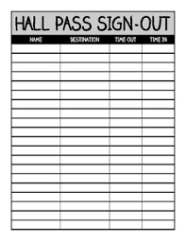
Details | The traditional solution used in many schools is a physical hall pass system, often combined with a paper sign-out sheet. When a student needs to use the bathroom, they ask the teacher, sign their name, get a time-out on a clipboard or sheet near the door, and take a physical pass such as a laminated card, wood/plastic pass, or a lanyard. When they return, they write the time in.
Analysis | While the paper pass and sign-out sheet approach is simple, it has several weaknesses. First, handwriting is often messy or incomplete, making it difficult for teachers to read names or times accurately. Students may forget to sign back in or may write incorrect times, so the duration of bathroom trips is not reliable. There is no automatic calculation of statistics, so teachers must manually scan the sheet if they want to look for trends. Because of these issues, paper passes do not effectively help teachers track or analyze bathroom usage data in a consistent, accurate, and efficient way.

Prior Design Attempt #2 - Pass Exchange System

Source | Implementing a phone exchange system—where students leave their phone on the teacher's desk before taking a bathroom pass—is an effective, actionable strategy to curb excessive bathroom breaks, as it removes the primary motivation for lingering, which is often socializing, checking social media, or scheduling meetups in hallways. While some argue that schools cannot fully control bathroom behavior, this "phone-for-pass" exchange directly tackles the issue of using the restroom as a place to avoid class, often leading to students realizing they do not actually need to go. This approach balances accountability with reasonable access, addressing the problem of "long bathroom breaks" by reducing the distraction-based excuses while allowing for legitimate needs.
Image | 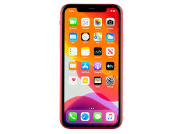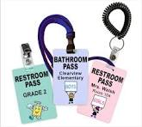
Details | This system makes the student have to exchange his/her phone in order to use the bathroom
Analysis | If a student does not have a phone because it got taken from another teacher, or they don’t have a phone, then they may not be able to use the bathroom.

Prior Design Attempt #3 - Commercial Digital Hall Pass System (e.g., E-Hallpass)

Source  State the source of the information about this design. taken from any of the following credible source categories: peer-reviewed journals (check out your public library for free digital access to journals), professional organizations, government agencies, local and national newspapers, patents, and reputable vendors and manufacturers. | A commercial digital hall pass system such as E-Hallpass is described on Lake Braddock Secondary school.
Image  Include at least one image of this prior design attempt. Make sure to cite all images. A website link is sufficient. | 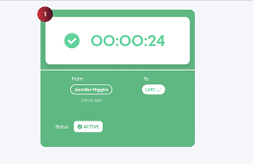
Details | A more advanced prior design is a commercial digital hall pass system, such as E-Hallpass or SmartPass, that replaces paper passes with a web- or app-based interface used on school devices. Students request a bathroom pass through the system, and the teacher approves or denies the request on a digital dashboard that logs the student’s name, origin classroom, destination (for example, a specific bathroom), and the start and end time of the pass (E-Hallpass, n.d.). Administrators can see all active passes in the building in real time and access reports that summarize how often each student leaves class, how long they are out, and which locations are used most frequently.
Analysis | Although commercial digital hall pass systems solve some problems with paper passes by automatically recording times and generating analytics, they also create new challenges for the defined problem. Detailed data about every bathroom trip raises privacy and surveillance concerns, since the system stores when and how often individual students use the bathroom and who can see that data is not always transparent.

