Prior Design Attempt #1 - HaulPro Handlebar Extender for Hand Truck
https://www.amazon.com/Handlebar-Extender-Hand-Truck-Attachment/dp/B0971SW3YY
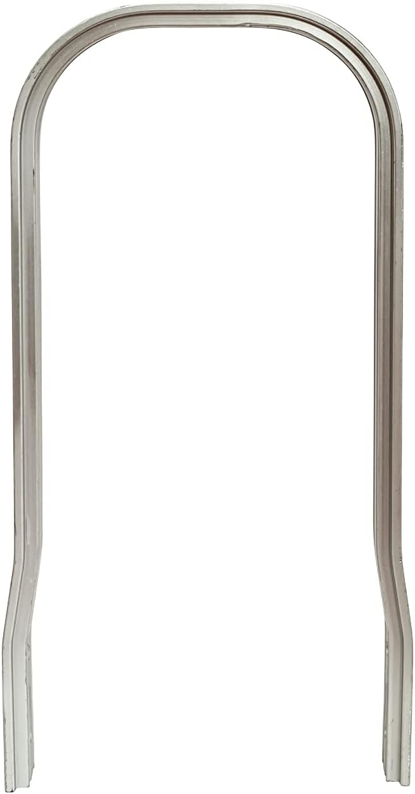
It’s bent steel, designed to be inserted vertically with the flared bottom facing further away from the user. It would work with a specific design of hand truck, providing a large lever arm and easy use inserting it into the cart/hand truck it’s built for. It solved a problem, but only for a specific cart type (namely, those with places to insert the handle into the cart). “Our” cart doesn’t have that ability, and we’re working without the ability to directly modify or change the cart.

Prior Design Attempt #2 - Bi-Unique Handlebar Extension
https://enablingtech.com/products/handle-bar-extension
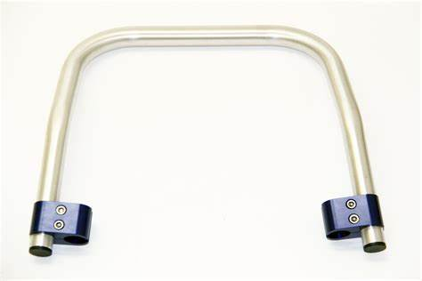
Bent metal tube with clamps on the end, to attach to any similar sized vertical handles.
It would only work for carts that have circular handles that are a similar size to the handle extension because the clamp is a similar size.

Prior Design Attempt #3 - Handlebars Extender Handle Extender for Baby Carriages Pram Trolley 45mm Clamp Mouth

https://www.walmart.com/ip/Handlebars-Extender-Handle-Extender-for-Baby-Carriages-Pram-Trolley-45mm-Clamp-Mouth/5055866940?wmlspartner=wlpa&selectedSellerId=101114713&adid=222222222221502142577_10001134075_1154489110932176_pla&wmlspartner=wmtlabs&wl0=e&wl1=o&wl2=c&wl3=72155908621962&wl4=pla-4575755106654175&wl5=&wl6=&wl7=&wl10=Walmart&wl11=Online&wl12=5055866940_10001134075&wl14=cart%20handle%20extender&veh=sem&msclkid=3a70561a883e1aa0b096315a6c832e2
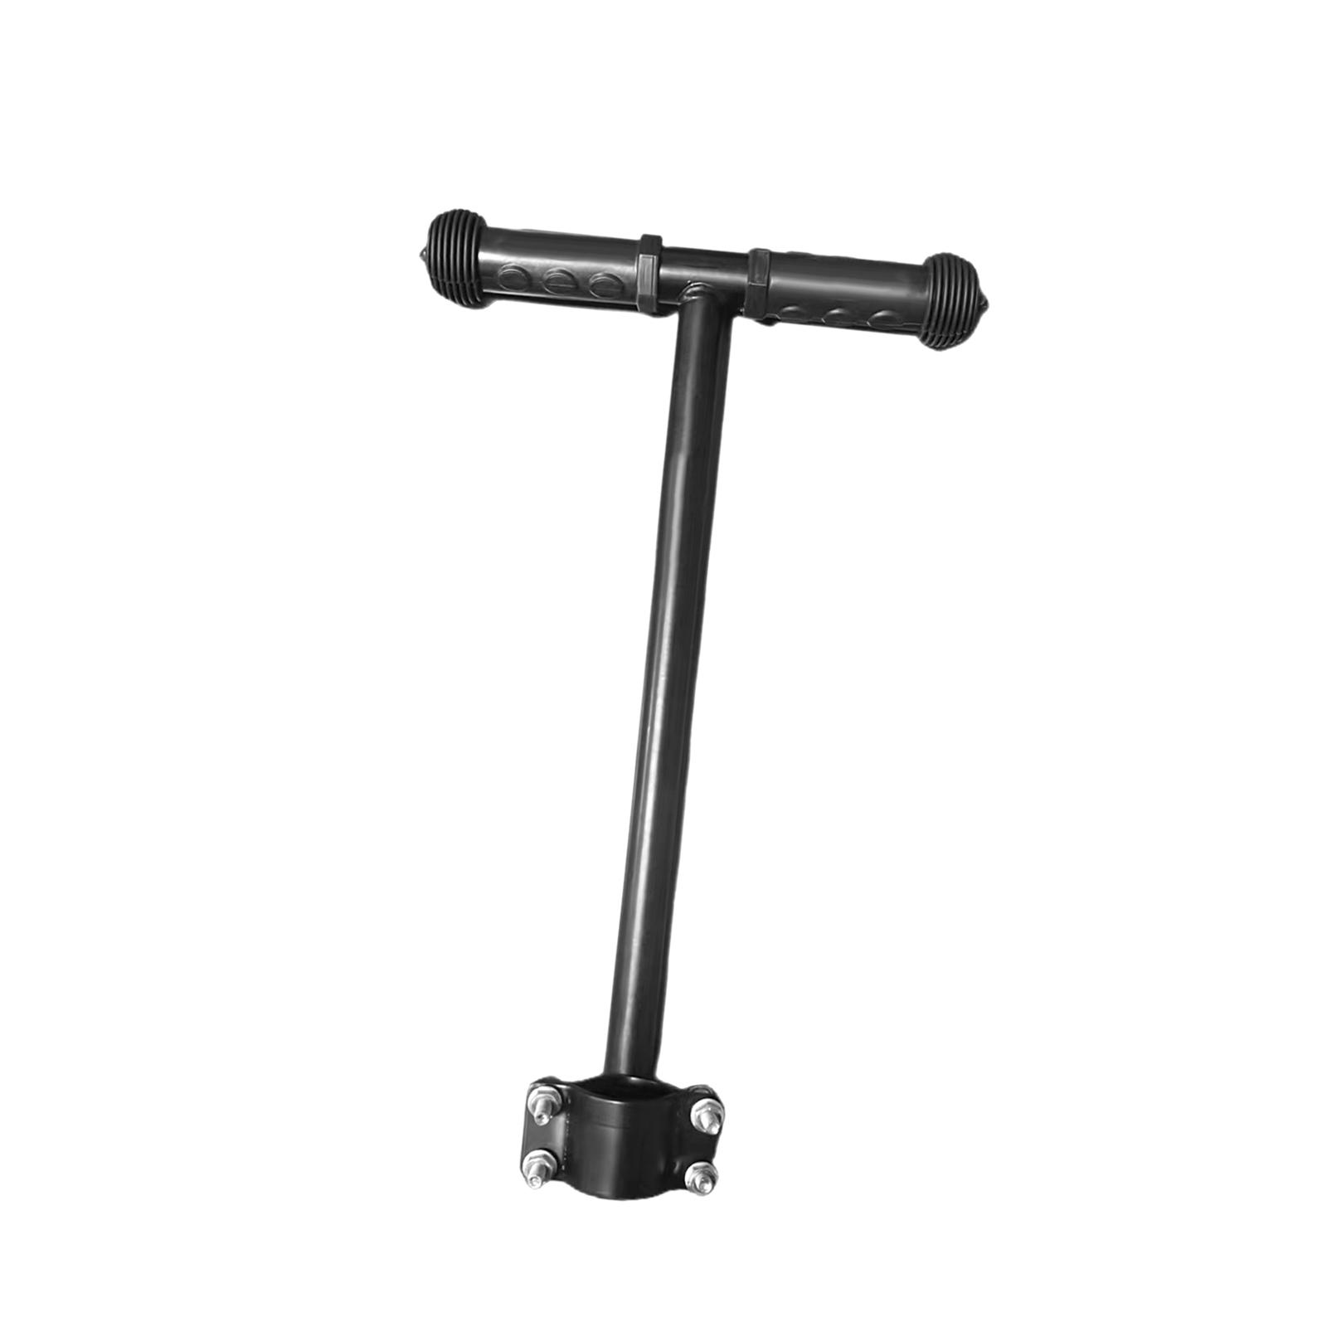
Details
It has 2 handles (grips, really) that attach to a vertical handle welded to a vertical clamp that gets screwed shut to tighten.
It’s not a very good design, requiring that the cart it’s attaching to already has one vertical handle, in which case this will at best be redundant and at worst get in the way. Because it only has one attachment point and a handle centered (and split by) the vertical, you either have to walk with both hands behind you, to pull both sides of the handle equally, or walk with one hand on the handle which doesn’t work sell when walking with that one hand not aligned to the center of mass. It wouldn’t be able to attach to the cart we were given, would be uncomfortable to use, and difficult to install/remove for someone with reduced movement (i.e. disks inserted in back from surgery)

Prior Design Attempt #4 - Harloff Offset Push Handle
https://www.savelives.com/offset-push-handle
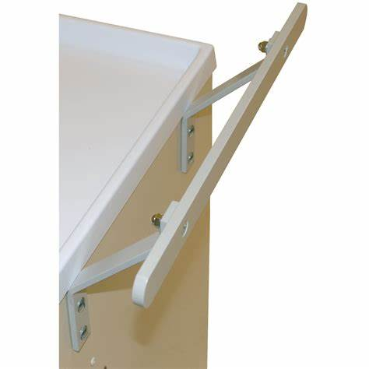
Details
Three wood or metal pieces held together by screws. One horizontal piece is held to the 2 vertical pieces at the end. The vertical pieces have holes for screws on the end. The ends of the vertical pieces are bent at a 45º angle.
Analysis
It would only work on things that are able to have screw holes (i.e. user is okay with it and it’s made of wood or thin plastic). It cannot be easily adjusted as it uses custom/proprietary parts. It is not easily replaceable as you take it off by removing 4 screws that all leave holes in the material of the cart. It doesn’t fit well in the hand because the handle is a thin piece of wood. Depending on the material the supports are made of, it might flex a lot when turning, causing increased fatigue.

