MyDesign Portfolio
Element E Initial Template

How to use this template
Students: The template below is one way to describe how your proposed solution is supported by STEM concepts and principles, but the specific assignment given by your instructor may require a different structure or dictate different details. If you make a copy of this template to edit, be sure to delete the instructions.

Element E: Application of STEM Principles and Practices

STEM Principles and Practices to Design Requirements (E1)
This section should describe how your proposed solution is supported by STEM (science, technology, engineering, mathematics, computer science, etc.) concepts.
Concepts can be laws, theories, and practices, including disciplinary core ideas (i.e., Next Generation Science Standards, Common Core State Standards) and standards for mathematical practice.
Go beyond describing the engineering design process to describe the STEM concepts as they apply to your proposed solution in order to meet the design requirements.
Be sure to apply the applicable STEM concepts in context, directly to the specifics of your design. Review concepts learned in your other classes and tackle new concepts as appropriate. Include any relevant calculations.
Element C indicates that you should have at least three high-priority design requirements to receive a score of 3 (and four for a score of 4, and five for a 5). Your number of design requirements and your number of high-priority design requirements should be the same throughout your portfolio. You should use the same three - five design requirements here too, and apply at least three of them to STEM concepts to achieve a score of 5 on E1. Use as many copies of this sub-template as needed.

STEM Principle for High-Priority Design Requirement #1
STEM Concept: Concepts can be laws, theories, and practices, including disciplinary core ideas (i.e., Next Generation Science Standards, Common Core State Standards) and standards for mathematical practice.

The first requirement is high priority because if our product is unable to hold up a guitar, it fails its purpose of being a guitar holder. To pass this requirement, our design must be able to hold up a guitar by itself for longer than ten seconds. This also ties to our research of fighting depression by providing a reliable product that can be used without worry.

Describe how STEM concept applies directly to the specifics of your design:

Because we need to hold the guitar, we need to fight against the gravity of the guitar, which connects to physics. The holder will hold the guitar in the opposite way the guitar falls, that will be the motions prediction. The design for the holder will be related to engineering. Because we need to calculate the gravity to design the holder, so it’s related to math.

STEM Principle for High-Priority Design Requirement #2
STEM Concept: Concepts can be laws, theories, and practices, including disciplinary core ideas (i.e., Next Generation Science Standards, Common Core State Standards) and standards for mathematical practice.

The next requirement, accessibility, is also a high priority. The Bridge to Wellness room has the guitars for a good reason, to help students face depression or mental health issues, and usually if a person is having a bad day, week, or month, any little inconvenience can break a person. In order to get around this, our device must be easy to use in order to prevent any inconvenience.

Describe how STEM concept applies directly to the specifics of your design:

Because we are considering students’ wellness, it’s related to biology.

STEM Principle for High-Priority Design Requirement #3
STEM Concept: Concepts can be laws, theories, and practices, including disciplinary core ideas (i.e., Next Generation Science Standards, Common Core State Standards) and standards for mathematical practice.

Our final high priority requirement is it must stay within the budget of 10 dollars. If we cannot stay within this budget, we will not be able to even create our product.

Describe how STEM concept applies directly to the specifics of your design:

Because we are calculating its cost, it’s related to math.

Proposed Solution to STEM Principles and Practices (E2)
While E1 was focused on how STEM applies to the design requirements, E2 is focused on how STEM is used to support the design solution.
For E2, use STEM concepts to justify your design decisions. It's important that the STEM Principles and Practices that are discussed are actually appropriate and useful to the problem. Use as many copies of this sub-template as needed.
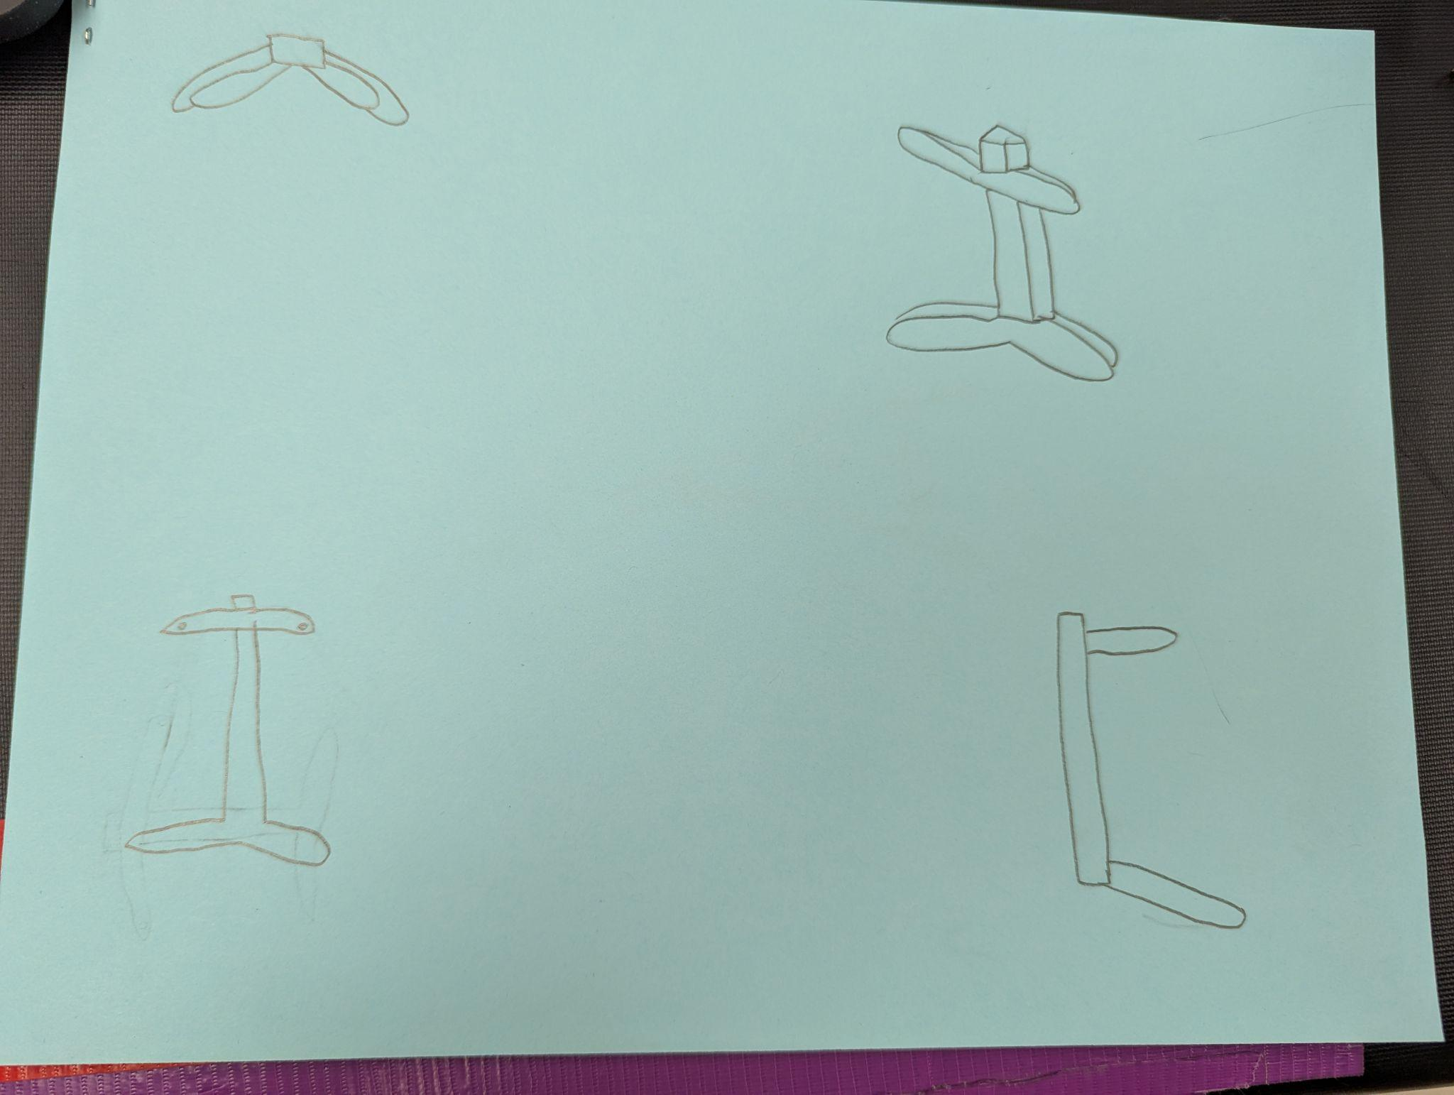

STEM Principle for Design Solution #1
STEM Concept: Concepts can be laws, theories, and practices, including disciplinary core ideas (i.e., Next Generation Science Standards, Common Core State Standards) and standards for mathematical practice.

Physics and engineering

Describe how STEM concept applies directly to the specifics of your solution:

For a reliable holder, we need to calculate the forces acting on the guitar and use engineering to design the most effective materials and structure for stability.

STEM Principle for Design Solution #2
STEM Concept: Concepts can be laws, theories, and practices, including disciplinary core ideas (i.e., Next Generation Science Standards, Common Core State Standards) and standards for mathematical practice.

Accessibility

Describe how STEM concept applies directly to the specifics of your solution:

To maximize accessibility, we will consider height, angle, and placement of the holder. We are going to design a structure that allows users to quickly and securely place or retrieve the guitar without unnecessary strain or difficulty. This ensures that even students who are stressed or experiencing mental health struggles can use the product effortlessly.

STEM Principle for Design Solution #3
STEM Concept: Concepts can be laws, theories, and practices, including disciplinary core ideas (i.e., Next Generation Science Standards, Common Core State Standards) and standards for mathematical practice.

Mathematics

Describe how STEM concept applies directly to the specifics of your solution:

Because our design must stay within a $10 budget, we use mathematical calculations to compare material costs, optimize efficiency, and minimize waste. We will analyze price-to-performance ratios of different materials to find the most cost-effective option without sacrificing strength or stability.

Evidence Design is Reviewed (E3)

"Field experts" are professionals who spend at least a portion of their time working in a field directly related to your project. These field experts are not permitted to double count as stakeholders.
E3 is about experts reviewing what you've said about the STEM connections in E1 and E2. It's important here to talk to an appropriate field expert who knows about the STEM content of the project - not to a stakeholder. We need to know what the expert said. Document in this sub-element what the expert said about the connections you've made from your design requirements to STEM principles and practices (E1) and what they said about the ways STEM principles and practices substantiate your design solution (E2). This documentation will support you to give a corrective response in E5. Potential formats for review include: interview notes, emails, audio/video tape with transcript, etc. Use as many copies of this sub-template as needed.
Documentation #1:
- What format: Interview notes, emails, audio/video tape with transcript, etc.
- What the expert said about the connection you’ve made from your design requirements to STEM principles and practices:

Feedback notes

- What the expert said about how STEM principles and practices substantiate your design solution:

He told us that having “accessibility” as one of our design requirements, although he thought that relating it to biology was a bit of a stretch.

Experts with Credentials (E4)
Document who your field experts are (names are not necessary) and what qualifies them as an expert. Use as many copies of this sub-template as needed.
Expert #1: Mr Elliot is the teacher who is in charge of the wellness room, therefore he knows what is good for the room.

Verification or Corrective Response to Design Review (E5)
Your conversation/interview with the expert(s) should inform some corrective responses. In E5, describe how those reviews informed your responses. For example, “__________ told us __________, which informed our decision to change/reconsider __________ .” (or "...which verified/reinforced our decision to __________.” )
Make sure to document the experts’ reviews (suggestions/feedback or criticisms of your proposed solution) and how they will inform iterations you will make to your proposed solution. Use as many copies of this sub-template as needed.
Interview with Expert #1 informs corrective response: ]
Mr. Elliot reinforced our decision to have accessibility as our design requirement but he also informed us to potentially reconsider relating it to biology and more to psychology.

