The Athletic Commons at GPS needs backpack organization because the backpacks cause safety issues, as well as creating a choke point which slows down everyone trying to use the athletic commons after school.
We repurposed 10 plexiglass dividers left over from COVID to build much needed backpack storage in the athletic commons (see figures 1-3). This not only made our project sustainable but also much cheaper because the school no longer wanted or needed them and gave them to us without any cost. Since we had so much material to work with, we were able to test a lot of different prototypes and ideas with no additional cost, and we were able to reuse the plexiglass that was just sitting in a closet. We were also able to use the 3D printers in the library to print hinges for the cubicles. Having this helped massively with choosing the type of hinge because we could print different ones and test them without having to order and wait for them.
We measured a backpack that was completely stuffed with binders, then we took those measurements and created a cubicle based off of them (Height: 10 in, Width:14 in, Length: 19 in). This made sure that almost any backpack is able to fit in it which is super important the the functionality of the design. The final prototype would not be as effective if we did not take measurements of the backpack to make the cubicle. Using a stuffed backpack gives a real life example of how big and heavy someone's backpack might be and gives us a more accurate idea of how the cubby will be used.
The 3D printed hinges and plexiglass panels were measured and designed to allow the backpack organizer to be collapsible, so that when the athletic commons is being used for events, they can be stored easily. Even though they are collapsible, the cubbies are still designed to be strong enough to hold backpacks and other athletic equipment. This is needed in the design because the athletic commons is a multipurpose space that gets super cluttered with backpacks during chapel, but also is needed to hold other school events.
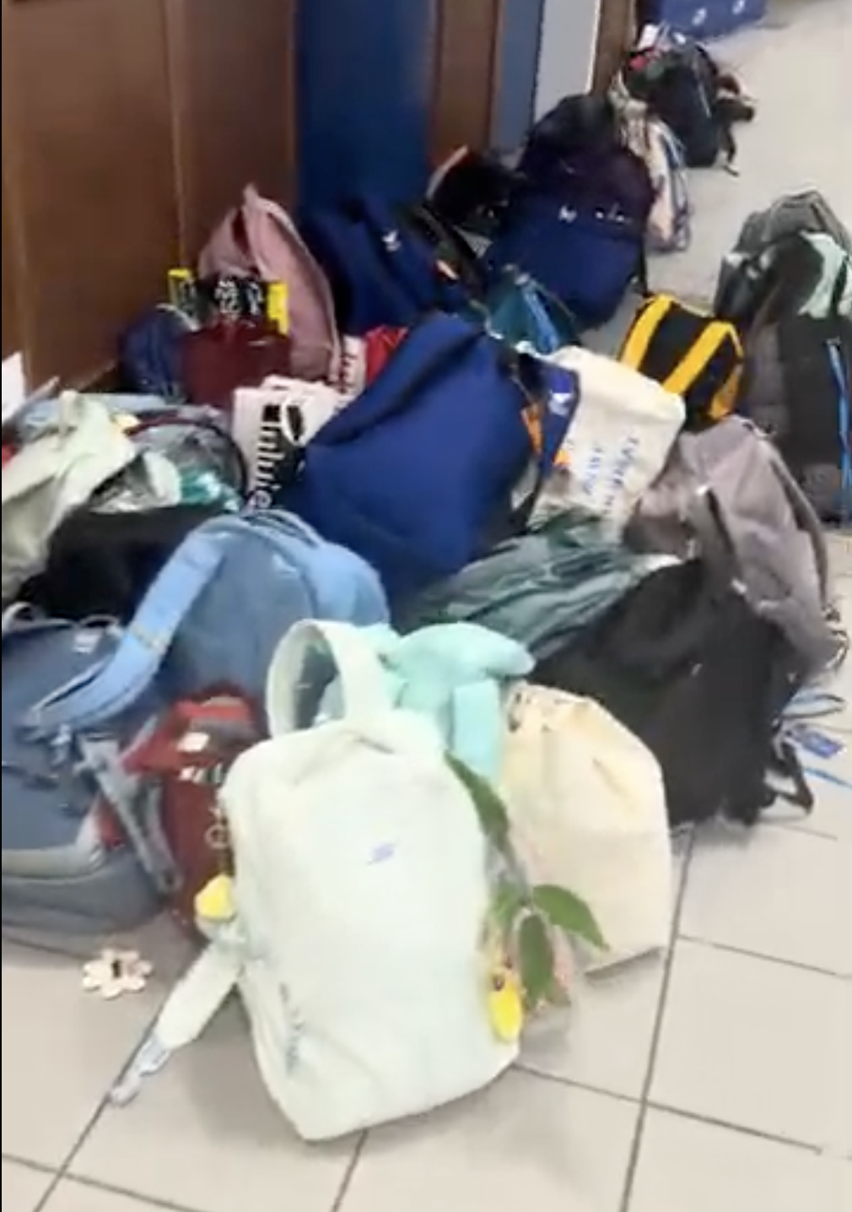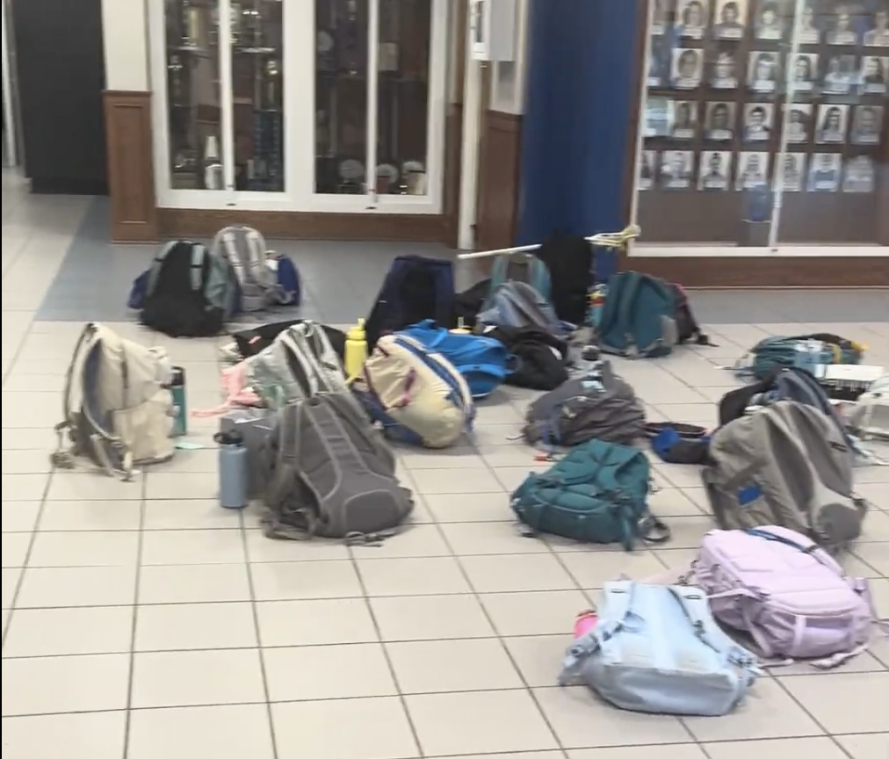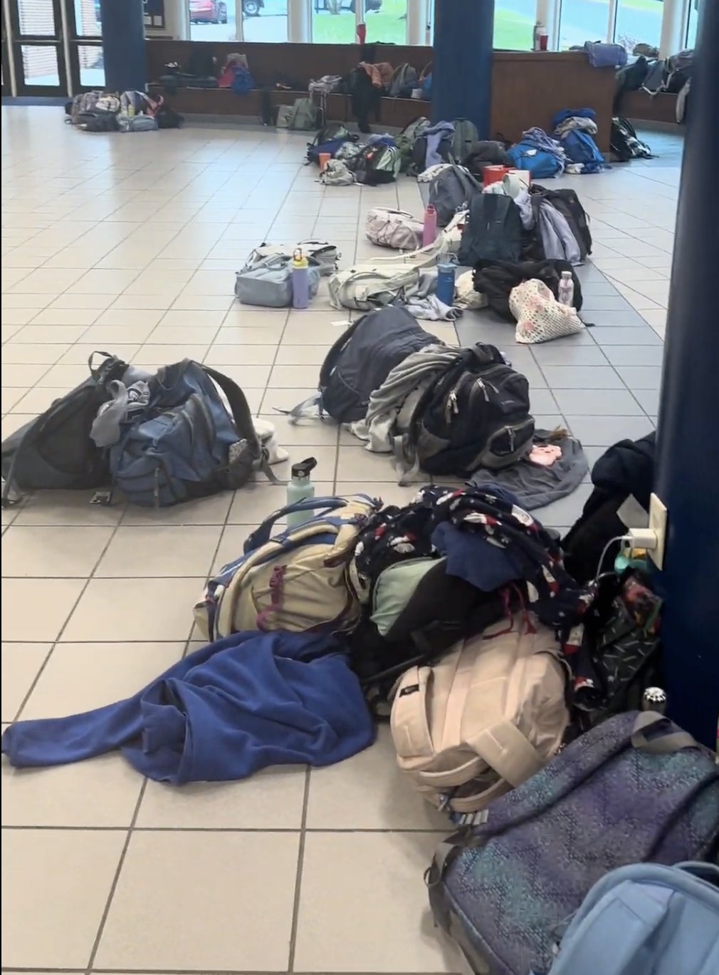
Figure 1 Figure 2 Figure 3

