MyDesign Portfolio
Element E Initial Template

How to use this template
Students: The template below is one way to describe how your proposed solution is supported by STEM concepts and principles, but the specific assignment given by your instructor may require a different structure or dictate different details. If you make a copy of this template to edit, be sure to delete the instructions.

Element E: Application of STEM Principles and Practices

STEM Principles and Practices to Design Requirements (E1)
This section should describe how your proposed solution is supported by STEM (science, technology, engineering, mathematics, computer science, etc.) concepts.
Concepts can be laws, theories, and practices, including disciplinary core ideas (i.e., Next Generation Science Standards, Common Core State Standards) and standards for mathematical practice.
Go beyond describing the engineering design process to describe the STEM concepts as they apply to your proposed solution in order to meet the design requirements.
Be sure to apply the applicable STEM concepts in context, directly to the specifics of your design. Review concepts learned in your other classes and tackle new concepts as appropriate. Include any relevant calculations.
Element C indicates that you should have at least three high-priority design requirements to receive a score of 3 (and four for a score of 4, and five for a 5). Your number of design requirements and your number of high-priority design requirements should be the same throughout your portfolio. You should use the same three - five design requirements here too, and apply at least three of them to STEM concepts to achieve a score of 5 on E1. Use as many copies of this sub-template as needed.

STEM Principle for High-Priority Design Requirement #1
STEM Concept: Concepts can be laws, theories, and practices, including disciplinary core ideas (i.e., Next Generation Science Standards, Common Core State Standards) and standards for mathematical practice.

One of the requirement is have all the supplies we will be using for this prototype only under 60$

Describe how STEM concept applies directly to the specifics of your design:

We have use Math to add up the total of supplies plus additional tax to make sure its under that amount.

STEM Principle for High-Priority Design Requirement #2
STEM Concept: Concepts can be laws, theories, and practices, including disciplinary core ideas (i.e., Next Generation Science Standards, Common Core State Standards) and standards for mathematical practice.

It project house has to have 3 rooms that are measured one big room that is length is 12 inches with a width of 8 and one small room with length 6 and width of 4

Describe how STEM concept applies directly to the specifics of your design:

STEM Principle for High-Priority Design Requirement #3
STEM Concept: Concepts can be laws, theories, and practices, including disciplinary core ideas (i.e., Next Generation Science Standards, Common Core State Standards) and standards for mathematical practice.

Math since we have to measure and divide the inches and make smaller to sketch with accuracy on the notebook we have drawn.

Describe how STEM concept applies directly to the specifics of your design:

Proposed Solution to STEM Principles and Practices (E2)
While E1 was focused on how STEM applies to the design requirements, E2 is focused on how STEM is used to support the design solution.
For E2, use STEM concepts to justify your design decisions. It's important that the STEM Principles and Practices that are discussed are actually appropriate and useful to the problem. Use as many copies of this sub-template as needed.
STEM Principle for Design Solution #1
STEM Concept: Concepts can be laws, theories, and practices, including disciplinary core ideas (i.e., Next Generation Science Standards, Common Core State Standards) and standards for mathematical practice.

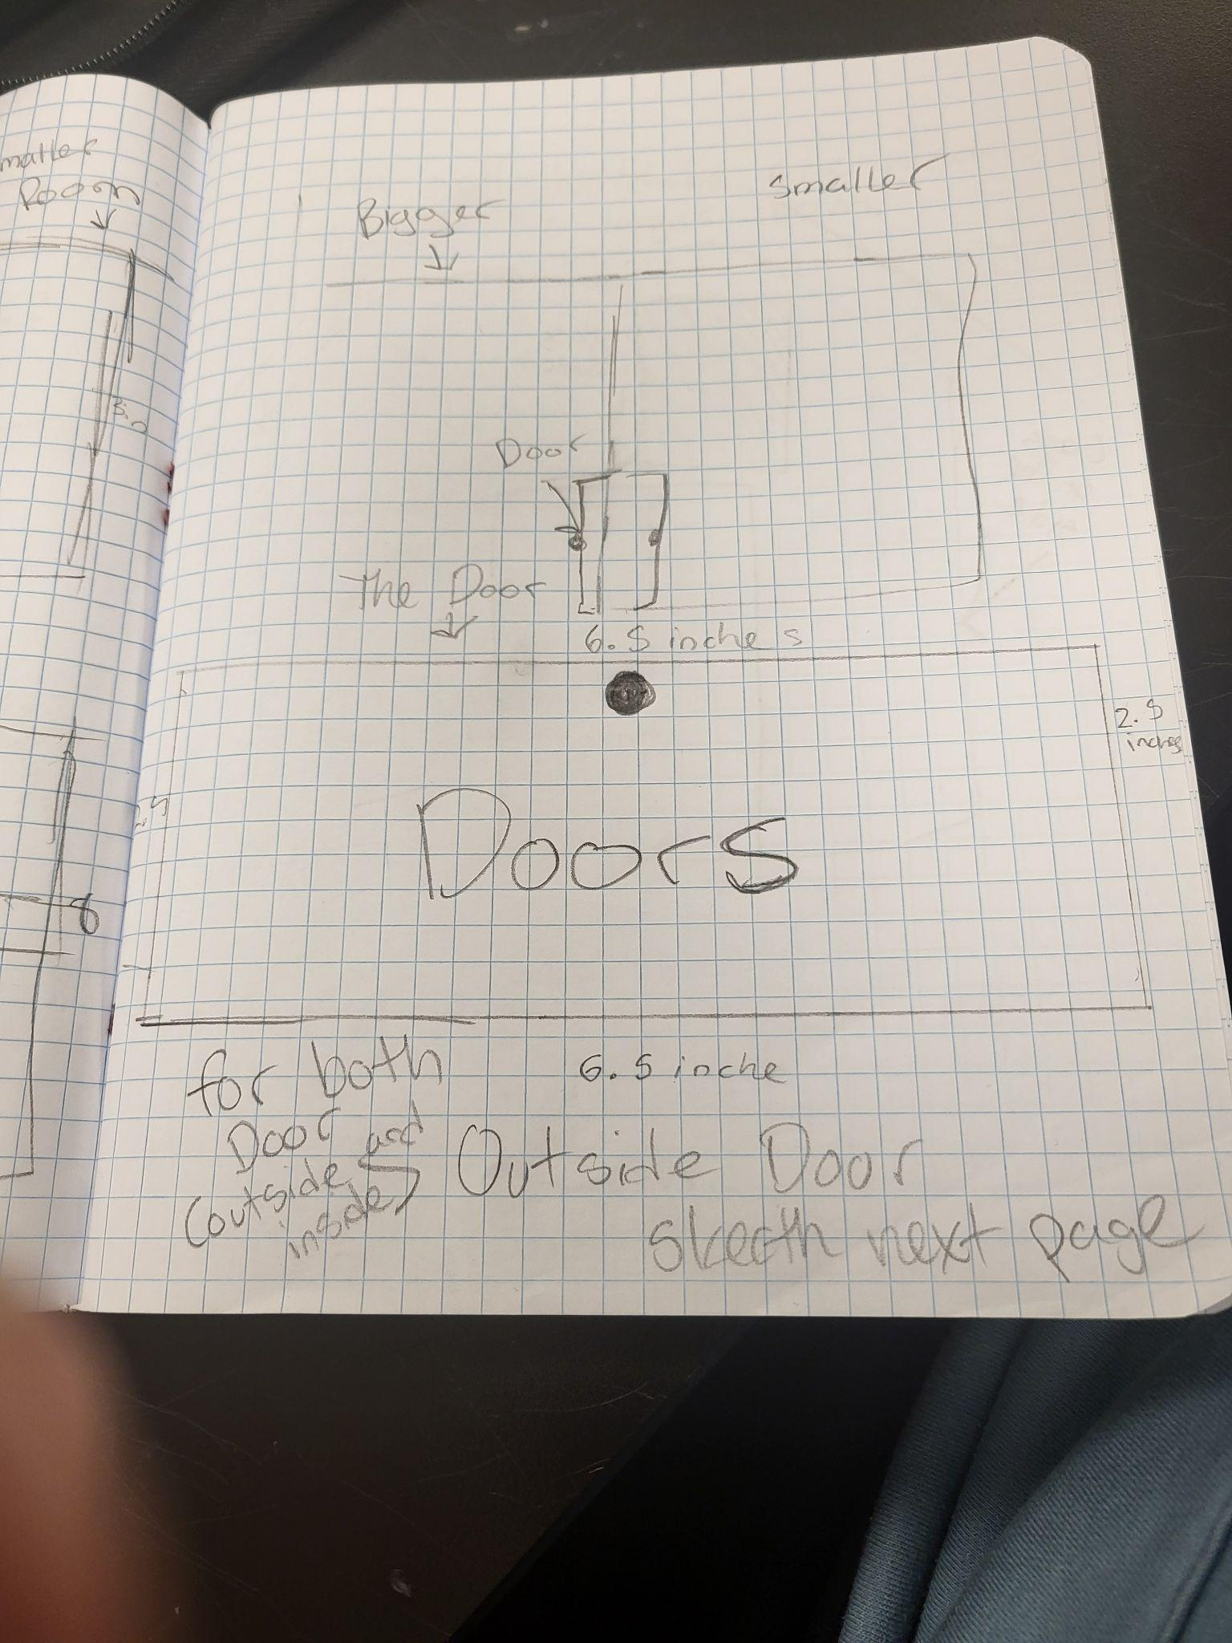 The measurement for the doors and wall

Describe how STEM concept applies directly to the specifics of your solution:

Using math, we had to divide and connect the pieces of the notebook.

STEM Principle for Design Solution #2
STEM Concept: Concepts can be laws, theories, and practices, including disciplinary core ideas (i.e., Next Generation Science Standards, Common Core State Standards) and standards for mathematical practice.

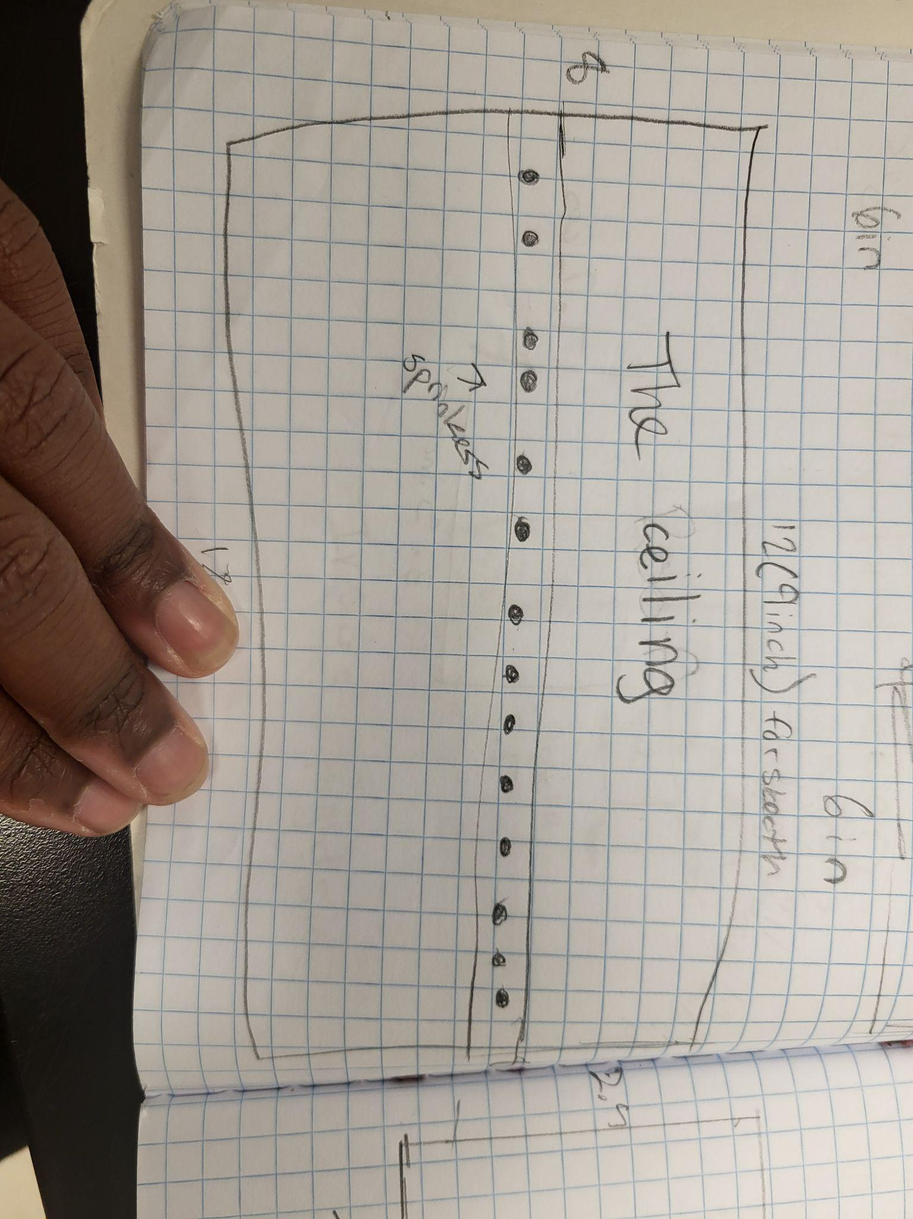 A concept of a suppression system written on a notebook.

Describe how STEM concept applies directly to the specifics of your solution:

Since we have to divide the stakeholders' lengths and widths of the suppression system to make them smaller or bigger.

STEM Principle for Design Solution #3
STEM Concept: Concepts can be laws, theories, and practices, including disciplinary core ideas (i.e., Next Generation Science Standards, Common Core State Standards) and standards for mathematical practice.

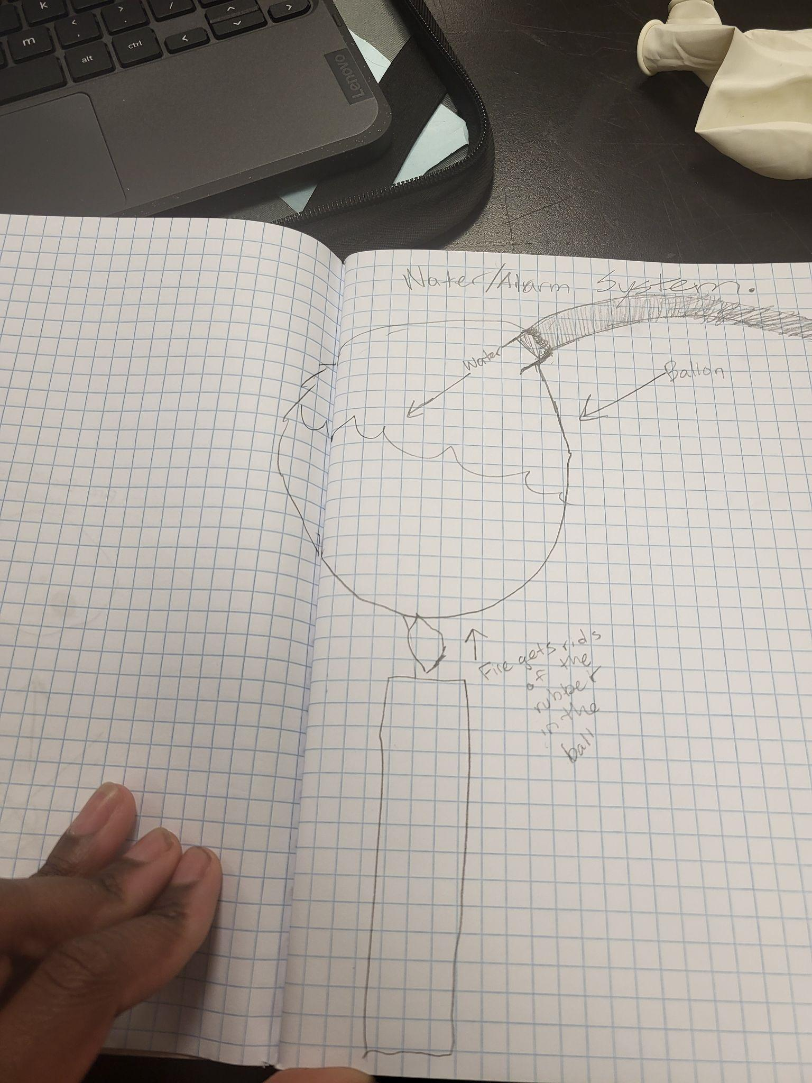 The new solution to the fire suppression system

Describe how STEM concept applies directly to the specifics of your solution:

Using the supplies that we brought we were able to connect a clear tube to the balloon

Evidence Design is Reviewed (E3)

"Field experts" are professionals who spend at least a portion of their time working in a field directly related to your project. These field experts are not permitted to double count as stakeholders.
E3 is about experts reviewing what you've said about the STEM connections in E1 and E2. It's important here to talk to an appropriate field expert who knows about the STEM content of the project - not to a stakeholder. We need to know what the expert said. Document in this sub-element what the expert said about the connections you've made from your design requirements to STEM principles and practices (E1) and what they said about the ways STEM principles and practices substantiate your design solution (E2). This documentation will support you to give a corrective response in E5. Potential formats for review include: interview notes, emails, audio/video tape with transcript, etc. Use as many copies of this sub-template as needed.
Documentation #1:
- What format: Interview notes, emails, audio/video tape with transcript, etc.
- What the expert said about the connection you’ve made from your design requirements to STEM principles and practices:

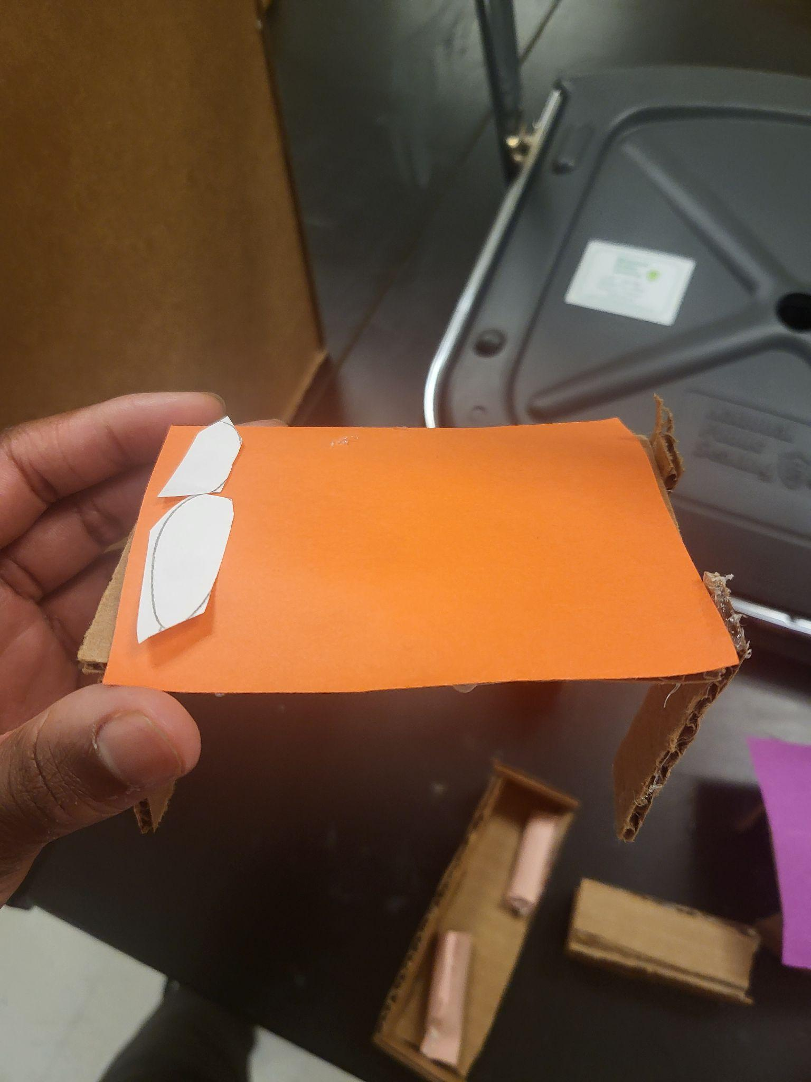

- What the expert said about how STEM principles and practices substantiate your design solution:

It says it fits the prototype design of the firehouse, but needs more stuff

Documentation #2:
- What format: Interview notes, emails, audio/video tape with transcript, etc.
- What the expert said about the connection you’ve made from your design requirements to STEM principles and practices:

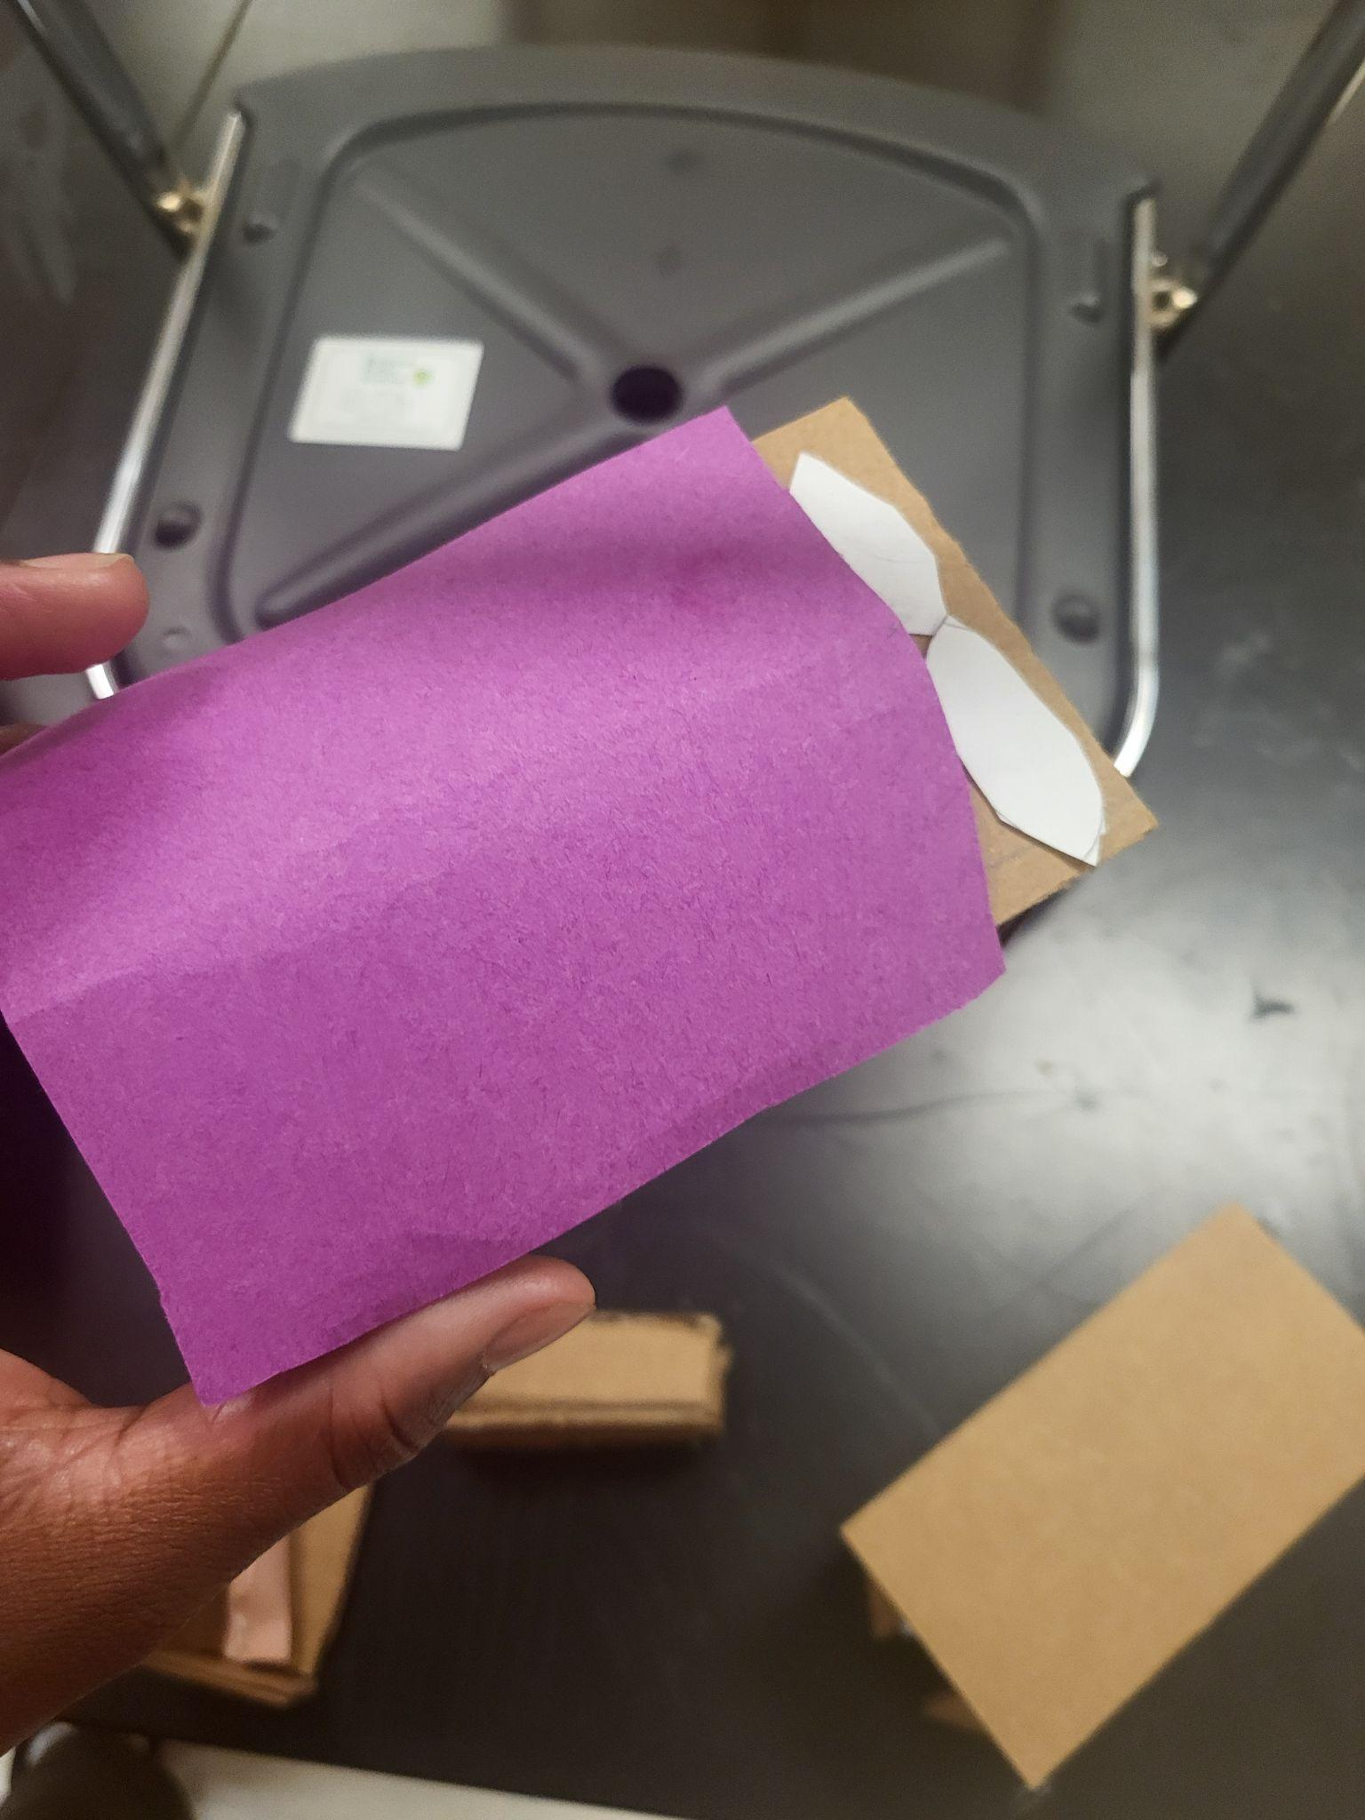

- What the expert said about how STEM principles and practices substantiate your design solution:

The bed fits the small room design the bed design is the better than the other.

Experts with Credentials (E4)
Document who your field experts are (names are not necessary) and what qualifies them as an expert. Use as many copies of this sub-template as needed.
Expert #1: Been a teacher for 25 years
Expert #2: Been at school for 4 years

Verification or Corrective Response to Design Review (E5)
Your conversation/interview with the expert(s) should inform some corrective responses. In E5, describe how those reviews informed your responses. For example,
Make sure to document the experts’ reviews (suggestions/feedback or criticisms of your proposed solution) and how they will inform iterations you will make to your proposed solution. Use as many copies of this sub-template as needed.
Interview with Expert #1 informs corrective response:
Interview with Expert #2 and Expert 1informs corrective response: Expert 2 told us that the project was ready to go which informed our decision to reconsider an improvement on the object which reinforced our decision to rebuild the object again.

