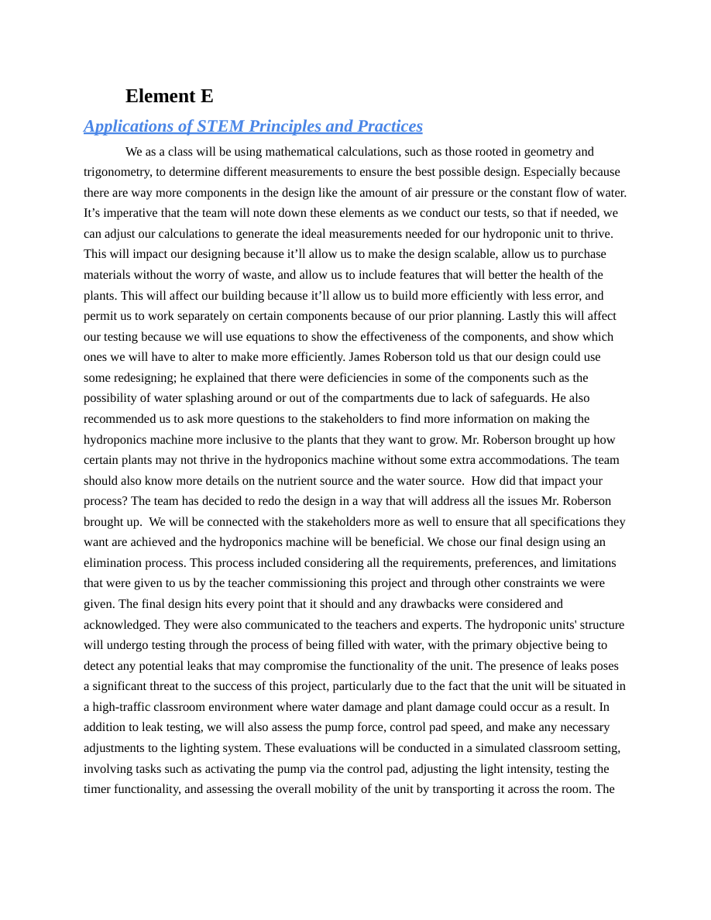

information given by our experts and stakeholders about potential obstacles is important because it allows us, as a team, to create a viable solution to present to our consumer.

