# What determines community level parkrun participation?

*Smith R1,Schneider PP1, Bullas A2, Bayley T1, Haake SSJ2, Brennan A1, Goyder E1*

*1School of Health and Related Research, University of Sheffield* *2Sheffield Hallam University Advanced Wellbeing Centre*

**Keywords**: parkrun, Participation, Physical Activity, Equity, Ethnicity.

**Intended Journal**: Journal of Racial & Ethnic Health Disparities, Sports Medicine Open,Behavioural and Social Sciences, Journal Of Epi & Comm Health.

# Abstract

parkrun has been very successful in encouraging people in England to participate in their weekly 5km running events. However, there is substantial heterogeneity in parkrun participation across different communities in England: after controlling for travel distances, deprived communities have significantly lower participation rates (Schneider et al. 2019).

This paper aims to expand on previous findings by investigating ethnic disparities in parkrun participation. We combined geo-spatial data, provided by parkrun and available through the ONS, and fitted multivariable Poisson regression models to study the effect of ethnic minorities on participation rates at the aggregate census area level.

We find that areas with a higher proportion of ethnic minorities had lower participation rates. This effect is independent of areas with high deprivation and a high proportion of ethnic minorities have the lowest participation rates. An opportunity exists for parkrun to engage with these communities and reduce potential barriers to participation.

# Introduction

parkrun is a collection of free mass participation 5km running events that takes place every Saturday morning. There are currently over 500 locations in England, with a combined weekly attendance of over 100,000. parkrun has been identified as being successful at engaging with individuals who may not otherwise have taken part in organised physical activity [Haake, 2018](http://shura.shu.ac.uk/24200/1/Haake_%20parkrun_a_new_model%28VoR%29.pdf) ; [Stevinson et al. 2013](https://academic.oup.com/jpubhealth/article/36/2/268/1548895), and there is some evidence that it has increased overall physical activity levels in participants [Stevinson et al. 2019](https://academic.oup.com/jpubhealth/advance-article/doi/10.1093/pubmed/fdy178/5123524). Overall, there is a consensus that parkrun has huge public health potential [Reece et al. 2019](https://bjsm.bmj.com/content/bjsports/53/6/326.full.pdf?casa_token=YEz1sYUvjksAAAAA:SABmbZd7t_qrEFEoWSWQkPZt3BCSLaBswWiFguQaSdXEEj_QI2IyBhDroWsScjq1EGiHHEvWbjc).

However, research from Sheffield [Goyder et al. 2018] and more broadly the UK [Fullagar et al. 2019](https://www.researchgate.net/profile/Simone_Fullagar/publication/336717033_Fullagar_S_Petris_S_Sargent_J_Allen_S_Akhtar_M_Ozakinci_G_in_press_2019_Action_research_with_parkrun_UK_volunteer_organisers_to_develop_inclusive_strategies_Health_Promotion_International/links/5db23b0c4585155e27f966d2/Fullagar-S-Petris-S-Sargent-J-Allen-S-Akhtar-M-Ozakinci-G-in-press-2019-Action-research-with-parkrun-UK-volunteer-organisers-to-develop-inclusive-strategies-Health-Promotion-International.pdf) identified that parkruns located in more deprived areas have lower attendances, and that ethnic diversity was limited, leading to a concern that as with many public health interventions, parkrun is “likely to be responsible for significant intervention generated inequalities in uptake of opportunities for physically active recreation.” [Goyder et al. 2018](https://jech.bmj.com/content/jech/72/Suppl_1/A61.2.full.pdf).

Understanding the determinants of participation in parkrun is therefore an important avenue of future research. A study from Australia using survey data from parkrun participants attempted to do this [Cleland et al., 2019](https://journals.sagepub.com/doi/pdf/10.1177/0890117118770106?casa_token=WIfzcbwmyFoAAAAA:v2iYFcITA7-__9Xn3pZvS9GRw-aIvKkDGLU1bU6__behSpsm__LwcvkTGclu79R42FECROneYL5N). However, due to the biases associated with surveying only parkrun participants the findings have no external validity (i.e. estimating the relationship between education and number of runs once engaged with parkrun does not tell us about the determinants of initial engagement with parkrun). The authors themselves note the limitation that “The sample was limited to a non-random sample of parkrun participants in one State of Australia and may not be generalizable to other parkrun populations.” (p.21).

Our previous work attempting to locate the optimal parks in which to locate the next 200 parkrun events, revealed that there is substantial heterogeneity in parkrun participation across different communities in England: after controlling for travel distances, deprived communities have significantly lower participation rates (Schneider et al. 2019). This analysis was able to quantify, for the first time, how participation in parkrun varied in different communities in England. However, the analysis was interested only in the relationship between participation, access and deprivation and did not consider other potential determinants of participation in parkrun. This paper extends this part of our previous analysis to better understand how access, deprivation, ethnicity, population density and age of the community influence parkrun participation.

Our initial hypothesis was that areas with a higher proportion of ethnic minority residents have lower participation in parkrun. We thought this because 1) there is strong evidence from survey data that ethnic minority individuals in England are less likely to be physcially active, and to engage in sport in general [Sport England](https://www.sportengland.org/media/3513/sports-participation-and-ethnicity-in-england-headline-findings.pdf), 2) previous research has identified low levels of ethnic minority participation in parkrun [Goyder et al. 2018](https://jech.bmj.com/content/jech/72/Suppl_1/A61.2.full.pdf) [Fullagar et al. 2019](https://www.researchgate.net/profile/Simone_Fullagar/publication/336717033_Fullagar_S_Petris_S_Sargent_J_Allen_S_Akhtar_M_Ozakinci_G_in_press_2019_Action_research_with_parkrun_UK_volunteer_organisers_to_develop_inclusive_strategies_Health_Promotion_International/links/5db23b0c4585155e27f966d2/Fullagar-S-Petris-S-Sargent-J-Allen-S-Akhtar-M-Ozakinci-G-in-press-2019-Action-research-with-parkrun-UK-volunteer-organisers-to-develop-inclusive-strategies-Health-Promotion-International.pdf).

# Methods

Data was obtained from multiple sources at the Lower layer Super Output Level, which are geographical areas containing around 1,000-3,000 people. There are 32844 LSOAs in England. [parkrunUK](https://www.parkrun.org.uk/) provided data on the number of runs from each LSOA in England between the 1st January and 10th December 2018. The ethnic breakdown of each LSOA was obtained from the Office of National Statistics (ONS) [here](https://www.ons.gov.uk/peoplepopulationandcommunity/populationandmigration/populationestimates/datasets/lowersuperoutputareamidyearpopulationestimates). The deprivation scores & population sizes for each LSOA was obtained from the ONS. More information can be found [here](https://assets.publishing.service.gov.uk/government/uploads/system/uploads/attachment_data/file/835115/IoD2019_Statistical_Release.pdf). The population density for each LSOA was obtained from the ONS [here](https://www.ons.gov.uk/peoplepopulationandcommunity/populationandmigration/populationestimates/datasets/lowersuperoutputareapopulationdensity). The geographic weighted centroids for each LSOA were obtained from the ONS [here](http://census.ukdataservice.ac.uk/get-data/boundary-data.aspx). The location of each parkrun event was obtained from the parkrunUK website [here](https://www.parkrun.org.uk/).

|  |  |  |
| --- | --- | --- |
| Variable | Description | Source |
| run_count | number of runs from each LSOA in England between 1st January and 10th December 2018 | parkrunUK |
| imd | IMD scores for each LSOA | <https://assets.publishing.service.gov.uk/government/uploads/system/uploads/attachment_data/file/835115/IoD2019_Statistical_Release.pdf> |
| total_pop | total number of individuals in each LSOA | <https://assets.publishing.service.gov.uk/government/uploads/system/uploads/attachment_data/file/835115/IoD2019_Statistical_Release.pdf> |
| pop_density | population density for each LSOA | <https://www.ons.gov.uk/peoplepopulationandcommunity/populationandmigration/populationestimates/datasets/lowersuperoutputareapopulationdensity> |
| perc_bme | percent of population non-white-british | <https://www.ons.gov.uk/peoplepopulationandcommunity/populationandmigration/populationestimates/datasets/lowersuperoutputareamidyearpopulationestimates> |
| mn_dstn | distance from LSOA centroid to nearest parkrun | derived |
| perc_non_working_age | derived from ONS data on age-groups in each LSOA | derived |
| run_rate | derived from run_count and LSAO populations | derived |

After merging these datasets we had detailed data on 32844 LSOAs participation in parkrun and several characteristics of the LSOAs which we hypothesised may influence participation. Since previous work has found corelations between participation and deprivation, distance to nearest event, and population density we included all of these variables. We also extended the analysis to include the percent of the population of black and ethnic minority and the percent of the population who are working age. We included ethnicity as we hypothesised that areas with higher percentages of residents of ethnic minorities would have lower participation rates. We included the percent of the population that is working age as a control to limit for the effect of populations heavily skewed toward older people (e.g. care homes), or very young people (e.g orphanages/immediately around special needs schools)). Since participation in parkrunUK is dominated by those aged 20-60 we felt this was justified.

We used R Software Environment to produce simple summary statistics and viewed simple correlations between the variables described. We then moved on to estimate the partial correlation coefficients between the variables, before running a poisson regression model on scaled data to estimate the relative influence of several determinants on parkrun participation.

# Results

Participation in parkrun varies between LSOAs. Around half of all communities (LSOA) average less than 1 run per week per 1000 people. Approximately a quarter average between 1 and 2 runs, and around an eighth between 2 and 3 runs.

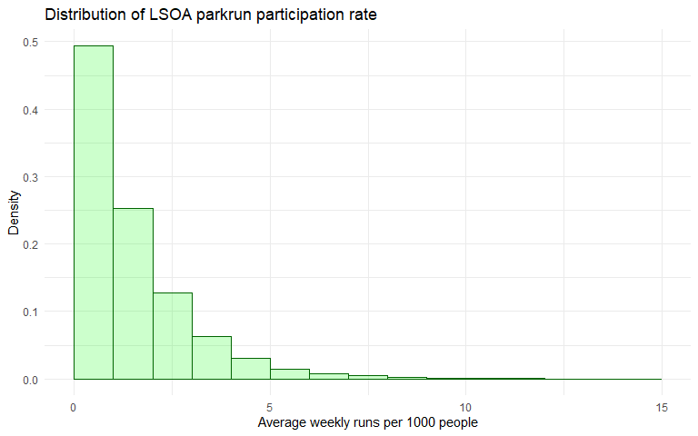

## Correlation Matrix

There is a negative correlation between particpation (run_count) and deprivation (imd), distance to nearest parkrun (mn_distance), population density (pop_density) and percent BME (perc_bme). Percent BME was strongly postively correlated with population density, negatively correlated with percent non-working age, and moderately positvely correlated with IMD suggesting that areas with more BME residents are more densely populated, more deprived and have fewer older people.

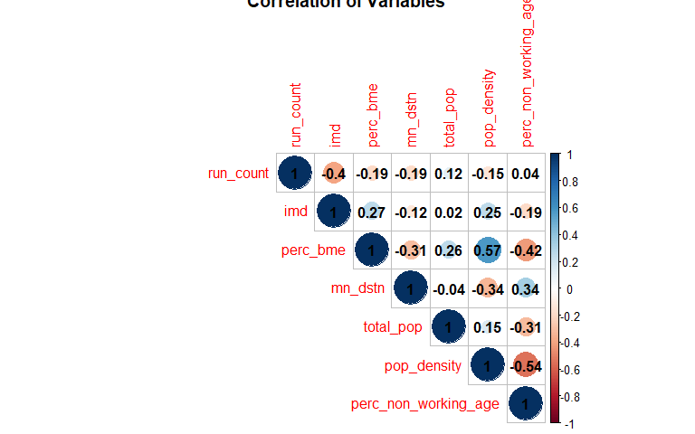

## Association plot

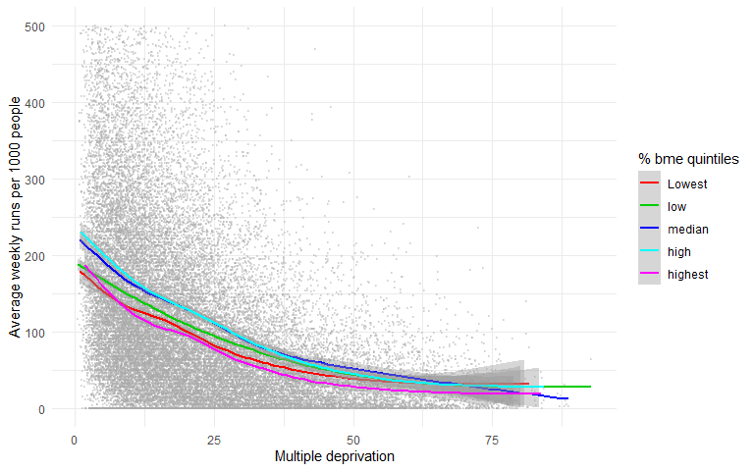

## Colour plot

We are interested in particular in how participation in parkrun varies by the percent BME and IMD of the community. We split our LSOA into deciles based on the two variables and represent the mean participation rate for LSOAs which fall into the repsective deciles (e.g. 2,5 means decile 2 for BME and 5 for IMD) as a colour on the plot.

The plot shows that participation is lowest in areas with the highest deprivation, and that there is a complex relationship between ethnicity and participation, with higher participation in areas with moderately high percentage BME.

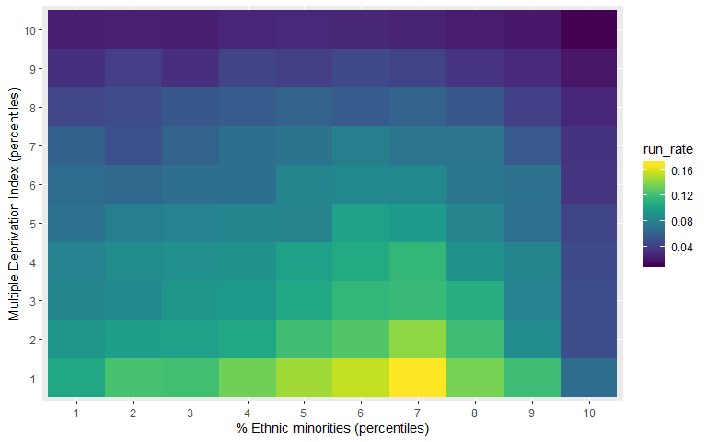

## Partial correlation matrix

In order to control for confounders, we created a partial correlation matrix. This estimates the correlation between the variables in the analysis holding all other variables constant.

Looking at the top row, it is clear that participation rates and deprivation is strongly correlated, but less so now we are controlling for other variables. Distance is also strongly correlated, as was the case in [Schneider et al., 2019]. The percent BME is also negatively correlated, suggesting that some of the relationship between participation and IMD is attributable to the ethnicity of residents.

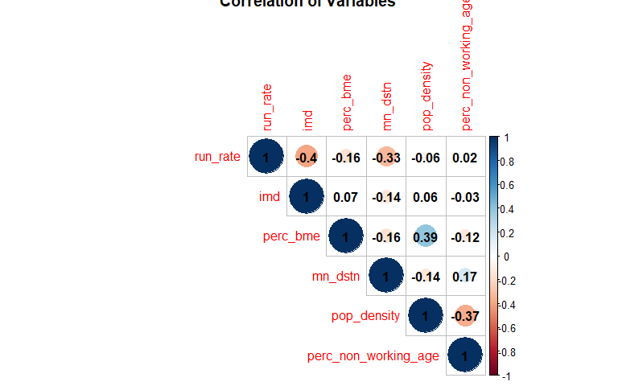

## Poissson Model

Poisson models are commonly used to estimate count data, where values are constrained by 0. In this case, because it is not possible for a community to have negative participation we use a Poisson regression.

The results of the poisson regression are not notoriously easy to interpret, but show that areas with a higher percent of residents who are non-White-British have lower participation rates, even when controlling for the effect of deprivation and distance to events. The effect is smaller than deprivation and distance, but still sizeable and significant.

% Table created by stargazer v.5.2.2 by Marek Hlavac, Harvard University. E-mail: hlavac at fas.harvard.edu % Date and time: Thu, Oct 31, 2019 - 10:22:08

# Discussion

Previous analysis by [Scheider et al., 2019](https://www.medrxiv.org/content/early/2019/08/29/19004143.full.pdf) has showed that participation in parkrun is lower in more deprived communities, and communities that are further from their nearest parkrun. This paper extends that analysis to include other community level characteristics which were hypothesized to influence parkrun participation. Our findings show that some of the negative effect on participation previously attributed to deprivation can actually be attributed to differences in participation by ethnic minotiries.

We find that communities with higher percentages of ethnic minority residents were less likely to participate in parkrun, even when controlling for deprivation. Since percentage ethnic minorotiy residents and deprivation are positively correlated, it is likely that some of the effect attributed to deprivation in our previous analysis [Scheider et al., 2019](https://www.medrxiv.org/content/early/2019/08/29/19004143.full.pdf) is is attributable to ethnicity.

parkrun’s mission states that they aim to increase levels of physical activity in deprived communities. Our findings indicate that participation in deprived communities with a high proportion of ethnic minorities is particularly low. parkrun should be consider incresing their efforts to reach minority communities. More research s needed to understand the barriers to attending parkrun for members of those communities.

# Limitations

This analysis is cross-sectional, using data on participation in parkrun events between 1st January and 10th December. We have not studied how participation rates have changed over time, therefore it is possible that participation is changing at different rates in different LSOAs, and therefore deprived communities and communities with higher proportions of ethnic minority residents may be decreasing or increasing relative to the population average. It would be interesting to replicate this analysis for each year from 2010-2020 to see how parkrun has grown over time.

Our dependent variable is the number of runs by residents of each LSOA. This is a count variable where each run is treated equally (e.g. 10 runs by one person is equal to 1 run by 10 people). We cannot therefore draw inferences on the number of people who took part within each LSOA at some point in the year, but instead focus on the total run count.

This analysis has been conducted at the LSOA level. Therefore we have been careful to say that participation is lower in areas with higher proportions of ethnic minority residents. It is not possible to make inferences about the effect of deprivation and ethnicity at a individual level from this data. However previous qualitative analysis [Goyder et al.,2018](https://jech.bmj.com/content/jech/72/Suppl_1/A61.2.full.pdf) has identified the small number of participants from ethnic minorities as an avenue for further research.

# References