;l

Foundations of Programming

Assignment No: 8

PROBLEM STATEMENT:
Write a program in C to accept marks of five courses of a student and compute the result. A student is considered PASS if he/she scores 40 marks or more in each course. If the student passes, calculate the aggregate percentage and assign the grade as follows:
- Aggregate ≥ 75% : Distinction
- Aggregate ≥ 60% and < 75% : First Division
- Aggregate ≥ 50% and < 60% : Second Division
- Aggregate ≥ 40% and < 50% : Third Division

OBJECTIVE:
- To understand the use of conditional statements in C
- To apply logical operators for decision making
- To calculate total, percentage, and grade of a student
- To enhance problem-solving skills using real-life scenarios

THEORY:
In academic evaluation systems, student performance is assessed based on individual subject marks as well as overall aggregate performance. In C programming, such evaluation systems can be implemented using conditional statements like if, else if, and else. Logical operators help in checking multiple conditions simultaneously. Percentage calculation involves arithmetic operations, and grading logic is implemented based on predefined ranges. This program demonstrates structured programming and decision-making in C.

ALGORITHM:

PLATFORM: Linux
PROGRAM
#include <stdio.h>

int main() {
int marks[5];
int i, total = 0;
int pass = 1;
float percentage;

printf("Enter marks for five courses (out of 100 each):");
for(i = 0; i < 5; i++) {
printf("Course %d: ", i+1);
scanf("%d", &marks[i]);
total += marks[i];
if(marks[i] < 40) {
pass = 0;
}
}

percentage = (float)total / 5;

printf("Total marks: %d ", total);
printf("Aggregate percentage: %.2f%%", percentage);

if(pass) {
printf("Result: PASS");
if(percentage >= 75) {
printf("Grade: Distinction");
} else if(percentage >= 60) {
printf("Grade: First Division");
} else if(percentage >= 50) {
printf("Grade: Second Division");
} else {
printf("Grade: Third Division");
}
} else {
printf("Result: FAIL (scored less than 40 in at least one course)");
}

return 0;
}

INPUT:
The user enters marks of five subjects.

Example Input:
Marks: 78 65 70 80 75
Paste Screen Shot
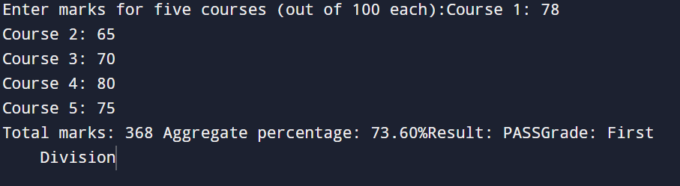

OUTPUT: The program displays the total marks, percentage, result, and grade.
Example Output:
Total Marks = 368
Percentage = 73.60%
Result: PASS
Grade: First Division
(Screen Shot of Output)

CONCLUSION: Thus, the program to calculate student result and grade based on marks was successfully implemented using C programming. This program demonstrates the effective use of conditional statements, logical operators, and arithmetic operations.

FAQs:
- What is the objective of this C program?
- Why is an if–else ladder used in this program?
- Which data types are generally used in this program?

